Instruction for usages of script

1. Running script method

* Usage

Please run the command prompt on the script folder.

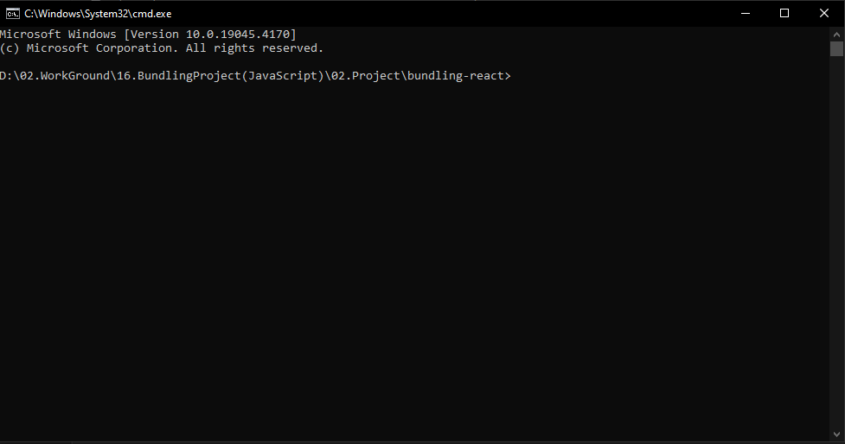

Picture 1. Command prompt running on your script folder.

* Running script

Run the script as you want using node.

Ex: node create-token.js

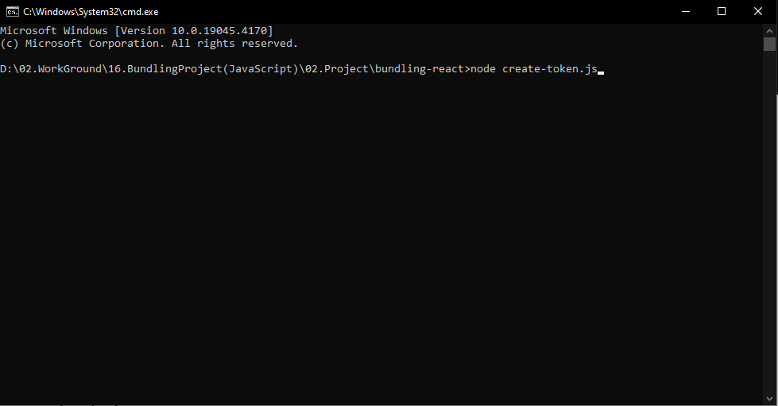

Picture 2. Running script code

Each script files functionality will be explained in Section 2.

1. Tree instruction of folder.

* JS files
* create-token.js

Use this script by mentioned on Section1 explain to create token.

* create-open-market.js

Use this script to create open market for your token.

* create-pool.js

Use this script to create pool for your token. According to .env files condition you can use Jito bundling or not. If you using Jito you can bundle the create pool and initial buy transaction. If not only create pool functionality will be execute.

Parameters of .env file will explain on .env file explanation

* buyToken.js

Use this script to buy your wanted token. You can execute buy transaction several time according to .env file condition. You can using bundle on this when you set the bundle condition.

* sellToken.js

Use this script to sell you wanted token. Execute condition is same as buyToken.

* mintToken.js

Use this script to mint the token.

* burnToken.js

Use this script to burn the token.

* transferToken.js

Use this script to transfer tokens to others.

* freezeToken.js

Use this script to freeze the token wallet.

* thawToken.js

Use this script to thaw(Refreeze) the frozen token wallet.

* revoke.js

Use this script to give up mint authority and freeze authority of token.

* .env file

This file contains all parameters that needed to control each functionalities. Here’s the explanation of each parameter.

* DEVNET_MODE

Value for choosing Devnet for Mainnet.

If true it means Devnet, false for Mainnet.

Ex: DEVNET_MODE=true

* MAINNET_RPC_URL

Rpc url for mainnet. You can change it as your wanted Rpc url.

Ex: MAINNET_RPC_URL= <https://proud-delicate-theorem.solana-mainnet.quiknode.pro/ca95305e4fa097624a21bfa02aff12d2f2c5b3a0/>

* OWNER_PRIVATE_KEY

Value for token owner private key.

* MINT_ADDRESS

Value for created token address. This value is generated when the token created.

* QUOTE_TOKEN

QUOTE_TOKEN_ADDRESS, QUOTE_TOKEN_DECIMAL, QUOTE_TOKEN_SYMBOL is values for Sol. You don’t need to change this value.

* USING_JITO_BUNDLE

Value for control using Jito. If true create-pool, buyToken, sellToken will be executed with Jito Bundle, false then create-pool, buyToken, sellToken will be execute in manual way.

* JITO Configure.

JITO_BLOCK_ENGIN_URL: Block engine url for bundling. (You don’t need to chage this value)

JITO_BUNDLE_TIP: Validator tip amount for JITO bundling.

JITO_AUTH_KEY: Value for Jito Auth wallet private key. You have to register your email and wallet private key for using Jito.   
You can register Jito Auth Key on this site: <https://web.miniextensions.com/WV3gZjFwqNqITsMufIEp>

* Create Token Environment

TOKEN_NAME: Value for name of creating token

TOKEN_SYMBOL: Value for symbol of creating token

TOKEN_DECIMAL: Value for decimal of creating token

TOKEN_SUPPLY: Value for total supply amount of token creating.

TOKEN_LOGO_PATH: Value for path of creating token’s logo.

* Create open book market Environment

MIN_ORDER_SIZE: Value for min order size of market.

TICK_SIZE: Value for tick size of market.

* Mint token Environment

MINTTO_ADRESS: Wallet address to get mint

MINTTO_AMOUNT: Token amount of mint.

You can copy this values by count so you can mint token for limit index value

Ex: MINTTO_ADRESS1=  
 MINTTO_AMOUNT1=

MINTTO_ADRESS2=  
 MINTTO_AMOUNT2=

MINTTO_ADRESS3=  
 MINTTO_AMOUNT3=

Note: Max limit at 30.

* Burn token Environment

BURNFROM_PRIVATEKEY: Wallet private key of will be token burn wallet.

BURNFROM_AMOUNT: Burn token amount.

* Buy Token Environment

Same as mint.

Note: Max count is 3

* Sell Token Environment

Same as sell

Note: Max count is 3

* FREEZE_ADDRESS

Wallet address to freeze.

* THAW_ADDRESS

Wallet address to thaw.

* Transfer Token Environment

FROM_PRIVATE_KEY: Sender of token wallet private key

TO_ADDRESS: Receive wallet address

TO_AMOUNT: Amount of token to send.

TO_ADDRESS and TO_AMOUNT is same as mint. So you can execute transfer transaction as you want.