COMMERCIAL INVOICE
Attn: Buyer’s Representative Company:
PURCHASE COMMERCIAL INVOICE OF EN590
SELLER COMPANY BELOW: |  |  |  |  |  |  |  | ISSUED DATE
COMPANY NAME: ZHENFU ENERGY (HAINAN) CO., LTD  LEGAL ADDRESS: Room 202-8, Comprehensive Building, High-end Food (Medicine) Material Processing Standardization Workshop, Haicheng 1st Road, Free Trade Zone, Haikou City, Hainan Province.  REGISTRATION №: 91460000MAEHLUW76G  REPRESENTED BY: Li SongBao  POSITION: Chairman  TELLPHONE:  E-MAIL: |  |  |  | PC-OIL/KAZ-TTT/EN590/10PPM/2026 |  |  |  | 3.19.2026
 |  |  |  | REFERENCE NUMBER |  |  |  | EXPIRY DATE
 |  |  |  | ZF-EN590-2026.326A |  |  |  | 3.XX.2026
 |  |  |  | CONTRACT NUMBER
 |  |  |  | PC-ZEHCL/KAZ-TTT/EN590/20260319
BUYER COMPANY BLOW:
COMPANY NAME: Hong Kong Unique International Trade Company
ADDRESS: RM 602, 6/F, KAI YUE COMM
BUILDING, NO.2C, ARGYLE
STREET, MONGKOK KOWLOON,
HONG KONG

REGISTRATION №: 7 7 5 0 2 7 8 8 - 0 0 0 - 1 2 - 2 4 - AREPRESENTED BY: wang'xian'wu
POSITION: chairman COUNTRY:FILL IN
TELLPHONE:
E-MAIL:
 |  |  |  | TERMS AND CONDITIONS OF PAYMENT AND DELIVERY
T/TV, ON TRANSFER MT103 START
(Including Intercoms)
INSPECTION |  | TYPE OF SHIPMENT |  | COUNTRY OF ORIGIN OF GOODS |  |  | COUNTRY OF FINAL DESTINATION
SGS, CIC, or SIMILAR |  | FOB TANK TO VESSEL |  | KAZAKHSTAN
CHARTER NAME |  | PORT OF LOADING |  | PORT OF DISCHARGE |  |  | DATE OF DEPARTURE
HONG KONG ORCHIRD  ADDRESS: RM4, 16/F, HO KING COMM CTR,  2-16 FAYUEN ST, MONGKOK  KOWLOON  HONG KONG  Email:  WEBSITE:  TEL NO:  COORDINATES: |  | VESSEL |  | QINGDAO PORT
PACKAGING |  |  |  | ANALYSIS REPORT NUMBER
VESSEL №: Start (9346079)
PRODUCER | DESCRIPTION  OF PRODUCT | QUALITY | UNIT QUANTITY |  | UNIT  MEASURE | FOB PRICE |  | AMOUNT
PETROLEUM  CAPITAL | EN590 | EXPORT  STANDARD | 100,000 MT  (ONE HUNDRED THOUSAND METRIC TONS) |  | MT | FOB Gross $530 PER METRIC TON |  | $53,000,000  Fifty Three Million US Dollars Only

REFINERY WORKING PROCEDURE FOB
FOB Tank to Vessel PROCEDURE:
1. Buyer issues ICPO and Company Registration Certificate or any I.D. With Charter Party Recap for Seller’s verification.
2. Seller issues Draft Commercial Invoice, Buyer signs and returns to Seller with his Charter Vessel Agreement (Buyer CPA).
3. Seller provides Buyer with FULL POP Documents:
a. Fresh SGS / CIC Report
b. Dip Test Authorization-Unconditional.
c. Injection Report.
d. Tank Storage Receipt with GPS Coordinates.
e. Tank Farm Bar-code Information.
f. Letter of Commitment to Supply.
g. Registration Certificate & Export License Copy.
h. Authority to Sell & Collect (ATSC).
i. Endorsed Injection Schedule by the Buyer& Buyer Tank Farm.
j. ATV– For Physical Verification.
k. Irrevocable Commitment to Supply for Spot and 12 months Contract.
4. Buyer conducts Dip-Test in Seller's tank via CIC at Buyer's cost.
5. Upon confirmation of Dip Test, Buyer executes Charter Agreement and receives Charter Vessel Receipt and Q88. Charter Vessel Receipt and Q88 sent to Seller and make port arrangements for laycan
6. Buyer’s vessel enters port. Upon Buyer’s vessel flange connection to Port Flange, Buyer deposits 30%] of cargo invoice and Seller begins to load Buyer’s Vessel.
7. Upon 100% completion of product loading, Seller injects final invoice of [70%] and Buyer makes payment on Q*Q by MT103 / TT.
8. Buyer pays for Seller’s Tank Fees of [10 days] after completion of loading by MT103/TT to Seller / Seller’s Tank Company
9. Seller transfers the Title of Ownership as per Buyer's instruction.
10 .The Buyer and the Seller confirm that, commencing on the day (T) when the full payment for the goods under this invoice from the Buyer is credited to the Seller's account, both parties shall, by means of Telegraphic Transfer (T/T), make the full payment of the agreed intermediary fee under this transaction to the designated bank accounts of each intermediary within three banking business days (T+3).
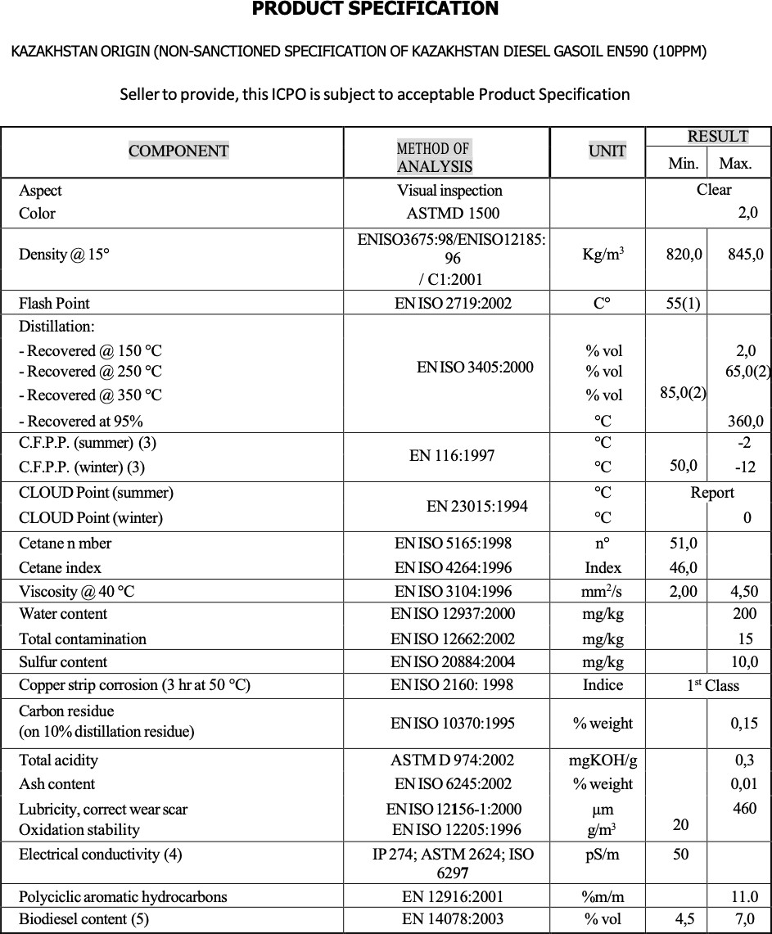

SELLER BANK INFORMATION
Bank Name | BANK OF CHINA LIMITED HAIKOU XIUYING SUB-BRANCH
Bank Address | NO. 288, BINHAI AVENUE, XIUYING DISTRICT, HAIKOU CITY
Bank Account Name | ZHENFU ENERGY (HAINAN) CO., LTD
Bank Swift Code | BKCHCNBJ740
REPRESENTATIVE: | HAN SIGUANG
Bank Account | 267545173354
BANK OFFICER TEL/EMAIL | +86-0898-66563027

BUYER’S BANK INFORMATION
Bank Name | CITIBANK N.A.
Bank Address | Champion Tower, Three Garden Road, Central, Hong Kong
Bank Account Name | Hong Kong Unique International Trade
Bank Swift Code | CITIHKHX (CITIHKHXXXX * If 11 characters are required)
REPRESENTATIVE: | wangxianwu
Bank Account | 395715394
BANK OFFICER TEL/EMAIL | 00852 2860 0333

We ZHENFU ENERGY (HAINAN) CO., LTD Hereby with Full Corporate Responsibility and With Power Vested in Its Officer Accept Confirm and Agree to Abide by This Agreement.
SELLER SIGNATURE/ STAMP OR SEAL:

Company name：ZHENFU ENERGY (HAINAN) CO., LTD

Representative name: LI SONGBAO
Representative position: CHAIRMAN

We Hereby With Full Corporate Responsibility And With Power Vested In Its Officer, Accept, Confirm And Agree To Abide By This Agreement.
BUYER SIGNATURE/ STAMP OR SEAL:

Company name：

Representative name:
Representative position:
This (CI) contract is signed in the witness of: (MINISTRY) For Law Management:Signature/ Stamp & Seal: Signature/ Stamp & Seal:

