Height Classification Internship

# Problem Definition

Perform object height classification using time domain analog waveform features extracted from current measurement cycle (max amplitude, time-spread, ring-up, ring-down time, etc.).

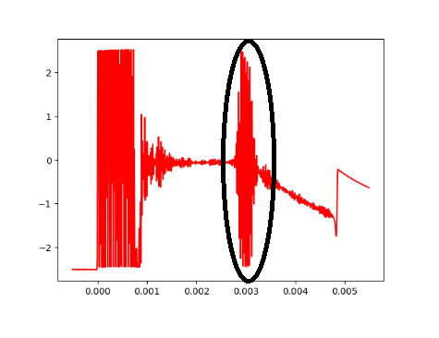See analog waveform in figure 1.

Figure1. Analog waveform

My hypothesis is that based on the distance and the type of object which reflects the ultrasonic pulse the shape of the outlined signal deforms in such a way that it could be correlated with the height of the object.

# Echo detection

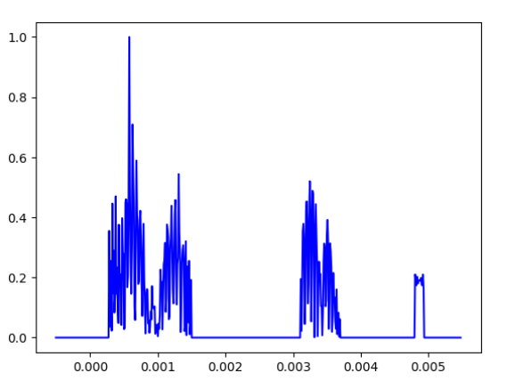To extract meaningful features from the analog waveform we need to implement an algorithm which detects the start of the reflected echo. This could be done using various signal processing techniques (Hilbert Transform, Matched Filter). See figure 2 and 3.

Figure 2. Correlation Analysis

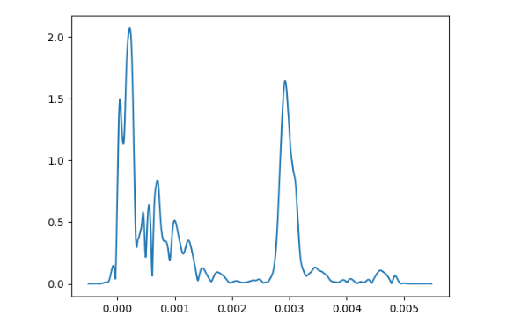

Figure 3. Hilbert Analysis

Starting moment could be identified by setting a threshold.

# Measurement Collection

In order to train a machine learning model, we need data.

Implement an automatic data collection pipeline using serial communication between a pc and Pico2 + sensors.

We have 2 possible approaches:

* First is using 2 sensors to perform trilateration to obtain the coordinates of the identified object + analog waveforms.
* Second is to put an object on a chessboard-like surface and move the object and label manually each position in relation to the ultra-sonic sensor.

# Feature Extraction

Extract relevant time domain features which will be used in the training phase of the ML model (time-spread, power, amplitude, ring-down, ring-up).

# ML Model

Devise/import a ML architecture for binary classification task (high/low). This can use distance, waveform features and even previous coordinates as inputs for the model. This model could be implemented either per slave or master.

# Train + Evaluation

Train and evaluate the machine learning model’s performance and apply additional operations if required. For model improvement (collect more data, apply regularization, etc.)