HLD-Snippet

OLM Moodle

|  |  |
| --- | --- |
| Document Information | |
| Document Name | HLD_Snippet_OLM_Moodle.docx |
| Service |  |
| Author | Bruce Moffat |
| Contributors |  |
| Reviewers | Markus Enders |
| Issue Date | 23.05.2018 |

|  |  |  |
| --- | --- | --- |
| Document History | | |
| **Version** | **Date** | **Summary of change** |
| 0.1 | 23.05.2018 | First Draft |
|  |  |  |
|  |  |  |

|  |
| --- |
| This document may include data that is **CONFIDENTIAL** and shall not be disclosed outside UCL and shall not be duplicated, used, or disclosed in whole or in part for any purpose other than to evaluate and implement procedures defined within this document. |

Table of Contents

Document Information 1

Document History 2

1 AS IS 4

1.1 Overview 4

1.1.1 Application Catalogue 4

1.1.2 Application Collaboration 4

1.2 Data Architecture 7

1.2.1 Data structure 7

1.2.2 Key Identifiers required. 9

1.2.3 Data exchange 9

2 To-Be 9

2.1 Business Architecture 9

2.2 Application Architecture 10

2.2.1 Overview 10

2.2.2 Application Catalogue 10

2.2.3 Application Collaboration 10

2.2.4 Key Identifiers 13

2.3 Data Architecture 13

3 Gap Analysis 16

4 Open Issues 16

5 Closed Issues 17

# AS IS

Moodle is UCL’s strategic e-learning content player, used predominately by students but also by staff for a smaller number of courses. There are five training providers who will go-live with OLM (Oracle Learning Management) who currently use Moodle for all of their e-learning courses.

OLM Provider Group

|  |  |
| --- | --- |
| Provider Name | Contact Name |
| Organisational Development | Vathani Mariampillai |
| Information Services | Caroline Norris |
| Safety Services | Tracy Samson |
| Arena | Peter Phillips |
| Finance and Business Affairs | Charles Demain |

## Overview

The current interaction for each provider differs, there is no single standard interaction pattern.

### Application Catalogue

|  |  |  |
| --- | --- | --- |
| **ID** | **Application / Application Component** | **Description** |
| 1 | Single Training Booking System (STBS) | Application to store course and enrolment details for training courses. |
| 2 | ResourceLink (RL) | HR application masters the training course details. |
| 3 | Moodle | Institutional virtual learning environment (VLE) to play on-line training courses. |

### Application Collaboration

As a result of HR implementation ResourceLink and STBS are to be replaced by Oracle e-business suite components HR and OLM. The aim is to use Moodle as the content player for all e-learning courses created and maintained in OLM.   
Currently there are five providers that will use OLM at go-live, our analysis of the current implementation only covered at a high level four providers’ method of using Moodle to deliver on-line courses.[1]

The diagram provides an ‘as is’ high-level overview.

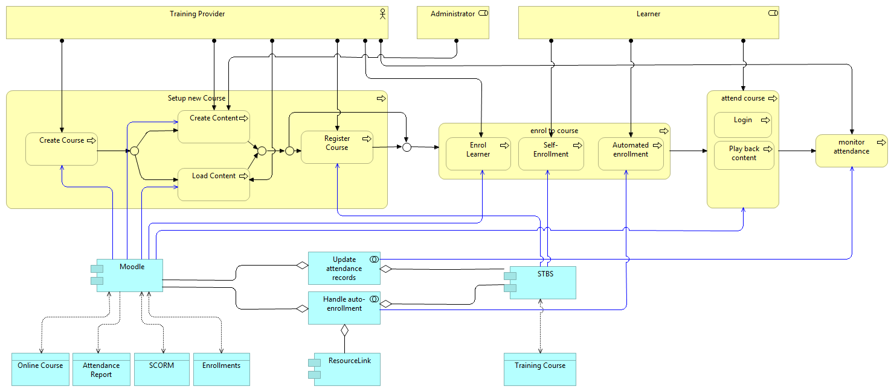

**Moodle** is the current and only tool supported by ISD that is used by UCL to run e-learning courses.

STBS is currently one of the tools used by staff to search the training catalogue administered by the providers listed above, however it is more likely the learner will search and enrol onto e-learning courses via Moodle. Not all e-learning courses are entered into STBS, there are instances where the course and enrolments are only mastered in Moodle.

If STBS is the tool used to access the course, the course details have to be entered into ResourceLink, this data is then interfaced to STBS to enable booking by the learner. All individuals with UCL credentials automatically have access to Moodle. Student Moodle accounts are created the first time a learner logs onto Moodle, staff accounts are created via a nightly process. Details are supplied from active directory via LDAP. Moodle can be accessed by individuals without UCL credentials via a guest account, which the owner of the course provides. No record of scores of assessment are recorded against guest accounts.

There is no single process defined by providers to create or run online courses.

**Setting up a course in Moodle**

In all cases whether the course is in STBS or not, the course has to be created in Moodle and the content loaded. This can be in the form of a complete SCORM package or manual components completed by the administrator after Moodle support team create the course. Providers are granted the required privileges to complete their tasks.

**Enrol onto a course**

There are various methods to direct the learner to Moodle for enrolment.

1. Manual enrolment in Moodle by the provider, then the provider emails the learner an invitation to log into a course in Moodle, and these courses can be activated with keys sent in the email by the learner. However it is not mandatory to have key access in Moodle.
2. The learner can find the course in STBS and will be re-directed to Moodle or a provider’s web page.
3. The learner can search and enrol themselves to a course in Moodle directly. Basically an automated enrolment by the learner.

Re-direction to Moodle can be directly to a course or just to the Moodle homepage where the learner will then have to search for the course. When the URL sends the learner directly to a course the URL will contain the course ID generated in Moodle at the point of course creation.

**Access / Attend a course**

Learner course access is via one of the following methods

* Via STBS the learner is at some point re-directed to Moodle and the learner has to always log in to Moodle to run the course, either with or without a key.
* In some cases the learner will have to search inside Moodle to find the course and self-enrol. If the enrolment has been manually set, the person manually enrolling the learner needs to have the correct privilege. Currently managers cannot manually enrol a learner (unless they are provider administrators as well). There are some specialised courses for which a training provider cannot generate the key.[2]

**Monitor attendances**

Upon completion of the course the status is not updated in ResourceLink, unless the provider manually applies the results, this is only for staff on the payroll. Organisational Development have a custom interface for one course which produces a comma separated file to enable the upload of the learner’s attendance into ResourceLink. All other providers’ user reports from Moodle are used to monitor completion rates. There is no automated method to ensure mandatory courses, such as IT security completed.

INT120 -> Create a RL course.

INT121 -> Update a RL course.

INT122 -> Delete a RL course.

INT123 -> Create a course in Moodle.

INT124 -> Enrol a learner onto a Moodle course.

INT125 -> Remove a learner from a Moodle course.

INT126 -> Update a learner’s attendance information.

| Interface | Between Systems | Update frequency | | Data transfer method | Data is replicated / transient | What records is required  (current / past / future) | How many records are transferred through the interface in a single request |
| --- | --- | --- | --- | --- | --- | --- | --- |
| INT120 | RL ->STBS | ADHOC | DB views | | Replicated | Current | Set of Records/Single Record |
| INT121 | RL ->STBS | ADHOC | DB views | | Replicated | Current | Set of Records/Single Record |
| INT122 | RL ->STBS | ADHOC | DB views | | Replicated | Current | Set of Records/Single Record |
| INT123 | Moodle | ADHOC | Manual | | Replicated | Current | Set of Records/Single Record |
| INT124 | STBS->Moodle | ADHOC | Redirection, Manual enrolment | | Replicated | Current | Set of Records/Single Record |
| INT125 | STBS->Moodle | ADHOC | Manual Removal | | Replicated | Current | Set of Records/Single Record |
| INT126 | Moodle ->  RL | ADHOC | Manual data entry | | Transient | Current | Set of Records/single Record |

## Data Architecture

### Data structure

The following are data items supplied to enable the creation, update and removal of courses from ResourceLink to STBS.

The mandatory attributes required to create a course in Moodle are; Category id, Course full name and Course short name.

|  |  |  |
| --- | --- | --- |
| Logical Entity | Data Fields | Data Type |
| Course | ID | Varchar2(10) |
| Course | Main Ref | Varchar2(8) |
| Course | Short Desc | Varchar2(10) |
| Course | Long Desc | Varchar2(80) |
| Course | Source ID | Varchar2(10) |
| Course | Min Attendees | Number(3) |
| Course | Max Attendees | Number(3) |
| Course | Duration | Number(5,2) |
| Course | Requirements Note Ref | Varchar2(8) |
| Course | Status Code Set ID | Varchar2(10) |
| Course | Objectives Note Ref | Varchar2(8) |
| Course | Coord Name | Varchar2(98) |
| Course | Coord Email | Varchar2(80) |
| Course | Type Long Desc | Varchar2(40) |
| Course | Type Short Desc | Varchar2(10) |
| Course | Type Narrative Code | Varchar2(6) |
| Course | Coord Long Desc | Varchar2(40) |
| Course | Coord Short Desc | Varchar2(10) |
| Course | Source Name | Varchar2(40) |
| Course | Source Tel No | Varchar2(20) |
| Course | Source Fax No | Varchar2(20) |
| Course | Course Rational Not Ref | Varchar2(8) |
| Course | Header Not Ref | Varchar2(8) |
| Course | Course Programme Note Ref | Varchar2(8) |
| Course | Course Desc Note Ref | Varchar2(8) |
| Course | Course SS Publish Flag | Varchar2(1) |
| Course | Course Security ID | Varchar2(6) |
| Course | Course Security ID Dept | Varchar2(40) |
| Course | Admin Role | Varchar2(15) |

### Key Identifiers required.

The following identifiers are required to enable the updates and deletions of courses from RL to STBS.

| Identifier | Master System / originates at |
| --- | --- |
| Course ID | ResourceLink |

### Data exchange

The following data objects are exchanged between RL and STBS

| **Interface** | **Logical Entity** | **Stored in Moodle** |
| --- | --- | --- |
| INT120 | Course Programme | Code, name and cohort of the course programme |
| INT121 | Course Programme | Code, name and cohort of the course programme |
| INT122 | Course Programme | Code, name and cohort of the course programme |

# To-Be

## Business Architecture

To enable the new interfaces, the following requirements and assumptions must be considered.

* All learners will enrol onto class via OLM either by enrolling themselves to a class[3], being enrolled to a class automatically (by the system) or being enrolled to a class by their manager or an administrating provider.
* Enrolment on the course in Moodle will always be self-enrolment by the learner. When the learner initiates the action to attend the class in OLM, they are re-directed to login to Moodle. The URL re-direction link can contain the Moodle course ID that will take the learner directly to the course after login that will be at the discretion of each provider.
* It is the responsibility of the Training Providers to setup appropriate classes in OLM as well as to upload the online content for the course in Moodle.
* OLM is the master data system for attendance information. All attendance information must be stored in OLM.

## Application Architecture

### Overview

Class creation in OLM; the flow will be from OLM to Moodle and then back to OLM to update the class with the key Moodle course identifier.

Update and deletion of a class will flow from OLM to Moodle.

Removal of a learner from a class will flow from OLM to Moodle.

Update of a learner attendance information will flow from Moodle to OLM.

* A course in Moodle equates to a class in OLM.
* A course in Moodle belongs to a category hierarchy, and category ID will need to be stored in EBS OLM before courses can be created.
* A category in Moodle equates a learning provider category in OLM; for each learning provider OLM will need store the Moodle category ID.

For the creation, update and deletion of a class and removal of a learner(s) from a class the interaction will be driven by the business event in OLM.

### Application Catalogue

|  |  |  |
| --- | --- | --- |
| **ID** | **Application / Application Component** | **Description** |
|  | EBS OLM | Oracle’s E-Business Suite (EBS) OLM module. OLM is the master system for all UCL staff training. |
|  | Moodle | UCL’s application to play e-learning courses. |
|  | Interface implementation | Application layer on top of EBS OLM that will provide the interface |
|  | WS02 | Web service platform. |

### Application Collaboration

The format for all interaction between the applications will be web-services. WS02 is a web service platform that will act as a proxy between the Moodle web service and EBS.

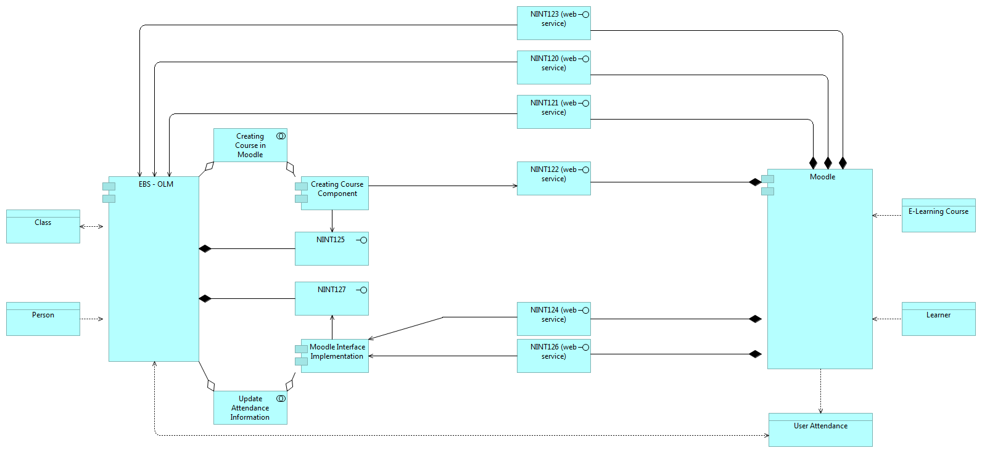

* The OLM business event of creating a class in OLM will invoke custom code, which will call a standard Moodle web service to create the course in Moodle[4]. The successful response will generate an internal course identifier, this identifier or a transformed equivalent will be loaded back into OLM and stored in a class descriptive flex-field accessible by providers but hidden to learners.
* The OLM business event of updating or deleting a class in OLM will invoke custom code, which will call a standard Moodle web service to update or delete the course in Moodle.[5]
* The OLM business event of removing a learner(s) from a class in OLM will invoke custom code, which will call a number standard Moodle web services. If the key internal identifier for a Moodle user is not currently assigned to a person in EBS, a call will be made to obtain the Moodle internal user ID or transformed equivalent to update OLM. Then call a second Moodle web service to remove the learner from the course in Moodle will be made.
* To update attendance information in OLM, a nightly process will be developed to identify all learners who have completed courses owned by the provider. This job may invoke multiple web services calls depending if the learner has key identifier against their person record in HR.

In the event of any failures, error a notifications will be sent to the appropriate groups.

NINT120 -> to create a course in Moodle.

NINT121 -> to update a course in Moodle.

NINT122 -> to delete a course in Moodle.

NINT123 -> to remove a learner from a course in Moodle.

NINT124 -> to obtain a learner’s attendance information from Moodle.

NINT125 -> to update a class in OLM with the key identifier.

NINT126 -> to obtain a learner’s key identifier from Moodle.

NINT127 -> to update a learner’s attendance information in OLM.

| Interface | Between Systems | Update frequency | Data transfer method | Data is replicated / transient | What records is required  (past / current / future) | How many records are transferred through the interface in a single request |
| --- | --- | --- | --- | --- | --- | --- |
| NINT120 | OLM -> Moodle | Adhoc | Web Service | Replicated/Transient | Current | Single Record |
| NINT121 | OLM -> Moodle | Adhoc | Web Service | Replicated/Transient | Current | Single Record |
| NINT122 | OLM -> Moodle | Adhoc | Web Service | Replicated/Transient | Current | Single Record |
| NINT123 | OLM -> Moodle | Adhoc | Web Service | Replicated/Transient | Current | Set of Records/Single Record |
| NINT124 | Moodle -> OLM | Nightly Scheduled | Web Service | Replicated/Transient | Current | Set of Records/Single Record |
| NINT125 | Moodle -> OLM | Adhoc | Web Service | Replicated/Transient | Current | Single Record |
| NINT126 | Moodle -> OLM | Adhoc | Web Service | Replicated/Transient | Current | Single Record |
| NINT127 | Moodle->OLM | Adhoc | Oracle API | Transient | Current | Set of Records/Single Record |

The low level implementation details of this interface/customisation can be found in the solution design document.

LINK TO SDD TO GO HERE…

### Key Identifiers

| Identifier | Master System / originates at |
| --- | --- |
| Course ID (internal identifier) | Moodle |
| User ID (internal identifier) | Moodle |

## Data Architecture

All course creation, updates or deletions and learner un-enrolment identified will be transferred from OLM to Moodle directly from EBS. Learner attendance information will be updated from Moodle to OLM directly.

The following details will be sent to Moodle.

|  |  |  |
| --- | --- | --- |
| *Interface* | *Logical Entity (OLM)* | *Comments* |
| NINT120 | Class | Trigger by a business event in OLM, will invoke the creation of a course in Moodle, returning the Moodle course ID. |

The above data will be pushed from OLM and created in Moodle, triggered by an OLM business event. The provider should set the class status to ‘planned’ in OLM, this will mean a learner cannot attempt to attend the class. The provider should also consider a future enrolment start date allowing time for the content to be loaded into Moodle. The standard Moodle web-service request will create the course in Moodle[6], the response will contain the Moodle course ID. The training provider team will receive a notification on any failures in the process. Records that fail to load into Moodle will need to be identified, and resolved. Changing the class status from planned to open in OLM will be refused until the course is manually created in Moodle and the course ID is manually updated in OLM. If the internal Moodle course ID is transformed there is an open issue (6) Open Issues in regard to obtaining and supplying this to the provider. If the internal ID is used then the Moodle support team will need to supply the training provider with the identification of the course ID.

The following details will be sent to OLM.

|  |  |  |
| --- | --- | --- |
| *Interface* | *Logical Entity (Moodle)* | *Comments* |
| NINT125 | Course | Triggered by NINT120 to update an OLM class with the Moodle course ID. |

The above data will be read from Moodle and updated in OLM. The response from the web service to create a course (NINT120) will return a Moodle course ID, this identifier or equivalent will then be uploaded into OLM, stored in the class descriptive flex-field. Interface NINT125 is coupled with NINT120 and will be a single process. The EBS support team and the training provider team will receive a notification for any failures in this step of the process. Records that fail to update the OLM class will need to be identified, and resolved. The training provider will have to manually update the class with the Moodle course ID, changing the class status from planned to open in OLM will be refused until the course is updated with the course ID. Open issue number 6 applies again.

The following details will be sent to Moodle.

|  |  |  |
| --- | --- | --- |
| *Interface* | *Logical Entity (OLM)* | *Comments* |
| NINT121 | Class | Triggered by the OLM business event, update of an OLM class. |
| NINT122 | Class | Triggered by the OLM business event, deletion of an OLM class. |

The above data will be pushed from OLM to update or delete a course in Moodle. The training provider team will receive a notification on any failures in the process. Records that fail to be updated or deleted into Moodle will need to be identified, and resolved manually.

The following details will be sent to Moodle.

|  |  |  |
| --- | --- | --- |
| *Interface* | *Logical Entity (OLM)* | *Comments* |
| NITN123 | Class | Triggered by the OLM business event, removal a learner from an OLM class. |

The above data will be pushed from OLM to remove a learner from a course in Moodle. The learner can only be removed if the key identifier exists on the EBS person record. The training provider team will receive a notification on any failures in the process. Records that fail to be updated into Moodle will need to be identified, and resolved manually.

The following details will read from Moodle and sent to OLM.

|  |  |  |
| --- | --- | --- |
| *Interface* | *Logical Entity (Moodle)* | *Comments* |
| NINT126 | USER | Trigger by NINT124 to obtain the Moodle user ID and update the person record in HR with that Moodle user ID. |

The above data will be pulled from Moodle to update a person’s record in EBS with the Moodle user ID. The EBS support team and training provider team will receive a notification for any failures in the process. Records that fail to be updated into HR will need to be identified and resolved manually.

The following details will be read from Moodle.

|  |  |  |
| --- | --- | --- |
| *Interface* | *Logical Entity (Moodle)* | *Comments* |
| NINT124 | User attendance. | Read the user’s attendance information from Moodle. |

This interface is coupled with NINT126 and NINT127, if the learner does not have the user key ID in EBS, NINT126 will be invoked to obtain the user ID or transformed equivalent, again open issues 6 will apply. NINT124 will be read the attendance data from Moodle.

The following details will be updated in OLM.

|  |  |  |
| --- | --- | --- |
| *Interface* | *Logical Entity (OLM)* | *Comments* |
| NINT127 | Learner attendance. | Triggered by NINT124 to update the learner’s attendance information in OLM. |

NINT127 will update a learner’s attendance in OLM via a scheduled nightly job, it is coupled with NINT124. The process will identify all learners where the status is not set to complete in OLM (for e-learning courses only). Any records that fail to load into OLM will need to be identified and resolved. The EBS support team and provider team will receive email notification on any failures in the process.

The following additional components will be required in EBS;

* A custom table in the UCL schema this table will be used store a record of error notifications send.
* A new lookup in EBS will be required to store the Moodle category ID for each provider, this lookup will also contain the provider email address required for error notification.

# Gap Analysis

The following Matrix shows which gaps had been detected in the various components and data streams where the change will apply.

|  |  |  |  |  |
| --- | --- | --- | --- | --- |
| **No.** | **Architecture** | **Gap** | **Resolution** | **Resolution Date** |
| 1 | Data Architecture | How to store Moodle course identifier in EBS | Class descriptive flex-field, displayed to the UCL Learning Administrator and UCL Learning Administrator Super User responsibilities. | 15/03/2018 |
| 2 | Data Architecture | How to store the Moodle identifier for a learner in EBS | Hidden person descriptive flex-field | 15/03/2018 |
| 3 | Application Architecture | New package invoking Moodle web services to create, update and delete records into Moodle. | Create a PLSQL package under the apps schema | 15/03/2018 |
| 4 | Application Architecture | New package to update enrolment records in EBS. | Create a PLSQL package under the apps schema | 15/03/2018 |
| 5 | Application Architecture | New scheduled job to invoke the process of update to a learner’s enrolment status. | Create a new concurrent job in EBS. | 15/03/2018 |
| 6 | Application Architecture | Store the Moodle category ID and emails for notification for each provider in EBS. | New EBS lookup for each provider. Moodle to supply the values. | 15/03/2018 |
| 7 | Application Architecture | Store error notifications sent. | New table in the EBS UCL schema | 15/03/2018 |
| 8 | Application Architecture | How to stop course status moving from planned to open. | Page personalisation. | 15/03/2018 |

# Open Issues

|  |  |  |  |  |
| --- | --- | --- | --- | --- |
| **No.** | **Architecture** | **Issue** | **Owner** | **Open Date** |
| ~~1~~ | ~~Data Architecture~~ | ~~Can Moodle identify and store the source owner~~ | ~~Bruce Moffat~~ | ~~10/03/2018~~ |
| ~~2~~ | ~~Application Architecture~~ | ~~What identifier is used for a learner in Moodle~~ | ~~Bruce Moffat~~ | ~~10/03/2018~~ |
| 3 | Data Architecture | What OLM class data attributes will be required for the Moodle course creation? | Tracy Samson | 10/03/2018 |
| 4 | Data Architecture | Is it possible for Moodle to set individuals as administrators at category level? | Bruce Moffat | 10/03/2018 |
| 5 | Data Architecture | Should there be a persistent identifier for Moodle objects (e.g. courses) instead of using Moodle internal identifiers. If so where should it be stored? | Markus Enders | 10/03/2018 |
| 6 | Data Architecture | How to supply the provider teams with a transformed Moodle Course ID for failed records | Markus Enders | 10/03/2018 |
| 7 | Data Architecture | The course ID response from the Moodle web service to create a course, is this the same ID that the Moodle team currently sent to providers when they manually create courses. | Moodle team | 10/03/2018 |

# Closed Issues

|  |  |  |  |  |  |
| --- | --- | --- | --- | --- | --- |
| **No.** | **Architecture** | **Issue** | **Resolution** | **Owner** | **Resolution Date** |
| 1 | Data Architecture | Can Moodle identify and store the source owner | Each provider should have a category | Bruce Moffat | 15/03/2018 |
| 2 | Application Architecture | What identifier is used for a learner in Moodle | User ID | Bruce Moffat | 15/03/2018 |
|  |  |  |  |  |  |
|  |  |  |  |  |  |
|  |  |  |  |  |  |
|  |  |  |  |  |  |

1. Finance and Business Affairs have not engaged thus we have not analysed their requirements.
2. Administrators have the ability to hide the courses from users.
3. OLM classes are instances of the OLM course, learners are only enrolled onto a class. An OLM class equates to a Moodle course.
4. Moodle category ID is a mandatory parameter, this must be stored in EBS.
5. To delete a class in OLM all learners must firstly be un-enrolled.
6. As a default all courses created in Moodle will be set to not visible, the training provider will change this at the appropriate time.