**Moodle 3.7 accessibility testing**

Table of Contents

Table of Contents 1

General notes 2

Common issues 2

Link-specific issues 4

Standalone login page 5

Home page, pre-login 5

Home page, post-login 5

Initial pop-up tour 5

Main page content 6

Arena Open landing page 8

Accessible Teaching Practices course 10

“Test your knowledge” quiz (in “1. Start here” tab) 10

Profile page 13

Edit profile 13

Events page 15

Moodle demo course (collapsed topics layout) 15

Moodle demo course (grid layout) 17

Moodle demo course (tabs layout) 17

Add a new glossary item 18

Moodle demo course (topics layout) 20

“Contemporary issues in clinical education” course 20

News forum 20

“Leadership skills for the healthcare professional” course 20

UCL Mechanical Engineering safety page 21

# General notes

The “Skip to main content” etc. links are very helpful.

## Common issues

* Lots of buttons are read as form fields; they should be read as links or buttons, depending on how they act, but not form fields.
  + Toggle messaging drawer button
  + Notifications button
  + Accessible teaching practices course has quite a few (not just on the quiz pages!)
  + Demo course with collapsed topics layout (on the “Open all” and “Close all” buttons)
* Headings on many pages do not follow the most accessible order (h1, then h5, then h4)
* The Twitter widget is a problem in many ways, as it is inescapable by screenreader, and it creates lots of identically-named links and unhelpfully-described images
* On some pages, the messaging button comes before the notifications button when navigating by keyboard, despite the order on the page showing the notifications button to the left of the messaging button
* There is a cog menu icon (announces as “actions menu button menu”) on some pages which blends into the background: 
* In staff courses, the “hidden to students” tabs are too low in contrast; more details in the Arena Open landing page section
* There are similar contrast issues with the drop-downs e.g. on the home page, and with the mid-grey text in the “Recently accessed courses” section:

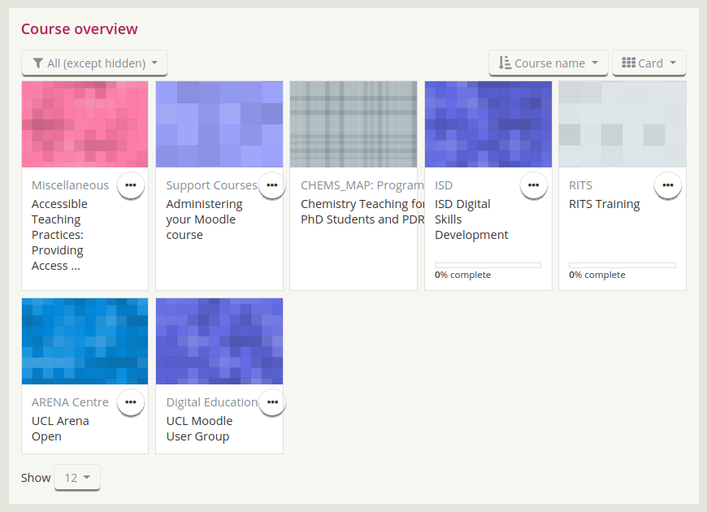

## Link-specific issues

* User profile: “Profile of [full name] [full name]”, where the full name is repeated twice
* The UCL logo: “logo link”
* Moodle News play and pause button: “link”
* The recently accessed courses navigation buttons: “number unavailable link” and “number link”
* Course overviews: “course image link” and “course image[course name without space] link”
* Back to top button: “same page link”
* Untitled links: “ ” (space)

**A more detailed description of the issues we found follow.**

# Standalone login page

When you’ve reached the page trying to get to a course without being logged in, there are two login areas: the main area of the page, and the top right area as is found on the main home page. Both appear to be functional, but are nonetheless confusing!

# Home page, pre-login

There is just the one login area, which is better!

# Home page, post-login

## Initial pop-up tour

This caused no problems for the screenreader, which pop-ups often do. The “Previous” button, when active, has quite dark text on a dark background, so that may need reviewing for contrast: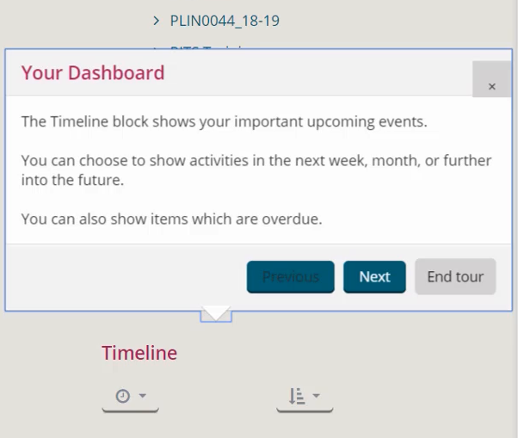

## Main page content

Navigating with the screenreader works well until it reaches the UCL logo graphic, where it gets stuck, and it is impossible to navigate away from it. It also reads as “logo link” (as the alt attribute for the image is just “logo”).

The profile drop-down link states it’s expandable, but it does not expand when navigating via the keyboard. It also claims to be expanded when using a screenreader, but visibly is not, and menu items still cannot be accessed via the keyboard. It also reads the profile image as “profile of [full name] [full name]”, where the full name of the user is repeated twice.

The “Moodle news” section has a play/pause button, which is read by the screenreader simply as “link” on Opera, and “slash number link” on IE. The a#play_trigger and a#pause_trigger elements both have href attributes with values of “#”, which is problematic for the reasons given in more detail below.

The “Recently accessed courses” section has left and right arrow buttons for navigation, which are read by the screenreader as “Number unavailable link” and “Number link” respectively, as shown in Figure 1. This appears to be the result of a link that technically “goes nowhere”, as it is used to perform a function within the same page, and so its href attribute is just a hash sign, which will be read by a screenreader as “number”. Note that this outcome came from testing on Opera, whereas on Firefox, it read out the whole, absolute (internal) URL verbatim with the hash sign at the end, rather than *just* the hash sign; however, it would still not be clear for a screenreader user exactly what that link does. [Further information about hyperlink accessibility can be found here](https://webaim.org/techniques/hypertext/).

In the “Course overview” section, the drop-downs don’t announce what they are, or the currently-selected items, including when they haven’t been changed. The course image links are all read as “course image”, and the course name textual links are read as “course name[course name]” without a space, as also shown in Figure 1.

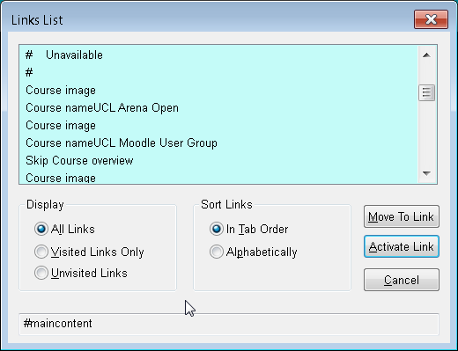

Figure : Links list for Moodle home page, showing several issues with link naming

The search button was read as just “button” when tested on Opera, but is read correctly as “search button” on Firefox. In Opera, the search text input field was read as “edit, type and text, alt plus six”, which is presumably indicating the accesskey attribute that gives it keyboard focus (Alt+6), but the placeholder text “Search Courses” was not read. Without that contextual information that the text field is a search field, its purpose would not be clear to a screenreader user.

The screenreader gets caught in a loop in the “Timeline” section, at “filter timeline options button menu”, and we can only get out of it by manually moving the focus with the mouse, which would pose a potential problem both for screenreader users and those with mobility issues.

In Opera, the icon-only links for social media are each read only as “link”, while they are read correctly (including the name of the social media site) on Firefox.

The “Reset user tour on this page” link is a good and helpful feature.

The “back to top” button at the bottom-right of the page is read only as “same page link” in Opera.

# Arena Open landing page

There are numerous links on this page. Depending on the browser, 263, 272, or 283 links are detected, many of which seem to stem from the Twitter widget, as shown in Figure 2. The more links a single page has, the harder navigation can be for screenreader users, as it becomes increasingly difficult to filter through the many links to find the required one.

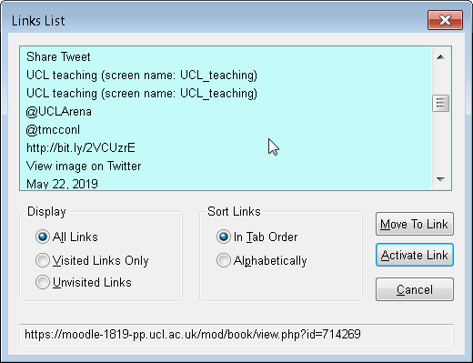

Figure : Links list of Arena Open landing page, showing links from the Twitter widget

The screenreader gets stuck in “Actions menu button menu”, which is the cog icon at the right-hand side of the main navbar. That icon itself also seems to be coloured the same as the page header until hovered over, at which point its colour changes to match that of the other items in the navbar.

The greyed-out “hidden from students” tabs and content will not meet contrast requirements (#999 foreground against #f7f8f2 background has a contrast ratio of 2.66:1, which fails requirements for normal and large text). The contrast ratio needs to be at least 4.5:1 for normal text (this would be a foreground of #707070 or darker), and 3:1 for large text (this would be a foreground of #8F8F8F or darker). These will need to be distinguished from non-hidden tabs and content in a different way, such as:

* Bolded non-hidden content and regular-weight hidden content
* Different colours, but not different shades

The Twitter widget announces all images each as “Twitter image” only, which is not helpful for screenreader users. Every Tweet has its own action menu, which is also read as identical “Tweet actions menu” form fields, as shown in Figure 3. Escaping the Twitter widget once entered was also very difficult to do using the keyboard.

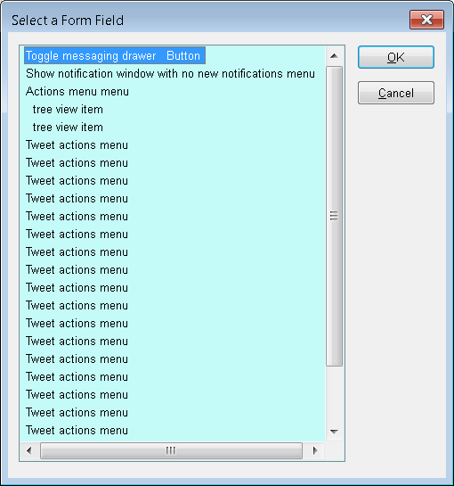

Figure : Form fields of Arena Open landing page, showing issues with the Twitter widget’s identical action menus

# Accessible Teaching Practices course

Many of the buttons seem to be detected as being form fields, when they should be shown as links/buttons/both (screenreaders can detect links and buttons separately).

## “Test your knowledge” quiz (in “1. Start here” tab)

**We were unsure how much of the following is down to individual course content and how much is down to the overarching theme, so feel free to ignore any irrelevant parts!**

The page jumps apparently randomly (not related to where the current keyboard focus is) while reading with the screenreader, both on the quiz landing page and within the individual quiz question pages. We are unsure whether this is an issue with the screenreader itself or the pages in question.

Common issues within the quiz:

* Questions are not read at any point
* Buttons such as “Check”, “Previous page”, and “Next page” are being detected as form fields rather than buttons or links
* Radio buttons are formatted in such a way that the screenreader is reading incorrect information

The first question has a combo box (drop-down) as its answer format. It runs off the page (which may be because the given answer options are themselves long sentences), so it is not immediately clear that it is a drop-down, as the icon that usually indicates it is hidden, and there is no placeholder text to indicate a selection must be made. Looking at the HTML, the combo box appears empty because the first option tag only contains a non-breaking space, and has a value attribute with no value (an empty string is preferable to nothing at all). The question text is also not connected to the combo box, and is in a p element instead of a label element with its for attribute matching the select element’s id attribute. [Further information about accessible form controls can be found here (see “select menus” in this case)](https://webaim.org/techniques/forms/controls). The control buttons are read as being form fields, rather than buttons or links.

The second and third questions have checkboxes as their answer format, which are read without issue by the screenreader. However, the question is still being skipped over, and there is no easy way to navigate from the links and answers to the actual question text. The control buttons are again in form fields.

The fourth question has a radio button answer format. The control buttons are again read as form fields, as are the radio buttons themselves. The first reading from the main question section by the screenreader, again ignoring the actual question text, is “radio button checked 3 of 3” when only two radio buttons are visible, and neither are checked. “Clear my choice button” keeps being read when there’s no such thing visible on the page, as shown in Figure 4. Looking at the HTML, it seems there’s a third “clear choice” radio button which is hidden from the user, and which is automatically checked. This is not clear for screenreader users, and if this is a common feature of quiz question pages with radio buttons, an alternative approach may be necessary (perhaps via another “standard” button instead of a radio button, so it could be visible on the page without being confused for another answer option).

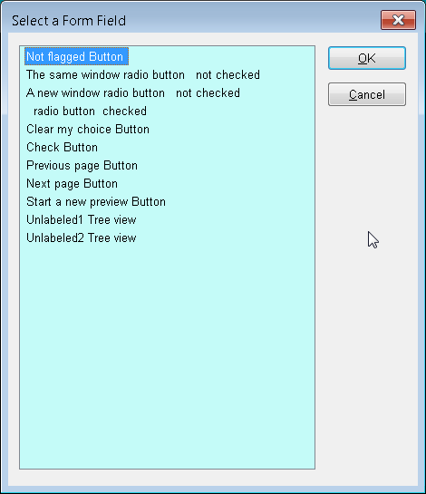

Figure : Accessible Teaching Practices course quiz page, showing radio buttons and control buttons that have been detected as form fields

The final question is a drag-and-drop format, as shown inFigure 5, and this has only been tested on IE, as the inaccessibility of this format is known to be universal. Those with mobility difficulties could have issues using the mouse for this purpose, and there is no clear way to drag and drop using the keyboard either. There is no clear way to interact with this format at all with the screenreader.

A more accessible approach would be to remove this style of answer format as an option entirely, in favour of repeated drop-downs for each “answer space”, where each drop-down contains all possible formerly-“drag-able” answers.

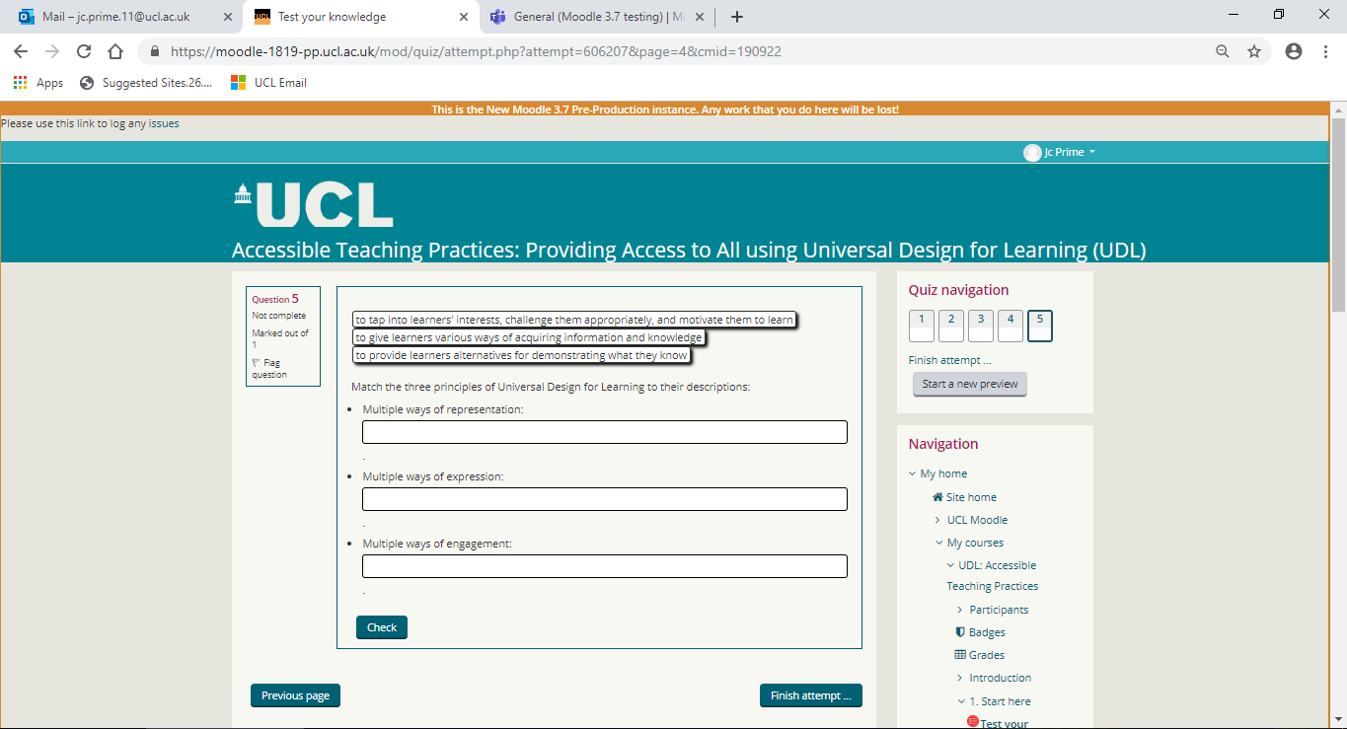

Figure 5: Final question of "Test your knowledge" quiz in Accessible Teaching Practices course, whose drag-and-drop format is fully inaccessible to screenreaders

# Profile page

There are some display issues with the main navbar on this page, as shown on Chrome in Figure 6. This is presumably an artefact of the overall testing process, with the “Reset page to default” and “Customise this page” buttons squashing the flexbox items of the main navbar to take up more than one line of text, but is being mentioned just in case, as it does affect readability!

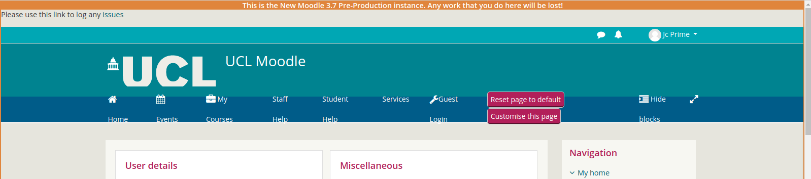

Figure : Main navbar display issues on profile page in Chrome

## Edit profile

Fields with attached help buttons are read with the button before the field name, even though they are displayed differently on the page. (“Help with email display button” is read before “Email display”.)

The “Email Display” combo box’s default selection is at the bottom of the combo box, as shown in Figure 7, so it appears non-navigable to screenreader users, as the default is usually at the top of the combo box. The “Timezone” combo box also has the bottom option as its default selection, as shown in Figure 8, which may be a problem for screenreader users, because in most cases the first action would be to navigate downwards, and the screenreader does not announce where in the options list the selected option is positioned.

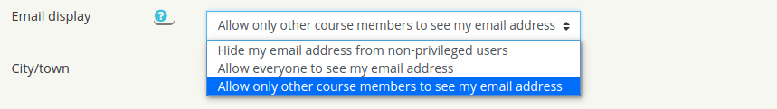

Figure : Email display combo box’s default selection is the last option in the list

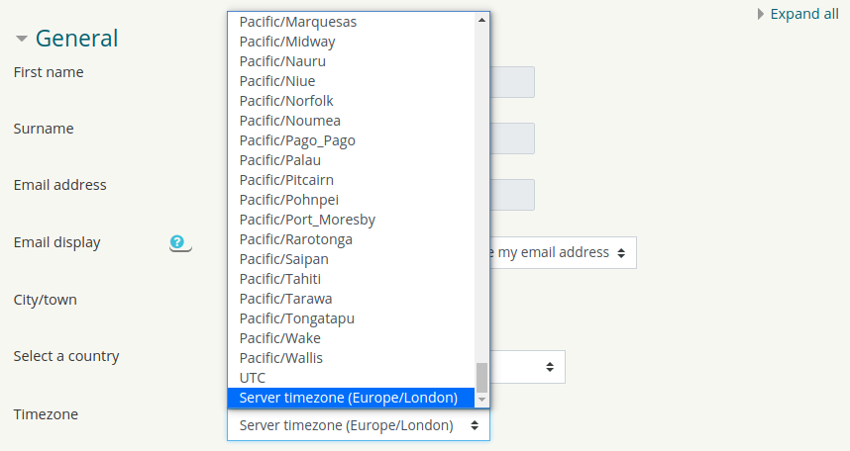

Figure : Timezone combo box’s default selection is the last option in the list

Combo boxes require “Enter” to be pressed to toggle in and out of edit mode, but if “Enter” is pressed while focused on the text input fields, it appears to save the profile and redirect to another page. Screenreaders will not be aware of this until the page has redirected though, as it is not announced upon navigation into the field. I’m not sure this has a fix, as it seems like more standard functionality to me (as in, I would expect this to happen if I pressed Enter while focus was in a text field!), but mentioning just in case.

In the User picture section, when trying to add a new picture, in “Upload a file”, clicking “Browse…” redirects the keyboard focus back to the “File” text input field, rather than opening a file-selection window. (Note that we recorded this happening on IE on Windows (7/6/19), but as I write this (8/6/19), it’s open on Chromium on Linux, and there’s no “File” text input field at all, only a “Choose file” button, which functions as expected.) The “Files” etc. links are also not as well-described as they could be; general link/button names could be improved by assuming that the screenreader will only read the linked words without context (e.g. “Files” might be better described as “Refresh uploaded files”, or something to that effect).

The list of accepted file types is quite low in contrast (#868e96).

The screenreader jumps a lot in the “Additional names” section. We are not sure whether this is the screenreader’s own issue or whether there’s something in this section specifically causing it. (I can’t see anything specifically in the page source that the screenreader could be reacting to.)

When focused on a given form field, if you navigate downwards with the keyboard, the field label is read while the keyboard focus appears to be still in the previous form field, and the keyboard focus stays there until the navigation hits the actual form field whose label has just been read. (I can’t see anything in the page source that could be causing this either.)

# Events page

The “Skip to main content” link is missing when navigating by tab. (Note that this was observed on IE on Windows (7/6/19), but as I type this, still on Chromium on Linux (8/6/19), it’s present and functional!)

The “New event” button is read as a form field again, and activates a pop-up which is not recognised at all by the screenreader.

“Monthly view” tabbing jumps from month headings to a single apparently-random number within the given month and then back to the next month heading. This in itself is not a particular problem, as navigation by arrow keys can take over from that point, but it would be better to jump consistently to either the first day of the month or the same number as the day of the current month in every case.

Dark pink text (#ac145a) on a light pink-ish background (#ffd3bd), as shown in Figure 9, is not a great combination for colour- or shade-blind users, as they are quite close on the colour spectrum, even if their contrast ratio is high enough to be accessible in itself (5.09:1).



Figure : Colour scheme of #ac145a text on #ffd3bd background

# Moodle demo course (collapsed topics layout)

Navigation via the main content section and sidebar makes for a lot of links (571 in this case) within the screenreader’s links list, and headings are similar (nearly 300 in this case), which makes navigation quite overwhelming for anyone who can’t see the screen!

The screenreader reads lots of blank lines where there appear to be none. Looking at the HTML, there are no blank elements, so I’m not sure if this is actually a Moodle issue at all, but it does seem to be worse on the demo course page than other pages tested so far. (I will try and find out if it’s a screenreader issue!)

“Open all” and “Close all” buttons could be clearer in their descriptions, e.g. “Open all topics” and “Close all topics”.

“Open all” and “Close all” buttons are read as form fields again.

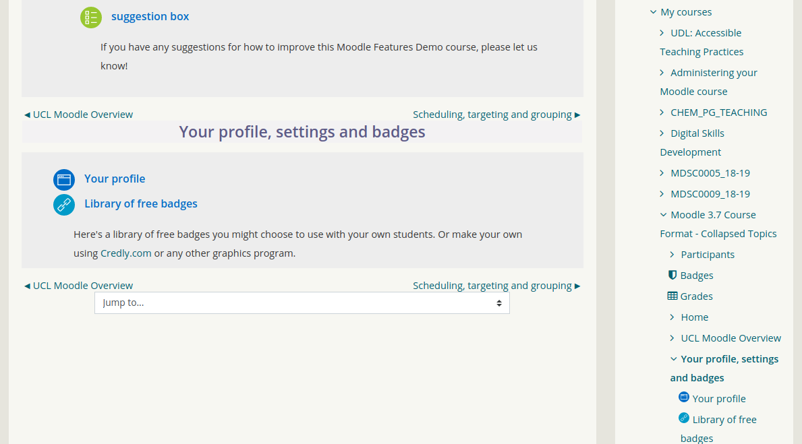The “View only ‘Topic 2’” button (looks like a filled-in radio button), for example, does not say what “Topic 2” is. When selected, it redirects to a new page without warning, where the layout needs to be navigated through differently, with no easy way to return to the previous layout on the page itself. Trying to return to the previous layout via the navigation buttons on the new page retains the one-topic-per-page layout, and there is no option in the main content to get back to the collapsed-topics layout, only in the navbar and sidebar (which take longer to navigate to from within the main content using a screenreader, so having an additional option within the main content is preferable).

Figure : One-topic-per-page layout of demo Moodle course, accessed from collapsed-topics layout

The main region background colour (#f7f8f2) could be a problem for dyslexic users, and while the inner background colour (#eee) is better, the font would need to be stronger in colour or weight to be more readable from a dyslexic standpoint. (Questions about this may be better posed to Michele directly, as she has more knowledge about the “why”s of this than I do!)

Otherwise, this layout is more effectively navigable than was expected!

# Moodle demo course (grid layout)

The large, square course “cells” in the grid make the page quite long, and the non-grid content obviously has the same issues as in all layout formats, in visual terms.

The Twitter feed continues to contribute form fields in great numbers, as it does with several other pages, and also causes numerous indistinguishable “Twitter image” links (302 links in total were detected on this page, not solely attributable to Twitter though!).

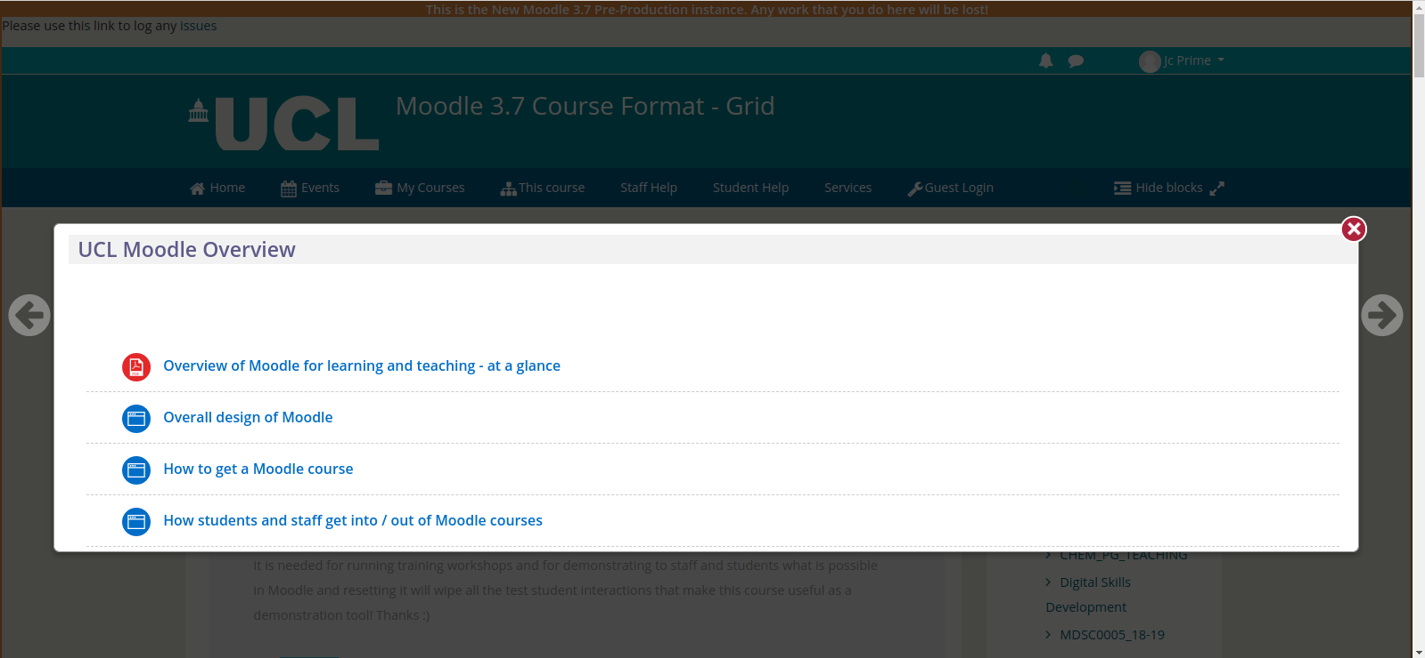When a grid “cell” is clicked on, the resulting pop-ups (shown in Figure 11) are not navigable by tabbing (as would have been expected), and can be unintentionally skipped over to end up navigating through the main page behind the pop-up instead.

Figure : Grid layout topic pop-up, which is generally inaccessible to screenreaders

# Moodle demo course (tabs layout)

While it is understandable that the selected tab is not in itself a link (i.e. back to the same page), the screenreader doesn’t acknowledge it when navigating by tab.

The Activities section of the sidebar reads the graphic as the singular version of the text that follows, and then reads the text in plural form, for all but a few of the links in this section, as shown in Figure 12.

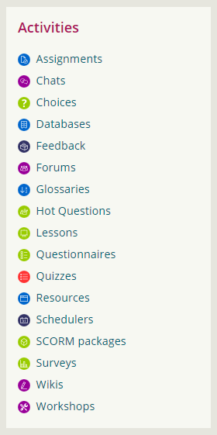 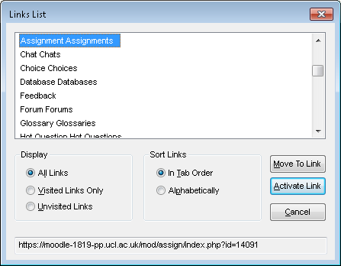

Figure 12: Activities section of the sidebar with duplicated link names

There are some links in the demo course which redirect to the UCL Wiki pages, requiring a username and password. When this happens, the screenreader reads nothing from the point of “clicking” the link until “Username edit type and text” of the Wiki page, but the user does not know what for.

The “Framed web link” page works less well with the screenreader. When “Skip to main content” is clicked, the frame seems to disappear and the page is navigable as a non-framed page would be.

Generally though, this layout is more accessible than the others.

## Add a new glossary item

The input fields were only focused when their label had been read, which is fine for the first of the fields, but from that point onwards, visually it appears as if the focus is still on the previous input field when the actual focus is on the label of the next one.

The exclamation mark inside a red circle symbols are not read at all by the screenreader, and even if they were, it is not clear what they mean until after the buttons to save changes or cancel. The explanation of the symbol (ideally also which can be read by screenreaders!) would be better placed at the start of the form. Note that as far as I can see, everything has been done correctly, code-wise, for a screenreader to be able to read it, using the title and aria-label attributes; this might be down to the i element having a lack of “focusability” (which is where the aria-label attribute would apparently be better placed, according to [Font Awesome’s own website](https://fontawesome.com/how-to-use/on-the-web/other-topics/accessibility#web-fonts-semantic)), otherwise providing a separate text-only element as an alternative would also work:

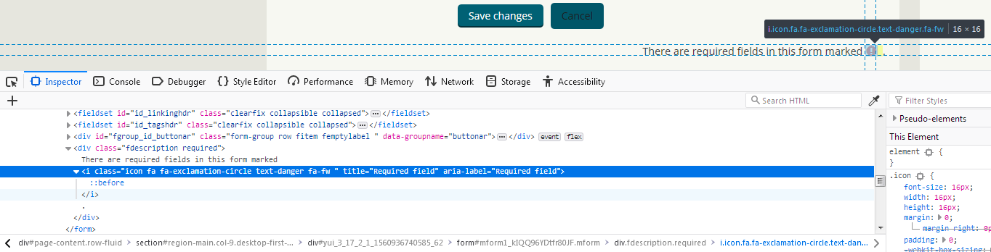

Only once you are in another input field will the screenreader read the warning from the previous input field saying it is a required field, but without context, the user may assume the warning relates to the current field rather than the previous one.

The “Cancel” button has dark text (#1d1c1c) on a dark background (#005668), much like the “Previous” button in the pop-up on the home page, which may just not have been overridden because both are suffixed with !important in the CSS:

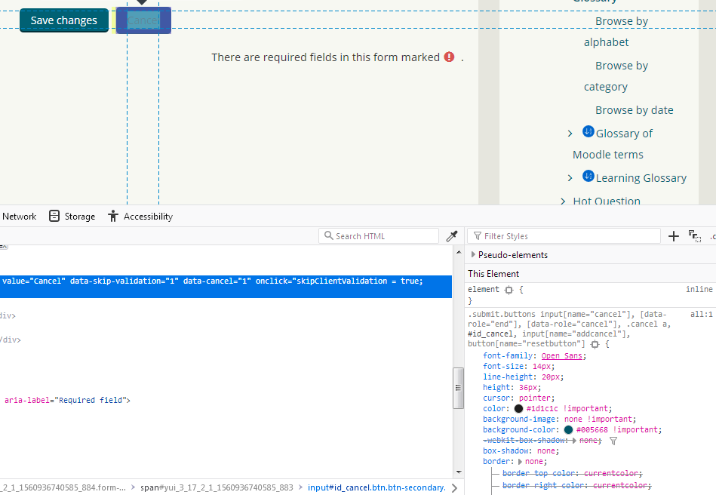

# Moodle demo course (topics layout)

The un-collapsible nature of the topic blocks makes for a very long page, with a lot of links (587 in this case) and headings (96 in this case).

Internal heading links cause the page to jump if not already focused on the right place when navigating with the screenreader. However, while using links in that context isn’t strictly necessary, it is still quite useful for ease of navigation.

# “Contemporary issues in clinical education” course

The heading structure is not well-ordered (they should follow consecutively as much as possible). Many necessary headings are also missing, and only show as links; ideally, they should show as both. The expandable topic headings are not recognised as headings, and only the non-linked headings are included.

The same issue as for the demo course with the collapsed topics layout was found, with the “View only ‘Topic [number]’” buttons (as links) not giving any contextual information.

Testing with *Read and Write* (text-to-speech) works well.

## News forum

The navbar’s usual list items have been squashed and translated downwards to be partially out of view, presumably as a result of the additional “Search forums” text input field and button.

# “Leadership skills for the healthcare professional” course

Colour schemes for the tabs are predictably problematic, in that there’s too many colours, not enough contrast in some cases, and the tab series as a whole has something of an overwhelming effect.

Headings are also spaced somewhat strangely, which makes for an elongated page where it isn’t necessary. This is actually still an accessibility issue to a degree, because what should be one (admittedly long) heading has been manually broken across four lines, so the screenreader’s headings list picks up four rather confusing headings of the same level (one just says “14th, 15th, 16th & 17th January 2019”), where there should only be one. The additional line breaks are also picked up as blank headings of the same level, so the screenreader will read a heading line (with its level announced first), then announce “heading level three” with no further content, before reading the next heading line.

There are several form fields announced only as “tree view item”, which is not a very helpful description, and they occur quite frequently across multiple pages, not just this one.

There are some unlabelled links (I think they are in the calendar section, but as they’re unlabelled, it’s hard to be sure!), which show up only as a space in the screenreader’s links list.

# UCL Mechanical Engineering safety page

(This page has a tab layout with sub-tabs.)

The colour scheme is better than the “Leadership skills for the healthcare professional” course, but still not ideal. From a dyslexic standpoint, the black-on-yellow and white-on-green tabs in particular are harder to read, and there is a consistency issue with having black text on just one tab when the text of all other tabs is white.

There is a series of what appear to also be tabs before the “obvious” sub-tabs, but without any obvious tab-like formatting other than the tab-sized border highlight when keyboard-focused. Is this a feature of this course specifically, or is it a wider feature that would therefore need further feedback?

Navigation via tabbing causes the page to jump again, for no clear reason.

Testing with *Read and Write* works well.