**mdl-db01p**

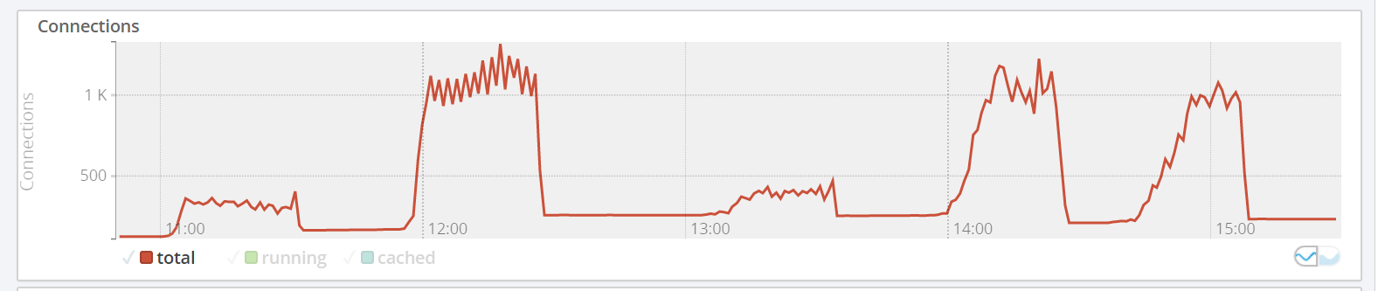

**mdl-cdb01p:**

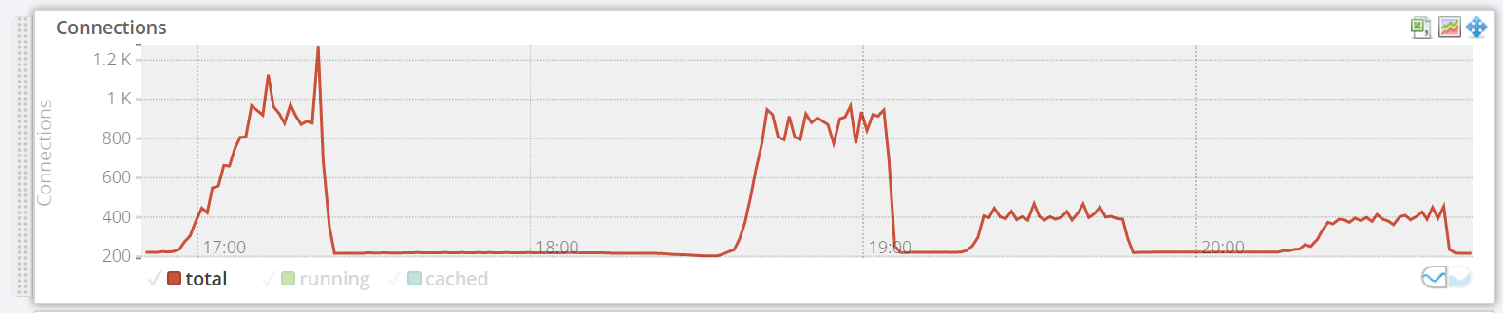

Total no of connections are close, not much difference, though mdl-db01p has a higher max value.

No improvement, close to parity.

**mdl-db01p:**

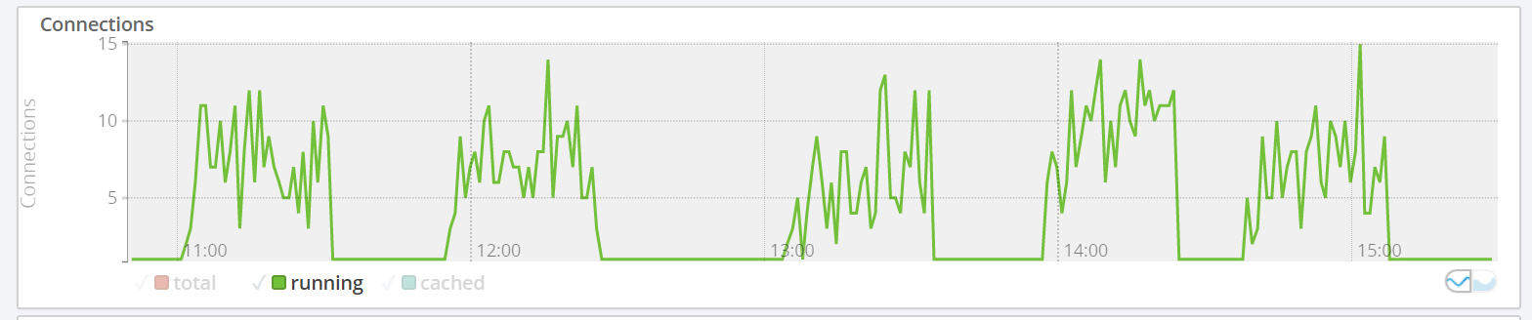

**mdl-dbc01p**

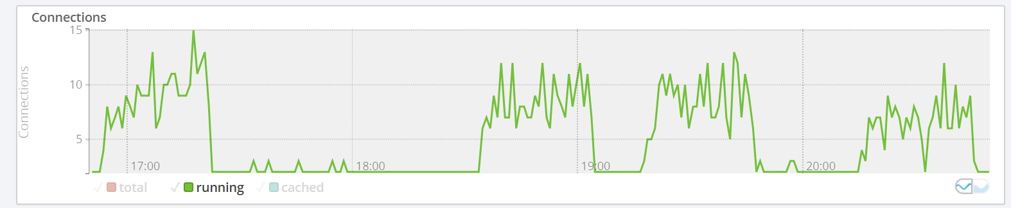

Running connections are close, both peak at the same value. Unsure why the connections on mdl-dbc01 drop to zero in the middle of a test run as there are no aborted connections (see below).

No improvement, close to parity.

**mdl-db01p:**

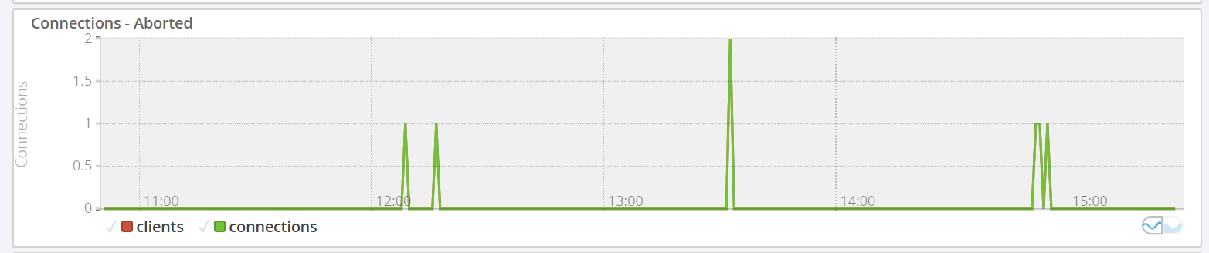

**mdl-dbc01p:**

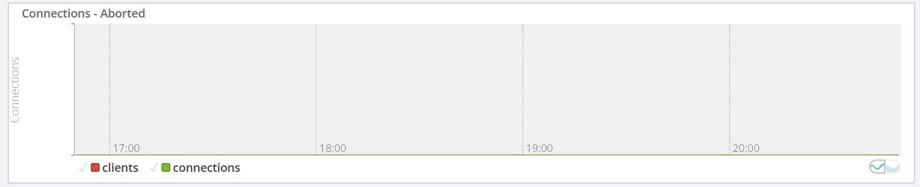

A small no of connections died on mdl-db01p. Connections remained stable on mdl-cdb01p.

Small improvement.

**mdl-db01p:**

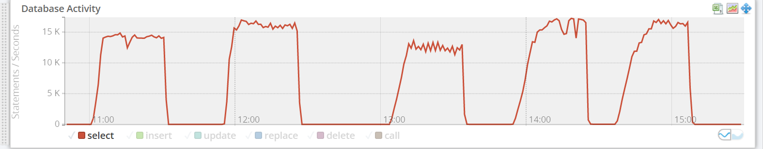

**mdl-cdb01p:**

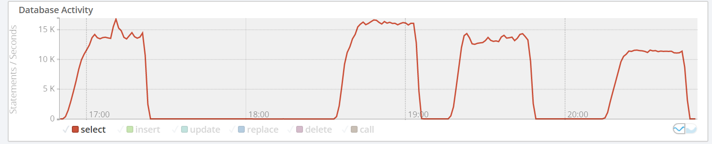

Queries per second are are very close, mdl-db01p has a higher max value.

No improvement, close to parity.

**mdl-db01p:**

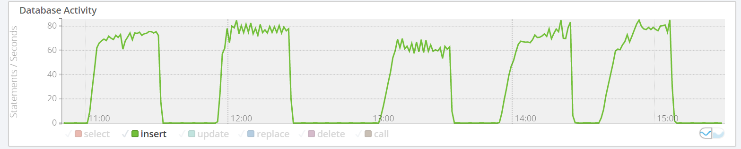

**mdl-dbc01p:**

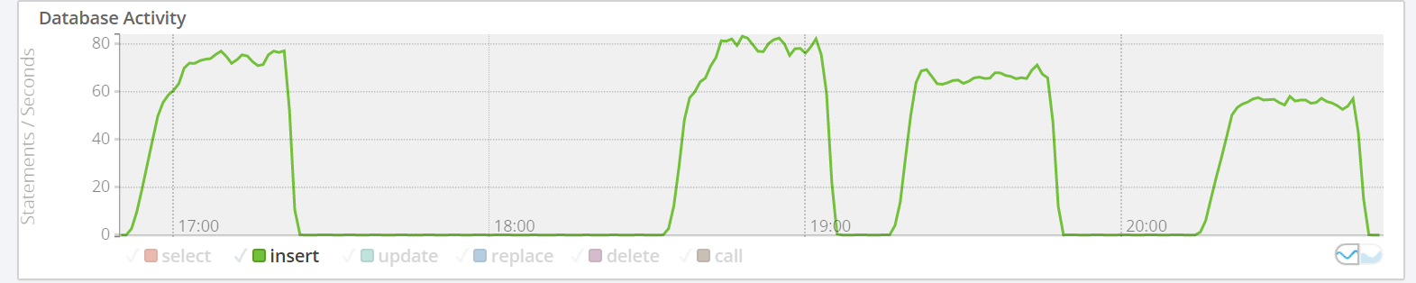

Inserts per second are are very close, mdl-db01p has a higher max value.

No improvement, close to parity.

**mdl-db01p:**

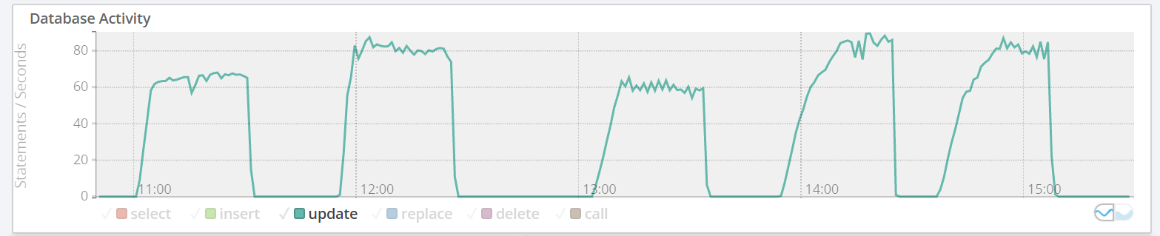

**mdl-dbc01p:**

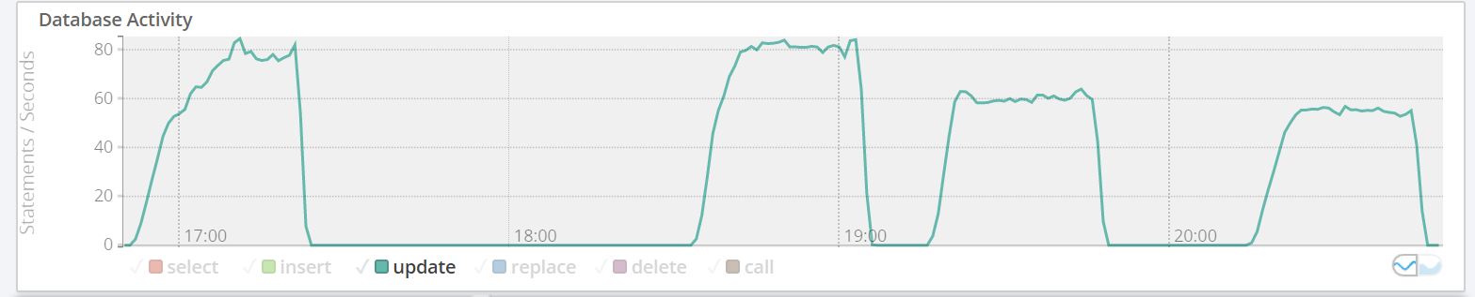

Updates per second are close, mdl-db01 has a higher max value.

No improvement, close to parity.

**mdl-db01p:**

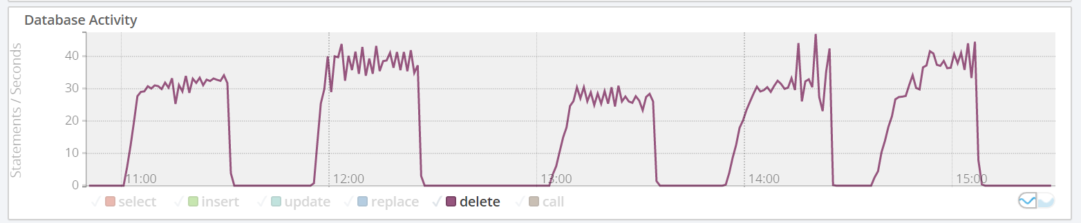

**mdl-cdb01p:**

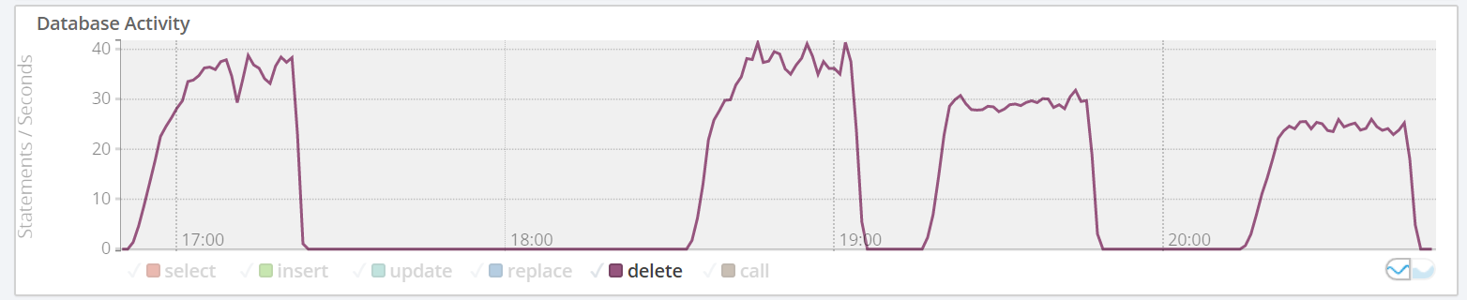

Updates per second are are very close but mdl-db01p has a higher max value.

No improvement, close to parity.

**mdl-db01p:**

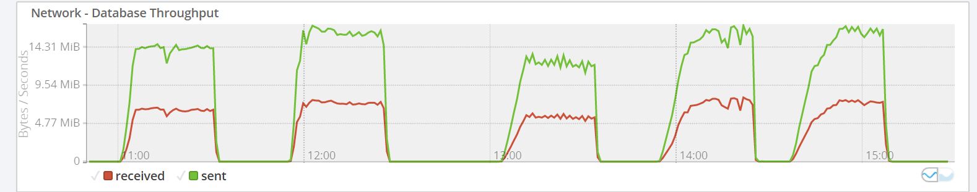

**mdl-cdb01p:**

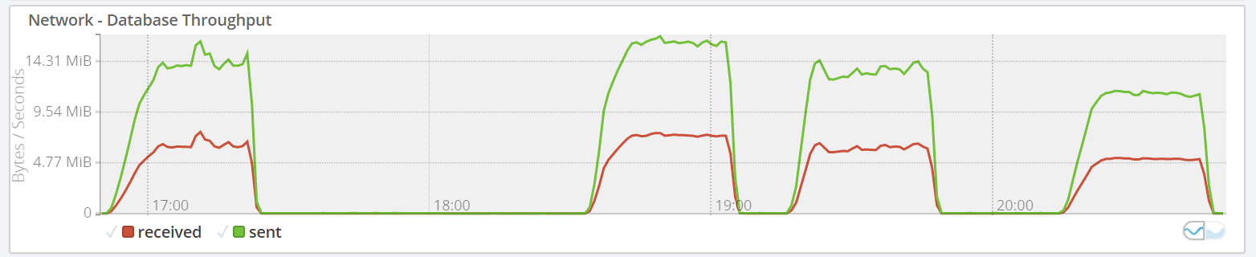

Network throughput similar but significant drop in sent bytes for mdl-cdb01p during final test.

Worse.

**mdl-db01p:**

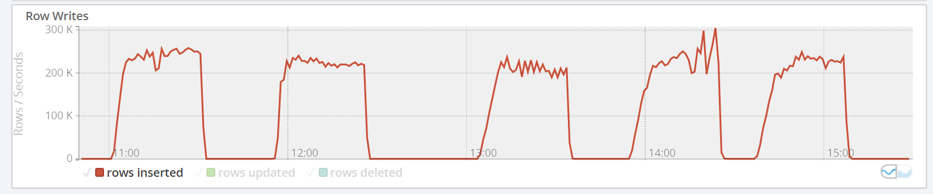

**mdl-cdb01p:**

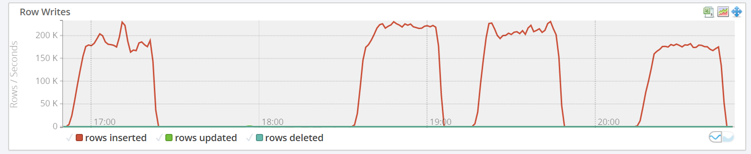

mdl-db01p peaks at inserting 300k rows per second and is consistently above 200k. Mdl-cd01p peaks at around 220k dropping below 200k

Significantly worse.

**mdl-db01p:**

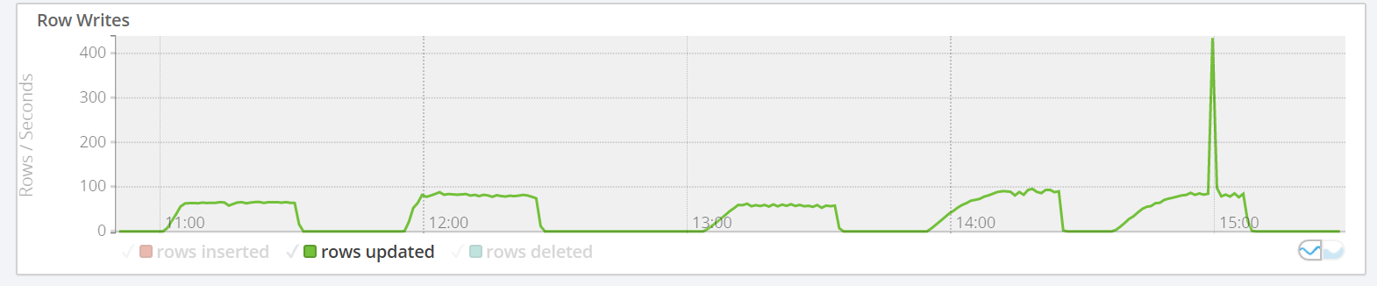

**mdl-cdb01p:**

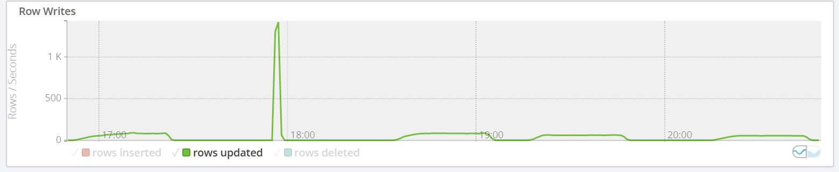

Row updates on mdl-cdb01p peaks at aroud 1500 rows, whereas mdl-db01p is far lower at around 420. Unsure what is happening here.

Significant Improvement.

**mdl-db01p:**

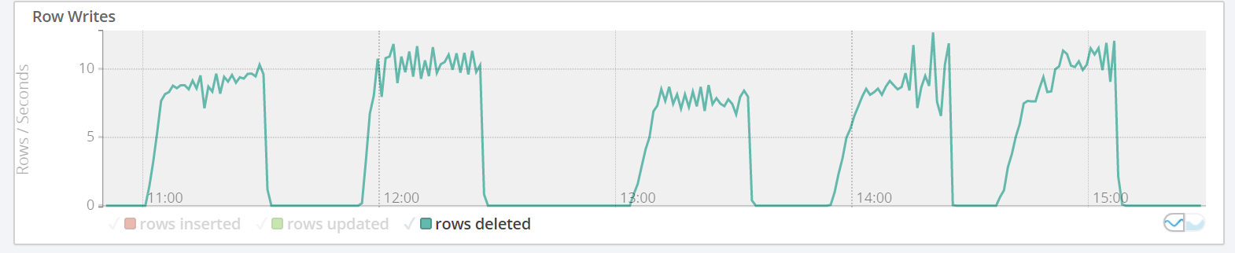

**mdl-cdb-01p:**

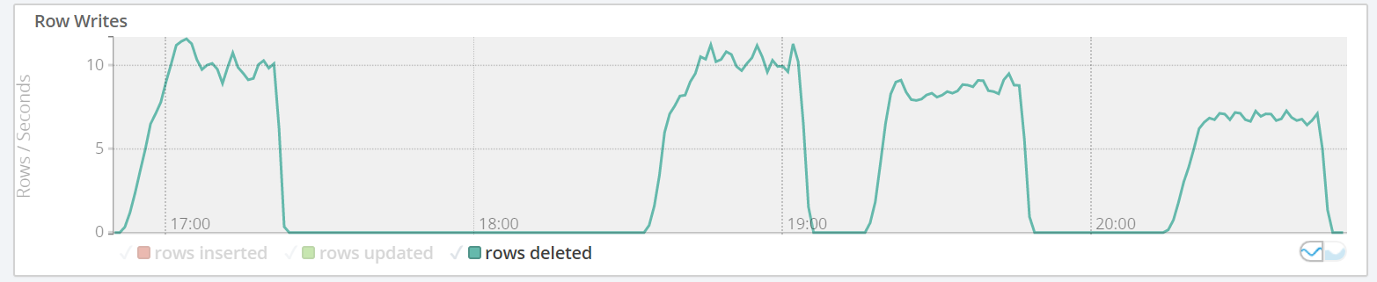

Rows deleted per second very close.

No improvement, close to parity.

mdl-db01p:

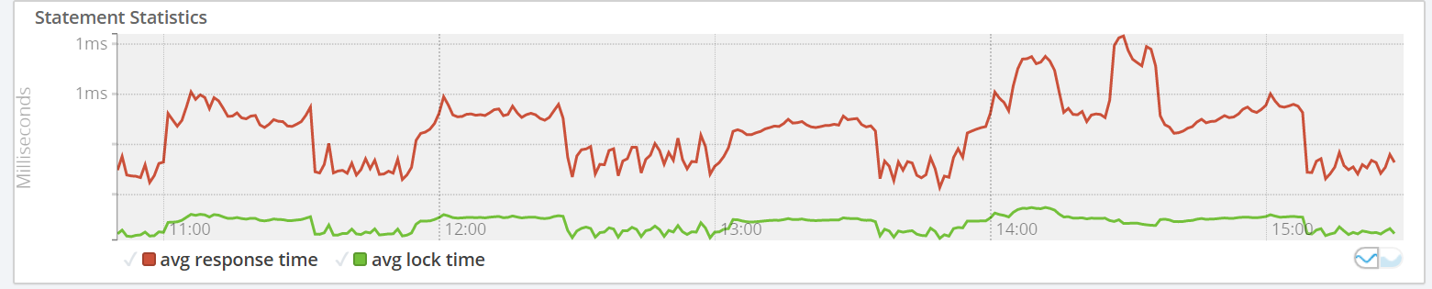

mdl-cdb01p:

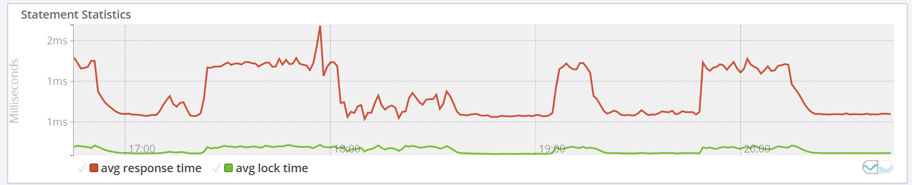

Most response times for mdl-db01p are under 1ms. All response times for mdl-cdb01p are above 1ms.

Significantly worse.

mdl-db01p:

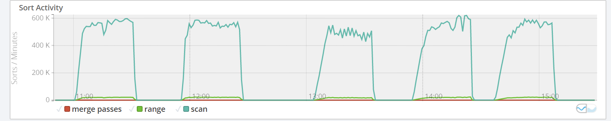

mdl-cdb01p:

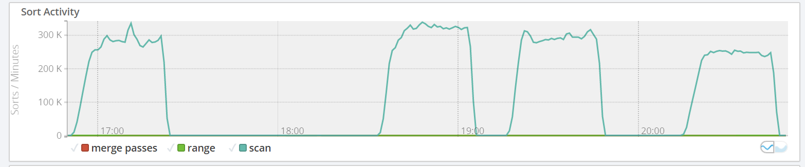

Sorts per second on mdl-db01p are twice as fast as those on mdl-cdb01p.

Significantly worse.

mdl-db01p:

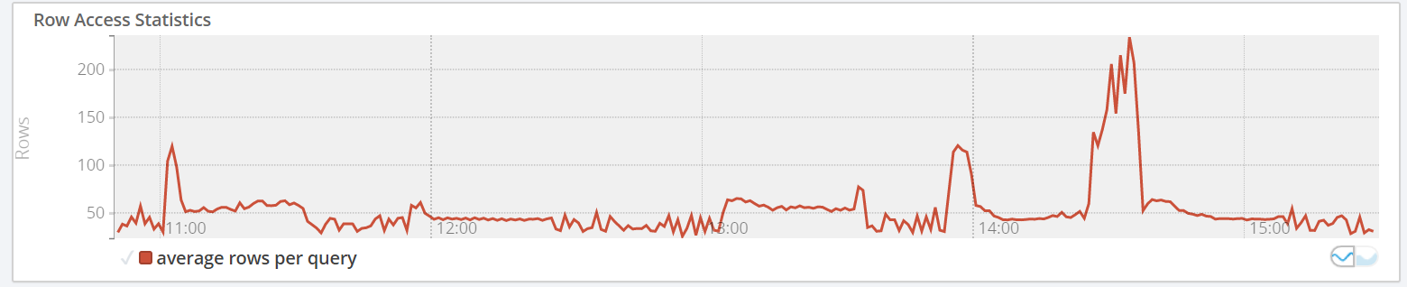

mdl-cdb01p:

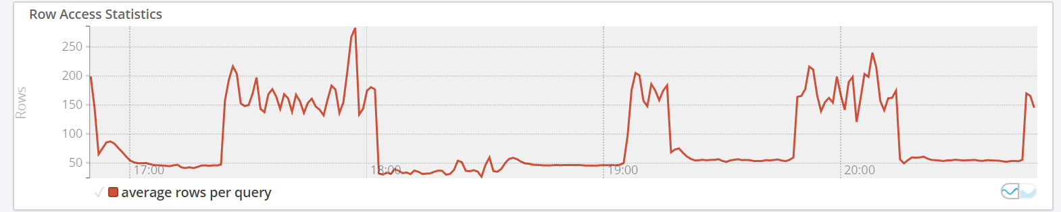

More rows per query on mdl-cdb01p, unsure why.