Moodle Adaptable theme colour settings

Table of Contents

Summary of changes made 1

Issues from previous reports 2

Fixed issues 2

Issues I can’t test or are not relevant to theme settings 2

Continuing issues 2

Considerations 2

Footer heading text 2

Disabled pop-up user tour buttons 3

General colour pairings in the theme settings 6

Top header 6

Secondary buttons on hover 6

Slider 1 submit 6

Cancel buttons 6

Cancel buttons on hover 7

Info-type alert boxes 7

Announcements 7

# Summary of changes made

|  |  |  |
| --- | --- | --- |
| **Setting** | **Before** | **After** |
| theme_adaptable | fontheadercolor | #AC145A | #E5438E |
| theme_adaptable | footerbkcolor | #424242 | #383838 |
| theme_adaptable | headerbkcolor | #29A8B7 | #28A1AF |
| theme_adaptable | buttonhovercolorscnd | #009688 | #008577 |
| theme_adaptable | slidersubmitbgcolor | #009688 | #008577 |
| theme_adaptable | buttoncolorcancel | #EF5350 | #E91916 |
| theme_adaptable | buttonhovercolorcancel | #E53935 | #E32926 |
| theme_adaptable | alertcolorinfo | #D9EDF7 | #2F6E8E (if normal text is involved) |
| theme_adaptable | alertcolorsuccess | #468847 | #3D763E |

# Issues from previous reports

Separating out contrast-related issues mentioned in previous reports:

## Fixed issues

* Drop-downs on home page have been addressed since they were last reported on
* I have no courses to view the contrast of the text on background in “Recently accessed courses” and “Course overview,” but on Moodle proper, the grey text is #6c757d on #ffffff background, which gives a contrast ratio of 4.68:1, meeting requirements for large and normal text
* The pop-up tour “End tour” button text no longer disappears when hovered over, and is distinguished from the “Previous” and “Next” buttons

## Issues I can’t test or are not relevant to theme settings

* Cog menu item is not visible on the test instance
* “Hidden to students” tabs are already advised on, but I have no courses to test with here
* The list of accepted file types in the Edit Profile page is likely not theme-dependent
* “A Moodle assignment is due” cannot be found in the test instance

## Continuing issues

* The pop-up tour greyed-out disabled “Previous” and “Next” buttons are still too low in contrast, and even if they are supposed to be greyed-out, their text should still be legible
* Footer heading text: the foreground text colour is #AC145A, and the background colour is #424242, which results in a contrast ratio of 1.43:1. This combination is not acceptable for normal or large text

# Considerations

## Footer heading text

Keeping the background colour the same, to meet the requirements for large text, the foreground text colour would need to be lightened to #E8599C (contrast ratio 3.03:1). To meet the requirements for normal text, the foreground text colour would need to be lightened to #F391BF (contrast ratio 4.60:1).

Keeping the foreground colour the same, to meet the requirements for large text, the background colour would need to be lightened to #ABABAB (contrast ratio 3.04:1). To meet the requirements for normal text, the background colour would need to be lightened to #D1D1D1 (contrast ratio 4.58:1). Alternatively, the background colour would just meet the requirements for *large text only* if darkened to #000000 (contrast ratio 3.00:1).

Since the footer heading text (at least on my screen) would be classified as large text, I tried changing the “headers font colour” from #AC145A to #E8599C.

Before:



After:



However, this setting change also affects other headings outside of the footer, and for headings on the main section background, with #E8599C text on #E6E6DE background, the contrast ratio becomes 2.64:1, which is too low even for large text:

Main headings after the (footer) heading colour change: foreground #E8599C on #E6E6DE background, now too low in contrast

For this combination, the lightest the text can be to meet requirements for large text is **#E5438E**, but then the contrast ratio for the footer, with #424242 background, becomes 2.64:1. The lightest shade the background can be with this new foreground colour is **#383838**, and the darkest tint the background can be is #E6E6E6, which of course is too close to the main section background to be much use in distinguishing between main section and footer.

So, I have changed the “**headers font colour**” setting to **#E5438E** and the “**footer background colour**” setting to **#383838**.



Of the available colours in the UCL palette, the following are also acceptable alternatives from a contrast perspective *with the original footer background #424242*, for large text only:

* #8F993E
* #EA7600

And those that are acceptable for large and normal text:

* #D6D2C4
* #B5BD00
* #BBC592
* #C6B0BC
* #8DB9CA
* #F6BE00
* #A4DBE8

Note that none of the bulleted colours have been tested against the light background in the main section. These options are just provided in case the change made above doesn’t work from a design perspective!

## Disabled pop-up user tour buttons

The current background for disabled buttons on the pop-up user tour is #CED4DA, and the foreground is #FFFFFF, which gives a contrast of 1.49:1.

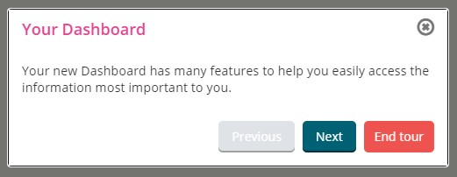

Even though disabled buttons are not required to conform to colour contrast requirements, as they are not active elements, they are still communicating information to the user, even if they are communicating what cannot be used! So they should still be legible to users with low vision who do not use screenreaders, and so I have considered them for contrast improvements regardless.

Keeping the background the same, the lightest shade the foreground text could be to meet requirements for normal text is #595959. Note here that opacity is set to 0.65, which affects the contrast as well as the colour value itself. With opacity at 0.65:

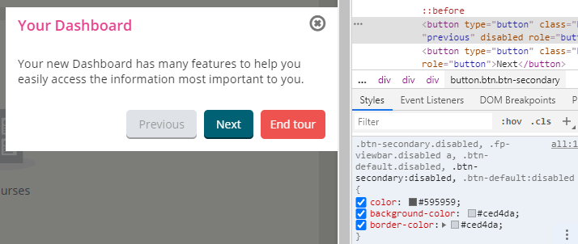

And with opacity at 1:

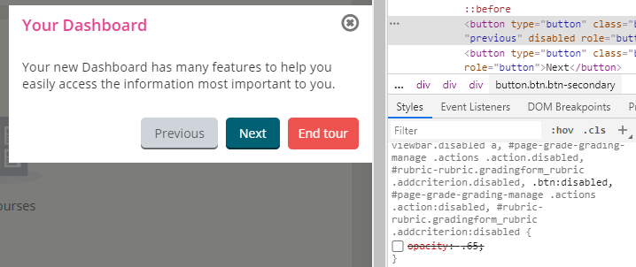

But there is a setting in the stylesheet that forces “color: #fff!important” for the “previous” button (specifically for [data-role=”previous”] elements), and thus blocks the original text colour of #212529:

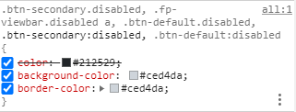

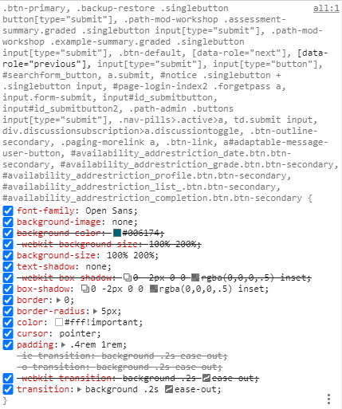

When I removed this setting, it defaulted to a much more readable form, with foreground text colour #212529, without any further changes (and with opacity at 0.65):

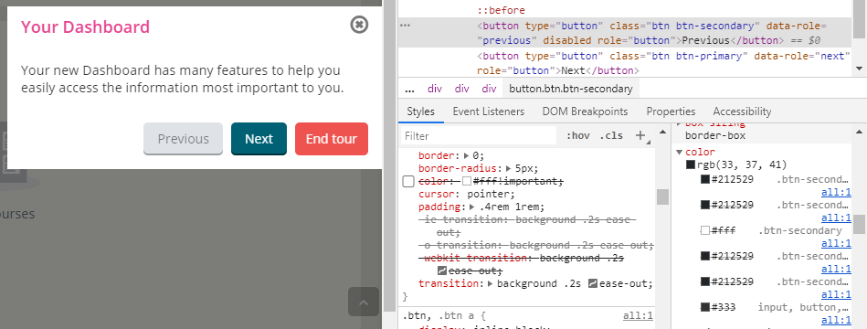

With opacity changed to 1:

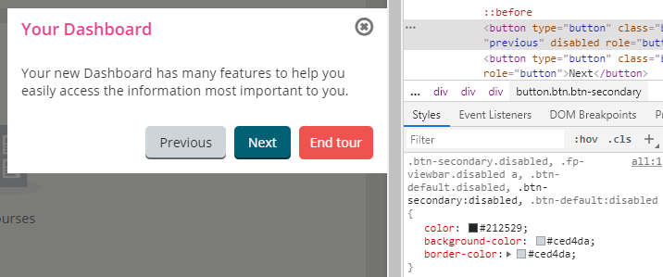

However, I cannot find a setting specific to this. Secondary button colours are there, but nothing specific to disabled buttons, nor any reference to the foreground or background colours within the settings page. My suggestion would be to leave the colours as they are, but remove the forced “color: #fff!important” for [data-role=”previous”] (or use something more specific to target the disabled user tour buttons alone!), and leave opacity at 1 for the foreground text.

# General colour pairings in the theme settings

I wrote some code to check foreground/background colour pairings, that may not have otherwise previously been tested, within the Adaptable theme settings, and seven of those pairings were tested to be too low-contrast in some form or another.

## Top header

Background colour #29A8B7 with foreground text and links colour #FFFFFF gives a contrast ratio of 2.84:1. Assuming the top header will always be classified as large text, the background needs to be shaded to #28A1AF or darker to meet contrast requirements for large text.

I have changed the “**top header background colour**” setting to **#28A1AF**.

## Secondary buttons on hover

Background colour #009688 with foreground text colour #FFFFFF gives a contrast ratio of 3.67:1. Button text is likely to be normal text rather than large, and so the lightest shade to meet contrast requirements for normal text is #008577.

I have changed the “**secondary button colour (when hovering)**” setting to **#008577**.

## Slider 1 submit

Same initial colour pairing as secondary buttons.

I have changed the “**slider 1 submit bg**” setting to **#008577**.

## Cancel buttons

Background colour #EF5350 with foreground text colour #FFFFFF gives a contrast ratio of 3.48:1. Button text is likely to be normal text rather than large, and so the lightest shade to meet contrast requirements for normal text is #E91916.

I have changed the “**cancel button colour**” setting to **#E91916**.

## Cancel buttons on hover

Background colour #E53935 with foreground text colour #FFFFFF gives a contrast ratio of 4.22:1. Button text is likely to be normal text rather than large, and so the lightest shade to meet contrast requirements for normal text is #E32926.

I have changed the “**cancel button colour (when hovering)**” setting to **#E32926**. If more of a difference is needed to distinguish between hovered and un-hovered states, then I would suggest darkening this shade rather than lightening it.

## Info-type alert boxes

Background colour #D9EDF7 with foreground colour #3A87AD gives a contrast ratio of 3.31:1. If these are effectively images, then contrast requirements do not apply in the same way, but the colour pairing meets requirements for graphical objects and user interface components (and large text!).

If they are normal text and not images, then to meet requirements for normal text, the foreground colour would need to be shaded to #2F6E8E or darker.

**I have left the “info colour” setting as is**, but I would recommend changing it to **#2F6E8E** if normal text is involved.

## Announcements

Background colour #DFF0D8 with foreground colour #468847 gives a contrast ratio of 3.61:1. I can reasonably assume announcements are text, but not the size of the text, so if they are only large text, then these settings are fine as is.

If it needs to meet requirements for normal text, then the foreground colour needs to be shaded to #3D763E or darker.

I have changed the “**announcement colour**” setting to **#3D763E**.