# Installing Activity feedback

## Create Profile fields

1. Add the following User profile fields under Site admin > Users > Accounts as a text input. They do not need to be a required field. Only needs the name and shortname

a. Programme of study (shortname - programme)

b. Year level (Shortname - year)

NB. The 'Affiliated department profile' field is nolonger required but if you try to delete it the query runs forever but doesn't delete the field so don’t attempt to do this.

## Create the roles

6. Add a new role under Site admin >> Users >> Permissions >> Define roles and upload the XML file 'pilot_myfeedback_report.xml' to import the 'Pilot MyFeedback Report' role that is used in the plugins. Also import the 'Personal tutor role' – personal_tutor.xml.

7. Ensure that the 'Pilot MyFeedback Report role only allows gradereport/myfeedbacklink:view and report/myfeedback:view and that it is set at the system and course contexts.

## Install plugins

2. Login to Moodle as admin

3. Copy the myfeedback folder to the report directory in Moodle on your server

a. Now becomes report/myfeedback

4. Copy the myfeedbacklink folder to the grade/report directory in Moodle on your server

a. Now becomes grade/report/myfeedbacklink

5. Install the plugins by navigating on your moodle site and clicking on Notifications under Site Admin then verifying that the plugins are listed to be upgraded and then select 'Upgrade the database'.

a. In the settings page of MyFeedback report specify the database slave as the host.

Hostname=moodle-db-b

Username=moodleuser

## Test that plugin is installed correctly

9. Enter the gradebook of any course

a. You should see the MyFeedback report link which when selected should take you to the MyFeedback report

10. From your My profile settings or from Yumika Brewster's My Profile setting click on Activity reports and then on MyFeedback.

a. This should take you to the MyFeedback report.

11. For the plugin to work change the Debugging from DEVELOPER.

Install the My feedback report block

12. Turn editing on and go to the site home page (only on certain pages can roles be assigned to this block)

13. Add a ‘Free text’ block (This could also show as HTML block)

14. Configure the block:

Block title = 'My feedback'

Content =

'<p style="margin-bottom:20px;">

Your programme has been specifically selected to be part of the pilot of our new My feedback facility.

</p>

<p>

Our <a href="/course/view.php?id=34851">My feedback preview</a> page contains more information.

</p>

<p>

Go to <a href="/report/myfeedback/">My feedback report.</a>

</p>'

15. Make sure you’re on the ‘site home’ page. Under where this block appears select ‘Display throughout the site’.

16. Once saved, click again on actions button (cog wheel) and assign roles (Make sure you're on the site home page'.

17. The page will say 'You are not able to assign any roles here'

18. However, Under the settings block, click on 'permissions' (under 'assign roles')

19. At the view block option (further down the page) remove all roles and add only the Pilot role for the Myfeedback report.

With this setting in place only students and personal tutors etc. that are assigned the system role ‘Pilot of my feedback report’ will see this block.

Install the Personal tutor block

20. From Site Home page ensure editing is turned on.

21. Under Add a block, add the Mentees block.

22. Click on the 'cog wheel' to configure the 'New Mentees' block.

23. Name the block 'My tutees'

24. Under page contexts, set it to 'Display throughout entire site'.

25. Save the settings

With this block installed, only users with the Personal tutor role will see and have access to this block.

--To assign a personal tutor role manually

27. Browse for the list of Users in site admin and select teh user you want to add a Personal tutor to.

28. Under Settings >> Profile settings for [the said user just clicked on] >> roles >> Assign roles relative to this user.

29. Click on the Personal tutor role and add the personal tutor by searching for the tutor under 'potential users' and clicking on the tutor and then adding them to the 'existing users' section.

30. You have to repeat this process for all students to be given a personal tutor.

The personal tutor has now been given the role and will see a block on their pages that says 'Personal tutees' and can click on their tutees, then follow the tutees profile settings >> avtivity reports >> My feedback report to see the tutees report.

**There is an automated way to assign Personal tutors but this is not yet configured.

--To automate the assigning ofPersonal tutors

31. install the plugin 'dbuserrel' under the enrol directory from here https://moodle.org/plugins/pluginversion.php?id=1573.

32. In the settings enter the details of the databse set up by Alexis in sits for mapping personal tutors and tutees. (This will be supplied by Alexis when complete)

# Assigning users to the ‘Pilot MyFeedback Report’ role

1. Open the CSV file in Excel

The file must contain following fields :

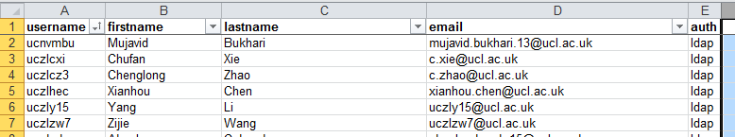

1. Add a new field called unique_string and populate the column with “xyxyxyxyxy”
2. Concatenate the unique_string and lastname fields and name this new column lastname. NB the string must be prepended to the lastname otherwise you wont be able to search for it. Do this by creating an equation in the new lastname column: =CONCATENATE(D2,"_",C2) and copy this to every row:

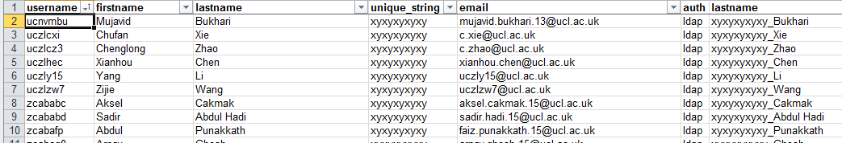

1. Delete the original lastname column and the unique_string column by hiding the 2 columns and then copy every row and pasting just the values in to a new spreadsheet. If you don’t copy just the values, the equation will fail because you’ve deleted the 2 columns it depends on:

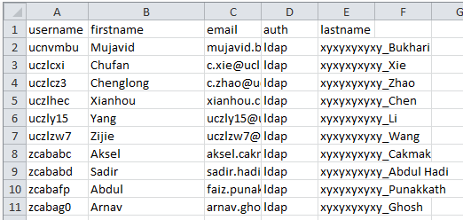

1. Now save the spreadsheet as a csv file.
2. In moodle go to Site administration > Users Accounts > Upload users

Specify the csv you just saved and select ‘upload users’.

1. Ensure the following settings are specified:

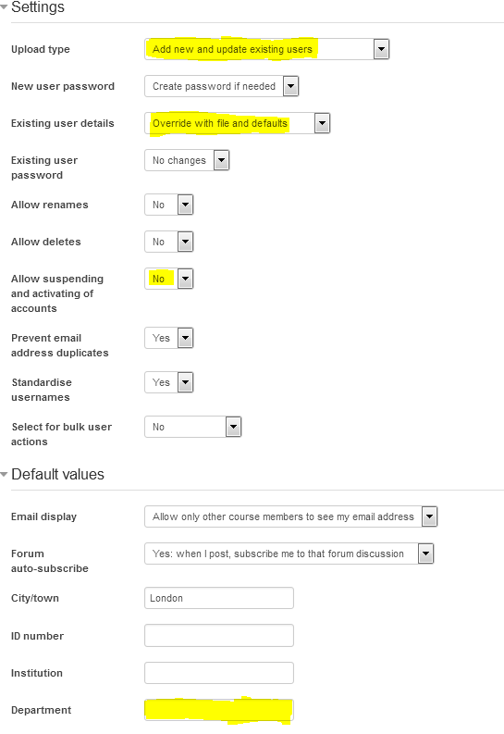

Assign the ‘'Pilot MyFeedback Report' role

1. Assign the newly created 'Pilot MyFeedback Report' role at the system level to the users who have the surname prepended with “xyxyxyxyxy”. You can do this under Site Admin >> Users >> Permissions >> assign system roles and search for “xyxyxyxyxy”.
2. Select all these users (about 752) and add them to the role.

Remove the string from the surname

1. In Excel open the original csv file and ensure it contains the following headings:



1. Repeat steps 6 and 7