Medial Moodle plugin – Media Central outage testing 12/12/2017

See <https://wiki.ucl.ac.uk/x/kQYuB> for full report.

[[MED009T] Media Central Outage - Viewing an existing Medial activity](https://wiki.ucl.ac.uk/display/ISMoodle/Tests-MediaCentral#Tests-MediaCentral-[MED009T]MediaCentralOutage-ViewinganexistingMedialactivity)

Mozilla Firefox???

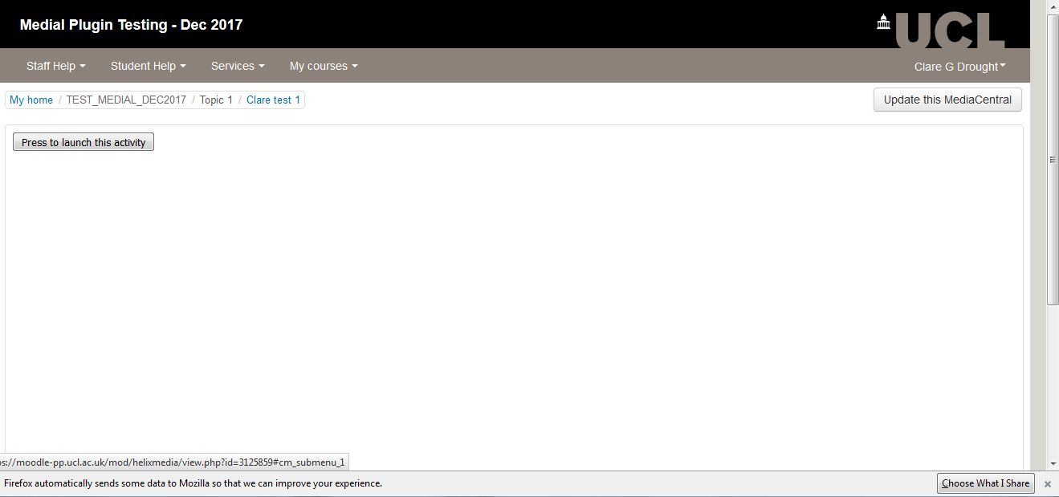

[[MED010T] Media Central Outage - Updating an existing Medial activity](https://wiki.ucl.ac.uk/display/ISMoodle/Tests-MediaCentral#Tests-MediaCentral-[MED010T]MediaCentralOutage-UpdatinganexistingMedialactivity)

Edge/IE???

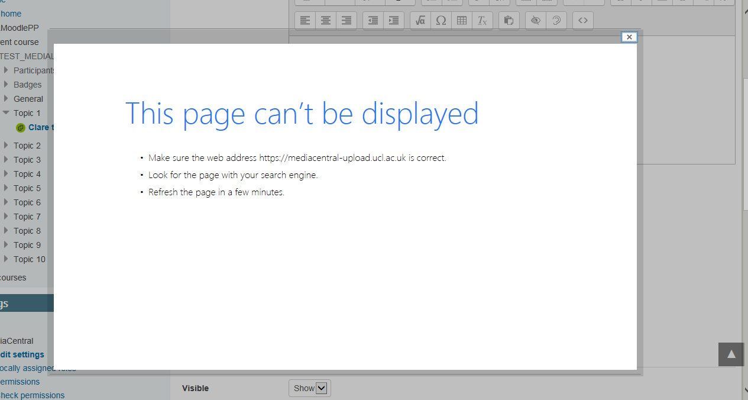

Chrome 62.0.3 (64bit)

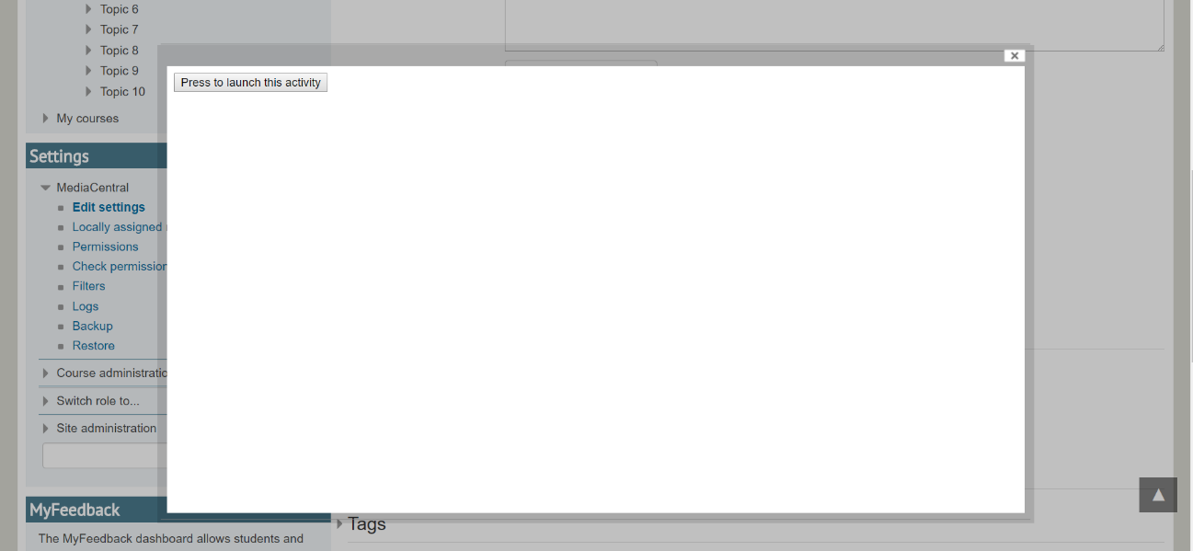

[[MED011T] Media Central Outage - Adding a Medial activity](https://wiki.ucl.ac.uk/display/ISMoodle/Tests-MediaCentral#Tests-MediaCentral-[MED011T]MediaCentralOutage-AddingaMedialactivity)

Chrome 62.0.3 (64bit)

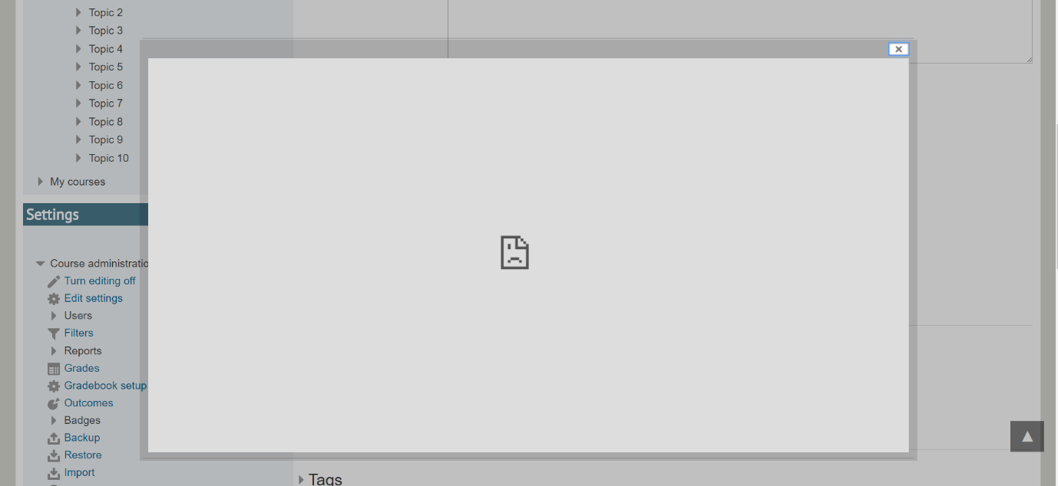

[[MED003S] Media Central Outage - Viewing an existing Medial activity](https://wiki.ucl.ac.uk/display/ISMoodle/Tests-MediaCentral#Tests-MediaCentral-[MED003S]MediaCentralOutage-ViewinganexistingMedialactivity)

Mozilla Firefox???

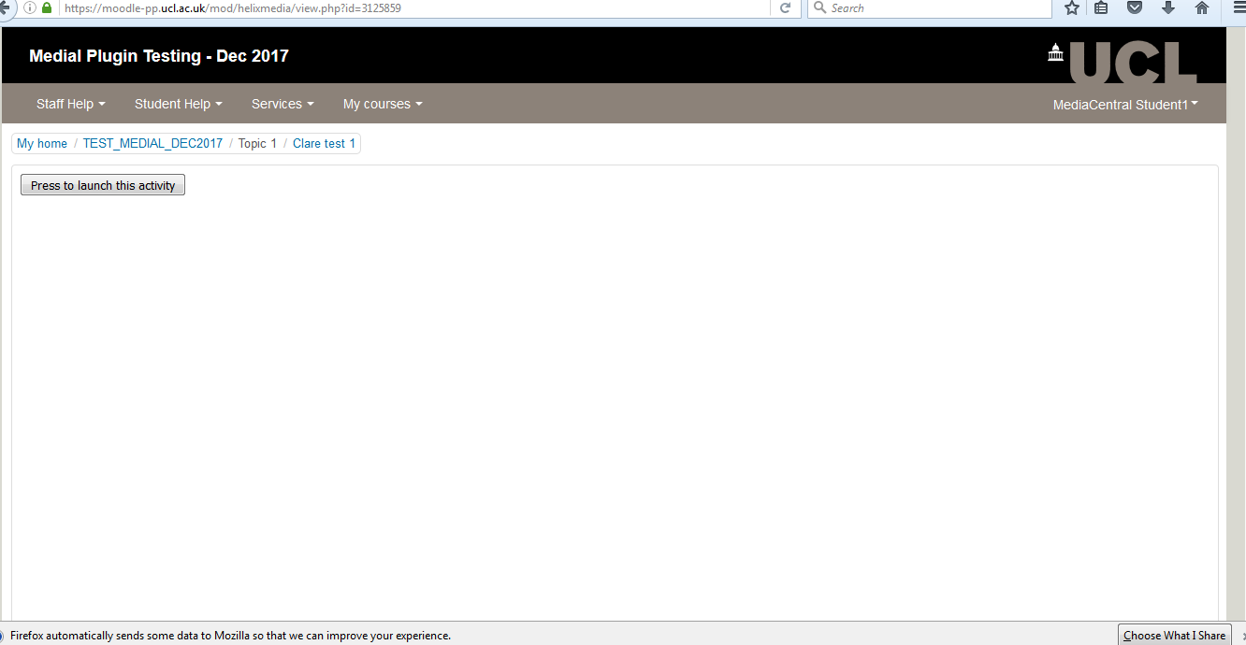

Edge/IE???

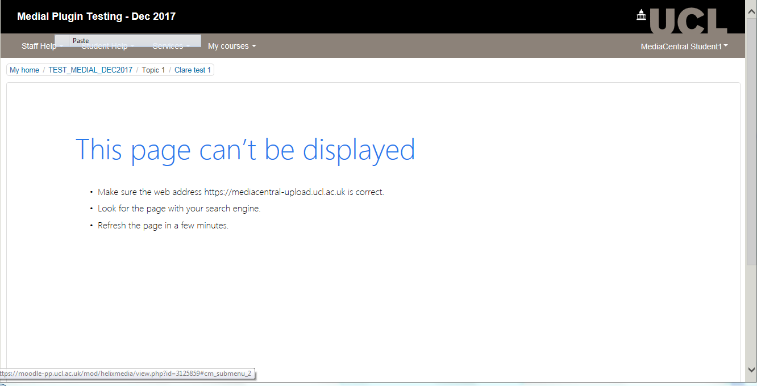

**Medial In-Editor plugin on Dev - Viewing an existing Medial activity during outage**

NB! Note that in dev where existing Medials had been embedded using the other 'in-editor' plugin, rather than the activity plugin which does not embed on course page, the page loads up with spaces for the embedded Media resources, but then hangs and waits for time outs for each resource. This will therefore seem unresponsive if you try to turn editing on or similar. Editing generally is slow to load. This is definitely something to consider if the 'in-editor' plugin were to be reviewed for implementation at a later date. Tested in: <https://v315.moodle-dev.ucl.ac.uk/course/view.php?id=41418>

