# Portico un-enrol plugin

1. The plugin can be accessed from site administration block

**Site administration -> UCL Tools -> Portico un-enrol**

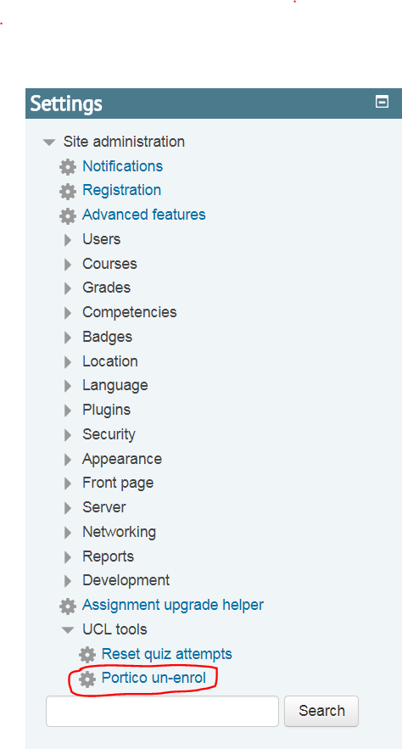

1. Clicking on Portico un-enrol displays a form to search for courses that have portico enrolled users

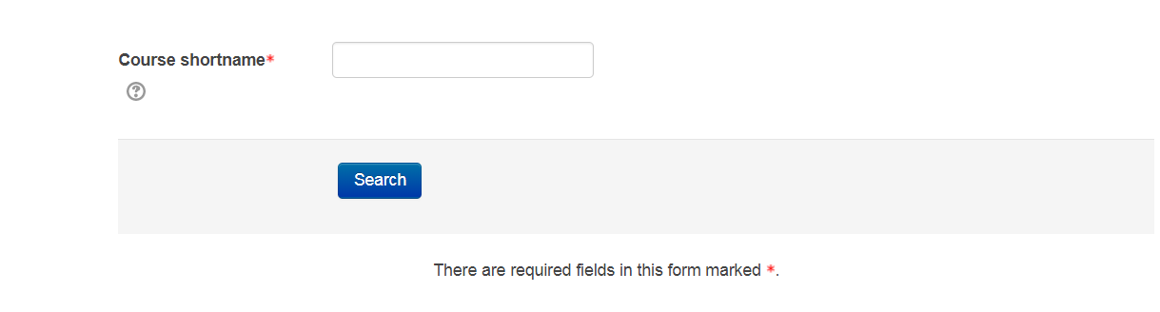

1. Enter the course short name which have users that are enrolled via portico.

E.g.: I would like to get list of users enrolled via portico on “(16/17)ANTH7004: Anthropology of Art” course. The shortname for the course is “(16/17)ANTH7004”

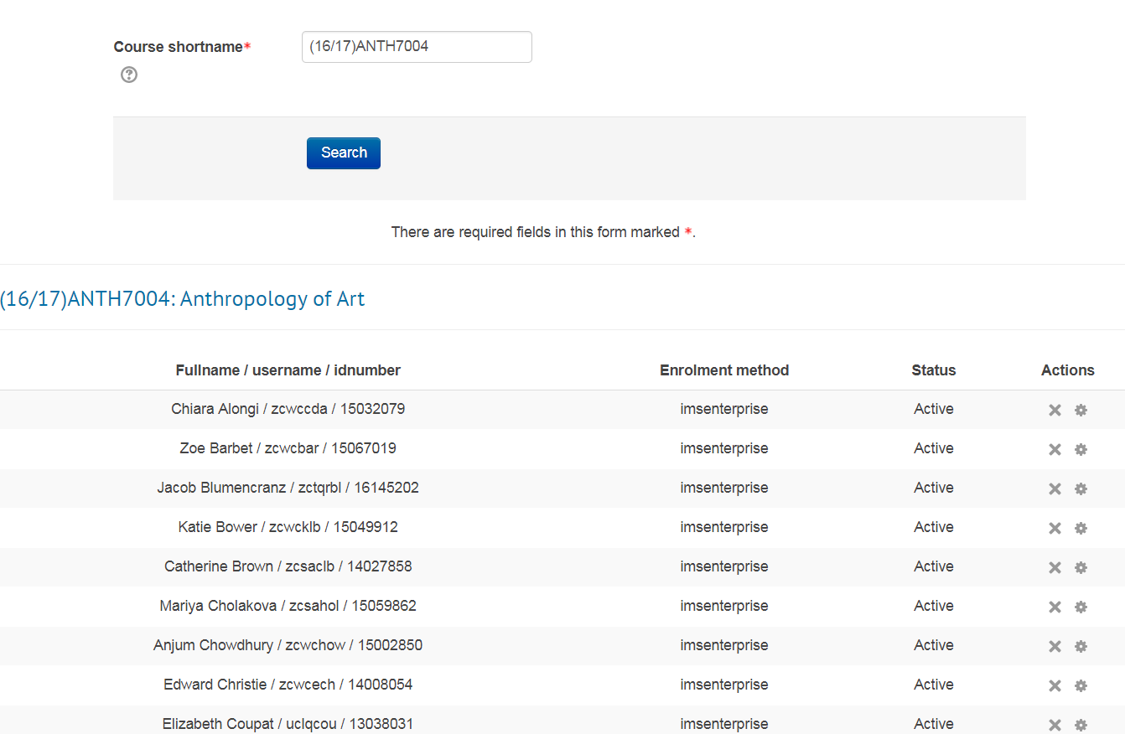

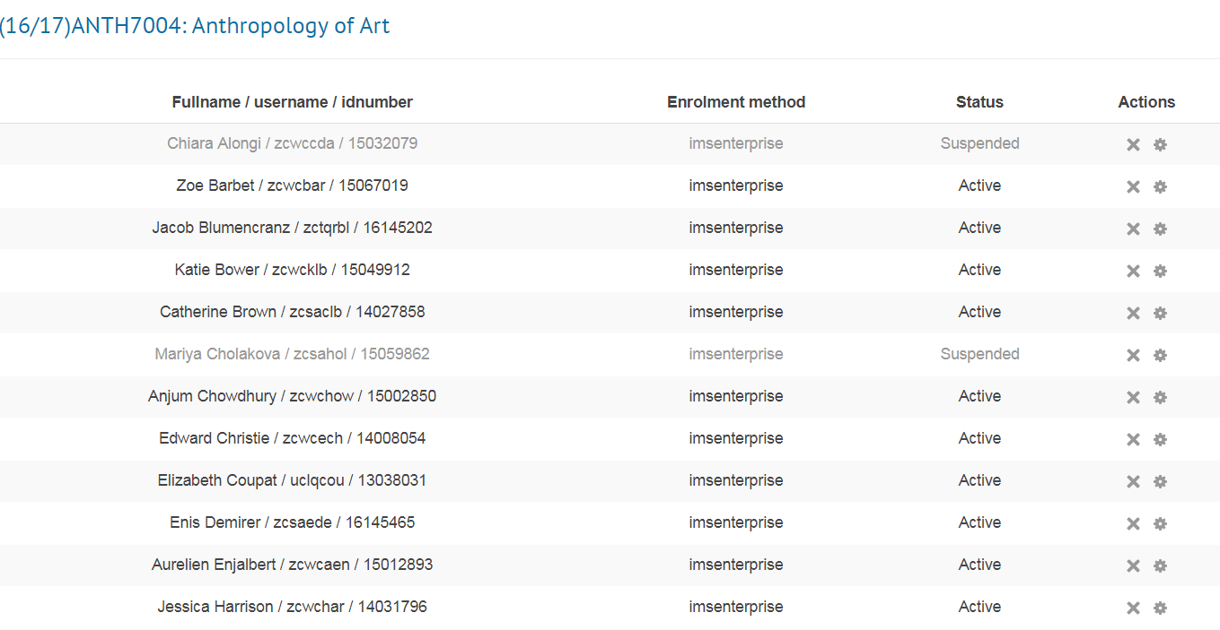

**‘Fullname/username/idnumber’** -> gives the fullname, username and idnumber of students

**‘Enrolment method’** -> specifies the enrolment method which is ‘imsenterprise’

**‘Status’** -> Shows if the user is active or suspended

**‘Actions’** -> Unenrol, suspend or make user active from the course

1. Clicking on un-enrol button un-enrols user from the course

**Note – Un-enrolling users from a course deletes their grades, modules enrolment etc for that course and not possible to retrieve the grades back. So, be very cautious before un-enrolling users from a course**

1. Clicking on suspend users button suspends users from the course and toggles between suspend and active. It’s possible to un-suspend users by clicking on ‘Make user active’ link. This retains user grades. The functionality is exactly similar to standard suspend Moodle functionality for Manual enrolment.