1. Access Mantis using the following URL

<https://www.ucl.ac.uk/mantis>

You will see a login screen as seen in Figure 1

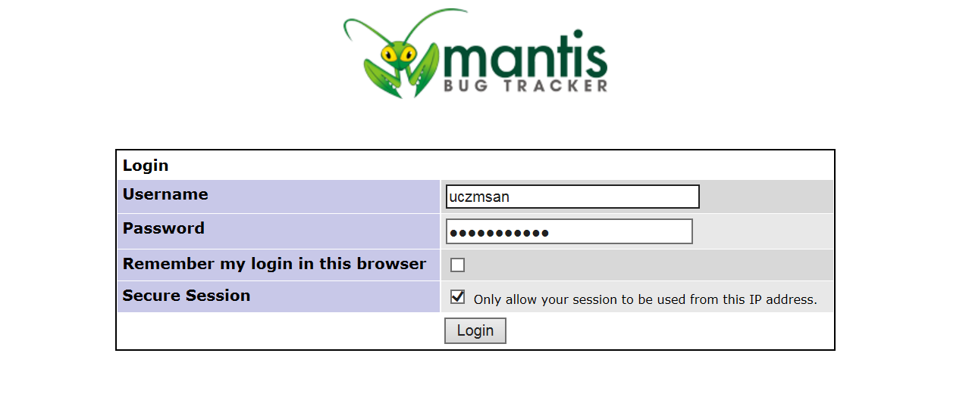

Figure

1. Login to Mantis using UCL credentials
2. On Logging in, please make sure you are in the right project space. Select Moodle Improvement Project from Project drop down list. Mantis remembers your selection and you would not have to do this step every time you log in.

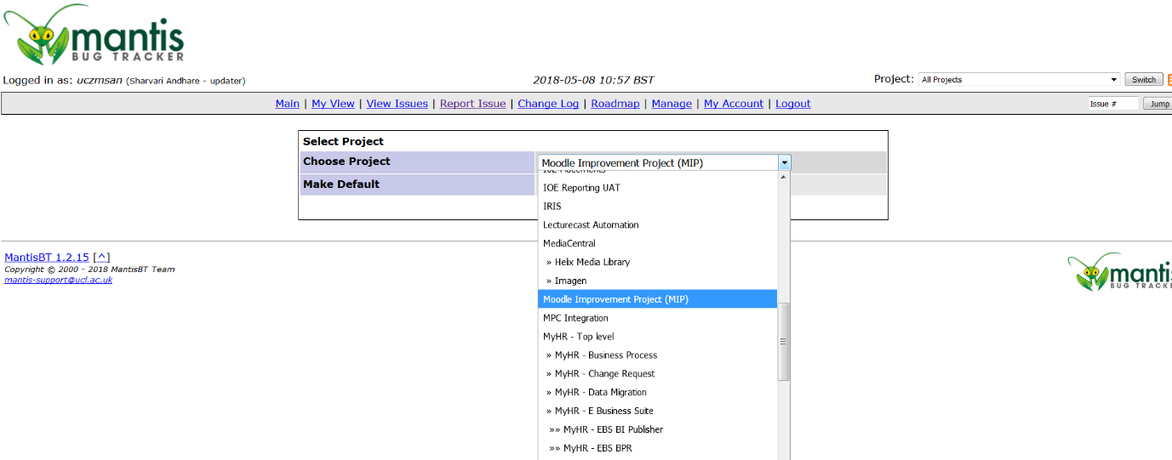

Figure

1. Upon login you see the project Dashboard as seen in Figure 3. Make sure you are in the right project space.

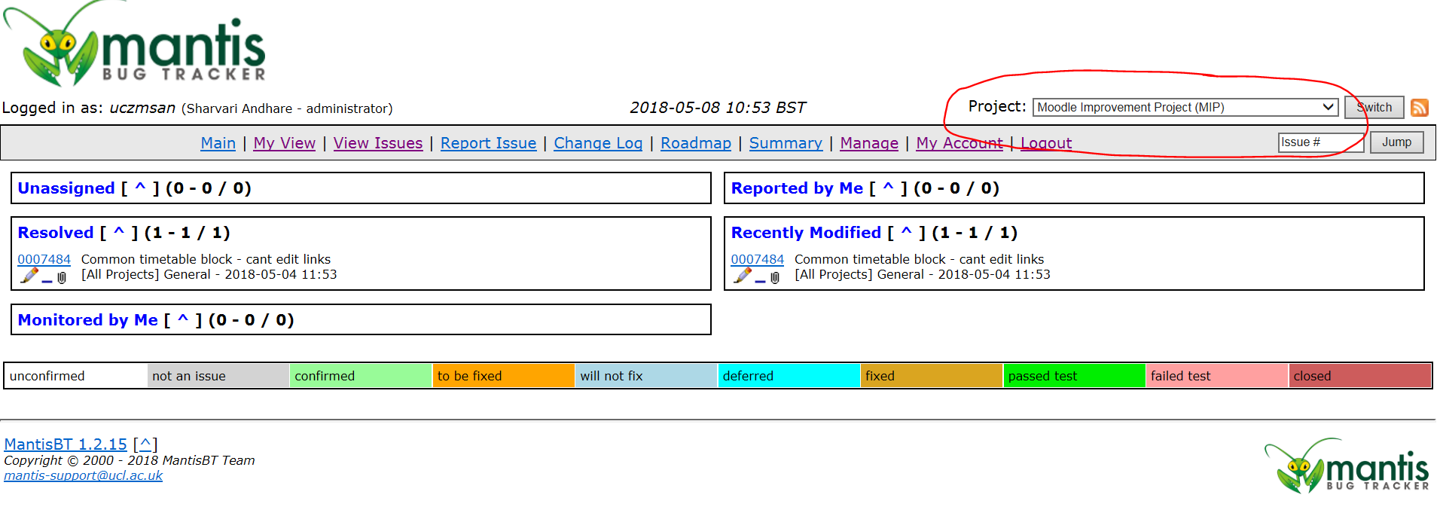

Figure

1. You can now log a new Issue under Moodle Improvement Project by clicking on Report Issue

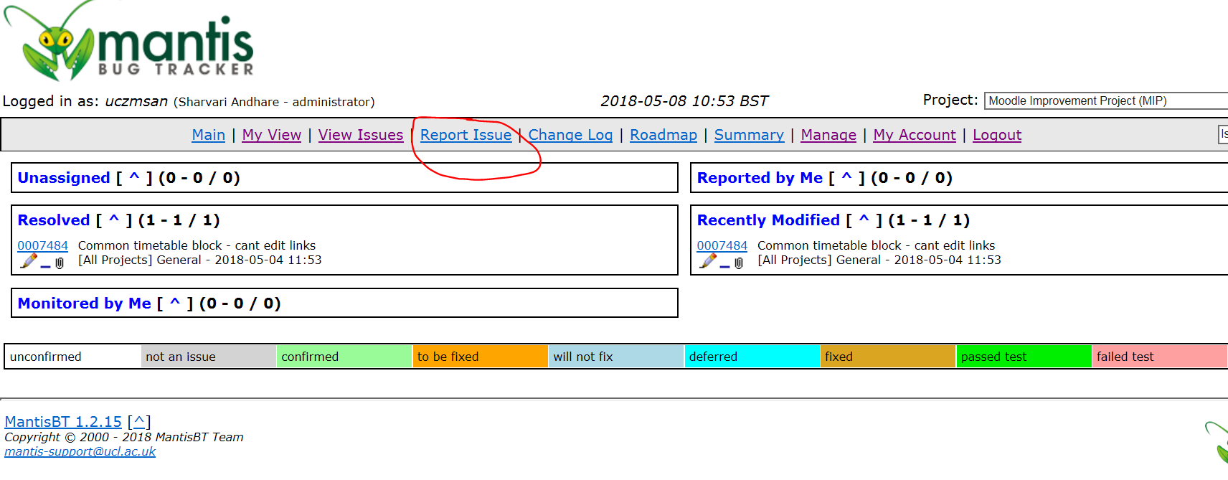

Figure

1. Enter the appropriate Issue details. The fields marked with red asterisk (\*) are mandatory.

Do not assign the issue to anyone if not sure who to assign to. See screenshot of report Issue form below

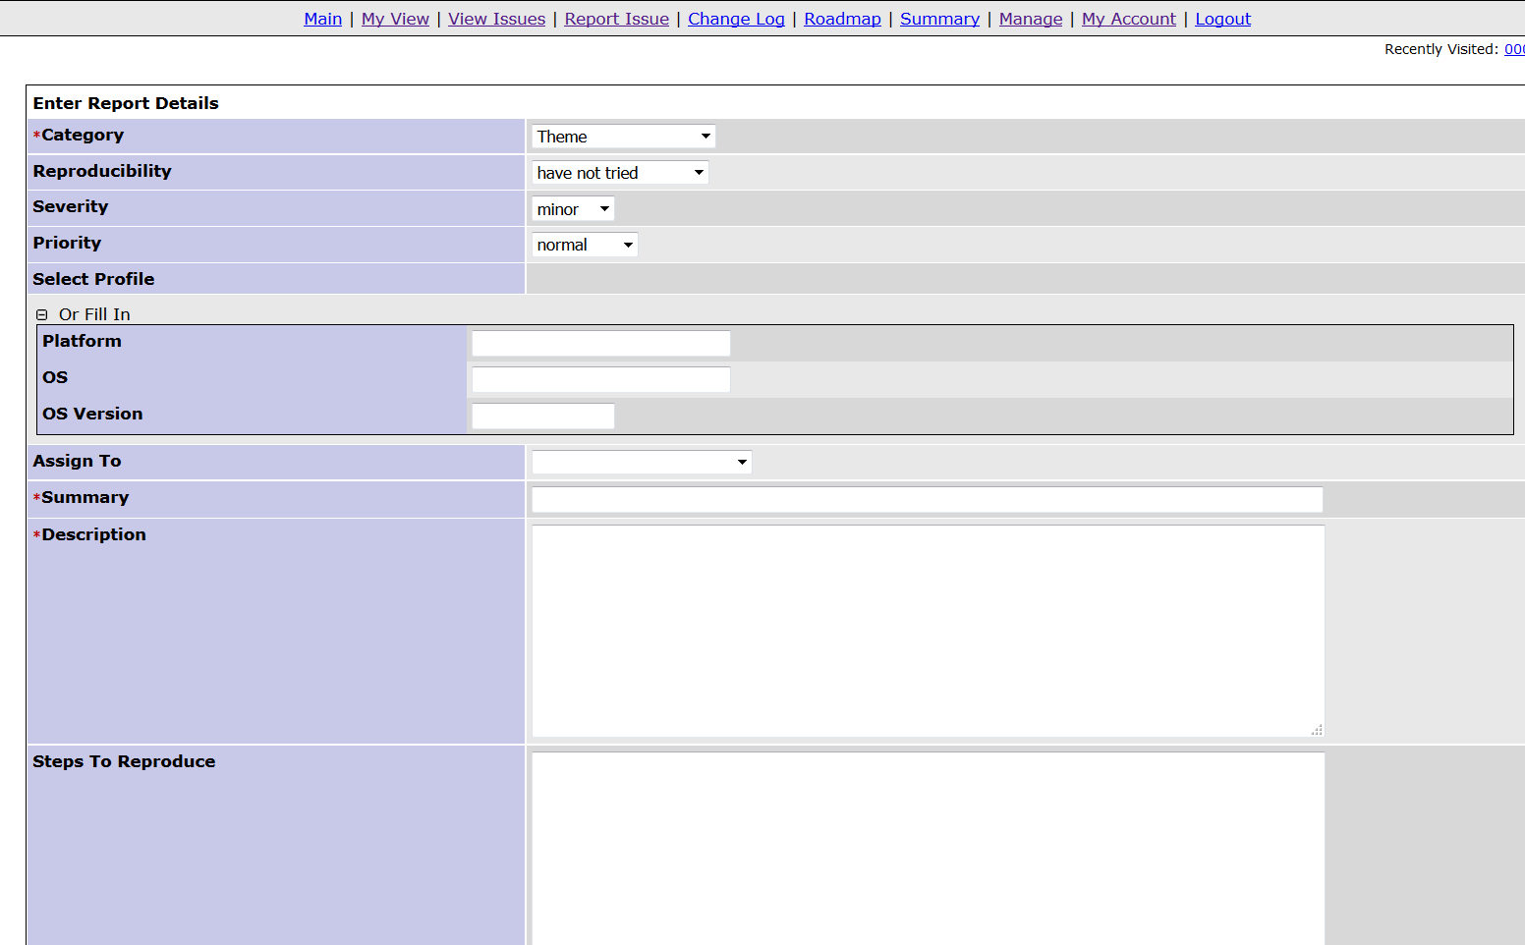

Figure

1. You can View all the issues reported under MIP by clicking View Issues

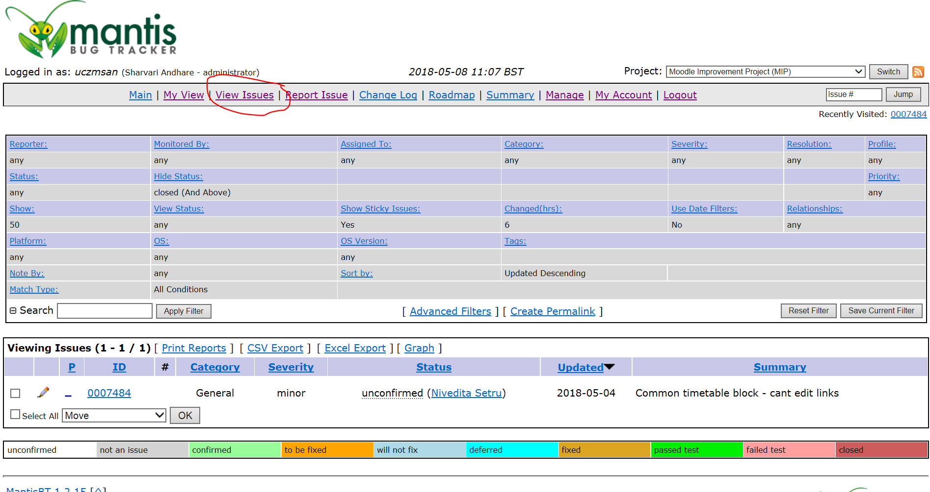

Figure

Filters can be applied to filter the list of issues displayed.

1. Once the issue is raised, developer in Project team will pick it up from Mantis

They will check it is really an issue. If it not an issue, the status would be set to ‘Not an Issue’. No further action will be taken.

If it is an issue, they will set the status of issue as ‘Confirmed’. The developer will fix the issue and update the status on Mantis accordingly.

The end-user, who logged the issue, will be notified via email of any updates to the status of the issue or any comments added to the issue.

1. One the issue is fixed, it will be passed back to the user who logged it to re-test. If the test is passed the issue can be closed. If the test fails, the user should assign the issue back to the developer who fixed it.