# PRIORITISATION - Feedback/Review of MIP Theme by Digital Education Core team - June 2018

08/06/2018

Comparing front page, and my courses page on the following:

1. Current MIP Adaptable/Accessible theme: <https://v34.moodle-01-u.ucl.ac.uk>
   1. *3.4 Moodle*
   2. *Adaptable theme with partial in-setting Accessible implementation*
   3. *Hereafter referred to as T1*
2. Original Accessible theme design: <https://v314-theme.moodle-dev.ucl.ac.uk>
   1. *3.1 Moodle*
   2. *Adaptable theme (older version) with full in-settings Accessible implementation*
   3. *Hereafter referred to as T2*
3. Current (Legacy) Moodle: <https://moodle.ucl.ac.uk/>
   1. *3.1 Moodle*
   2. *UCL Essential Theme*
   3. *Hereafter referred to as T3*
4. Moodle Mount Orange Demo site: <https://school.demo.moodle.net/>
   1. *3.4 Moodle?*
   2. *Boost theme*
   3. *Hereafter referred to as T4*

To keep it as short as possible, we will refer to T# when comparing different theme versions - see above.

General principles:

* Attempt to continue to follow accessibility good practice as far as understood
* Provide users with some continuity between current (Legacy) Moodle and new MIP Moodle, especially in terms of functionality.
* Ensure that theme functionality is aligned to UCL processes and setup.

### **(T1) Current MIP Adaptable/Accessible theme:** [**https://v34.moodle-01-u.ucl.ac.uk**](https://v34.moodle-01-u.ucl.ac.uk)

**Front Page:** [**https://v34.moodle-01-u.ucl.ac.uk**](https://v34.moodle-01-u.ucl.ac.uk)

**ESSENTIAL:**

* Favicon to match current UCL style, rather than Adaptable theme default.
* Remove search courses box - not present on T3 and conflicts with standard branding placement for UCL logo.
* UCL logo should be moved to the right of the header, as with T2, T3 and UCL branding guidelines.
* There are currently no links to staff or student support in T1 or T2. These are only shown once user has logged in. Since one of these includes a link for login issues it is important that these be accessible before login.
  + > If possible, add Menu bar back in with limited items for non-logged in users.
  + Only Staff Help, Student Help and Services items to be shown.
* Announcements
  + Announcements not all caps
  + Does not seem to link Site Announcements/Forum - same on T2
  + Suggest either linking ticker to site announcements as on T3.
  + Or restyling Site Announcements block to similar style, even if does not have ‘ticker’ functionality.
* Help and ideas block should be styled as a heading rather than block - magenta text, no colour fill and bottom border only - see T2
* Four bottom help icons styled as in T2 - magenta text, no colour fill, and sized only around icons and text.
* Remove following blocks:
  + Course Listing
  + Course/Site Summary block - unless restyled to be UCL’s Virtual Learning Environment heading element as in T2 under announcements.
  + Settings
  + Navigation block
* Footer
  + Add back in standard UCL footer - see <http://www.ucl.ac.uk/> (this was never implemented in T2)
  + Currently has a link urging users to download Moodle app - is this desirable?

**DESIRABLE:**

* No option for guest login on either T1 or T2 until failed login.
  + > Suggesting adding Guest login option, either to the right of login field in header, or into Menu bar if re-implemented on front page.
* Help Menu bar
  + Ideally view controls (Hide blocks and Full Screen) options removed but not essential.
  + If Menu bar reimplemented then look at adding Guest login option (but only on front page)
* Add back in ‘UCL's Virtual Learning Environment’ Header as in T2 - otherwise actually no clear indication of what the site is for?
* Footer – add back in Server letter as on T3

**NICE TO HAVE**

* No icons for username and password as in T2.
  + > Suggest reimplementing icons to ensure better visibility of main functionality of page. Compare with T3 where login box is biggest item.
* Marketing slots (since will only be appearing on Landing page (L1) - styling more aligned with slots on T2
  + No colour border for images.
  + Text in slots
    - URLs not differentially styled (see T2)
    - Header text seems to be implementing full paragraph spacing, rather than .5 or similar as on T2.
    - Body text is too long for slot and is partially truncated (may just need to know not to put more than x chars in each slot)

**MyCourses/Dashboard Page:** [**https://v34.moodle-01-u.ucl.ac.uk/my/index.php**](https://v34.moodle-01-u.ucl.ac.uk/my/index.php)

**ESSENTIAL:**

* Remove search courses box - not present on T3 and conflicts with standard branding placement for UCL logo.
* Announcements - as in front page.
* Remove extra blocks:
  + Private Files
  + Online users
  + Calendar
* Add/move blocks to this order:
  + Navigation
  + MyFeedback
  + Upcoming events
  + Latest badges
  + Maintenance (HTML) blog
* Search Courses box to be added in course overview area or as a block at top of right column (could include link to all courses here if easier?)
* Courses overview block **– FURTHER TESTING AND ALTERNATIVE UNDER INVESTIGATION** 
  + **– please could** [**https://moodle.org/plugins/block_course_overview**](https://moodle.org/plugins/block_course_overview) **be added to UAT for further testing as an alternative**
  + Add back in link to All courses as in T3.
  + Fix odd styling where Timeline/Courses tab is shown as dark when selected, like items that can be interacted with.
  + Timeline tab
    - No change to styling of Sort by Courses/Dates buttons when clicked so hard to tell which is ‘active’. Style to show selected - compare with T4.
    - Sort by Courses option
      * View course button is white text on grey – doesn’t look clickable unless hover over. Should be styled as other clickable buttons
      * Replace ‘course’ image (circle with dots) displayed if no completion set to another more intelligible icon (e.g. graphic saying ‘Activity completion not set’)
      * More Courses button at bottom is not properly greyed out – looks very similar to clickable buttons.
  + Courses tab:
    - Hard to tell which [In progress, Future, Past] is ‘active’ when first land, as no differentiation in style. Style to show selected as with Sort by Courses/Dates buttons in Timeline view.
    - Replace ‘course’ image (circle with dots) displayed if no completion set to another more intelligible icon (e.g. graphic saying ‘Activity completion not set’)
    - << 1 >> buttons at bottom of block are not actually active unless have more than 6 courses – could they be greyed out/styled as inactive if there are not multiple pages of courses.

**DESIRABLE**:

* My home icon - replace speedometer icon with House icon (appears in breadcrumb trail once in a course, links to same place)
* Course overview block
  + Set default view if possible? - e.g. start on timeline and then sort by courses
  + Courses tab
    - Picture from course summary not displayed anywhere? See T4 for example in Boost theme.

**NICE TO HAVE:**

* Menu bar has a mix of clickable links (My Home, Events) and menus (My Courses, Staff help etc…) - no fix needed but odd behaviour. This is the same in T2.
* Logged in user block added with (add link to <https://v34.moodle-01-u.ucl.ac.uk/user/edit.php> )
* Navigation block
  + Can this be collapsed by default?

### Proposed Landing course Page: Based on screenshot below

**ESSENTIAL:**

* Remove top right pink login button.
* Add in explanatory heading - “Welcome to UCL’s Virtual Learning Environment” (see screenshot 1 below for suggested styling and placement).
* Move buttons for access to legacy/new Moodle to sit above text in blocks - more accessible not to have to read through text before getting to buttons.
* Change button text to Legacy rather than old.
* Add in buttons below instance access boxes, linking to:
  + [Staff Guides] (<https://wiki.ucl.ac.uk/display/MoodleResourceCentre>)
  + [Student guides] (<https://wiki.ucl.ac.uk/display/ELearningStudentSupport/Moodle>)
* Add back in standard UCL footer - see moodle.ucl.ac.uk

**DESIRABLE:**

* Thumbnails of front pages of two Moodles might be a nice visual cue for people.

*Screenshot 1– T2 (Accessible theme in 3.1 Moodle showing suggested styling and placement for welcome message – red box for emphasis only!)*

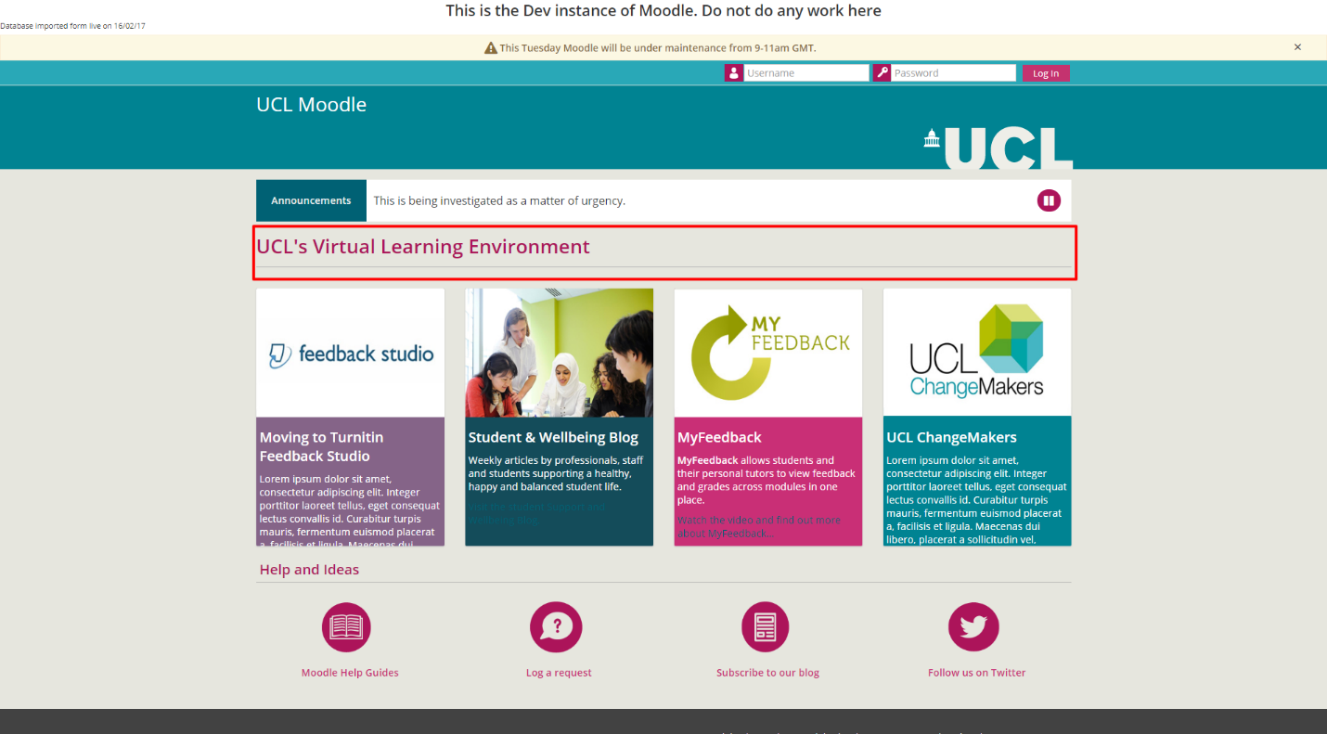

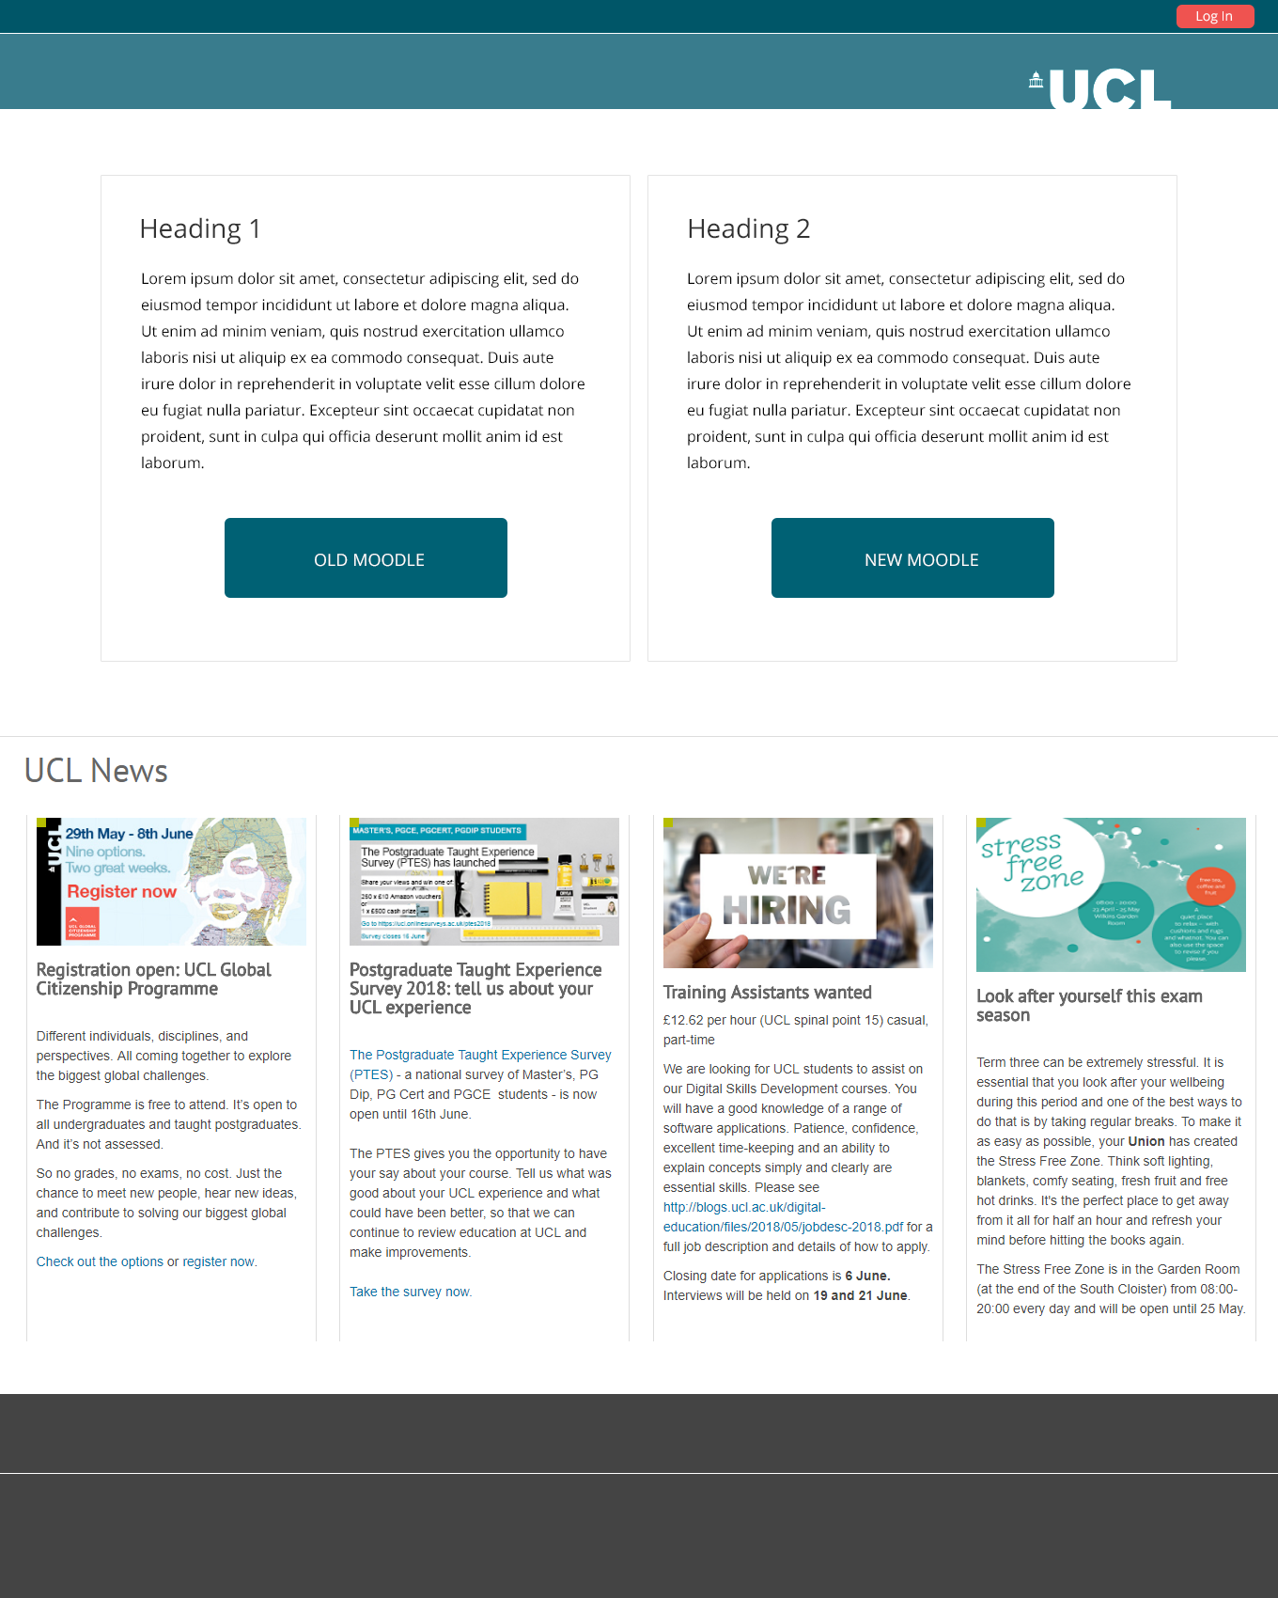

*Screenshot 2– L1 (Catalyst proposed design for landing page, June 2018)*