Part 1 – Search should only return modules for the current academic year

The module search should only return modules for the 2019 academic year.

https://git.automation.ucl.ac.uk/moodle/moodle-block_portico_enrolments/blob/master/ajax.php#L27 needs to also filter to mod_occ_year_code=’2019’

This can be hardcoded for now as would allow a deployment with no setting or version change & therefore no downtime.

Ideally this would become a setting in the Moodle admin interface where it can be more easily changed over (i.e. defined in the plugin’s settings.php)

Part 2 – View of existing mappings & search should display the academic year of the module instance/occurance

https://git.automation.ucl.ac.uk/moodle/moodle-block_portico_enrolments/blob/master/view.php

Should display to the end user the mod_occ_year_code both in the listing of “Current mappings” and in the search results when clicking “+add mappings” and typing a module code in “Seach term” and clicking “Search”

→ This currently displays as “mod_code” - “mod_occ_mav” - “mod_occ_psl_code”

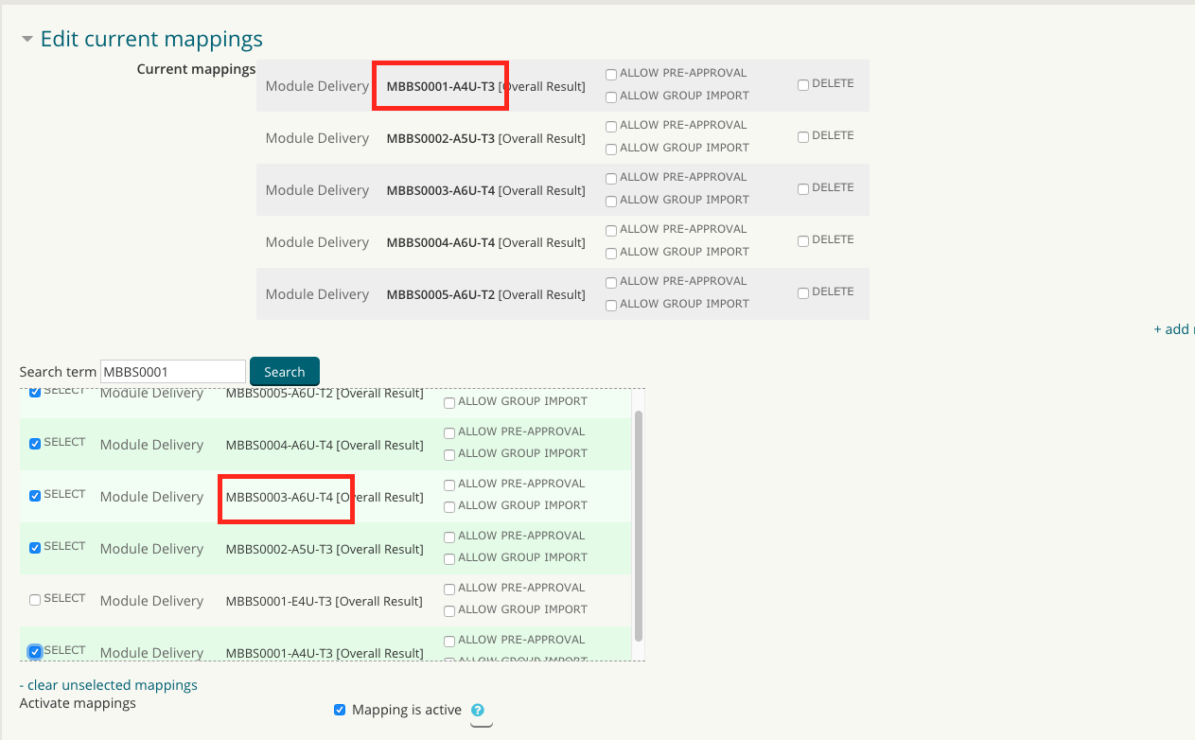
The simplest change would be to amend this to display as:
“mod_code” - “mod_occ_mav” - “mod_occ_psl_code” - “mod_occ_year_code ”

The aim here is to display to course admins that the mapping is tied to a specific academic year. If it is for the incorrect academic year, they would then be able to delete the mapping and search for the correct one for 2019.

Part 3 – the remaining problem of incomplete mappings

Due to search results returning multiple versions(for each academic year) of the same module, the admin teams have been advised to select both(or more) versions of the module they want to map/ enrol into Moodle. The Moodle Portico Enrolments block however, saves both or more mappings in the moodle_int_management.sits_moduleoccurence_mapping table which does allow for enrolments to feed through. However, only one of these gets displayed in the block’s “Current mappings” listing. Removing one mapping and trying to map the other may or may not work -
thinking this can be investigated as relating to:
https://git.automation.ucl.ac.uk/moodle/moodle-block_portico_enrolments/blob/master/view.php#L89-90

and something not being saved in another table. It looked like there is a risk that the moduleoccurence mapping is saved & active but never displayed to Moodle course admin users – this would require fixing up tables.

