Turnitin testing – October 2011 using IE 8

Global settings: Grademark = No, Anonymous marking = No

Test | Outcome (Pass, Problems, Fail) | Notes
Create a new Moodle course and enrol ltss01-03 as tutors and 04-09 as students | Pass
Log in to Moodle as ltss01 and create Turnitin assignment with settings | Pass | Remember to make course available to students before logging out
Log on as tutor ltss02 and change due date to now + 10 minutes, post date to now + 30 mins | Pass
Log in as ltss04 and submit work. Log in as ltss05 and submit work. | Pass
Log in as ltss04 and wait for originality report to be available, hitting Refresh | Pass
Ltss04 views own originality report | Pass
Tutor ltss03 logs in and views originality report of both ltss04 and 05 | Pass | API Warning  Error:212  objectID does not exist for this user  - First time you try to view doc  Screenshot?
Ltss04 attempts to resubmit | Pass
*wait for due date to pass*
Ltss06 attempts to submit | Pass | No option passed
Ltss02 gives grade (34) and feedback to ltss05 using the Grade and Feedback columns | Problems | Grade doesn’t update instantly in Moodle – also shows in TTI type font – grey, small – IE – see screenshot 1
Refresh submissions | Pass | Pass
Ltss02 downloads ltss05’s paper | Pass
Ltss02 checks Moodle grade book | Pass | Grade of 34 is reported against assignment
Ltss02 deletes attempt from ltss05 | Pass
Ltss01 logs in and gives grade and feedback for ltss04 | Problems | Grade disappears, feedback again is lost on refresh
Ltss01 sets due date to now + 10 mins, post date to now+20 mins for both parts | Pass
Ltss06 submits part 1 and part 2 | Pass | More than one class exists with this title and unique ids must be used in this case CODE: 220 in pink banner  -when trying to submit part 2 first  -had to click – submit to TTI in submission inbox  -seems submitted, now trying to view report – An error has occurred which prevents the application from running – internal inconsistency  [reload] :s (screenshot 2)  -uploading second submission taking long time to sync
Ltss05 resubmits part 2 |  | Submission was not accepted as that assignment part has already been submitted to. If you need to resubmit, please delete the current submission then upload the new file.  More information about this error  screenS 3- But no delete button as student? Due date not passed
Ltss05 submits part 2 only
Ltss04 attempts to view originality report
Ltss04 attempts to submit part 1 only, late
Ltss02 views originality reports of 04, 05 and 06 |  | Horrible <hr /> on options tab? (SS4)
Ltss02 gives grades and feedback |  | Have given one grade of 79– gradebook shows 39.5. add 39% to part 2 – gradebook still shows 39.5
Ltss02 downloads documents
Ltss04 views assignment before post date |  | Cannot see reports, grades or feedback which is correct. But gets message that “The due date for this assignment has passed and late submissions are not allowed.” Which is incorrect.
Ltss04 views assignment after post date |  | Can see grades, but feedback has been lost
Ltss05 views assignment after post date |  | Can see grade for part 2 and still allowed to submit

Global settings: Grademark = No, Anonymous marking = Yes

Test | Outcome (Pass, Problems, Fail) | Notes
Ltss01 sets up assignment with settings { File Upload, 1 Part, 20 MB, 100, Yes [anonymous marking], Yes, No, First report is final, No, Yes, Yes, Yes, No groups } | Pass
Changes due date to now+10 mins, post date to now+20 | Pass
Ltss04 submits work | Pass
Ltss05 submits work | Pass
Ltss02 reviews work prior to due date | Pass | Formatting is a little awkward, they are all grouped under a ‘Part 1’ heading even though there is only one part. But anonymity is preserved
Ltss02 reviews originality reports | Pass | Anonymity preserved
*waits till after due date*
Ltss03 reviews work submitted | Pass | Anonymity preserved
Ltss03 requests a reveal | Pass | Student name revealed
*waits for post date*
Ltss02 checks student work | Pass | All names now revealed
Ltss04 checks own work | Pass

Global settings: Grademark = Yes, Anonymous marking = Yes

Test | Outcome  (Pass, Minor problems, Major problems) | Notes
Ltss01 sets up assignment with settings { File Upload, 1 Part, 20 MB, 100, Yes [anonymous marking], Yes, No, First report is final, No, Yes, Yes, Yes, No groups } | Pass
Ltss01 sets due date to +10 mins and post to +20 | Pass
Ltss 04 05 and 06 submit work | Pass
Ltss02 reviews student work | Pass | Anonymity preserved. Grade option replaced with red apple button
Ltss02 launches grademark on Andrew, adds general feedback, highlight comments and gives mark | Pass
Ltss02 reviews grademark on Andrew | Pass | Grade, comments and feedback remain
*waits till due date*
Ltss01 adds additional feedback to Andrews paper and revises mark to 63 | Pass | LTSS01 sees the comments and feedback previously added by ltss02
Ltss04 checks marks and feedback and grademark comments | Pass | Can see originality report but not grades or feedback
*waits till post date*
Ltss04 checks marks and feedback and grademark comments | Pass | Can see originality report and grades/ feedback using grademark
Ltss04 checks Moodle grades | Not sure | No entry shown in Moodle grades
Question:
If you are using grademark to mark, then the marks do not show up in the Moodle gradebook. But is there any way to download them all in one go?

Integration of moodle and submit.ac.uk

Ccaasro creates Turnitin assignment via Moodle | Pass
Ltss04 and 05 submit work via Moodle | Pass
Ccaasro checks for submissions within submit.ac.uk | Pass (but had to change owner to Stephen Rowett from LTSS01)

Testing Turnitin with Groups

Establish groups and set Turnitin assignment to visible groups | Fail | Turnitin plug in does not support groups

Course maintenance

Backup course with full user data. Restore to new course | Process succeeds.  Restored course does not contain any Turnitin assignments | Turnitin plug in does not support groups
Reset course – with options to keep existing Turnitin assignments, empty existing assignments, or create new ones (tried in TII Testing RC 2).
Reset keep existing | Pass
Reset create new | Pass

Screenshots:
Screenshot 1: (grey TTi font for grade)
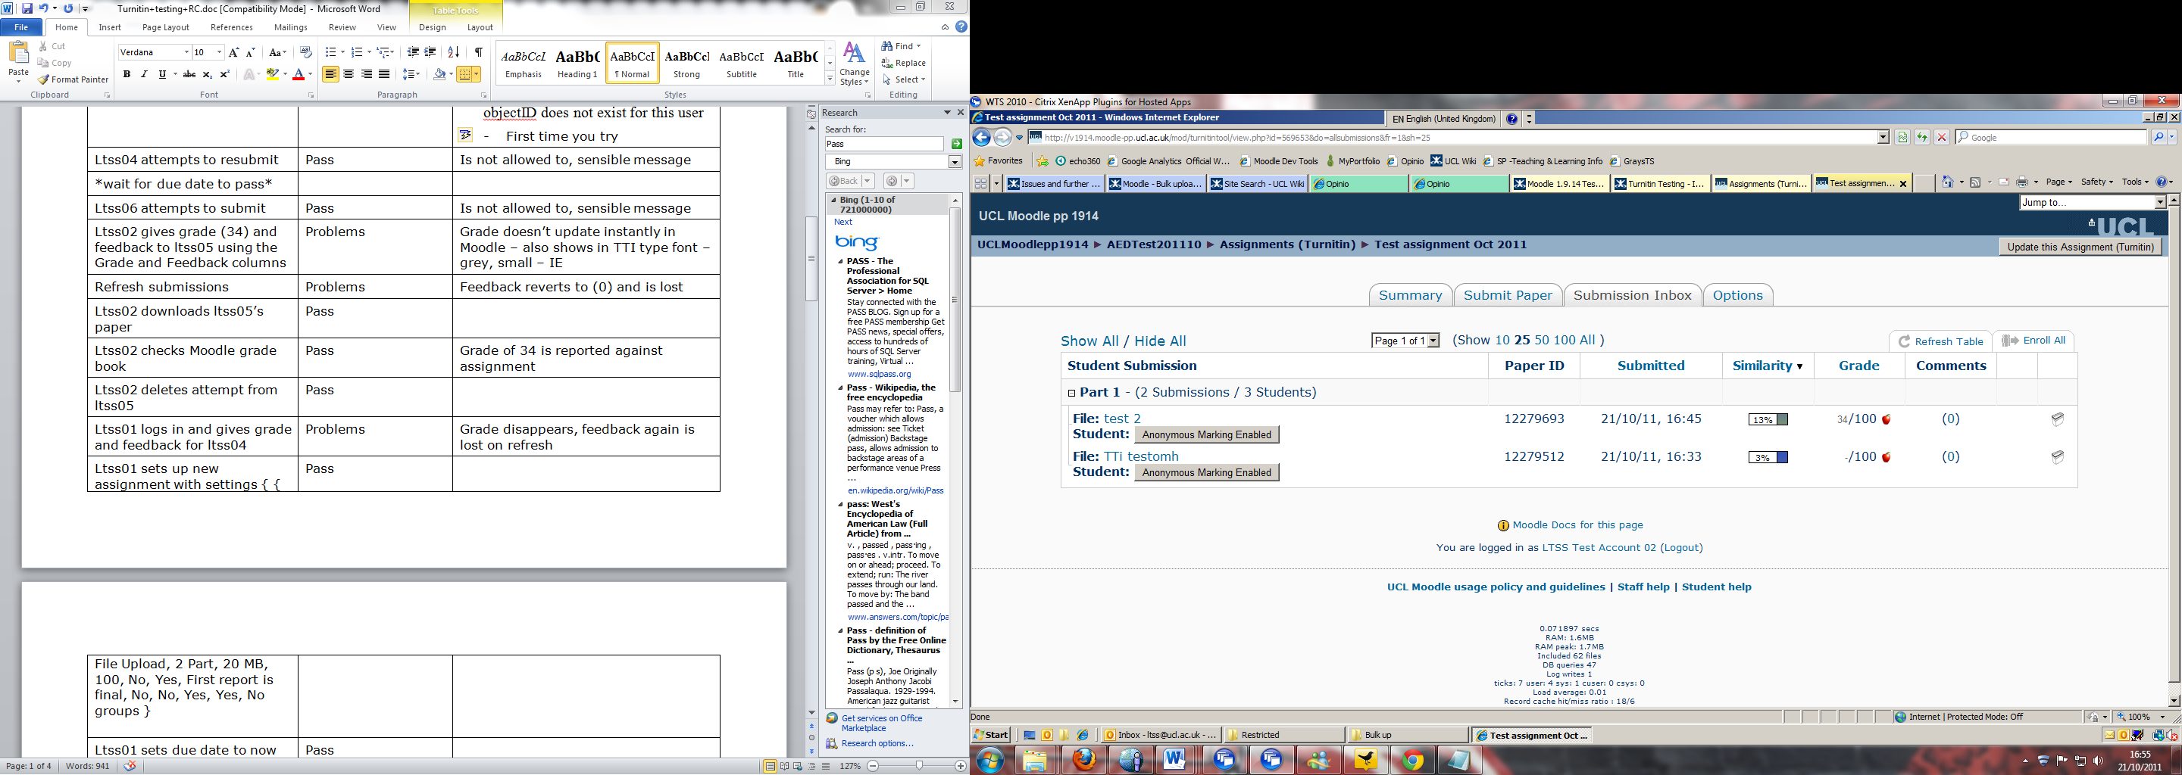

Screenshot 2:
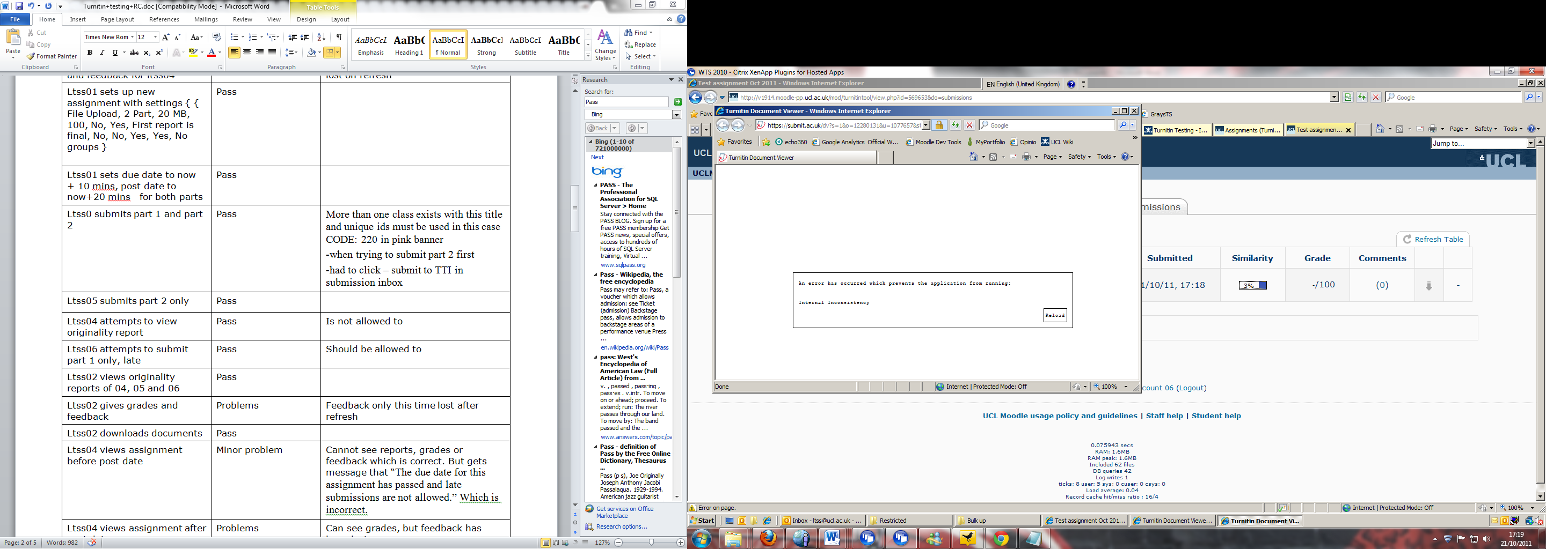

Screenshot 3
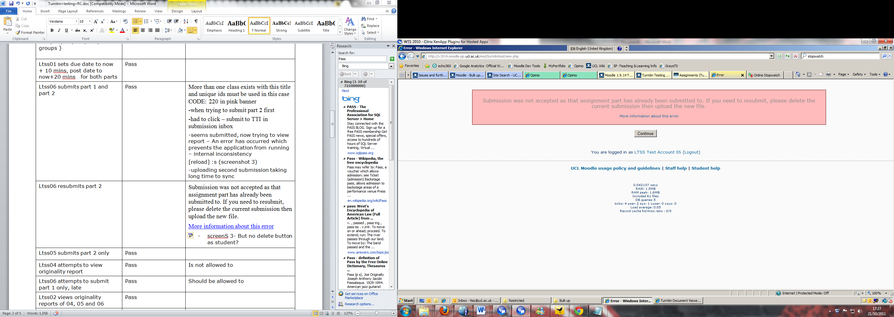

SS 4
