

Management Systems Division

Data Interface Specification for:

SITS:Vision -> WebCT interface
AC Part: /MSD/SITS/interfaces/WebCT/Spec-SITSVision-WebCT-Interface.doc
AC User: Mick Cairns (MSD)
AC Date: 16/10/2007 12:28:13
AC Version: 008

Version | Date | Author | Changes
006 | 17/09/07 | MJC | Amended following discussions with IS for Moodle

Author: Jacek R. Wolski, MSD
Reference: Meeting on 02/05/2006, SITS/WebCT Interface.

Contents
1. Introduction 1
2. Process Overview 1
3. Data Mapping 2
4. Selection Criteria 2
5. File Structures 4
6. Security 5
7. Validation 5
8. Operation 5
8.1 Technical solution 5
8.1.1 Webct_export.sql 5
8.1.2 Webct.com 6
8.2 Transfer Method 6
8.3 Monitoring and Logging 6
8.4 Error Correction 6
8.5 Triggering 6
8.6 Timing aspects 6
8.7 User Authority 6
8.8 Other Functional Requirements 6
9. Transition Plan 7
9.1 Initialisation 7
9.2 Schedule 7

Table of Figures
Figure 1 - Data Mapping Table - Students 2
Figure 2 - Data Mapping Table - Staff 2

Introduction

This document contains specification of a one-way data interface from SITS:Vision to WebCT system.
The interface components not developed by Portico development team are not specified.
If not specified otherwise the specification applies to the interface from SITS:Vision to WebCT.

The interface’s main objective is to provide data for WebCT virtual learning system.

This specification will typically be located in All Change:
/MSD/SITS/interfaces/WebCT/Spec-SITSVision-WebCT-Interface.doc

Process Overview
WebCT will receive an XML file loaded to a specified location by secure ftp by a nightly batch job.
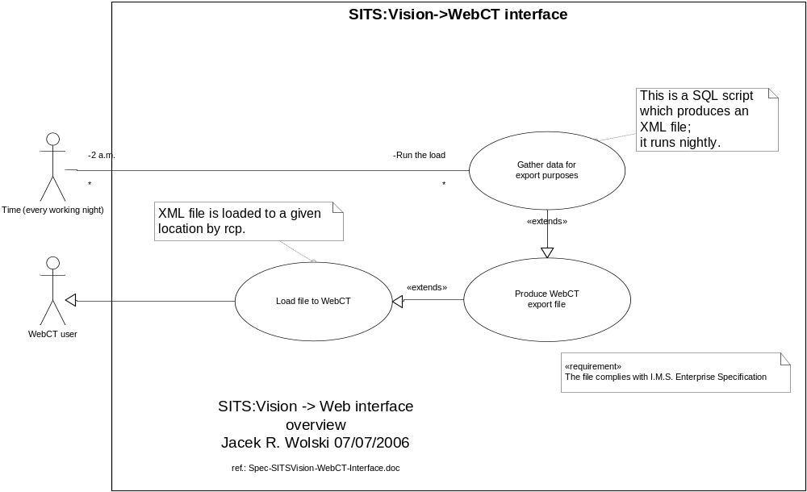

Assumptions and limitations:

- Only records which have been Approved by the Teaching department will be exported (sms_udf1=’APP’).
- SMS records are temporary and are cleared down by the Portico Services office during the academic year. The impact of this is to be considered by IS.
- If a person is both a student and staff then a student’s data takes preference.

Data Mapping
The following table describes the data mapping for students:

Ref | SITS | Data Type | WebCT | Comments
1 | SRS_MST.MST_CODE | Char | <person><sourceid><id>
2 | MEN_MUA.MUA_EXTU | Char | <person><userid>
3 | INS_STU.STU_NAME | Char | <person><name><fn>
4 | INS_STU.STU_SURN | Char | <person><name><n><family>
5 | INS_STU.STU_FNM1 | Char | <person><name><n><given>
6 | INS_STU.STU_INEM | Char | <person><email>
7 | INS_MOD.MOD_CODE ||CAM_MAV.MAV_OCCUR||INS_AYR.AYR_SNAM||CAM_MAV.PSL_CODE | Char | <group><sourceid><id>
8 | INS_MOD.MOD_NAME | Char | <group><description><short>
9 | INS_DPT.DPT_NAME | Char | <group><org><orgunit>
10 | INS_MOD.MOD_CODE ||CAM_MAV.MAV_OCCUR||INS_AYR.AYR_SNAM||CAM_MAV.PSL_CODE | Char | <membership><id>
11 | SRS_MST.MST_CODE | Char | <membership><member><sourceid><id>
12 | MEN_MUA.MUA_EXTU | Char | <membership><member><role><userid>
Figure 1 - Data Mapping Table - Students

The following table describes the data mapping for staff:

Ref | SITS | Data Type | WebCT | Comments
1 | SRS_MST.MST_CODE | Char | <person><sourceid><id>
2 | MEN_MUA.MUA_EXTU | Char | <person><userid>
3 | INS_PRS.PRS_NAME | Char | <person><name><fn>
4 | INS_PRS.PRS_SURN | Char | <person><name><n><family>
5 | INS_PRS.PRS_FNM1 | Char | <person><name><n><given>
6 | INS_PRS.PRS_EMAD | Char | <person><email>
7 | INS_MOD.MOD_CODE ||CAM_MAV.MAV_OCCUR||INS_AYR.AYR_SNAM||CAM_MAV.PSL_CODE | Char | <group><sourceid><id>
8 | INS_MOD.MOD_NAME | Char | <group><description><short>
9 | INS_DPT.DPT_NAME | Char | <group><org><orgunit>
10 | INS_MOD.MOD_CODE ||CAM_MAV.MAV_OCCUR||INS_AYR.AYR_SNAM||CAM_MAV.PSL_CODE | Char | <membership><id>
11 | SRS_MST.MST_CODE | Char | <membership><member><sourceid><id>
12 | MEN_MUA.MUA_EXTU | Char | <membership><member><role><userid>
Figure 2 - Data Mapping Table - Staff

Selection Criteria
The interface will process all modules running in the current academic year which have been approved or confirmed for at least one student i.e. an sms record exists for the current academic year with SMS_UDF1=’APP’ or SMS_UDF4 = ‘CON’ (the latter is to allow the inclusion of sms records which have been ‘blanket’ confirmed by the parent department without approval by the teaching department).
The current academic year is returned from the function ucl_sits_api.get_current_academic year which uses the current system date to return the academic year based on the system date and the start and end dates in the table SRS_AYR.
.

File Structures
The following files are used
- Webct.xml (XML file)

The XML file will first contain entities in the following sequence:
- <person> entities (students and staff)
- <group> entities (module data)
- <member> entities (membership data)

The XML file structure:
Structure | Example
<?xml version="1.0"?>  <enterprise>  <properties lang="en">  <datasource>sits:vision</datasource> <datetime>to_char(sysdate,'dd/mm/yyyy')</datetime>  </properties>  <person>  <sourcedid>  <source>sits:vision</source>  <id>mst.mst_code</id>  </sourcedid>  <userid></userid>  …  <name>  <fn>stu.stu_name</fn>  <n>  <family>stu.stu_surn</family>  <given>stu.stu_fnm1</given>  </n>  </name>  <email>  stu.stu_inem  </email>  <extension>  <webcredential></webcredential>  </extension>  </person>  …  <group>  <sourcedid>  <source>sits:vision</source> <id>||mod1.mod_code||mav.mav_occur||ayr.ayr_snam||mav.psl_code||</id>  </sourcedid>  <description>  <short>mod1.mod_name</short>  </description>  <org>  <orgunit>dpt.dpt_name</orgunit>  </org>  <extension>  <template>blank</template>  </extension>  </group>  <membership>  <sourcedid>  <source>sits:vision</source> <id>||mod1.mod_code||mav.mav_occur||ayr.ayr_snam||mav.psl_code||</id>  </sourcedid>  <member>  <sourcedid>  <source>sits:vision</source>  <id> || mst.mst_code || </id>  </sourcedid>  <idtype idtype="1"/>  <role roletype="01">  <userid> || mua.mua_extu || </userid>  …  <status>1</status>  </role>  </member>  …  <member>  <sourcedid>  <source>sits:vision</source>  <id> || mst.mst_code || </id>  </sourcedid>  <idtype idtype="1"/>  <role roletype="02">  <userid> || mua.mua_extu || </userid>  …  <status>1</status>  </role>  </member>  …  </membership>  </enterprise> | <?xml version="1.0"?>  <enterprise>  <properties lang="en"> <datasource>sits:vision</datasource>  <datetime>04/05/2006</datetime>  </properties>  <person>  <sourcedid>  <source>sits:vision</source>  <id>AAKAN11</id>  </sourcedid>  <userid></userid>  <name>  <fn>Adegoke Akanbi</fn>  <n>  <family>AKANBI</family>  <given>ADEGOKE</given>  </n>  </name>  <email>  </email>  <extension> <webcredential></webcredential>  </extension>  </person>  …  <group>  <sourcedid>  <source>sits:vision</source>  <id>PHOL1001A1985 / 86T1/2</id>  </sourcedid>  <description>  <short>mammalian phys.</short>  </description>  <org>  <orgunit>physiology</orgunit>  </org>  <extension>  <template>blank</template>  </extension>  </group>  <membership>  <sourcedid>  <source>sits:vision</source>  <id>PHOL1001A2005/06T1/2</id>  </sourcedid>  <member>  <sourcedid>  <source>sits:vision</source>  <id>AAKAN11</id>  </sourcedid>  <idtype idtype="1"/>  <role roletype="01">  <userid></userid>  <status>1</status>  </role>  </member>  …  <member>  <sourcedid>  <source>sits:vision</source>  <id>JWOLS07</id>  </sourcedid>  <idtype idtype="1"/>  <role roletype="02">  <userid>UCZMJWO</userid>  <status>1</status>  </role>  </member>  </membership>  </enterprise>

Security
Detail security issues and technical solution
- Secure ftp to the result load file
- Username / password used for automated jobs
- File encryption required: NO

Validation
The following data validation must be (is) performed on data entering WebCT: NONE.

Operation

Technical solution

Webct_export.sql
An SQL (/u01/siapp/vision/live/ucl/webct/webct_export.sql) script generates an XML file containing data specified in chapter 5.
The script uses the following functions from UCL_SITS_API:

get_IS_usernames
To get IS usernames associated with a particular UPI (i.e. master code).

Get_current_academic_year
To get the current academic year

Membership_data
To select members for each module

Approved
Returns APP the current string for approved sms records

Confirmed
Returns CON the current string for confirmed sms records

Webct.com
The result (webct.xml) is copied using rcp to Socrates.
The load is operated by a ksh script (/u01/siapp/vision/live/ucl/webct/webct.com). The script is run using crontab as urouter user on sits-b/sits-a machines.
Temporary files are stored in $HOME directory of urouter user.

The process sends a notification e-mail to portico-technical-support@ucl.ac.uk and is-appsdev-section@ucl.ac.uk.

Transfer Method
How the identified data is actually transferred e.g.:
- Via an XML file that is rcp'd to WebCT.
The report will be run using cron on sis-b/sis-a machines from urouter account.
The file is expected to hold approximately 100MB of text data.

Monitoring and Logging
The interface is monitored daily by Portico team checking the logs produced.

Error Correction
Failed transfers will be dealt with by Portico team.

Correction / reconciliation will be dealt with by WebCT team.

Triggering
The interface is triggered nightly at 2 a.m (every working week night).
Crontab entry:
00 2 * * 1-5 /u01/siapp/vision/live/ucl/webct/webct.com SIS

Timing aspects
- Is it a daily process
- It takes up to an hour to execute
- The interface can be operated concurrently without error.

User Authority
Who is responsible: Julie Voce.
Who would be affected by failure of this interface: WebCT team.

Other Functional Requirements
The interface enables:
- Notification of failure to System Admin
- Log file to be generated of actions and failures: NONE.
- System audit i.e. date & user affecting the data insert/update: NONE.

Transition Plan

Initialisation
Any special procession required to initialise the interface
- Initial selection criteria include all MAV records
The first and all subsequent loads will contain all relevant data available in SITS.

Schedule
The data interface will be introduced in the following manner:
- Timing: by the end of July’2006
- It will be tested by WebCT team beforehand

