Project : CMIS–Moodle Integration

Basic Architecture

Models -> to handle REST exceptions and responses
Application execution
Console
Import Groups and Groupings
Outline
Prerequisites
Database
Model
Create groups in Moodle
Create groupings in Moodle
Assign groups from groupings in Moodle
Add or delete members in Groups
Outline
Database
Model
Adds group members in Moodle
Delete group members in Moodle
Add or delete tutor members in Groups
Outline
Prerequisites
Database
Model
Adds group members in Moodle
Delete group members in Moodle
Delete groups and groupings in Moodle
Outline
Database
Model
Delete groups in Moodle
Delete groupings in Moodle

Basic Architecture

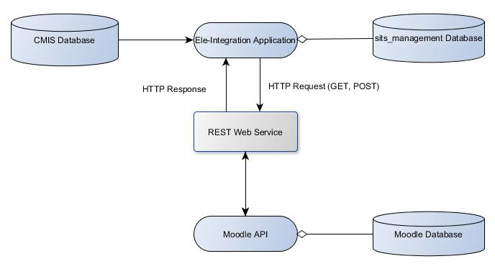

REST Web Service
    - Client based on REST/SOAP – to make function calls
    - Moodle API – external functions from Moodle that could be used to perform various updates to Moodle database

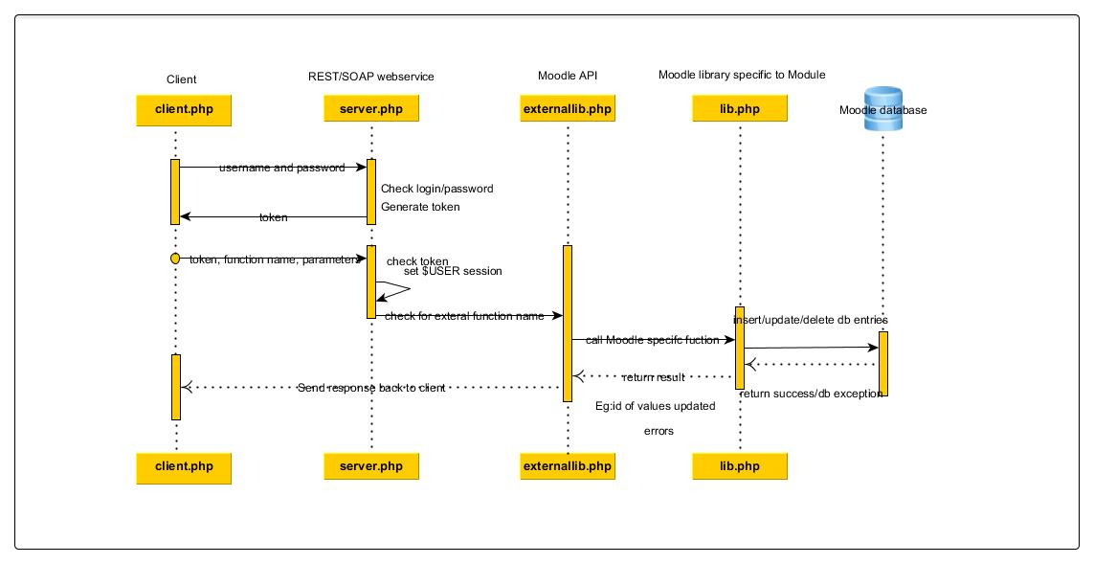

Controllers -> to handle REST calls
Class RestConfig
- Public fields of type array to store REST service config details and functions relating to REST service calls
Class RestClientController
- Acts as base controller. Initialise config details for REST calls
Class MoodleRestClientController Extends RestClientController
- Acts as REST client. Implement functions to communicate with Moodle APIs.
Class RestErrorHandlerController Extends RestClientController
- Handle Errros or Exceptions from realted to REST call
Class RestResponseHandlerController Extends RestClientController
- Handle Responses from received after calling Moodle-APIs

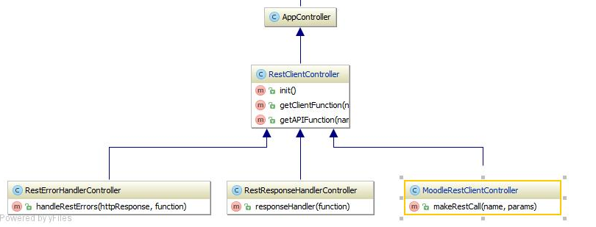

Models -> to handle REST exceptions and responses

Class RestResponseHandler
- Handle responses received from REST calls to Moodle. Redirects control to classes or functions that should be triggered for further tasks post REST calls
Class RestErrorHandler
- Handle errors or exceptions received from REST calls to Moodle. Logs error messages and exceptions to a table (rest_error_logs) and clean corrupt data from tables(cmis_groups_course, cmis_groups)
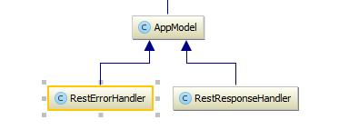

Application execution

From command line ->
$ cd /path_to_sitsfilter2/sits_filter2
$ cake RunCmis runCmisCronJob

Console
Class RunCmisShell
- Acts as starting point for this application to run. Calls to models and controllers are generated from RunCmisShell.

Import Groups and Groupings

Outline
Import group data from CMIS and create groups and groupings within Moodle.

- Read data from Oracle view (Eg : MOODLE_V_CMIS_MODGRP)
- Dump data from view into intermediate database table (moodle_sits_management.cmis_groups_dump)
- Read and compare data from dump table and insert into intermediate database table (moodle_sits_management.cmis_groups, moodle_sits_management.cmis_groups_course) if groups data not found
- Establish successful handshaking between client (sits_filter-2 app) and server (Moodle)
- Call Moodle REST API function :: core_group_get_course_groups -> Get current groups from a course in Moodle
- Check if new groups to be created already exist in Moodle. Skip group, if group with same name already exist in Moodle.
- Call Moodle REST API function :: core_group_get_course_groupings -> Get current groupings from a course in Moodle
- Check if new groupings to be created already exist in Moodle. Skip grouping if grouping with same name already exist in Moodle.
- Get all groups from moodle_sits_management.cmis_groups_course table where ‘toadd’ flag is set to 1.
- Call Moodle REST API function :: core_group_create_groups -> Create groups in Moodle
- Record created groups in Moodle within intermediate database table (moodle_sits_management.cmis_moodle_groups)
- Call Moodle REST API function :: core_group_create_groups -> Create groups in Moodle
- Record created groupings in Moodle within intermediate database table (moodle_sits_management.cmis_moodle_groupings)
- Call Moodle REST API function :: core_group_create_groupings -> Create groupings in Moodle
- Call Moodle REST API function :: core_group_assign_grouping -> Assign each group to a grouping with same name
- Update moodle_sits_management.cmis_groups_course with moodlegroupid and moodlegroupingid

Prerequisites

1) Modules where group_import is selected, it should be mapped to a course. 'mapping_action' field should be set to 'ADD' for group_import to work in a course

Database
Table :: cmis_groups_dump – Dump of data from Oracle groups view
Table :: cmis_groups – Group details
Table :: cmis_groups_course – Data mapped from mapped_modules table and cmis_groups table. Keeps record of insert, update, found and delete operations for groups.
Table :: cmis_groups_moodle – Record responses received from REST call. Records of groups created in Moodle.
Table : : cmis_groupings_moodle – Record responses received from REST call. Records of groupings created in Moodle

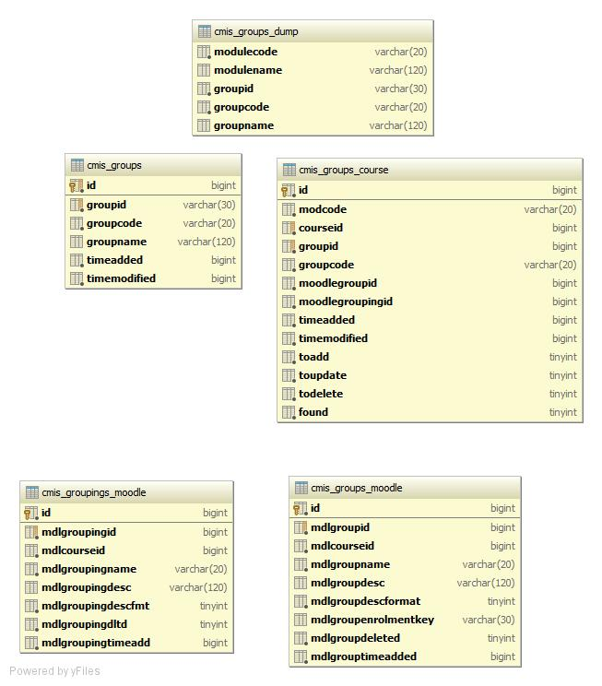

Model

Class GroupsOracleDb
- Interact with Oracle view. Check initial connection to oracle database and view.
Class CmisImport
Class GroupsImport Extends CmisImport
- Import data from Oracle view into 'cmis_groups_dump' table
Class Groups
- Implement functions to perform insert, update and delete of groups data
Class GroupsCourse
- Interacts with its default table to perform insert,update and delete of groups.
Class GroupsMoodle
- Interacts with its default table to add newly created Moodle groups
Class GroupingsMoodle
- Interacts with its default table to add newly created Moodle groupings

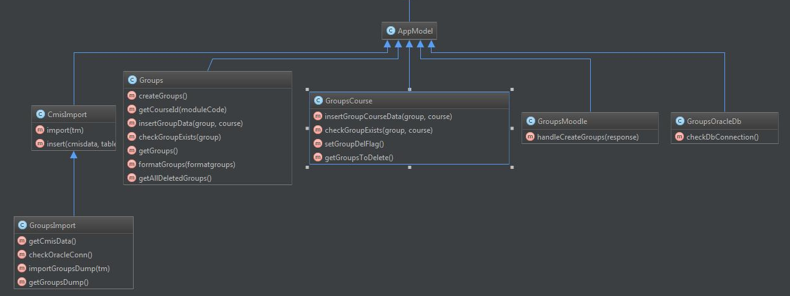

Create groups in Moodle

External function name : core_group_create_groups( )
Arguments : List of group object with course id, group name, group description, group description format, group enrolment key

// Argument format
list of (
object {
courseid int //id of course
name string //multilang compatible name, course unique
description string //group description text
descriptionformat int Default to "1" //description format (1 = HTML, 0 = MOODLE, 2 = PLAIN or 4 = MARKDOWN)
enrolmentkey string Optional //group enrol secret phrase
}
)
Response : This includes list of group objects that are created successfully or error message on failure

//Response format
//List of group object. A group has an id, a courseid, a name, a description and an enrolment key.
list of (
object {
id int //group record id
courseid int //id of course
name string //multilang compatible name, course unique
description string //group description text
descriptionformat int //description format (1 = HTML, 0 = MOODLE, 2 = PLAIN or 4 = MARKDOWN)
enrolmentkey string //group enrol secret phrase
}
)
Error Handling: This is done at client side. If there is a fault with data, create_groups( ) function would throw an exception which will be returned as a response to the client.

Create groupings in Moodle

External function name : core_group_create_groupings( )
Arguments : List of group object with course id, grouping name, grouping description, grouping description format, grouping enrolment key

//List of grouping object. A grouping has a courseid, a name and a description.
list of (
object {
courseid int //id of course
name string //multilang compatible name, course unique
description string //grouping description text
descriptionformat int Default to "1" //description format (1 = HTML, 0 = MOODLE, 2 = PLAIN or 4 = MARKDOWN)
}
)

Response : This includes list of group objects that are created successfully or error message on failure
General structure

//List of grouping object. A grouping has an id, a courseid, a name and a description.
list of (
object {
id int //grouping record id
courseid int //id of course
name string //multilang compatible name, course unique
description string //grouping description text
descriptionformat int //description format (1 = HTML, 0 = MOODLE, 2 = PLAIN or 4 = MARKDOWN)
}
)

Error Handling: This is done at client side. If there is a fault with data, create_groupings( ) function would throw an exception which will be returned as a response to the client.

Assign groups from groupings in Moodle
External function name : core_group_assign _grouping( )
Arguments : List of object with groupid and groupingid
General structure

list of (
object {
groupingid int //grouping record id
groupid int //group record id
}
)

Response : n/a
Error Handling: This is done at client side. If there is a fault with data assign _grouping( ) function would throw an exception which will be returned as a response to the client.

Add or delete members in Groups

Outline
Import group members data from CMIS into groups within Moodle.

- Read data from Oracle view (Eg : MOODLE_V_CMIS_STUGRP)
- Dump data from view into intermediate database table (moodle_sits_management.cmis_groupmembers_dump)
- Establish successful handshaking between client (sits_filter-2 app) and server (Moodle)
- Call Moodle REST API function :: core_enrol_get_enrolled_users -> get enrolled users for courses that exist in cmis_groups_course table.
- Dump all enrolled users for courses into moodle_sits_management.cmis_enrolledusrs_moodle table. This is truncated and fresh data is inserted every time cron runs
- Get all members to be added or deleted in groups from moodle_sits_management.cmis_v_groupmembersmerge view. View reads data from combination of tables with status as ADD,FOUND,DEL
- Call Moodle REST API function :: core_group_add_group_members -> add members to groups in Moodle
- Record details about members added into groups within moodle_sits_management.cmis_groupmembers
- Call Moodle REST API function :: core_group_delete_group_members -> delete members from groups in Moodle
- Record details about members deleted from groups within moodle_sits_management.cmis_groupmembers_deleted

Prerequisites

- Only users or members enrolled to courses are enrolled into groups. If there are any members that are not enrolled to a course, are ignored.

Database
Table :: cmis_groupmembers_dump – Dump of data from Oracle group members view
Table :: cmis_groupmembers – Group members details
Table :: cmis_groupmembers_deleted – Deleted group members details
Table :: cmis_enrolledusrs_moodle – Details of enrolled users in courses from Moodle
View :: cmis_v_groupmembers_merge – View with data from different table

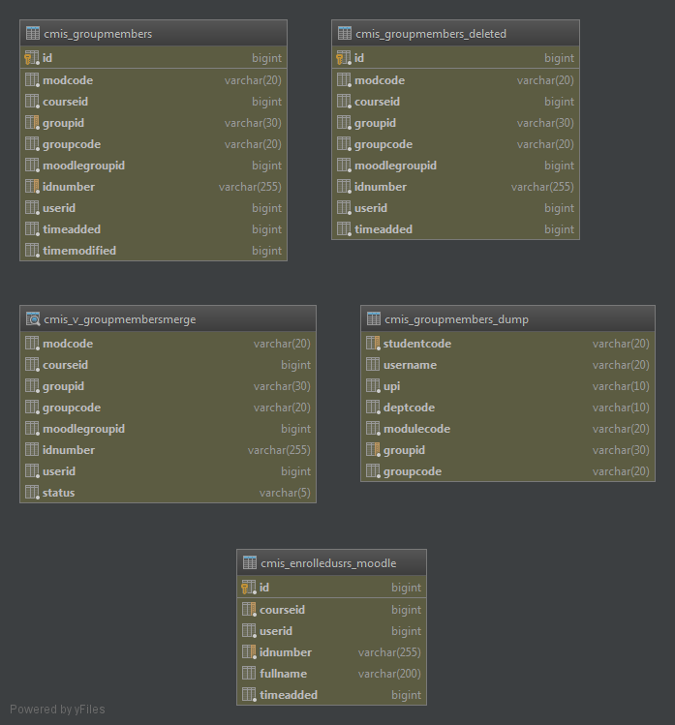

Model
Class GroupMembersOracleDb
- Interact with Oracle view. Check initial connection to oracle database and view.
Class CmisImport
Class GroupMembersImport Extends CmisImport
- Import data from Oracle view into 'cmis_groupmembers_dump' table
Class GroupMembers
- Implement functions to perform insert, update and delete of group members data
Class GroupMembersDelete
- Implement function to handle deletion of group members data from Moodle

Adds group members in Moodle
External function name : core_group_add_group_members ( )
Arguments : List of object with userid and groupid

General structure

list of (
object {
groupid int //group record id
userid int //user id
}
)

Response : n/a

Delete group members in Moodle
External function name : core_group_delete _group_members ( )
Arguments : List of object with userid and groupid

General structure

list of (
object {
groupid int //group record id
userid int //user id
}
)

Response : n/a

Add or delete tutor members in Groups

Outline
Import group members data from CMIS into groups within Moodle.

- Read data from Oracle view (Eg : MOODLE_V_CMIS_TUTGRP)
- Dump data from view into intermediate database table (moodle_sits_management.cmis_tutgroupmembers_dump)
- Establish successful handshaking between client (sits_filter-2 app) and server (Moodle)
- Call Moodle REST API function :: core_enrol_get_enrolled_users -> get enrolled users for courses that exist in cmis_groups_course table.
- Dump all enrolled users for courses into moodle_sits_management.cmis_enrolledusrs_moodle table. This is truncated and fresh data is inserted every time cron runs
- Get all members to be added or deleted in groups from moodle_sits_management.cmis_v_grouptutmembersmerge view. View reads data from combination of tables with status as ADD, FOUND, DEL
- Call Moodle REST API function :: core_group_add_group_members -> add members to groups in Moodle
- Record details about members added into groups within moodle_sits_management.cmis_tutgroupmembers
- Call Moodle REST API function :: core_group_delete_group_members -> delete members from groups in Moodle
- Record details about members deleted from groups within moodle_sits_management.cmis_tutgroupmembers_deleted

Prerequisites

- Only users or members enrolled to courses are enrolled into groups. If there are any members that are not enrolled to a course, are ignored.

Database
Table :: cmis_tutgroupmembers_dump – Dump of data from Oracle group members view
Table :: cmis_tutgroupmembers – Group tutor members details
Table :: cmis_tutgroupmembers_deleted – Deleted group members details
Table :: cmis_enrolledusrs_moodle – Details of enrolled users in courses from Moodle
View :: cmis_v_grouptutmembers_merge – View with data from different tables

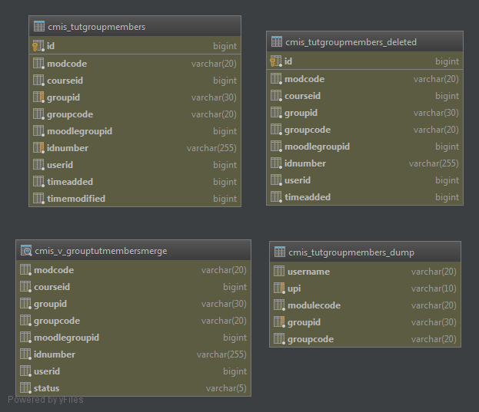

Model
Class GroupTutorMemsOracleDb
- Interact with Oracle view. Check initial connection to oracle database and view.
Class CmisImport
Class GroupTutorMemsImport Extends CmisImport
- Import data from Oracle view into 'cmis_tutgroupmembers_dump' table
Class GroupTutorMembers
- Implement functions to perform insert, update and delete of group members data
Class GroupTutorMembersDelete
- Implement function to handle deletion of group members data from Moodle

Adds group members in Moodle
External function name : core_group_add_group_members ( )
Arguments : List of object with userid and groupid

General structure

list of (
object {
groupid int //group record id
userid int //user id
}
)

Response : n/a

Delete group members in Moodle
External function name : core_group_delete _group_members ( )
Arguments : List of object with userid and groupid

General structure

list of (
object {
groupid int //group record id
userid int //user id
}
)

Response : n/a

Delete groups and groupings in Moodle

Outline
- Get groups to be deleted from sits_management database
- Establish successful handshaking between client (sits_filter-2 app) and server (Moodle)
- Implement REST client functions to call delete group and groupings Moodle API functions.
- Delete groupingss within Moodle
- Delete groups within Moodle
- Record deleted groups and groupings within sits_management.cmis_groups_deleted table
- Clear groups data from sits_management.cmis_groups and sits_management.cmis_groups_course
- Handle responses and exceptions from RES T call

Database
Table : cmis_groups_deleted – groups and groupingid deleted from Moodle
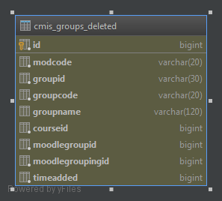

Model
Class GroupsDelete
- Performs insertion of deleted Moodle groups into its default table

Delete groups in Moodle

External function name : core_group_delete_groups( )
Arguments : List of groupids to be deleted

list of (
int //Group ID
)

Response : n/a
Error Handling: This is done at client side. If there is a fault with data, delete_groups( ) function would throw an exception, which will be returned as a response to the client.

Delete groupings in Moodle

External function name : core_group_delete_groupings( )
Arguments : List of groupids to be deleted

list of (
int //Grouping ID
)

Response : n/a
Error Handling: This is done at client side. If there is a fault with data, delete_groups( ) function would throw an exception, which will be returned as a response to the client.

