An empty moodle course with one enrolled tutor (ltss01)
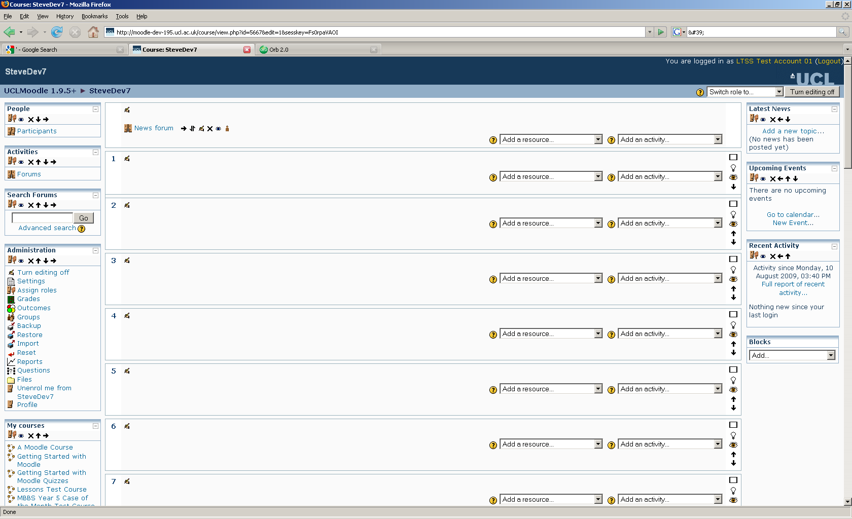

Create a turnitin assignment with these settings
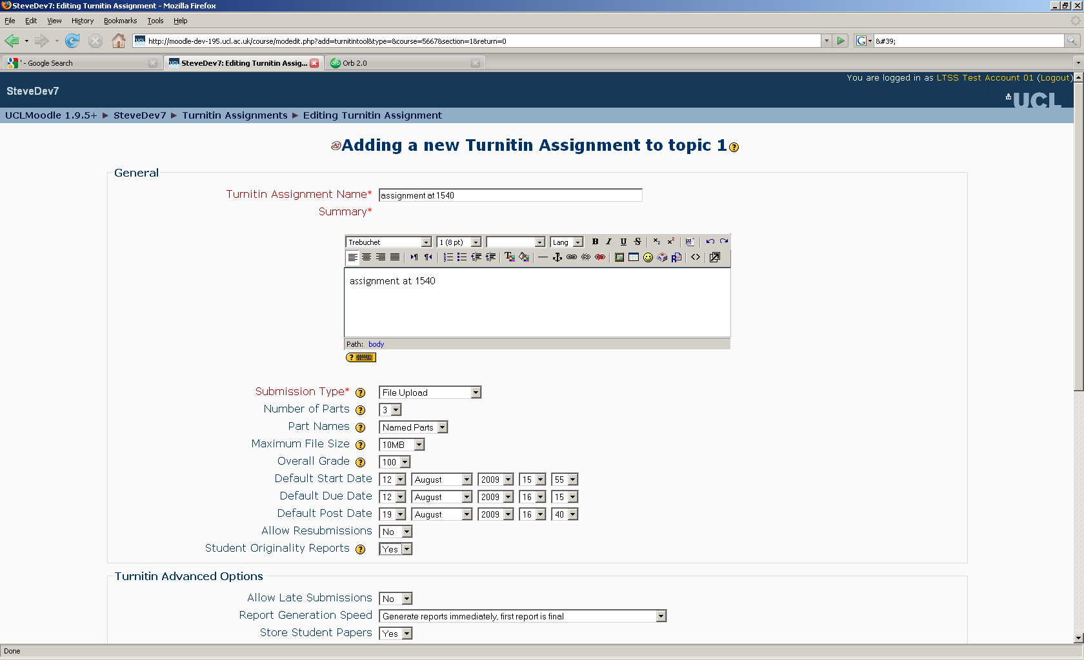

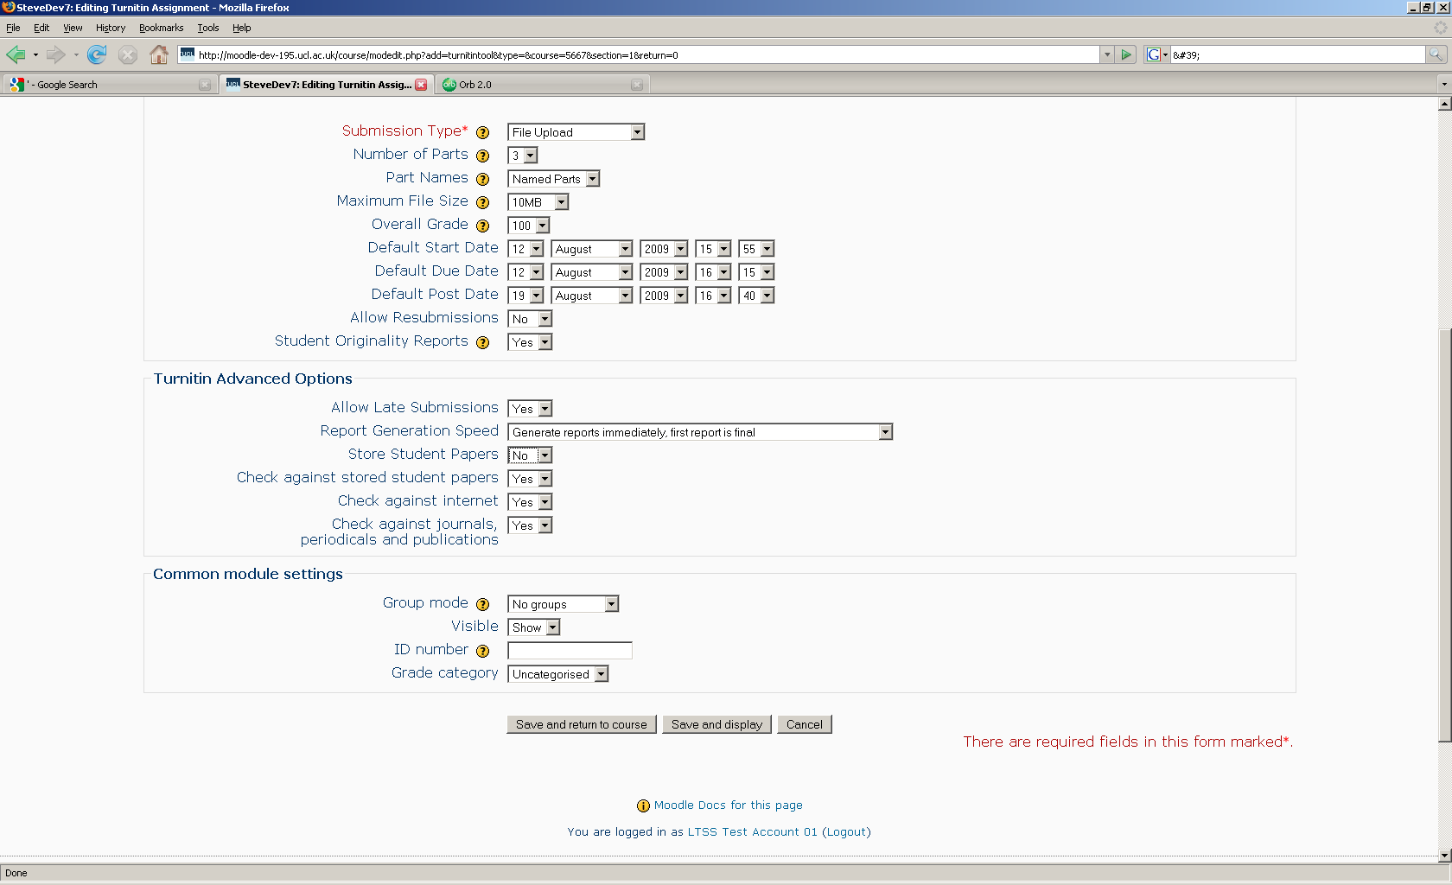

The synchronisation starts and this error is returned:

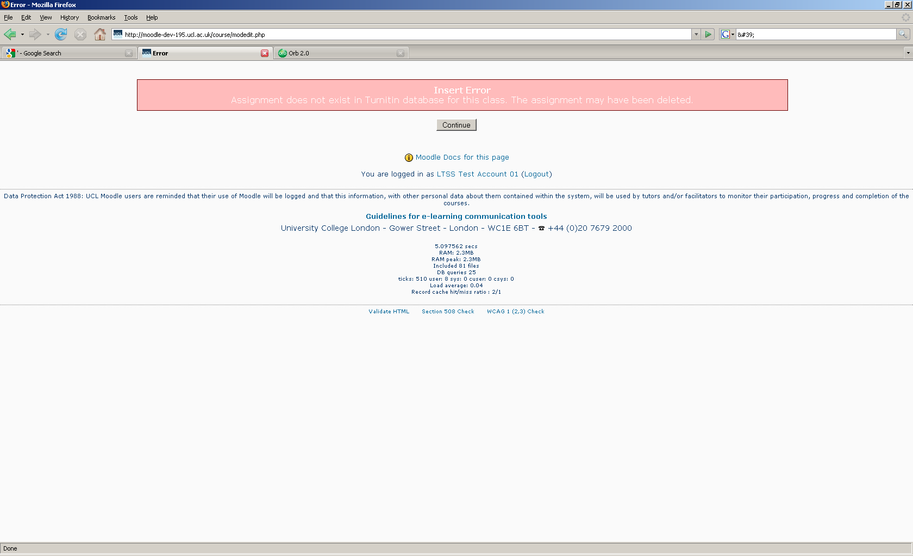

Enrolled a different tutor (ccaasro = s.rowett@ucl.ac.uk) and repeated the process with exactly the same settings except the assignment name which became ‘assignment at 1543). Then got this error:
