**Anomaly Detection in Sensors Data**

**CUSUM Algorithm**

**Algorithm:**

Cusum-Anomaly-Detection(T, threshold, drift)

S0 = 0, g0+ = 0, g0- = 0

for t in range 1 to number of measurements do:

St = Tt – Tt-1

gt+ = max(gt-1+ + St – drift, 0)

gt- = max(gt-1- - St – drift, 0)

if gt+ > threshold or gt- > threshold then:

talarm.append(t), gt+ = 0 gt- = 0

return talarm

* T – the dataset
* threshold – maximum normal variation between two consecutive measurements
* drift – parameter used to reduce the number of FP (false positive observations)

Hardware Architecture designed based on this algorithm follows a streaming approach and uses FIFO buffers between the processing units which perform computations.

**Components:**

* Add/Sub – adder or subtractor
* Max – unit which outputs the maximum value of inputs
* Threshold exceeding detector – unit which checks if any of gt+ or gt- exceeds the threshold given as input and

Architecture:

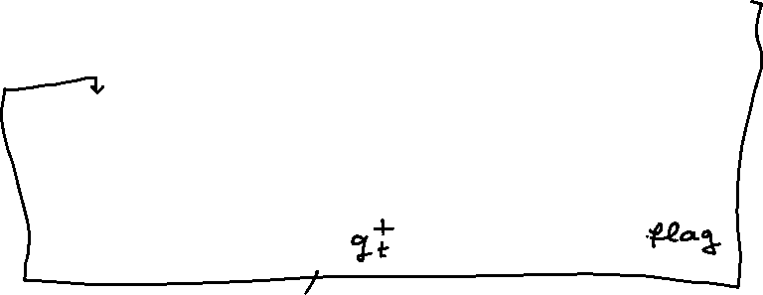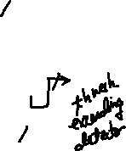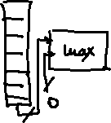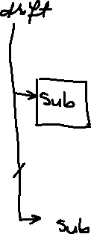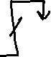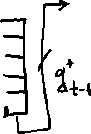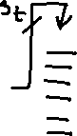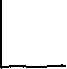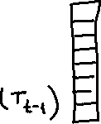

Implementation details:

1. Implementation for floating point data type

Sources:

* fp_max – unit to get the maximum value of inputs
* threshold_exceeding_detector – unit which checks if computed values for gt+ and gt- exceed the threshold
* cumulative_sums_detector – top module

1. Integer Implementation for integer data type

Sources:

* int_adder_subtractor – adder/subtractor with AXI-Stream I/O interfaces for adding or subtracting two integers
* int_max – unit to get the maximum value of inputs (integer)
* int_threshold_exceeding_detector – unit which checks if computed values for gt+ and gt- exceed the threshold

Additional sources used for programming the basys3 device are: mpg, fp_rom256x32, diplay_7seg, rom256x32 and counter32.

Testbench files’ names begin with “tb_”.