

Journal of Virological Methods 131 (2006) 65–71

A broadly reactive one-step real-time RT-PCR assay for rapid and sensitive detection of hepatitis E virus*

Narayanan Jothikumar a*,*b*,*∗, Theresa L. Cromeans a*,*c,

Betty H. Robertson a, X.J. Meng d, Vincent R. Hill a

a *Centers for Disease Control and Prevention, National Center for Infectious Diseases, 4770 Buford Highway,*

*Mailstop F-36, Atlanta, GA 30341, USA*

b *Emory University, Department of Global Health, Rollins School of Public Health, Atlanta, GA, USA*

c *Atlanta Research and Education Foundation, Decatur, GA, USA*

d *Center for Molecular Medicine and Infectious Diseases, College of Veterinary Medicine, Virginia Polytechnic Institute and State University, Blacksburg, VA, USA*

Received 19 May 2005; received in revised form 11 July 2005; accepted 14 July 2005

Available online 24 August 2005

**Abstract**

Hepatitis E virus (HEV) is transmitted by the fecal–oral route and causes sporadic and epidemic forms of acute hepatitis. Large waterborne HEV epidemics have been documented exclusively in developing countries. At least four major genotypes of HEV have been reported worldwide: genotype 1 (found primarily in Asian countries), genotype 2 (isolated from a single outbreak in Mexico), genotype 3 (identified in swine and humans in the United States and many other countries), and genotype 4 (identified in humans, swine and other animals in Asia). To better detect and quantitate different HEV strains that may be present in clinical and environmental samples, we developed a rapid and sensitive real-time RT-PCR assay for the detection of HEV RNA. Primers and probes for the real-time RT-PCR were selected based on the multiple sequence alignments of 27 sequences of the ORF3 region. Thirteen HEV isolates representing genotypes 1–4 were used to standardize the real-time RT-PCR assay. The TaqMan® assay detected as few as four genome equivalent (GE) copies of HEV plasmid DNA and detected as low as 0.12 50% pig infectious dose (PID50) of swine HEV. Different concentrations of swine HEV (120–1.2 PID50) spiked into a surface water concentrate were detected in the real-time RT-PCR assay. This is the first reporting of a broadly reactive TaqMan® RT-PCR assay for the detection of HEV in clinical and environmental samples.

© 2005 Elsevier B.V. All rights reserved.

# Introduction

Hepatitis E virus (HEV), currently classified in the genus *Hepevirus* (Emerson et al., 2004), is a small, non-enveloped RNA virus that causes acute hepatitis in humans. Large waterborne outbreaks have occurred in developing countries (Corwin et al., 1996; Divizia et al., 2004; Hui et al., 2001; Jothikumar et al., 2000; Pina et al., 1998; Singh et al., 1998;

* Use of trade names and commercial sources is for identification only and does not imply endorsement by the Centers for Disease Control and Prevention or the U.S. Department of Health and Human Services.

* Corresponding author. Tel.: +1 770 488 3776; fax: +1 770 488 4253.

*E-mail address:* [JIN2@cdc.gov](mailto:JIN2@cdc.gov) (N. Jothikumar).

Souto et al., 1997; Vaidya et al., 2003), in addition to sporadic cases. These waterborne outbreaks have typically been asso- ciated with deficient drinking water systems or poor sanitary practices. Asymptomatic carriers of HEV have been reported and such cases are potential human reservoirs of HEV during epidemics (Nicand et al., 2001). Although HEV is transmit- ted by the fecal–oral route, person-to-person transmission of HEV is not common (Hui et al., 2001).

Since the identification of swine hepatitis E virus (swine HEV) from pigs in the United States in 1997, isolates of swine HEV that are genetically and antigenically related to human HEV have been identified from pigs worldwide. The poten- tial for zoonotic transmission and cross species transmission has been demonstrated (Meng et al., 1998). More recently,

0166-0934/$ – see front matter © 2005 Elsevier B.V. All rights reserved. doi:10.1016/j.jviromet.2005.07.004

ingestion of raw or undercooked contaminated deer and boar meat has been linked to sporadic cases of acute hepatitis E in humans (Matsuda et al., 2003; Tei et al., 2003).

At least four major genotypes of HEV have been iden- tified based on complete genome sequence analyses. Most isolates from Pakistan, Nepal, India and China are closely related, with 93% nucleotide sequence homology across the genomes, and are classified as genotype 1 (Emerson and Purcell, 2003; Tam et al., 1991). A single representative of genotype 2 was isolated from an outbreak in Mexico (Huang et al., 1992). Genotype 3 isolates were detected in swine in the United States and other countries, in addition to iso- lates from human patients (Mansuy et al., 2004; Meng et al., 1997). Variant isolates of genotype 4 HEV have been iden- tified in animals and sporadic human cases in Taiwan, Japan and China (Meng, 2003). A novel strain of HEV, designated as avian HEV, was recently identified from chickens with hepatitis–splenomegaly syndrome, and proposed to belong to either a new genotype 5 or a separate genus (Haqshenas et al., 2001, 2002; Huang et al., 2004a, 2004b). Considering the heterogeneity of the HEV strains circulating in humans and other animals, development of a broadly reactive assay is needed for detection of the various HEV strains that can infect humans.

In general, when genotype 3 or genotype 4 viruses have been found in swine and humans from the same geographic regions, they have been genetically very similar, and in some cases indistinguishable (Clemente-Casares et al., 2003; Hsieh et al., 1999; Nishizawa et al., 2003). The genotype 3 swine HEV from a pig in the United States has been shown to infect non-human primates under experimental conditions (Meng et al., 1998). Also, in countries previously thought to be non- endemic such as the United States, 5–20% of some subgroups of the population, such as swine workers, have antibodies to HEV (Chau et al., 1993; Jeggli et al., 2003; Pina et al., 2000). In vivo infectivity assays have been developed for swine HEV and avian HEV, which are the only models of infectivity for HEV in the host of origin (Kasorndorkbua et al., 2002; Meng et al., 1998; Sun et al., 2004). No reliable, reproducible in vitro (cell culture) infectivity assay has been developed, although there have been recent reports of limited success in this area (Emerson and Purcell, 2003; Huang et al., 2004a, 2004b). Conventional RT-PCR assays for HEV are available but these assays are not broadly reactive or rapid, and are often less sensitive than fluorescence based real-time RT- PCR assays. Conventional RT-PCR assays are also prone to contamination when performed as nested PCR procedures. Real-time, quantitative assays for HEV are needed for rapid detection of these viruses for clinical diagnostics and pub- lic health response. Two real-time RT-PCR methods for the detection of HEV have been reported (Mansuy et al., 2004; Orru et al., 2004). Orru et al. (2004) reported a SYBR Green RT-PCR assay for detection of HEV, but these researchers did not report testing their assay with the various HEV geno- types in circulation. In addition, their SYBR Green assay uses short primers (15–16mer) that raise the potential for

detection problems when used for testing environmental sam- ples due to the low *T*m of the primers and the possibility for non-specific amplification of non-target nucleic acid (Wang and Seed, 2003). The other assay reported was a TaqMan® assay, for which the authors report a method sensitivity of 1000 copies/ml of serum sample, but do not report the abil- ity of the assay to detect multiple HEV genotypes (Mansuy et al., 2004).

The development of a broadly reactive real-time assay using the TaqMan® chemistry was preferable to other flu- orescent assay types based on lower relative cost, relative ease of design, robustness of the TaqMan® chemistry, and the higher specificity of the probe-based TaqMan® assay versus non-probe approaches like SYBR Green. Consider- ing that HEV is transmitted through contaminated water and other environmental media, the development of a rapid detec- tion assay for HEV in environmental samples will be useful for molecular epidemiological investigations and tracking of environmental contamination sources. Such a real-time RT- PCR assay would have even greater utility for public health preparedness if it can also be used for diagnostic applica- tions. Consequently, the objectives of this study were: (1) to develop a broadly reactive, quantitative RT-PCR assay to detect all HEV genotypes with high specificity, (2) to deter- mine the sensitivity of the assay, and (3) to investigate the assay for detection of HEV in clinical specimens and water samples.

# Materials and methods

* 1. *HEV isolates*

The swine HEV isolate used in this study has an infec- tious titer of 104.5 PID50 (50% pig infectious doses per ml of inoculum) Meng et al., 1998. Nine swine HEV isolates (01- 16138-2, 01-16138-3, 01-16139-2, 01-12116-2, 01-15555A,

UMC7-b, 18934D2, UMC7a and UMC12b) recovered from pigs in the United States were also used in this study (Huang et al., 2002). The isolates of Burma (genotype 1) and Mexico (genotype 2) used in this study were extracted from CDC iso- lates, and have been described previously (Reyes et al., 1990; Yarbough et al., 1991). The genotype 4 strain 1380 was pro- vided by Dr. R.H. Purcell (NIH, Bethesda, MD) and Dr. J.-C. Wu (National Yang-Ming University, Taipei, Taiwan) (Wu et al., 2002).

* 1. *TaqMan*® *assay design*

Primers and probes were designed manually based on a multiple sequence alignment of HEV genome sequences in the ORF3 region available in GenBank. Oligonu- cleotide primers/probe were analyzed for the absence of possible hairpins, secondary structure, and melting temperature with Gene Runner 3.05 (Hastings software,

Inc.). The forward primer (JVHEVF; 5×-GGTGGTTTCT-

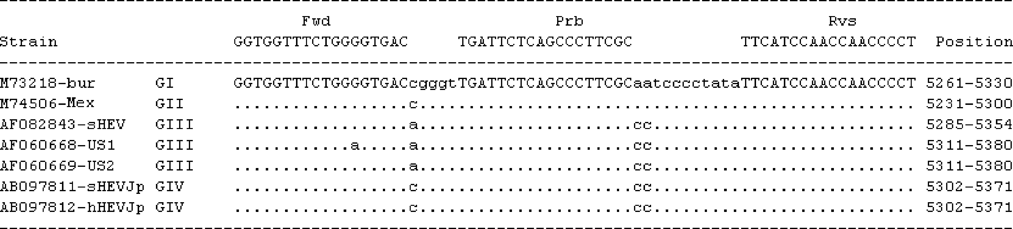

Fig. 1. Alignment of HEV strain sequences used to design the TaqMan® probe. The forward primer (Fwd), TaqMan® probe (Prb) and reverse primer (Rvs) are shown in capital letters. The sequence position corresponds to 5261–5330 based on GenBank accession no. M73218.

GGGGTGAC-3×) and reverse primer (JVHEVR; 5×-AGGG- GTTGGTTGGATGAA-3×) were calculated to have a *T*m value of 61.2 ◦C. The probe (JVHEVP; 5×-TGATTCT- CAGCCCTTCGC-3×) had a *T*m = 62.5 ◦C. The TaqMan® probe contained a 5× 6-carboxy fluorescein fluorophore and 3× black hole quencher (BHQ). The primers and probe were synthesized in the CDC Biotechnology Core Facility. BLAST

searches for the TaqMan® assay primers and probe show that the genetic sequences of the different HEV genotypes are highly conserved in the ORF3 region where the primers and probe anneal (Fig. 1).

* 1. *Plasmid standard*

A plasmid was constructed from the prototype strain of U.S. swine HEV using a TrueBlue® MicroCartridgeTM PCR Cloning Kit (Genomics One, Quebec) and the primers described in Fig. 1. Plasmid DNA was purified using the Nucleobond 100 kit (Promega) and was quantified with the Nanodrop ND-1000 instrument according to the man- ufacturer’s instructions (Wilmington, DE). Two microliters of stock DNA contained 4 109 genome equivalent (GE) copies of the plasmid. Serial 10-fold dilutions of DNA were made in nuclease free water containing 100 ng/µl of tRNA

×

−

(100 ng/microliter), and aliquots were stored at 70 ◦C until

use. Standard curves were generated using 100 to 109 copies

of plasmid DNA. The GE titers of HEV were determined based on the standard curve and were extrapolated by refer- ence to the standard curves. However, the GE copy numbers do not reflect the number of RNA molecules, since the effi- ciency of RT was not directly determined.

* 1. *Real-time PCR*

For TaqMan® RT-PCR, the 20 µl reaction contained 10 µl of 2 QuantiTect Probe RT-PCR kit Master Mix (Qiagen, Valencia, CA), 0.2 µl of enzyme, 2 µl of RNA, and primers and probe at concentrations of 250 and 100 nM, respec- tively. A ruggedized advanced pathogen identification device (RAPID) thermal cycler (Idaho Technology Inc., Salt Lake City, UT) was used for all real-time RT-PCR tests. Reverse transcription was carried out at 50 ◦C for 30 min, followed

×

by denaturation at 95 ◦C for 15 min. DNA was amplified immediately with 45 PCR cycles at 95 ◦C (10 s), 55 ◦C (20 s) and 72 ◦C (15 s). Real-time RT-PCR data were collected after the reaction and the crossing points (CP) calculated by the

RAPID system software. For generation of standard quantita- tion curves, the CP values were plotted proportionally to the logarithm of the input copy numbers. Negative controls were included in each run. To minimize potential contamination, plasmids were prepared in a separate room, and capillaries containing plasmid standards were not taken into the RT-PCR set-up room.

* 1. *Concentration of water samples*

A 10 L sample of surface water was filtered through a dou- ble layer of 142 mm diameter 1 MDS disk filters (Cuno, Inc., Meriden, CT) to adsorb virus. The flow rate was adjusted at 1 ml/min/cm2 of the filter surface using a peristaltic pump. After filtration, the filters were eluted with 1.5% beef extract (Becton Dickinson; Sparks, MD) containing 0.05 M glycine at pH 9.0. After pH adjustment to 7.0, 8% polyethylene gly- col (PEG) 8000 MW (Sigma Chemical Co., St. Louis, MO) and 0.3 M NaCl were added to the eluate. The sample was

precipitated overnight at 4 ◦C and was centrifuged for 30 min at 10,000 *g*. The resulting pellet was resuspended in 1 ml of

×

PBS to produce the water concentrate sample. Three different inocula [120, 12 and 1.2 PID50] of swine HEV were added to 100 µl of the water concentrate and to 100 µl of nuclease free water. The TaqMan® RT-PCR assay was then performed using 2 µl of extracted HEV RNA.

* 1. *RNA extraction*

Samples (250 µl of lab specimens or 100 µl of water sam- ples) were treated with sodium dodecyl sulfate (SDS) and proteinase K at final concentrations of 0.5% and 5 mg/ml, respectively, incubated at 55 ◦C for 30 min, and followed

by two extractions with phenol–chloroform–isoamyl alco-

hol (PCI) (Jothikumar et al., 1993). RNA was precipitated by the addition of 0.3 M ammonium acetate and 2.5 volumes of ice cold ethanol, followed by incubation at −70 ◦C for

30 min. The pellet was centrifuged at 11,000 × *g* for 30 min,

washed with 75% ethanol, and resuspended in 50 µl of TE buffer.

# Results

* 1. *Assay speciﬁcity*

The HEV TaqMan® assay was evaluated for the detection of HEV RNA from isolates representing all four HEV geno- types. Using the TaqMan® RT-PCR assay, 13 of 13 specimens representing genotypes 1–4 were correctly identified as pos- itive for HEV (Table 1). The results were further confirmed by agarose gel electrophoresis (data not shown). The RT-PCR fluorescence curves for the genotypes 1–4 isolates shown in Fig. 2 demonstrate that the TaqMan® assay is efficient at amplifying the HEV templates. The specificity of the assay was evaluated by testing 22 non-HEV specimens, including RNA from five isolates of different genotypes of hepatitis A virus (IA, IB, IIA, IIB, and III), RNA from seven enterovirus isolates, RNA from two different genotypes norovirus (GI–IV

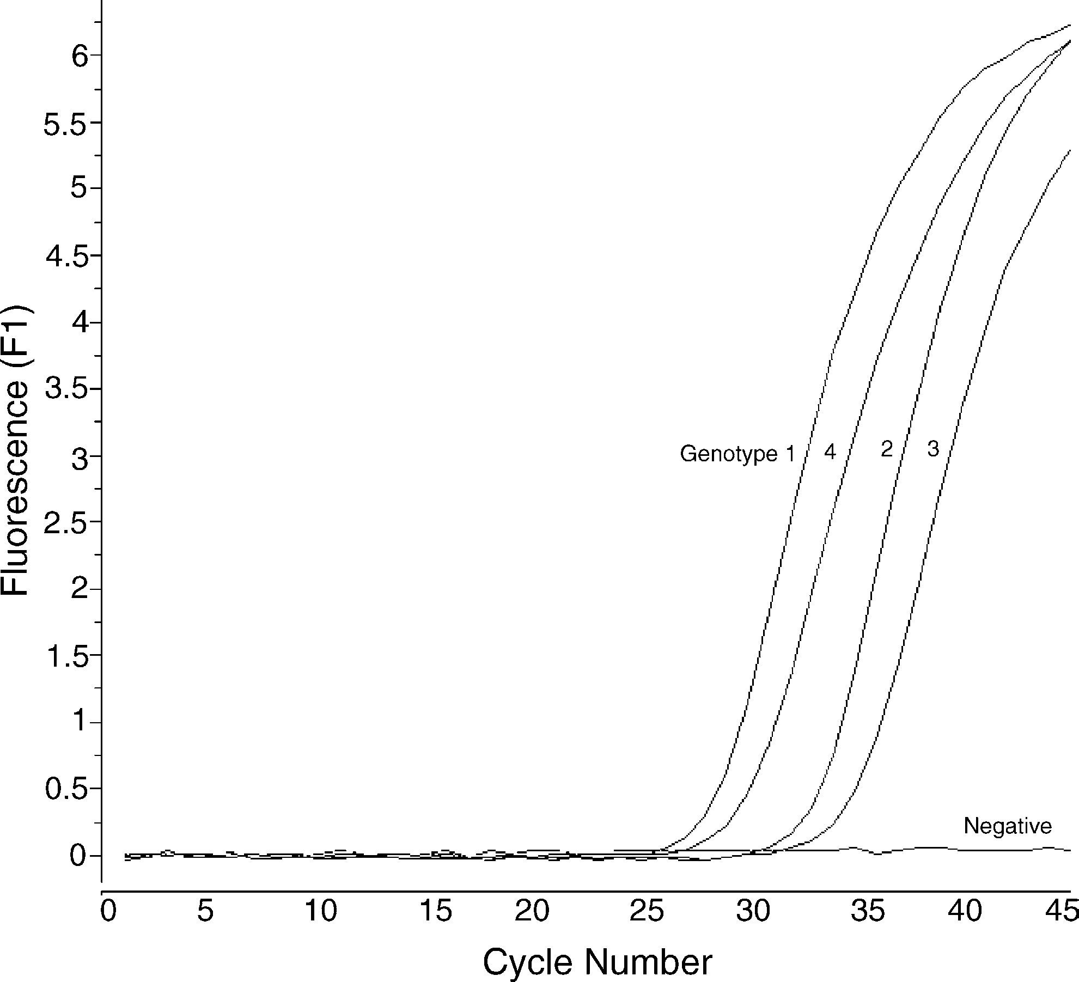

Fig. 2. Detection of HEV genotypes 1–4 (prototype U.S. swine HEV strain) by TaqMan® RT-PCR assay.

Table 1

Results of testing to assess the specificity of the HEV TaqMan® assay using HEV strains representing four different genotypes

|  |  |  |  |
| --- | --- | --- | --- |
| Virus isolatesa | Characteristics | Positive/negative | Source/reference |
| hHEV-HEV (Burma) | Genotype 1 | + | Tam et al., 1991 |
| hHEV-HEV (Mexico) | Genotype 2 | + | Huang et al., 1992 |
| Prototype U.S. sHEV strain | Genotype 3 | + | Meng et al., 1997 |
| sHEV-01-16138-2 | Genotype 3 | + | Huang et al., 2002 |
| sHEV-01-16138-3 | Genotype 3 | + | Huang et al., 2002 |
| sHEV-01-16139-2 | Genotype 3 | + | Huang et al., 2002 |
| sHEV-01-12116-2 | Genotype 3 | + | Huang et al., 2002 |
| sHEV-01-15555A | Genotype 3 | + | Huang et al., 2002 |
| sHEV-UMC7a | Genotype 3 | + | Huang et al., 2002 |
| sHEV-UMC7-b | Genotype 3 | + | Huang et al., 2002 |
| sHEV-UMC12b | Genotype 3 | + | Huang et al., 2002 |
| sHEV-18934D2 | Genotype 3 | + | Huang et al., 2002 |
| Strain 1380 | Genotype 4 | + | NIH; Wu et al., 2002 |
| HAV HLD-2 (IA) | Genotype IA | − | CDC |

HAV HM175, clone 24A (IB) Genotype IB − CDC

HAV CF53 (IIA) Genotype IIA − CDC

HAV Sierra Leonne (IIB) Genotype IIB − CDC

HAV GA76 (III) Genotype III − CDC

Coxsackievirus A8 Enterovirus − Sewage

Coxsackievirus A10 Enterovirus − VR30

Coxsackievirus B3 Enterovirus − Sewage

Coxsackievirus B4 Enterovirus − Sewage

Echovirus 1 Enterovirus − CDC

Echovirus 27 Enterovirus − Sewage

Echovirus 29 Enterovirus − Sewage

Norovirus—GI–IV Genotypes I–IV − CDC

Norovirus—GII–IV Genotypes II–IV − CDC

Rotavirus ds1 Group A, serotype G2 − VR-2550

Rotavirus sa11-simian Group A, serotype G3 − VR-899

Rotavirus wa Group A, serotype G1 − VR-2018

Rotavirus WI61 Group A, serotype G9 − VR-2551

Adenovirus type 2 Human enteric virus − CDC

Adenovirus type 5 Human enteric virus − CDC

Adenovirus type 40 Human enteric virus − CDC

Adenovirus type 41 Human enteric virus − CDC

a hHEV: human HEV; sHEV: swine HEV.

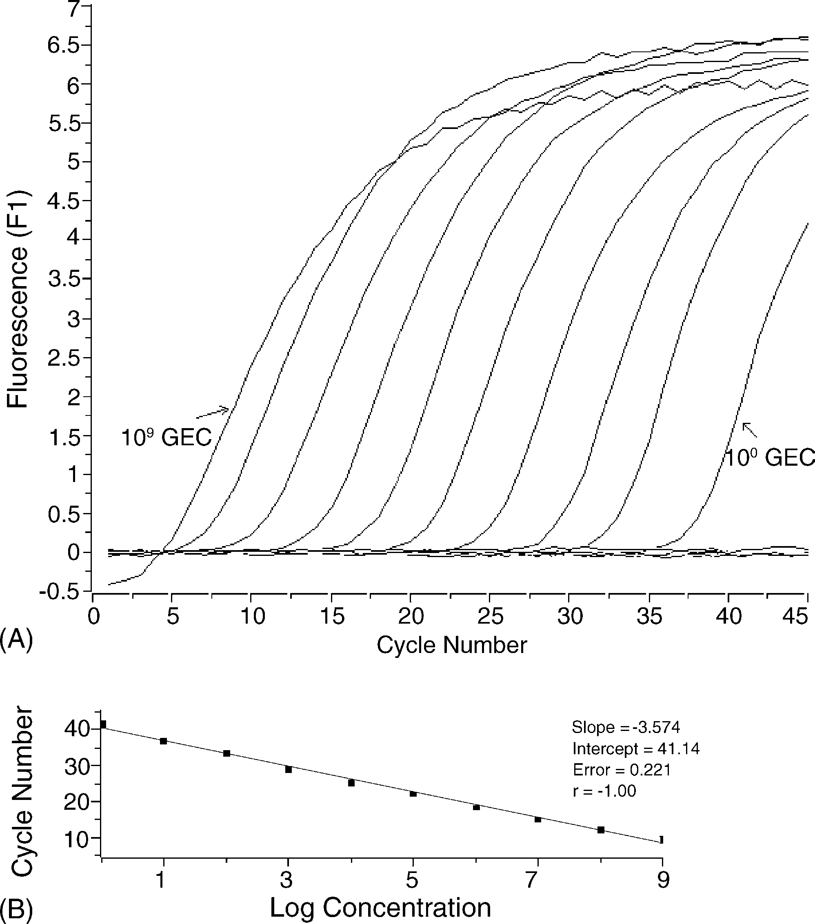

Fig. 3. Quantification of a serially diluted plasmid DNA containing the ORF3 region of swine HEV by TaqMan® amplification. (A) Amplification plots obtained at different concentrations of plasmid DNA (from 4 109 to 4 copies of genome equivalents per tube). (B) Standard curve obtained by plotting the value of crossing point (CP) vs. the concentration of genome equivalents. Data are reported as the mean of three replicates for each stan- dard dilution.

×

and GII–IV), RNA from four rotavirus isolates, and DNA from four adenovirus isolates (AdV2, AdV5 and AdV40 and AdV41) (Table 1). No false positive amplification results were observed when testing the non-HEV specimens using the HEV TaqMan® assay.

* 1. *Assay sensitivity*

Using a dilution series of 100 to 109 copies of HEV plasmid DNA, as few as four copies of DNA could be repro- ducibly detected (Fig. 3). The crossing points were linearly proportional to the logarithm of the input copy number over 10 orders of magnitude (*R*2 = 1.0). The *Y* intercept in Fig. 3B reflects the theoretical CP value (CP = 41) at one copy of input DNA, while the slope (*S*) of the linear regression curve cor-

relates with the efficiency (*E*) of the PCR reaction according to the formula: *E* = [10−1/slope] 1. The calculated PCR effi- ciency for this assay, based on the slope value of 3.574, was

−

−

0.90. When the 100 dilution was excluded from the regression analysis a slope value of 3.43 was obtained resulting in an efficiency of 0.96. Based on the multiple sequence alignment for HEV genotypes 1–4 shown in Fig. 1, it is expected that the sensitivity data reported here using swine HEV should be similar when other genotypes of HEV are used for the TaqMan® RT-PCR assay.

−

*3.3. Application to water testing*

Based on CP comparisons, inhibition of RT-PCR was not observed for the TaqMan® assay when the pelleted materials from a 10 L surface water sample were spiked with 120, 12 and 1.2 PID50 of swine HEV. These seeding levels resulted in CP values of 32.0, 36.5 and 39.0, respectively, with a lin- ear regression slope value of 3.514. These results show that the TaqMan® assay can detect relatively low levels of HEV expected in an environmental sample. Additional research is planned to evaluate the effectiveness of the TaqMan® RT-PCR assay for detecting HEV in concentrates of large volumes water samples collected from different sources rep- resenting varying water quality.

−

# Discussion

Design of a monoplex, broadly reactive TaqMan® assay for detection of all HEV genotypes is a complex and chal- lenging task due to the heterogeneity among the various HEV genotypes. Attempts by other researchers at developing such an assay have not been successful (Gardner et al., 2003). The SYBR Green RT-PCR reported in Orru et al. (2004) is a one-step assay that uses shorter primers (15–16mer) than are typically used in RT-PCR and PCR assays. The short primers used in the Orru et al. assay raise the potential for detec- tion problems when used for testing environmental samples due to the low *T*m of the primers and the possibility for non- specific amplification of non-target nucleic acid. Orru et al. (2004) did not discuss the potential sensitivity of their assay as a broadly reactive detection technique for HEV genotypes 1–4. The TaqMan® assay reported by Mansuy et al. (2004) is a two-step RT-PCR assay that uses degenerate primers and a degenerate probe, which may reduce the sensitivity and specificity of the assay when used to detect heterogeneous targets. As reported by other researchers, degenerate primers can have less sensitivity than non-degenerate primers, due to factors such as the lower effective concentration of each individual primer, difficulty in estimating the consensus *T*m for the degenerate primers, and difficulty in evaluating sec- ondary structures and primer–primer interactions resulting from the degeneracies (Jothikumar et al., 2005; Stoecklein et al., 2002). While Mansuy et al. reported the successful detection of genotype 3 strains, the authors did not discuss its potential effectiveness for other HEV genotypes.

The broadly reactive TaqMan® assay described in the present study has been designed to target a conserved region in ORF3, allowing the detection of different genotypes of HEV without the use of degenerate primers or probes. The assay was able to correctly detect 13 of 13 HEV isolates rep- resenting four different HEV genotypes. Using cDNA from a genotype 3 swine HEV strain, the assay was determined to have a sensitivity of four GE copies, which is comparable to the detection limit reported for a conventional nested PCR assay for HEV (Williams et al., 2001). However, real-time

RT-PCR has the benefit of shorter detection times and min- imal potential for laboratory contamination. The detection limit of 4 GE copies reported here is also comparable with the sensitivity of 10 GE copies reported by Orru et al. (2004). Based on infectivity units, the detection limit of the TaqMan® RT-PCR assay reported here for swine HEV (0.12 PID50) is lower than the detection limit of 3.2 PID50 for the nested RT- PCR assay reported by Williams et al. (2001).

The major objective of this study was to develop a broadly reactive TaqMan® RT-PCR assay for the detection of HEV in environmental and clinical samples. This goal was accom- plished with an assay that was shown to be sensitive and specific for the detection of HEV genotypes 1–4. The assay was also tested with a HEV-spiked surface water concen- trate and found to be effective for detecting HEV RNA in this type of environmental sample. These data indicate that the TaqMan® RT-PCR assay can be an effective method for detecting HEV in environmental samples, although addi- tional work is needed to evaluate the method with other types of environmental samples (e.g., other water sources, wastew- ater, food). Since the TaqMan® RT-PCR assay was validated using clinical specimens, further research is planned to inves- tigate its effectiveness for detecting HEV in human and animal clinical specimens in addition to any available envi- ronmental samples. We anticipate that this assay will be a valuable, rapid tool for screening clinical or environmental samples for diverse HEV strains during routine and epidemic investigations.

# Acknowledgments

We thank Drs. R.H. Purcell (National Institutes of Health, Bethesda, MD, USA) and J.-C. Wu (National Yang-Ming University, Taipei, Taiwan) for the generous gift of the geno- type 4 HEV sample for this study.

# References

Chau, K.H., Dawson, G.J., Bile, K.M., Magnius, L.O., Sjogren, M.H., Mushahwar, I.K., 1993. Detection of IgA class antibody to hepatitis E virus in serum samples from patients with hepatitis E virus infection. J. Med. Virol. 40 (4), 334–338.

Clemente-Casares, P., Pina, S., Buti, M., Jardi, R., MartIn, M., Bofill-Mas, S., Girones, R., 2003. Hepatitis E virus epidemiology in industrialized countries. Emerg. Infect. Dis. 9 (4), 448–454.

Corwin, A.L., Khiem, H.B., Clayson, E.T., Pham, K.S., Vo, T.T., Vu,

T.Y., Cao, T.T., Vaughn, D., Merven, J., Richie, T.L., Putri, M.P., He, J., Graham, R., Wignall, F.S., Hyams, K.C., 1996. A waterborne outbreak of hepatitis E virus transmission in southwestern Vietnam. Am. J. Trop. Med. Hyg. 54 (6), 559–562.

Divizia, M., Gabrieli, R., Donia, D., Macaluso, A., Bosch, A., Guix, S., Sanchez, G., Villena, C., Pinto, R.M., Palombi, L., Buonuomo, E., Cenko, F., Leno, L., Bebeci, D., Bino, S., 2004. Waterborne gastroen- teritis outbreak in Albania. Water Sci. Technol. 50 (1), 57–61.

Emerson, S., Purcell, R., 2003. Hepatitis E virus. Rev. Med. Virol. (13), 145–154.

Emerson, S.U., Anderson, D., Arankalle, A., Meng, X.J., Purdy, M., Schlauder, G.G., Tsarev, S.A., 2004. In: Fauquet, C.M., Mayo, M.A.,

Maniloff, J., Desselberger, U., Ball, L.A. (Eds.), Hepevirus. Else- vier/Academic Press, London, pp. 851–855.

Gardner, S.N., Kuczmarski, T.A., Vitalis, E.A., Slezak, T.R., 2003. Lim- itations of TaqMan PCR for detecting divergent viral pathogens illustrated by hepatitis A, B, C, and E viruses and human immun- odeficiency virus. J. Clin. Microbiol. 41 (6), 2417–2427.

Haqshenas, G., Huang, F.F., Fenaux, M., Guenette, D.K., Pierson, F.W., Larsen, C.T., Shivaprasad, H.L., Toth, T.E., Meng, X.J., 2002. The putative capsid protein of the newly identified avian hepatitis E virus shares antigenic epitopes with that of swine and human hepatitis E viruses and chicken big liver and spleen disease virus. J. Gen. Virol. 83 (Pt 9), 2201–2209.

Haqshenas, G., Shivaprasad, H.L., Woolcock, P.R., Read, D.H., Meng, X.J., 2001. Genetic identification and characterization of a novel virus related to human hepatitis E virus from chickens with hepatitis- splenomegaly syndrome in the United States. J. Gen. Virol. 82 (Pt 10), 2449–2462.

Hsieh, S.Y., Meng, X.J., Wu, Y.H., Liu, S.T., Tam, A.W., Lin, D.Y.,

Liaw, Y.F., 1999. Identity of a novel swine hepatitis E virus in Taiwan forming a monophyletic group with Taiwan isolates of human hepatitis E virus. J. Clin. Microbiol. 37 (12), 3828–3834.

Huang, C.C., Nguyen, D., Fernandez, J., Yun, K.Y., Fry, K.E., Bradley, D.W., Tam, A.W., Reyes, G.R., 1992. Molecular cloning and sequenc- ing of the Mexico isolate of hepatitis E virus (HEV). Virology 191 (2), 550–558.

Huang, F.F., Haqshenas, G., Guenette, D.K., Halbur, P.G., Schommer, S.K., Pierson, F.W., Toth, T.E., Meng, X.J., 2002. Detection by reverse transcription-PCR and genetic characterization of field isolates of swine hepatitis E virus from pigs in different geographic regions of the United States. J. Clin. Microbiol. 40 (4), 1326–1332.

Huang, F.F., Sun, Z.F., Emerson, S.U., Purcell, R.H., Shivaprasad, H.L., Pierson, F.W., Toth, T.E., Meng, X.J., 2004a. Determination and anal- ysis of the complete genomic sequence of avian hepatitis E virus (avian HEV) and attempts to infect rhesus monkeys with avian HEV. J. Gen. Virol. 85 (Pt 6), 1609–1618.

Huang, Y.W., Haqshenas, G., Kasorndorkbua, C., Halbur, P.G., Emer- son, S.U., Meng, X.J., 2004b. Capped RNA transcripts of full-length cDNA clones of swine hepatitis E virus are replication-competent when transfected into Huh7 cells and infectious when intrahepatically inoculated into pigs. J. Virol. 79 (3), 1552–1558.

Hui, Y., Sattar, S.A., Murrell, K.D., Nip, W., Stanfield, P.S. (Eds.), 2001. Hepatitis A and E viruses, vol. 2: Viruses, Parasites, Pathogens, and HACCP, 2nd ed. Marcel Dekker, Inc..

Jeggli, S., Steiner, D., Joller, H., Steffen, R., Hotz, P., 2003. Hepatitis E and exposure to waste water. Schweiz. Rundsch. Med. Prax. 92 (10), 433–435.

Jothikumar, N., Aparna, K., Kamatchiammal, S., Paulmurugan, R., Sar- avanadevi, S., Khanna, P., 1993. Detection of hepatitis E virus in raw and treated wastewater with the polymerase chain reaction. Appl. Environ. Microbiol. 59 (8), 2558–2562.

Jothikumar, N., Lowther, J.A., Henshilwood, K., Lees, D.N., Hill, V.R., Vinje, J., 2005. Rapid and sensitive detection of noroviruses by using TaqMan-based one-step reverse transcription-PCR assays and appli- cation to naturally contaminated shellfish samples. Appl. Environ. Microbiol. 71 (4), 1870–1875.

Jothikumar, N., Paulmurugan, R., Padmanabhan, P., Sundari, R.B., Kamatchiammal, S., Rao, K.S., 2000. Duplex RT-PCR for simulta- neous detection of hepatitis A and hepatitis E virus isolated from drinking water samples. J. Environ. Monit. 2 (6), 587–590.

Kasorndorkbua, C., Halbur, P.G., Thomas, P.J., Guenette, D.K., Toth, T.E., Meng, X.J., 2002. Use of a swine bioassay and a RT-PCR assay to assess the risk of transmission of swine hepatitis E virus in pigs. J. Virol. Meth. 101 (1/2), 71–78.

Mansuy, J.M., Peron, J.M., Abravanel, F., Poirson, H., Dubois, M., Miedouge, M., Vischi, F., Alric, L., Vinel, J.P., Izopet, J., 2004. Hep- atitis E in the south west of France in individuals who have never visited an endemic area. J. Med. Virol. 74 (3), 419–424.

Matsuda, H., Okada, K., Takahashi, K., Mishiro, S., 2003. Severe hepatitis E virus infection after ingestion of uncooked liver from a wild boar. J. Infect. Dis. 188 (6), 944.

Meng, X.J., 2003. Swine hepatitis E virus: cross-species infection and risk in xenotransplantation. Curr. Top. Microbiol. Immunol. 278, 185–216. Meng, X.J., Halbur, P.G., Shapiro, M.S., Govindarajan, S., Bruna, J.D., Mushahwar, I.K., Purcell, R.H., Emerson, S.U., 1998. Genetic and experimental evidence for cross-species infection by swine hepatitis

E virus. J. Virol. 72 (12), 9714–9721.

Meng, X.J., Purcell, R.H., Halbur, P.G., Lehman, J.R., Webb, D.M., Tsareva, T.S., Haynes, J.S., Thacker, B.J., Emerson, S.U., 1997. A novel virus in swine is closely related to the human hepatitis E virus. Proc. Natl. Acad. Sci. U.S.A. 94 (18), 9860–9865.

Nicand, E., Grandadam, M., Teyssou, R., Rey, J.L., Buisson, Y., 2001. Viraemia and faecal shedding of HEV in symptom-free carriers. Lancet 357 (9249), 68–69.

Nishizawa, T., Takahashi, M., Mizuo, H., Miyajima, H., Gotanda, Y., Okamoto, H., 2003. Characterization of Japanese swine and human hepatitis E virus isolates of genotype IV with 99% identity over the entire genome. J. Gen. Virol. 84 (Pt 5), 1245–1251.

Orru, G., Masia, G., Romano, L., Piras, V., Coppola, R.C., 2004. Detec- tion and quantitation of hepatitis E virus in human faeces by real-time quantitative PCR. J. Virol. Meth. 118 (2), 77–82.

Pina, S., Buti, M., Cotrina, M., Piella, J., Girones, R., 2000. HEV iden- tified in serum from humans with acute hepatitis and in sewage of animal origin in Spain. J. Hepatol. 33 (5), 826–833.

Pina, S., Jofre, J., Emerson, S.U., Purcell, R.H., Girones, R., 1998. Char- acterization of a strain of infectious hepatitis E virus isolated from sewage in an area where hepatitis E is not endemic. Appl. Environ. Microbiol. 64 (11), 4485–4488.

Reyes, G.R., Purdy, M.A., Kim, J.P., Luk, K.C., Young, L.M., Fry, K.E., Bradley, D.W., 1990. Isolation of a cDNA from the virus responsible for enterically transmitted non-A, non-B hepatitis. Science 247 (4948), 1335–1339.

Singh, V., Raje, M., Nain, C.K., Singh, K., 1998. Routes of transmission in the hepatitis E epidemic of Saharanpur. Trop. Gastroenterol. 19 (3), 107–109.

Souto, F.J., Fontes, C.J., Parana, R., Lyra, L.G., 1997. Short report: further evidence for hepatitis E in the Brazilian Amazon. Am. J. Trop. Med. Hyg. 57 (2), 149–150.

Stoecklein, N.H., Erbersdobler, A., Schmidt-Kittler, O., Diebold, J., Schardt, J.A., Izbicki, J.R., Klein, C.A., 2002. SCOMP is superior to degenerated oligonucleotide primed-polymerase chain reaction for global amplification of minute amounts of DNA from microdissected archival tissue samples. Am. J. Pathol. 161 (1), 43–51.

Sun, Z.F., Larsen, C.T., Huang, F.F., Billam, P., Pierson, F.W., Toth, T.E., Meng, X.J., 2004. Generation and infectivity titration of an infectious stock of avian hepatitis E virus (HEV) in chickens and cross-species infection of turkeys with avian HEV. J. Clin. Microbiol. 42 (6), 2658–2662.

Tam, A.W., Smith, M.M., Guerra, M.E., Huang, C.C., Bradley, D.W., Fry, K.E., Reyes, G.R., 1991. Hepatitis E virus (HEV): molecular cloning and sequencing of the full-length viral genome. Virology 185 (1), 120–131.

Tei, S., Kitajima, N., Takahashi, K., Mishiro, S., 2003. Zoonotic trans- mission of hepatitis E virus from deer to human beings. Lancet 362 (9381), 371–373.

Vaidya, S.R., Tilekar, B.N., Walimbe, A.M., Arankalle, V.A., 2003. Increased risk of hepatitis E in sewage workers from India. J. Occup. Environ. Med. 45 (11), 1167–1170.

Wang, X., Seed, B., 2003. A PCR primer bank for quantitative gene expression analysis. Nucl. Acids Res. 31 (24), 154.

Williams, T.P., Kasorndorkbua, C., Halbur, P.G., Haqshenas, G., Guenette, D.K., Toth, T.E., Meng, X.J., 2001. Evidence of extrahepatic sites of replication of the hepatitis E virus in a swine model. J. Clin. Microbiol. 39 (9), 3040–3046.

Wu, J.C., Chen, C.M., Chiang, T.Y., Tsai, W.H., Jeng, W.J., Sheen, I.J., Lin, C.C., Meng, X.J., 2002. Spread of hepatitis E virus among different-aged pigs: two-year survey in Taiwan. J. Med. Virol. 66 (4), 488–492.

Yarbough, P.O., Tam, A.W., Fry, K.E., Krawczynski, K., McCaust- land, K.A., Bradley, D.W., Reyes, G.R., 1991. Hepatitis E virus: identification of type-common epitopes. J. Virol. 65 (11), 5790–

5797.