Evidence Controlled Retrieval Augmented Clinical Decision Support with Medication Screening
[Author names in final order]
[Department and institution affiliations]

Abstract—This paper examines evidence control in a local healthcare question-answering prototype. The implemented RAG pipeline combines BGE-small-en embeddings, FAISS, BM25, rank fusion, cross-encoder reranking, an evidence policy, TinyLlama generation, and deterministic proposition checks. Medication interaction lookup and prescription extraction remain separate services. Saved experimental records are analyzed independently because their corpora and procedures differ. In a 160-query historical retrieval experiment, dense Hit@5 is 0.8938 versus 0.8500 for hybrid retrieval; the nominal reranking condition uses fallback. A separate three-generator comparison accepts 0, 3, and 4 of 22 generated candidates under its internal verifier. These outcomes expose limited supported-answer coverage and cannot establish clinical accuracy. The contribution is an inspectable evidence-control design and a measured characterization of its limitations. Exact prompt-evidence alignment, complete final-response verification, independent clinical labels, and matched component comparisons remain necessary for stronger conclusions.
Index Terms—Retrieval-augmented generation, clinical decision support, evidence grounding, answer verification, abstention, medication screening.

I. INTRODUCTION
Medical question answering requires relevant evidence and an answer that preserves its meaning. RAG supplies reference passages to a language model [1], but retrieval relevance does not establish that a generated statement is supported. A passage can concern the right medicine while omitting the requested dose, population restriction, or clinical qualifier. Releasing a fluent answer therefore requires a separate decision about its support.
This project implements a local RAG service within a modular CDS system, with medication rules, prescription extraction, and a doctor-portal bridge. Its research focus is the relation between evidence selection, deterministic answer verification, and useful-answer coverage. Standard retrieval algorithms and portal integration are enabling components. The study does not claim a new retrieval algorithm, autonomous clinical decision making, or demonstrated clinical benefit.
The paper describes implemented behavior and proposed disclosure conditions, then analyzes the available records without combining incompatible experiments into a single accuracy score. Its findings include hybrid retrieval underperformance in one historical setting and low verifier acceptance in generation experiments. These findings define an evaluation problem rather than justify a universal safety claim.

II. RELATED WORK
RAG couples document retrieval with language generation [1]. RRF combines ranked lists without calibrating their raw score scales [2]; using it does not guarantee improvement over an individual retriever. FActScore motivates atomic factuality assessment [3], while citation-based evaluation separates citation presence from support [4]. These ideas inform the present control design, but the deterministic verifier is not a reproduction of those evaluation systems or a general entailment model.
Unanswerability evaluation motivates assessing abstention alongside useful responses [5]. Medication extraction systems such as MedEx structure drug names and dosing attributes [6], a task distinct from clinical appropriateness. The team's earlier framework paper [7] describes an integrated RAG, interaction-detection, and prescription-safety direction. The present study narrows that framing to implemented evidence control and recorded evaluation; the earlier framework description is not treated as proof of current experimental effectiveness.

III. PROPOSED METHODOLOGY

A. Research Objective and System Architecture
The system retrieves medical reference passages, generates a short candidate answer, and checks its statements before deciding what to return. RAG provides the reference material [1]. Two checks have different roles: the evidence policy decides whether retrieval provides enough relevant material to proceed; the answer verifier checks whether the generated statements agree with that material. The research question is whether deterministic evidence checks can restrict unsupported disclosure while preserving useful answers in a small local language model. The study examines the combined evidence policy and proposition verifier through implementation checks and local evaluation. Standard retrieval methods are reused. Clinical benefit and superiority are not established.
Medical references, private EHR records, and medication rules are kept separate. The CDS gateway coordinates question answering, interaction lookup, and prescription extraction. Generated explanations and rule-based alerts remain distinguishable. Patient records do not enter the shared reference indexes. Figure 1 distinguishes retrieval, evidence selection, and disclosure. Table III separates implemented components and remaining extensions. Section IV attributes historical results to their own settings.
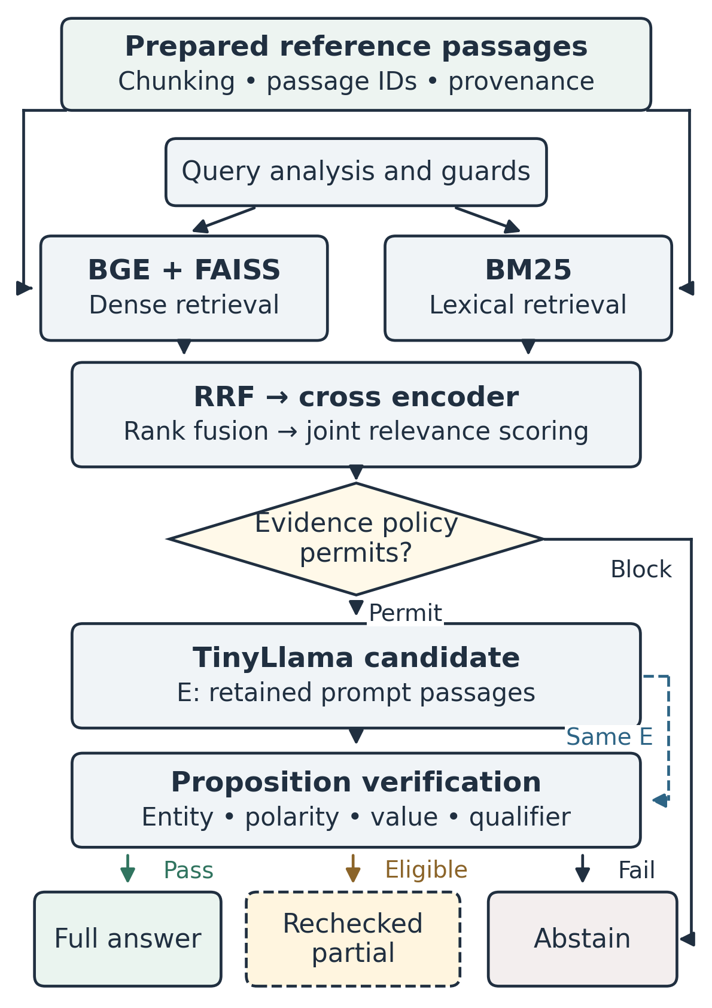
Fig. 1. Evidence preparation, retrieval, and disclosure. The policy decision includes the separate retrieval guard. Input guards can divert requests before retrieval. Dashed evidence alignment and partial disclosure specify proposed requirements not uniformly enforced by evaluated fallback paths. Medication services and integration boundaries are in Table III.

B. Reference Preparation and Indexing
Reference records retain source, document and passage identifiers, titles, sections, URLs, and available provenance. Preprocessing is intended to preserve negation, numbers, units, and population restrictions; the available tests do not establish preservation across the complete corpus. The configuration uses 250-word passages, 35-word overlap, and a minimum length of 40 characters. Overlapping passages are not independent evidence. Manifests and hashes identify corpus and index artifacts.
The configured collection contains 2,204 source-labeled passages: 2,176 DailyMed, 16 MedlinePlus, eight ICMR, and four MoHFW passages. Source labels are metadata; authenticity, currency, and coverage require separate assessment. Dense and lexical indexes use the same passage identifiers. Table I lists the main model and retrieval settings.
TABLE I. CORE MODEL AND PIPELINE CONFIGURATION
Stage | Configuration
Preparation | 250 words; 35-word overlap; minimum 40 characters
Dense encoder | BAAI/bge-small-en; 384 dimensions; L2 normalization; 512-token encoder limit
Dense search | FAISS IndexFlatIP; exact cosine-equivalent inner product
Lexical retrieval | Regex tokens; BM25 k₁ = 1.5, b = 0.75
Candidate budgets | Dense/BM25: 15/15, 20/20, 25/25, 30/30; selection: 4/5/6/8
Fusion | Equal weights; RRF constant 60; pool max(k_d, k_b, 3k_s)
Cross encoder | cross-encoder/ms-marco-MiniLM-L-6-v2; joint query–passage relevance scoring
Policy and guard | Dense policy: 0.50/0.35; BM25 weak: 3.0; separate similarity guard: 0.55; weak generation enabled by default
Context | At most 3 passages; Jaccard threshold 0.85; approximate 1,500-token budget
Generator | TinyLlama-1.1B-Chat-v1.0; input truncated at 2,048 tokens
Decoding | Sampling; 90 new tokens; temperature 0.2; top-p 0.9; repetition penalty 1.15

C. Query Analysis and Hybrid Retrieval
Query analysis identifies clinical intent, candidate entities, negation, numbers, and population cues. Recognized medication names can be normalized for retrieval. Emergency and injection patterns can divert requests before generation. These guards have bounded pattern coverage and are not validated clinical triage. Simple, moderate, complex, and multipart queries request 15, 20, 25, and 30 candidates per retrieval branch, with selection targets of 4, 5, 6, and 8. Request-level limits can override selection. The prompt still retains at most three passages.
BAAI/bge-small-en encodes queries and passages separately into 384-dimensional vectors. Queries use “Represent this sentence for searching relevant passages: ” as a prefix; passages do not. The encoder limit is 512 tokens. FAISS IndexFlatIP searches normalized vectors:
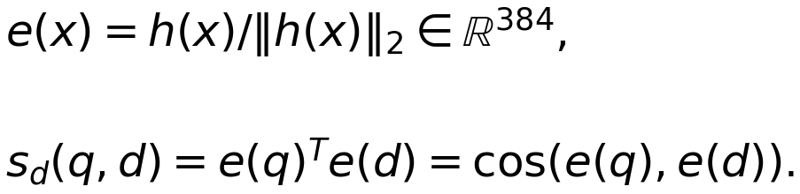
(1)
Here h(x) is a nonzero encoder output, e(x) its L2-normalized vector, q the query, d a passage, and T transpose. For unit vectors, the inner product equals cosine similarity. The score measures embedding similarity, not medical confidence. A word-based passage can exceed the encoder's token limit and be truncated.
BM25 retrieves lexical matches from the same collection using lowercase regex tokens:
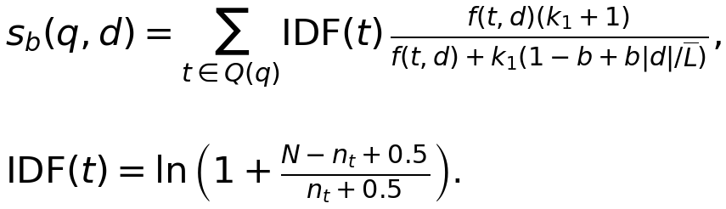
(2)
Q(q) is the query-token multiset, f(t,d) is token frequency in d, |d| is passage length, and L̄ is average passage length. N is the number of passages and nₜ the number containing t. The settings k₁ = 1.5 and b = 0.75 control frequency saturation and length normalization. Rare matching terms receive more weight, repeated passage occurrences have diminishing influence, and repeated query tokens contribute repeatedly. Dense and lexical retrieval run in parallel.

D. Rank Fusion and Cross Encoder Reranking
Equal-weight reciprocal rank fusion combines the two lists [2]:
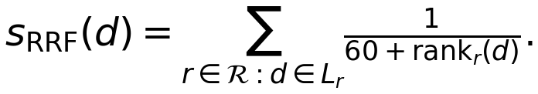
(3)
ℛ contains the retrieval methods, Lᵣ is method r's list, and rankᵣ(d) is its one-based passage rank. A missing passage contributes zero. The constant 60 moderates rank differences without comparing incompatible raw scores. The fused pool is limited to max(k_d, k_b, 3k_s), where k_d and k_b are the branch budgets and k_s is the selection target.
The reranker, cross-encoder/ms-marco-MiniLM-L-6-v2, processes each query–passage pair jointly and sorts candidates by relevance. The dense encoder embeds texts independently; the cross encoder evaluates their token interactions together. Entity-aware ordering and clinical-section selection then favor the query subject and relevant sections. Neither ranking stage proves entailment. If reranker loading or inference fails, the incoming order is retained; that execution must be reported as fallback, not as a reranking result.

E. Evidence Selection and Generation Control
The evidence policy checks usable content, metadata, subject agreement, term overlap, relevance, and conflict signals. Table II gives the decision order. GROUNDED is the policy's name for evidence suitable for generation; it is not a judgment about an answer. Conflict scanning uses document or subject correspondence and can miss contradictions.
TABLE II. PRE GENERATION EVIDENCE POLICY
Priority and state | Generation decision
1. CONFLICTING_EVIDENCE | Block when usable evidence has detected conflict signals
2. INSUFFICIENT_EVIDENCE | Block for absent/unsuitable evidence, unsupported subject, or inadequate relevance
3. WEAK_EVIDENCE | Permit only if weak generation is enabled; includes marginal relevance or limited coverage
4. GROUNDED | Permit when evidence is suitable and usable-passage coverage is sufficient
Both the policy and a separate retrieval guard must permit generation. Their thresholds are mode-dependent heuristics, not calibrated probabilities. The minimum usable-passage count is one by default. Weak evidence remains subject to answer verification.
Context construction removes near-duplicates using word-level Jaccard overlap and retains at most three passages. The nominal 1,500-token limit is estimated from word counts; tokenized model input is separately truncated at 2,048 tokens. The strict proposed design defines E as the exact reference passages retained in the prompt. Generation, verification, and citation mapping should use that same E, and empty accepted evidence should cause abstention. The evaluated pathway has exceptions described below.

F. Candidate Generation and Grounding Verification
TinyLlama/TinyLlama-1.1B-Chat-v1.0 generates a candidate from instructions, evidence, and query text. Table I gives the decoding settings. The 90-token output limit can shorten or omit qualifications, so prompt instructions are followed by deterministic checking.
Sentence and pattern rules extract propositions and answer components. The verifier checks entities, target concepts, polarity, numbers, units, frequency, qualifiers, and citation identifiers. Claim-level evaluation is motivated by atomic factuality assessment [3]; having a citation and being supported are separate properties [4]. Outcomes include supported, unsupported, contradicted, and mismatch labels. The rules can miss claims or misjudge support and do not provide general semantic entailment.
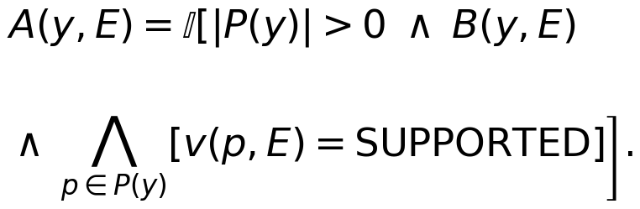
(4)
In (4), y is the candidate, P(y) its extracted propositions, v(p,E) the verifier label for proposition p, and B(y,E) the remaining component and citation checks. A(y,E) is one only when at least one proposition is extracted, every extracted proposition is labeled SUPPORTED, and B passes. This prevents empty extraction from passing automatically. The equation states the intended acceptance condition, not an independently validated medical judgment.

G. Answer Disclosure and Abstention
The proposed disclosure rule is:
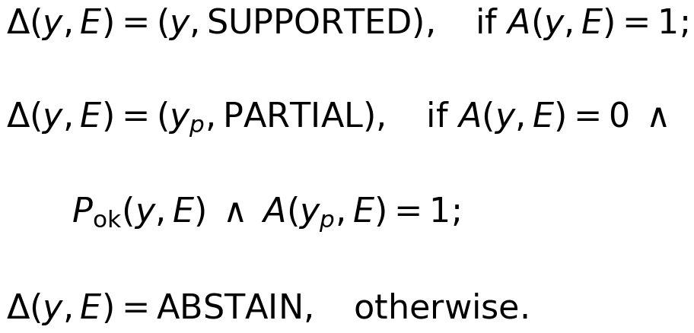
(5)
Δ(y,E) is the returned output. A fully accepted candidate is released. Otherwise, yₚ is reconstructed from eligible supported components. P_ok(y,E) denotes eligibility, which excludes contradictions and disqualifying entity, numerical, qualifier, or citation mismatches. The complete reconstructed response must pass A(yₚ,E). A dosage fallback must be treated as another candidate and checked in full. If these conditions fail, the system abstains.
The evaluated pathway does not uniformly establish this rule: accepted-evidence filtering can fall back to selected candidates, verification can use more evidence than the prompt, and a dosage fallback can emit a candidate after a partial-eligibility check. Exact evidence alignment and final-text rechecking are therefore proposed improvements. Withholding an answer does not prove safety; evaluation must measure useful supported answers and unnecessary abstention together [5].

H. Medication Services and Integration Boundaries
Interaction lookup checks normalized medication pairs against eight local rules and 20 drug/adverse-effect profiles. A matched alert includes its rule and source. When no rule matches, the result means only that no listed interaction was found. Prescription extraction uses spaCy EntityRuler patterns and regular expressions for medicine, dose, frequency, route, and duration. These are medication-information fields [6], not a judgment that a prescription is appropriate. Completeness indicators and simple allergy-name checks do not establish dose suitability or comprehensive medication safety.
The doctor portal implements an authenticated CDS route. It checks the doctor's relationship to the requested patient through appointment or prescription records, gathers selected EHR fields, and forwards context to the CDS gateway. Active medications support the interaction service. Context is also passed to RAG, but the evaluated core does not use it to establish patient-specific generation. This route does not establish authorization coverage for every interface or direct gateway request.
English, Hindi, and Marathi handling includes language detection, dictionary-based query mapping, safety templates, and glossary-based response localization. Some response text can remain English. These are implemented language functions, not independently validated clinical translation. English verification labels are retained during localization; translated clinical meaning has no independent accuracy estimate. FHIR exchange, OCR, and multimodal retrieval remain extensions. Table III summarizes these boundaries.
TABLE III. COMPONENT AND EVALUATION BOUNDARIES
Component scope | Evidence status
RAG retrieval, policy, generation, verification | Implemented and exercised in saved experiments; strict disclosure invariant is not fully established
Interaction rules and prescription extraction | Implemented services; independent medication-screening and field-extraction accuracy are not established
Doctor portal and CDS gateway | Implemented authenticated bridge and doctor–patient relationship check; context supports interaction lookup. Patient-conditioned RAG and clinical effectiveness are not established
Language and other extensions | English/Hindi/Marathi mapping and template/glossary localization are implemented; clinical translation accuracy is unmeasured. FHIR, OCR and multimodal retrieval remain extensions

IV. EXPERIMENTAL EVALUATION AND LIMITATIONS

A. Evaluation Scope and Reproducibility
This exploratory prototype study separates retrieval relevance, verifier acceptance, software correctness, and clinical correctness. Table IV identifies the saved experiments. They use different corpora and execution procedures; their results cannot be pooled into one RAG accuracy score. Incomplete corpus hashes, model revisions, and hardware records limit exact replay. The current 2,204-passage configuration is not the R160 corpus.
TABLE IV. EXPERIMENTAL RECORDS AND MEASUREMENT SCOPE
Record | Design and interpretation
R160 | 160 retrieval queries; 26,143 passages. Hit@K and MRR; reranker fallback
G46 A/B | 46 queries per run; separately sampled answer and trace; internal support and abstention labels
G3 | 3 generators × 46 requests; 22 generation-eligible contexts shared across models; greedy adapter
M100 | 100 mixed requests; generation enabled at 25 positions; source-return proxies and mixed latency
Software checks passed for four normalized-vector identities, 11 BM25 cases, five RRF cases, and 27 repository-authored synthetic verifier tests. BM25 was checked against independent calculations; RRF used the source-extracted class with fixed retrieval lists. These checks exclude model/API inference and the separate static-rule audit. They validate selected behaviors, not clinical accuracy or universal enforcement of (4)–(5).

B. Retrieval Relevance
R160's stored Recall@K implements Hit@K: at least one annotated chunk or document appears within K results. MRR averages the reciprocal rank of the first match, assigning zero when absent. Document matching can credit another passage from the same document. Table V reports means recomputed from per-query records; these are retrieval measures, not answer accuracy or full passage recall.
TABLE V. HISTORICAL RETRIEVAL MEASURES
Method | Hit@1 | Hit@5 | Hit@10 | MRR
Dense | 0.6875 | 0.8938 | 0.9313 | 0.7705
BM25 | 0.4062 | 0.7000 | 0.8000 | 0.5337
Hybrid | 0.5813 | 0.8500 | 0.9062 | 0.6917
Fallback | 0.5813 | 0.8500 | 0.9062 | 0.6917
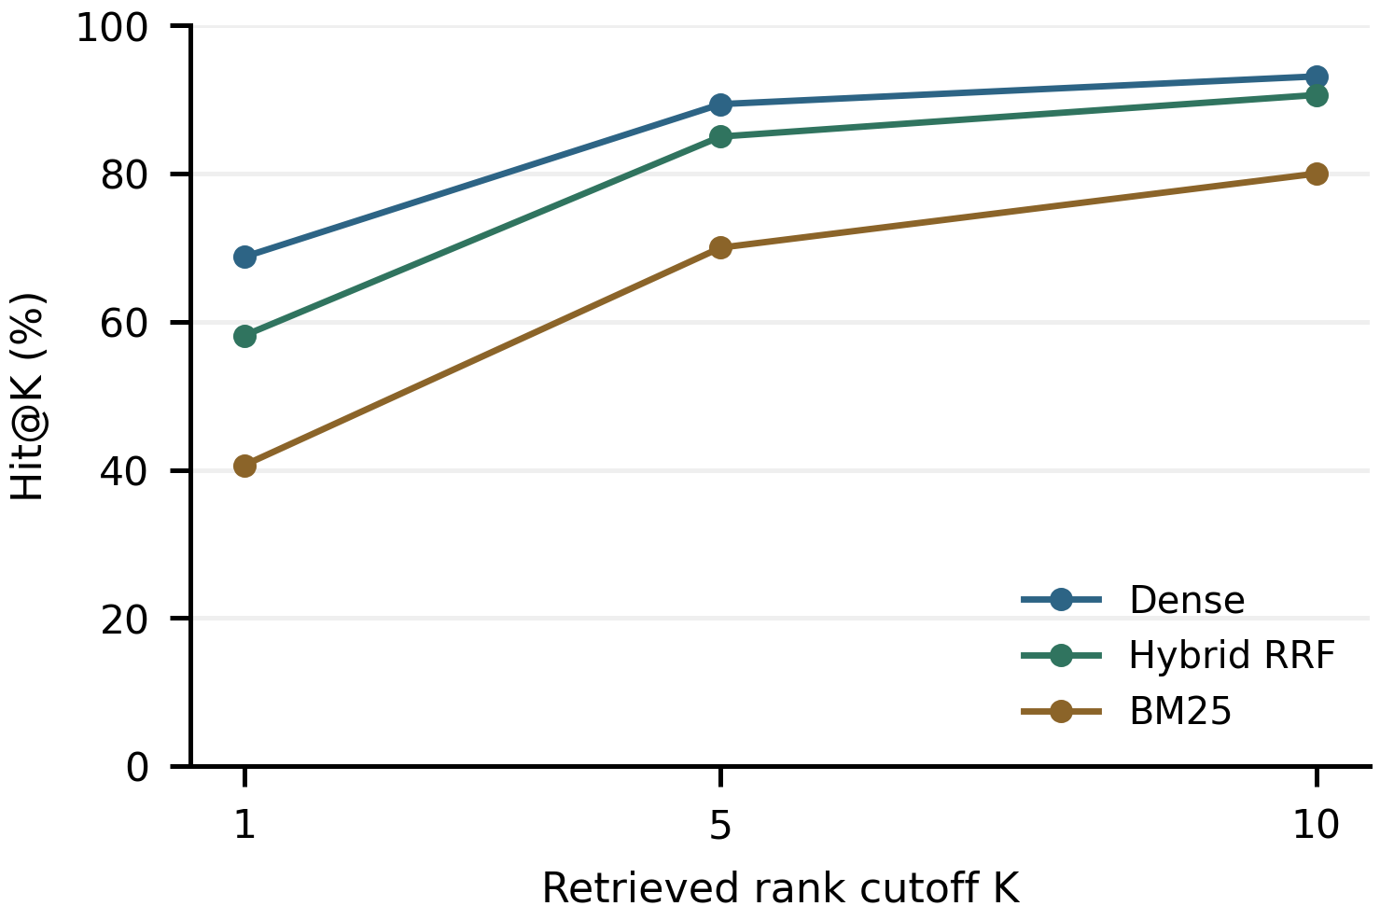
Fig. 2. R160 historical retrieval hits. The pass-through fallback duplicates hybrid and is omitted. These measures are not clinical answer accuracy.
Dense retrieval exceeds hybrid retrieval on all displayed measures. Hybrid exceeds BM25. The nominal reranking condition used an unavailable BGE reranker and retained the incoming order. It therefore provides no evidence of reranking benefit and is separate from the current MiniLM configuration. Figure 2 shows the retrieval trend without claiming hybrid superiority.

C. Generation and Verifier Acceptance
In G46, runs A and B contain 46 queries each. The runner labels 0/46 and 1/46 requests as grounded answers, 24/46 in each as correct abstentions, and 22/46 and 21/46 as unnecessary abstentions. It labels no requests as incorrect answers. Supported trace propositions are 18/102 (17.65%) and 22/85 (25.88%). These are internal labels: separate answer and trace requests can produce different sampled candidates, and abstention correctness is not independently adjudicated. A leakage counter that omits missing verification cannot prove zero unsupported output. For example, a lisinopril answer containing “It” is flagged as an entity mismatch; such labels need not indicate a wrong-drug statement.
The additional G3 comparison freezes retrieval and prompt context before evaluating three generators. Its adapter uses greedy decoding, at most 150 new tokens, a 2,048-token input limit, repetition penalty 1.1, and model-specific chat templates. This differs from the current sampled, 90-token configuration. Of 46 requests, 22 reach generation; 24 are blocked by policy or diverted as emergencies. Table VI reports counts and generation-only latency recomputed from stored rows. Recorded hardware is an RTX 3050 Laptop GPU with 4 GB VRAM and 16 GB RAM.
TABLE VI. G3 GENERATOR ACCEPTANCE AND GENERATION LATENCY
Model | Accepted | Median s | P95 s
TinyLlama | 0/22 | 5.471 | 6.225
Qwen2.5 | 3/22 | 5.155 | 8.348
SmolLM2 | 4/22 | 3.215 | 6.187
The verifier accepts 0/22 TinyLlama, 3/22 Qwen, and 4/22 SmolLM2 candidates; Figure 3 shows these small counts alongside median generation latency. Supported candidate propositions are 26/86, 22/72, and 24/60, respectively, including candidates withheld from users. The saved mismatch counters are not an exhaustive partition of these totals and are not used as a confusion matrix. Policy-blocked requests are automatically labeled correct abstentions, so the record cannot establish clinical specificity. Greedy decoding and shared contexts improve comparability, but a single run without independent labels cannot establish a superior clinical model. TinyLlama remains the implemented generator; the alternatives are historical comparisons.
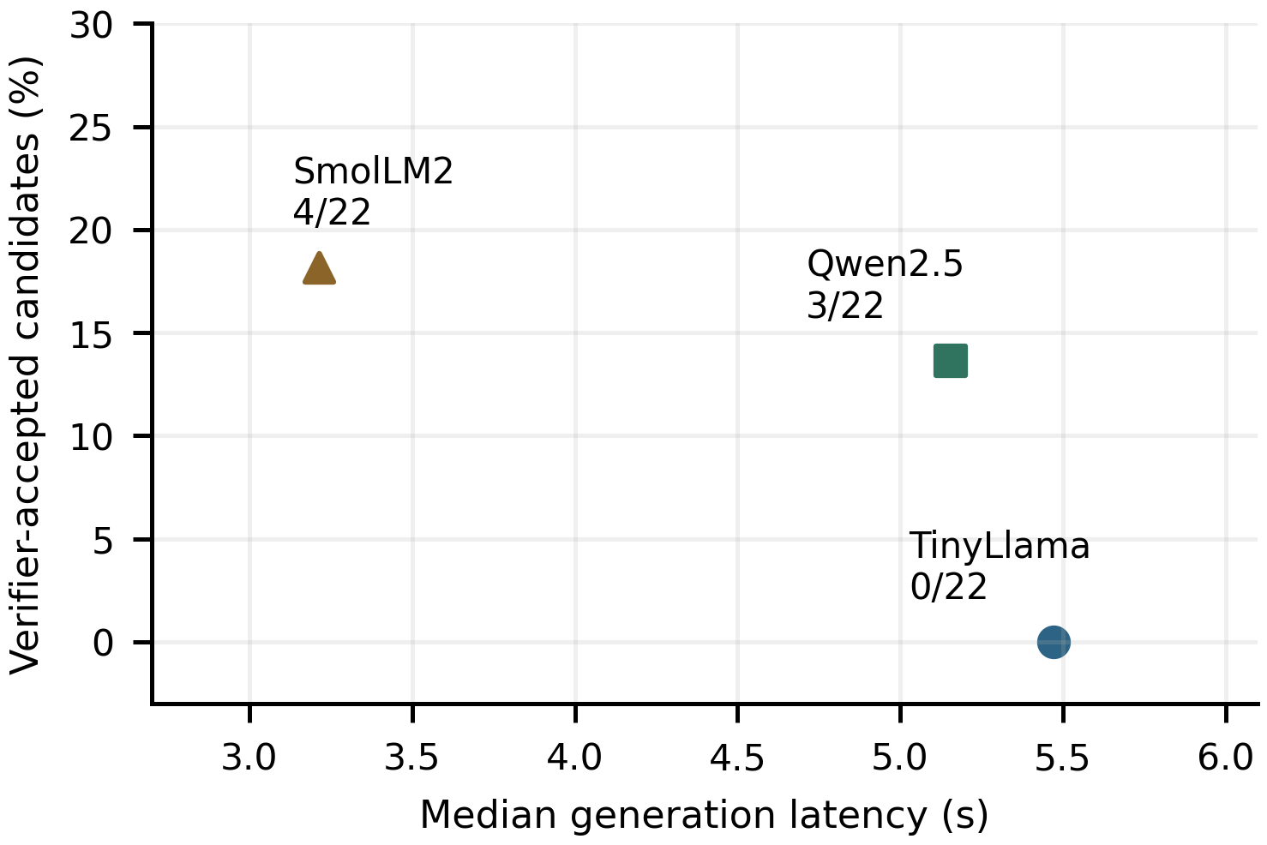
Fig. 3. G3 historical verifier acceptance among 22 generated candidates per model and generation-only median latency. Acceptance is an internal label, not clinical accuracy or current-system improvement.

D. Mixed Requests and Resource Measurements
M100 enables generation at only 25 fixed positions. Its source-return proxy finds target-entity strings at rank one for 45/88 requests (51.14%) and within five sources for 48/88 (54.55%). The denominator includes six unknown-entity requests and excludes emergency, injection, and out-of-domain categories. Abstention and outward citation formatting affect these values; they are not comparable with R160 or clinical accuracy.
M100 records 43 abstentions and four emergency diversions. Fourteen category-designated requests abstain; the summary groups these with emergency diversions as 18 correct abstentions, although emergency records set abstention to false. Another 29/82 requests abstain (35.37%); category membership does not independently establish answerability. Emergency diversion is 4/4 here and 1/2 in each G46 run, on different scenarios. These observations do not prove robust triage or injection resistance.
Median, 95th-percentile, and mean latency are 0.332 s, 35.731 s, and 6.359 s across retrieval-only, blocked, and generation-enabled requests. Reported memory is 2,678.29 MB at the end of the run, not a sampled peak. Fixed zero leakage and perfect citation-validity fields are excluded. A provenance counter expects a document identifier absent from outward citations and cannot establish underlying source authenticity.

E. Accuracy Definitions and Remaining Evidence
An independently labeled evaluation should report three distinct outcomes: supported-answer coverage = useful supported responses / all requests; selective accuracy = correct substantive responses / all substantive responses; and unnecessary abstention = withheld answerable requests / independently answerable requests. Partial responses require a predefined task-completeness criterion. Unsupported-output leakage must be assessed on actual returned text, including unverified and fallback paths. These definitions are proposed measures, not obtained clinical results.
Each execution should bind prompt evidence, candidate, verification, and final output. Independent reviewers must label answerability, statement support, missing qualifications, and task completeness. Matched experiments should compare generation with policy only, verifier only, both, and neither, using fixed corpus/model revisions, development-set threshold selection, and paired uncertainty estimates. Medication screening requires labeled medication pairs; prescription extraction requires labeled fields and medicine–attribute associations for precision, recall, and F1. Source authenticity and preprocessing preservation require separate audits.
The evidence supports selected software behaviors and measured retrieval and verifier-acceptance outcomes. Low answer coverage limits usefulness. Clinical accuracy, clinical safety, the complete disclosure invariant, and the incremental benefit of the combined controls remain unestablished.

V. CONCLUSION
This study describes a modular CDS prototype that separates reference retrieval, evidence policy, answer verification, and medication services. Its proposed disclosure contract requires alignment with the exact prompt evidence and rechecking of every retained response; the evaluated pathway does not uniformly establish that contract. Historical retrieval favors dense over hybrid search in the tested setting, while generation records show low verifier-accepted answer coverage. Passing synthetic tests and withholding answers do not establish clinical accuracy or safety. The next research step is an independently labeled, matched evaluation of useful supported answers, unnecessary abstention, and unsupported returned content. Patient-specific RAG, clinical translation quality, and broader medication-screening coverage require separate validation.

ACKNOWLEDGMENT
AI-assisted tools were used to draft and edit manuscript text and prepare figures.

References
[1] P. Lewis et al., “Retrieval-augmented generation for knowledge-intensive NLP tasks,” in Advances in Neural Information Processing Systems, vol. 33, 2020, pp. 9459-9474. [Online]. Available: https://papers.neurips.cc/paper/2020/hash/6b493230205f780e1bc26945df7481e5-Abstract.html
[2] G. V. Cormack, C. L. A. Clarke, and S. Buettcher, “Reciprocal rank fusion outperforms condorcet and individual rank learning methods,” in Proc. 32nd Annu. Int. ACM SIGIR Conf. Res. Develop. Inf. Retrieval, 2009, pp. 758-759, doi: 10.1145/1571941.1572114.
[3] S. Min et al., “FActScore: Fine-grained atomic evaluation of factual precision in long form text generation,” in Proc. Conf. Empirical Methods Natural Lang. Process., 2023, pp. 12076-12100, doi: 10.18653/v1/2023.emnlp-main.741.
[4] T. Gao, H. Yen, J. Yu, and D. Chen, “Enabling large language models to generate text with citations,” in Proc. Conf. Empirical Methods Natural Lang. Process., 2023, pp. 6465-6488, doi: 10.18653/v1/2023.emnlp-main.398.
[5] X. Peng, P. K. Choubey, C. Xiong, and C.-S. Wu, “Unanswerability evaluation for retrieval augmented generation,” in Proc. 63rd Annu. Meeting Assoc. Comput. Linguistics, vol. 1, Long Papers, 2025, pp. 8452-8472, doi: 10.18653/v1/2025.acl-long.415.
[6] H. Xu, S. P. Stenner, S. Doan, K. B. Johnson, L. R. Waitman, and J. C. Denny, “MedEx: a medication information extraction system for clinical narratives,” J. Amer. Med. Inform. Assoc., vol. 17, no. 1, pp. 19-24, 2010, doi: 10.1197/jamia.M3378.
[7] B. K. Makde, K. N. Thakre, A. Aware, Md. Shahanwaz, and P. Sabnis, “A retrieval-augmented generation (RAG) framework for clinical decision support, drug interaction detection & prescription safety,” Int. J. Innov. Res. Comput. Commun. Eng., vol. 14, no. 7, pp. 5209-5217, Jul. 2026, doi: 10.15680/IJIRCCE.2026.1407069.

