Question 1:-

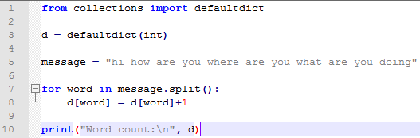

Question 2:-

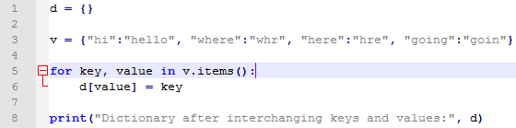

Question 3:-

