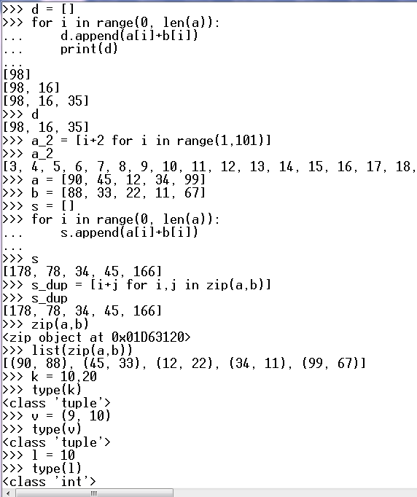

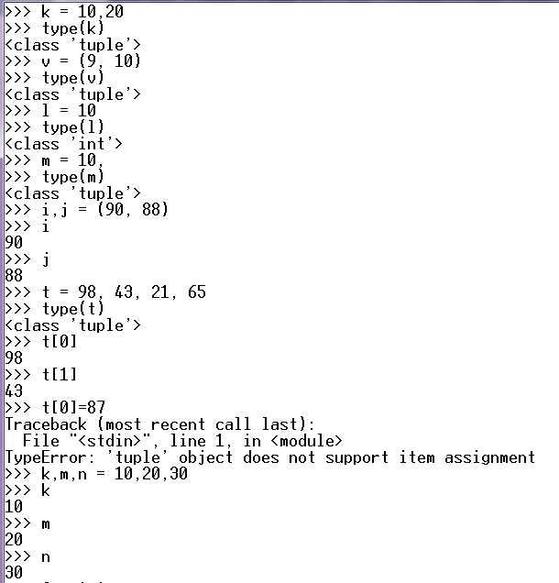

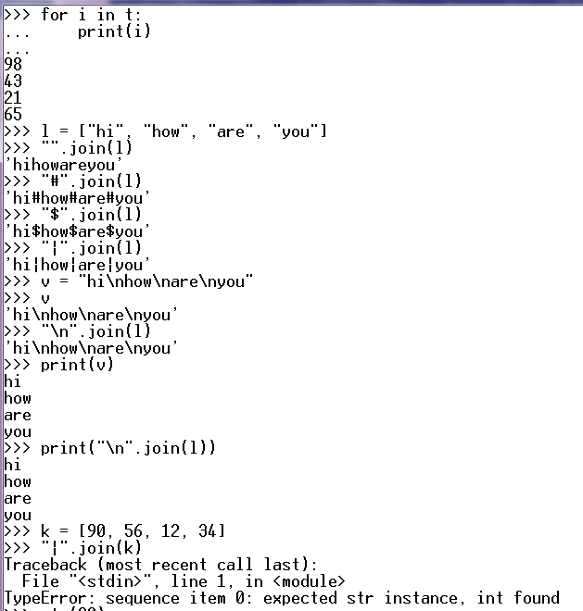

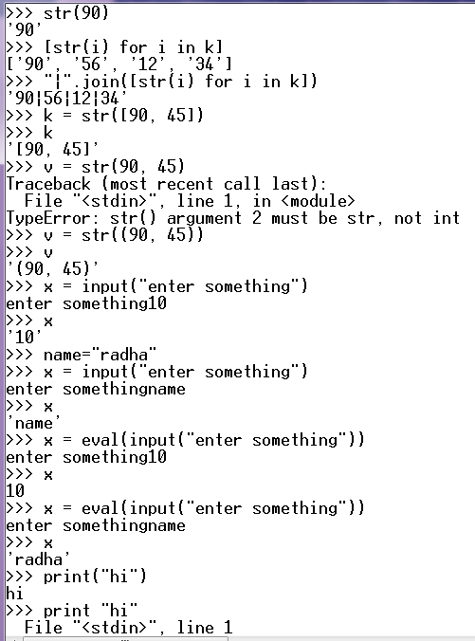

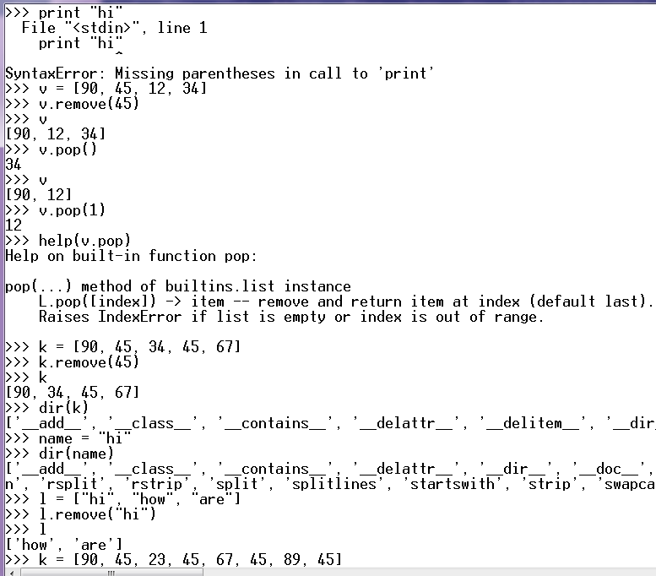

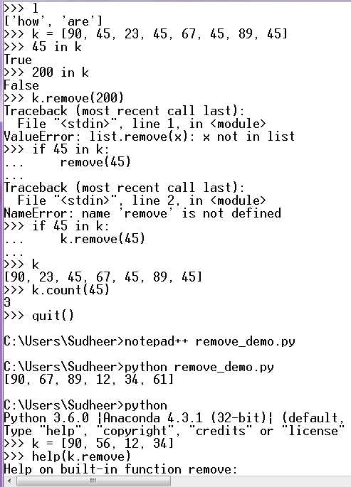

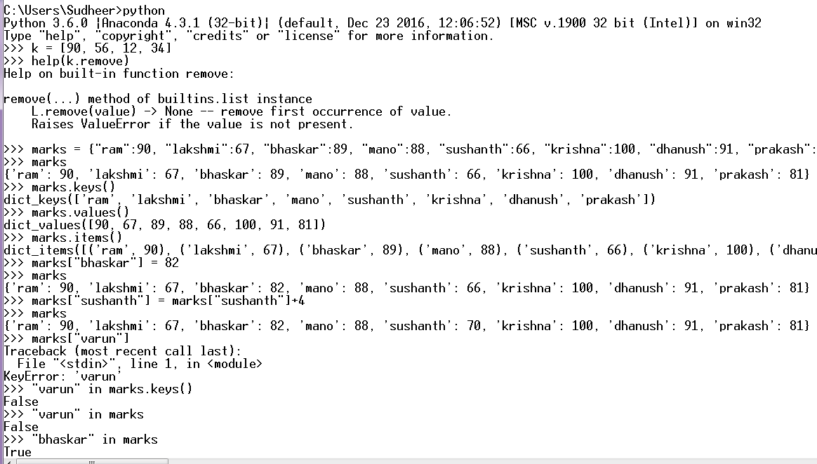

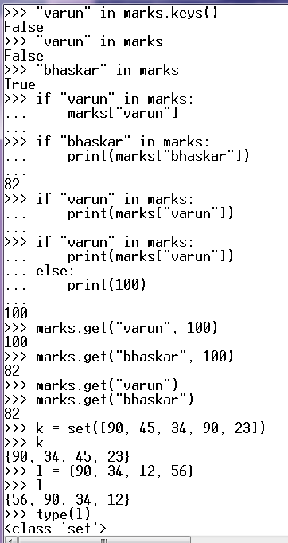

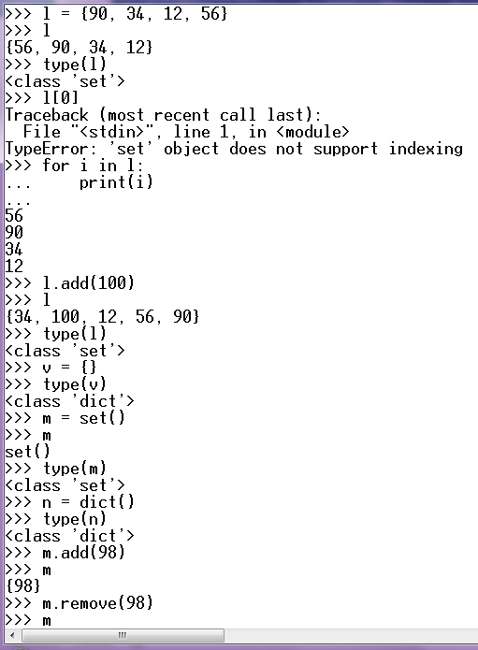

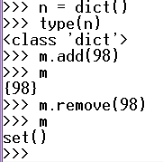

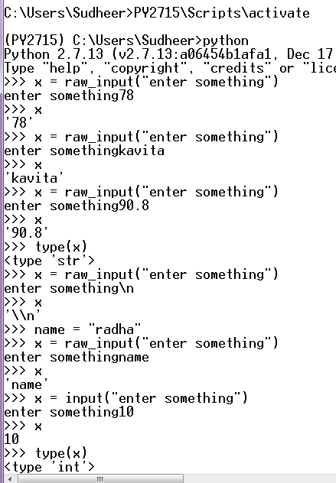

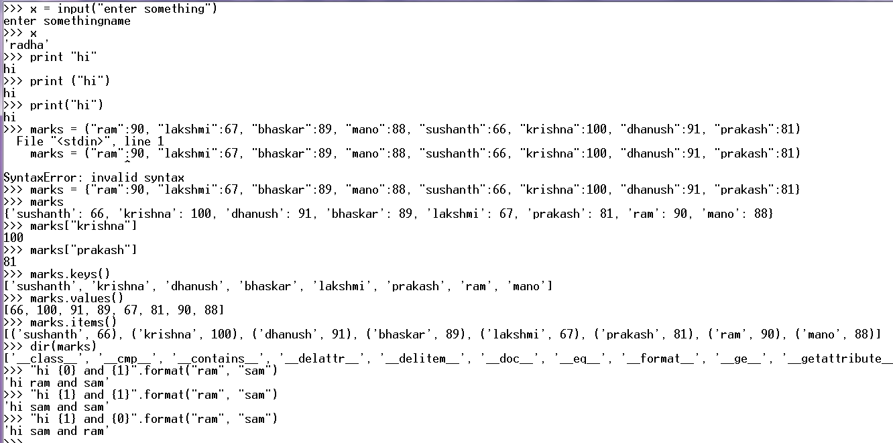

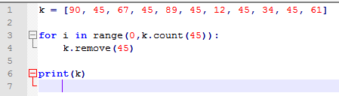

a tuple is a sequence of values seperated by commas

optionally enclosed in paranthesis

tuples are immutable

join

string into list of words split

list of values into a string join

how to take input from user

in 2.x:-

raw_input : it considers every input as a string

it is unable to interpolate variables

input

able to recognize type

able to interpolate variables

in 3.x

there is no raw_input function in 3.x

input : acts as raw_input of 2.x

eval(input) : acts as input of 2.x

print is a statement in 2.x

print is a function in 3.x

function => ()

pop

if you don't mention the index by default it

removes the last element

dictionary:

unordered collection of key value pairs

both sets and dictionaries use the same algorithm to store elements

a set is treated as a dictionary with out values