WORLD ENGINE / ARCH-006

Диаграмма компонентов
FULL CONTENT · ARCHITECTURE AUDITED · COMPLETE

Идентификатор | ARCH-006
Версия | 2.0
Русский | Русский
Дата | 2026-09-04
Статус редакции | Проверено архитектурным аудитом — полная консолидированная версия
Проверено архитектурным аудитом — полная консолидированная версия

Содержание
Содержание

Назначение и правила применения
Этот документ является полной консолидированной версией. Он объединяет действующие проверенные решения, подробное техническое содержание прежних версий, дополнения, таблицы и схемы. Краткий проверенный слой ниже имеет нормативный приоритет. Если сохранённый исторический фрагмент ему противоречит, действует исправленное правило из нормативного слоя; исторический фрагмент оставлен только для полноты и прослеживаемости.

Правило приоритета
Нормативные формулировки текущей проверенной версии заменяют несовместимые формулировки ранних версий. Остальные подробности ранних версий сохраняются как действующая детализация, если они не конфликтуют с нормативным слоем.

Полная подробная спецификация и прослеживаемость

Проверенный текстовый источник: ARCH-006_Component_Diagram_Audited_Source_v1_2.md
docs/01_Architecture/ARCH-006_Component_Diagram/ARCH-006_Component_Diagram_Audited_Source_v1_2.md

ARCH-006 — Component Diagram — Audited Source v1.2
Status: Audit branch source candidate
Baseline: ADR-008 + ADR amendments + ARCH-004/005 audited candidate model
Supersedes in audit: ARCH-006_Component_Diagram_Audited_Source_v1_1.md
Date: 2026-09-01

1. Diagram semantics
The legacy component diagram mixed implementation dependencies, runtime calls, event flow and data flow. This source keeps them separate.
The first diagram is a static component/contract view.
• solid arrow A --> B: component A imports/depends on public contract or abstraction B;
• two components pointing to the same port means consumer/implementation are bound through that abstraction; it does not create a concrete implementation cycle;
• dotted arrow: lifecycle wiring, external runtime connection or evidence flow — not an ordinary static module dependency;
• event producer/subscriber relations are shown separately;
• runtime call order belongs to ARCH-007.
flowchart TB
subgraph EXT[External Systems]
GAME[Skyrim / Supported Game]
LOCALAI[Local AI Runtime]
EXTAI[External LLM]
end
subgraph HOST[Application Host / Composition Root]
H[Construction • DI • Config/Profile Selection • Startup/Shutdown • Application Readiness]
end
subgraph INT[Integration]
GA[MOD-002 Game Adapter]
PD[Plugin Detection / Analyzer]
end
GIN[[Game Ingress Port]]
GOUT[[Game Output / Capability Port]]
subgraph COORD[Coordination / Application]
CORE[MOD-001 Core]
EV[MOD-011 Event Engine]
SCH[MOD-012 Scheduler]
end
DLGPORT[[Dialogue Command Port]]
subgraph SIM[Simulation / Domain Application]
MEM[MOD-003 Memory Engine]
CHAR[MOD-004 Character Engine]
DLG[MOD-005 Dialogue Engine]
ORG[MOD-006 Organization Engine]
REL[MOD-007 Relationship Engine]
ECO[MOD-008 Economy Engine]
POL[MOD-009 Politics Engine]
QUEST[MOD-010 Quest Engine]
end
SPEECH[[Speech Output Port]]
MEMCTX[[Memory Read / Context Source Port]]
MEMREP[[Memory Repository Port]]
subgraph AIM[AI / Media]
AIA[AI Adapter]
CTX[Context Manager]
PROV[[Provider Abstraction]]
LPROV[Local Provider Implementation]
EPROV[External Provider Implementation]
VOICE[MOD-014 Voice Engine]
end
subgraph PERSIST[Persistence]
SAVE[MOD-013 Save Manager]
SAVEPORT[[Save Persistence Port]]
PART[[SaveParticipant Contracts]]
HIST[[Event History Persistence Port]]
REP[Repository Implementations]
DB[(SQLite Database)]
end
%% Game ports: both sides depend on contracts, not each other's implementation.
GA --> GIN
CORE --> GIN
CORE --> GOUT
GA --> GOUT
GAME -. runtime integration .-> GA
%% Coordination and synchronous use-case ports.
CORE --> EV
CORE --> SCH
CORE --> SAVE
CORE --> DLGPORT
DLG --> DLGPORT
SCH --> EV
%% Domain/static dependencies.
CHAR --> MEM
REL --> CHAR
ORG --> REL
ECO --> ORG
POL --> ORG
POL --> ECO
QUEST --> MEM
QUEST --> REL
QUEST --> POL
DLG --> MEM
DLG --> CHAR
DLG --> REL
DLG --> QUEST
DLG --> AIA
%% Speech capability through an inverted media port.
DLG --> SPEECH
VOICE --> SPEECH
%% AI boundary and provider abstraction.
AIA --> CTX
CTX --> MEMCTX
MEM --> MEMCTX
AIA --> PROV
LPROV --> PROV
EPROV --> PROV
LPROV -. local runtime transport .-> LOCALAI
EPROV -. HTTPS/provider transport .-> EXTAI
%% Persistence through dedicated logical ports.
MEM --> MEMREP
REP --> MEMREP
SAVE --> SAVEPORT
REP --> SAVEPORT
SAVE --> PART
MEM --> PART
CHAR --> PART
REL --> PART
ORG --> PART
ECO --> PART
POL --> PART
QUEST --> PART
EV --> HIST
REP --> HIST
REP --> DB
%% Evidence is not a static module dependency.
PD -. plugin profile evidence .-> GA
PD -. fingerprint evidence .-> SAVE
%% Process-level lifecycle wiring/config/readiness.
H -. lifecycle wiring .-> GA
H -. lifecycle wiring .-> PD
H -. lifecycle wiring .-> CORE
H -. lifecycle wiring .-> EV
H -. lifecycle wiring .-> SCH
H -. lifecycle wiring .-> MEM
H -. lifecycle wiring .-> CHAR
H -. lifecycle wiring .-> DLG
H -. lifecycle wiring .-> REL
H -. lifecycle wiring .-> ORG
H -. lifecycle wiring .-> ECO
H -. lifecycle wiring .-> POL
H -. lifecycle wiring .-> QUEST
H -. lifecycle wiring .-> AIA
H -. lifecycle wiring .-> VOICE
H -. lifecycle wiring .-> SAVE
H -. lifecycle wiring .-> REP

2. Important interpretation rules
1. The diagram does not mean that every module communicates through Event Engine.
2. Event Engine coexists with approved direct command/query/use-case contracts.
3. Game Adapter never imports or calls Dialogue/Memory/Quest implementations directly.
4. Core does not import the concrete Game Adapter implementation. Both sides bind through Game Ingress and Game Output/Capability contracts.
5. Dialogue does not call the concrete Game Adapter. It returns its use-case result to the application boundary.
6. Scheduler does not depend directly on Save Manager. Autosave is an event relation.
7. Save Manager does not discover concrete simulation modules through a registry. SaveParticipant implementations are injected by Composition Root.
8. Context Manager does not access Repository/SQLite directly. Memory context is read through Memory Read / Context Source.
9. Normal domain persistence uses dedicated repository ports. Memory Repository Port is shown as the representative example; other state owners may define equivalent owned repository ports when required.
10. Voice Engine implements optional speech output and does not own Dialogue semantics.
11. AI provider implementations depend on the provider abstraction; consumers do not import provider/model SDKs.
12. Host/Composition Root lifecycle wiring is not an ordinary runtime service lookup and Host is not a Service Locator.

3. Event relation view
flowchart LR
SCH[Scheduler] -->|AutosaveDue| EV[Event Engine]
EV -->|deliver| SAVE[Save Manager]
CORE[Core/Application] -->|semantic game/world events| EV
EV -->|deliver| MEM[Memory]
EV -->|deliver| CHAR[Character]
EV -->|deliver| REL[Relationship]
EV -->|deliver| ORG[Organization]
EV -->|deliver| ECO[Economy]
EV -->|deliver| POL[Politics]
EV -->|deliver| QUEST[Quest]
PD[Plugin Detection] -->|ProfileDetected / ProfileChanged| EV
EV -->|evidence notification| GA[Game Adapter]
EV -->|evidence notification| SAVEC[Save compatibility consumer]
Event arrows represent producer/subscriber relationships only and do not redefine the static dependency graph in ARCH-005.

4. Legacy corrections captured
This source removes the legacy ARCH-006 problems identified by the audit:
• All modules communicate through Event Engine;
• Core services registry / Service Locator implication;
• Save Manager shown as a Simulation component;
• Voice shown in the wrong ownership layer;
• missing AI Adapter boundary;
• Scheduler-to-Database/persistence visual coupling;
• concrete bidirectional arrows that implied implementation cycles;
• direct domain-to-Repository implementation coupling without owned repository ports;
• provider/runtime transport depicted as if it were the same kind of relation as a static dependency.

Проверенный текстовый источник: ARCH-006_Component_Diagram_Audited_Source_v1_1.md
docs/99_Archive/01_Architecture/ARCH-006_Component_Diagram/ARCH-006_Component_Diagram_Audited_Source_v1_1.md

ARCH-006 — Component Diagram — Audited Source v1.1

Diagram semantics
This source replaces the legacy diagram that mixed static dependencies, runtime calls, event flow and data flow in one arrow style.
The diagram below is primarily a static component/contract view.
• solid arrow A --> B: A statically depends on B's public contract;
• port node: inner-owned contract used for dependency inversion;
• dotted arrow: lifecycle wiring/evidence, not ordinary module dependency;
• event relations are shown separately and do not imply producer-to-subscriber static dependency;
• runtime sequences belong to ARCH-007.
flowchart TB
subgraph EXT[External Systems]
GAME[Skyrim / Supported Game]
LOCALAI[Local AI Runtime]
EXTAI[External LLM]
end
subgraph HOST[Application Host / Composition Root]
H[Construction • DI • Config/Profile Selection • Startup/Shutdown • App Readiness]
end
subgraph INT[Integration]
GA[MOD-002 Game Adapter]
PD[Plugin Detection / Analyzer]
end
GIN[[Game Ingress Port]]
GOUT[[Game Output / Capability Port]]
subgraph COORD[Coordination / Application]
CORE[MOD-001 Core]
EV[MOD-011 Event Engine]
SCH[MOD-012 Scheduler]
end
DLGPORT[[Dialogue Command Port]]
subgraph SIM[Simulation / Domain Application]
MEM[MOD-003 Memory Engine]
CHAR[MOD-004 Character Engine]
DLG[MOD-005 Dialogue Engine]
ORG[MOD-006 Organization Engine]
REL[MOD-007 Relationship Engine]
ECO[MOD-008 Economy Engine]
POL[MOD-009 Politics Engine]
QUEST[MOD-010 Quest Engine]
end
SPEECH[[Speech Output Port]]
MEMCTX[[Memory Read / Context Source Port]]
subgraph AIM[AI / Media]
AIA[AI Adapter]
CTX[Context Manager]
PROV[Provider Abstraction]
VOICE[MOD-014 Voice Engine]
end
subgraph PERSIST[Persistence]
SAVE[MOD-013 Save Manager]
SAVEPORT[[Save Persistence Port]]
PART[[SaveParticipant Contracts]]
REP[Repository Implementations]
DB[(SQLite Database)]
HIST[[Event History Persistence Port]]
end
GAME --> GA
GA --> GIN
GIN --> CORE
CORE --> GOUT
GA --> GOUT
GOUT --> GA
GA --> GAME
CORE --> EV
CORE --> SCH
CORE --> SAVE
CORE --> DLGPORT
DLG --> DLGPORT
SCH --> EV
CHAR --> MEM
REL --> CHAR
ORG --> REL
ECO --> ORG
POL --> ORG
POL --> ECO
QUEST --> MEM
QUEST --> REL
QUEST --> POL
DLG --> MEM
DLG --> CHAR
DLG --> REL
DLG --> QUEST
DLG --> AIA
DLG --> SPEECH
VOICE --> SPEECH
AIA --> CTX
AIA --> PROV
CTX --> MEMCTX
MEM --> MEMCTX
PROV --> LOCALAI
PROV --> EXTAI
MEM --> REP
SAVE --> SAVEPORT
SAVEPORT --> REP
SAVE --> PART
EV --> HIST
HIST --> REP
REP --> DB
PD -. plugin profile evidence .-> GA
PD -. fingerprint evidence .-> SAVE
H -. lifecycle wiring .-> GA
H -. lifecycle wiring .-> PD
H -. lifecycle wiring .-> CORE
H -. lifecycle wiring .-> EV
H -. lifecycle wiring .-> SCH
H -. lifecycle wiring .-> DLG
H -. lifecycle wiring .-> AIA
H -. lifecycle wiring .-> SAVE
H -. typed config / readiness .-> INT
H -. typed config / readiness .-> COORD
H -. typed config / readiness .-> SIM
H -. typed config / readiness .-> AIM
H -. typed config / readiness .-> PERSIST

Important interpretation rules
1. The diagram does not mean that every simulation module must communicate through Event Engine.
4. Core does not import the concrete Game Adapter implementation; outbound game operations use Game Output/Capability Port.
5. Dialogue does not call the concrete Game Adapter; it returns the use-case result to Core/Application.
6. Scheduler does not depend directly on Save Manager. Autosave is an event relation shown below.
8. Context Manager does not access Repository/SQLite directly.
9. Voice Engine implements optional speech capability and does not own Dialogue semantics.
10. Host/Composition Root lifecycle arrows are not ordinary module dependencies and Host is not a runtime Service Locator.

Event relation view
flowchart LR
SCH[Scheduler] -->|AutosaveDue| EV[Event Engine]
EV -->|deliver| SAVE[Save Manager]
CORE[Core/Application] -->|semantic game/world events| EV
EV -->|deliver| MEM[Memory]
EV -->|deliver| CHAR[Character]
EV -->|deliver| REL[Relationship]
EV -->|deliver| ORG[Organization]
EV -->|deliver| ECO[Economy]
EV -->|deliver| POL[Politics]
EV -->|deliver| QUEST[Quest]
PD[Plugin Detection] -->|ProfileDetected / ProfileChanged| EV
EV -->|evidence notification| GA[Game Adapter]
EV -->|evidence notification| SAVE2[Save compatibility consumer]
Event arrows above represent producer/subscriber relations only. They do not change the static dependency graph in ARCH-005.

Legacy corrections captured
This source removes the following legacy ARCH-006 problems:
• All modules communicate through Event Engine statement;
• Save Manager shown as Simulation component;
• ambiguous bidirectional module arrows with no contract semantics.

Источник: ARCH-006_Component_Diagram_v1_2_Architecture_Audited.svg
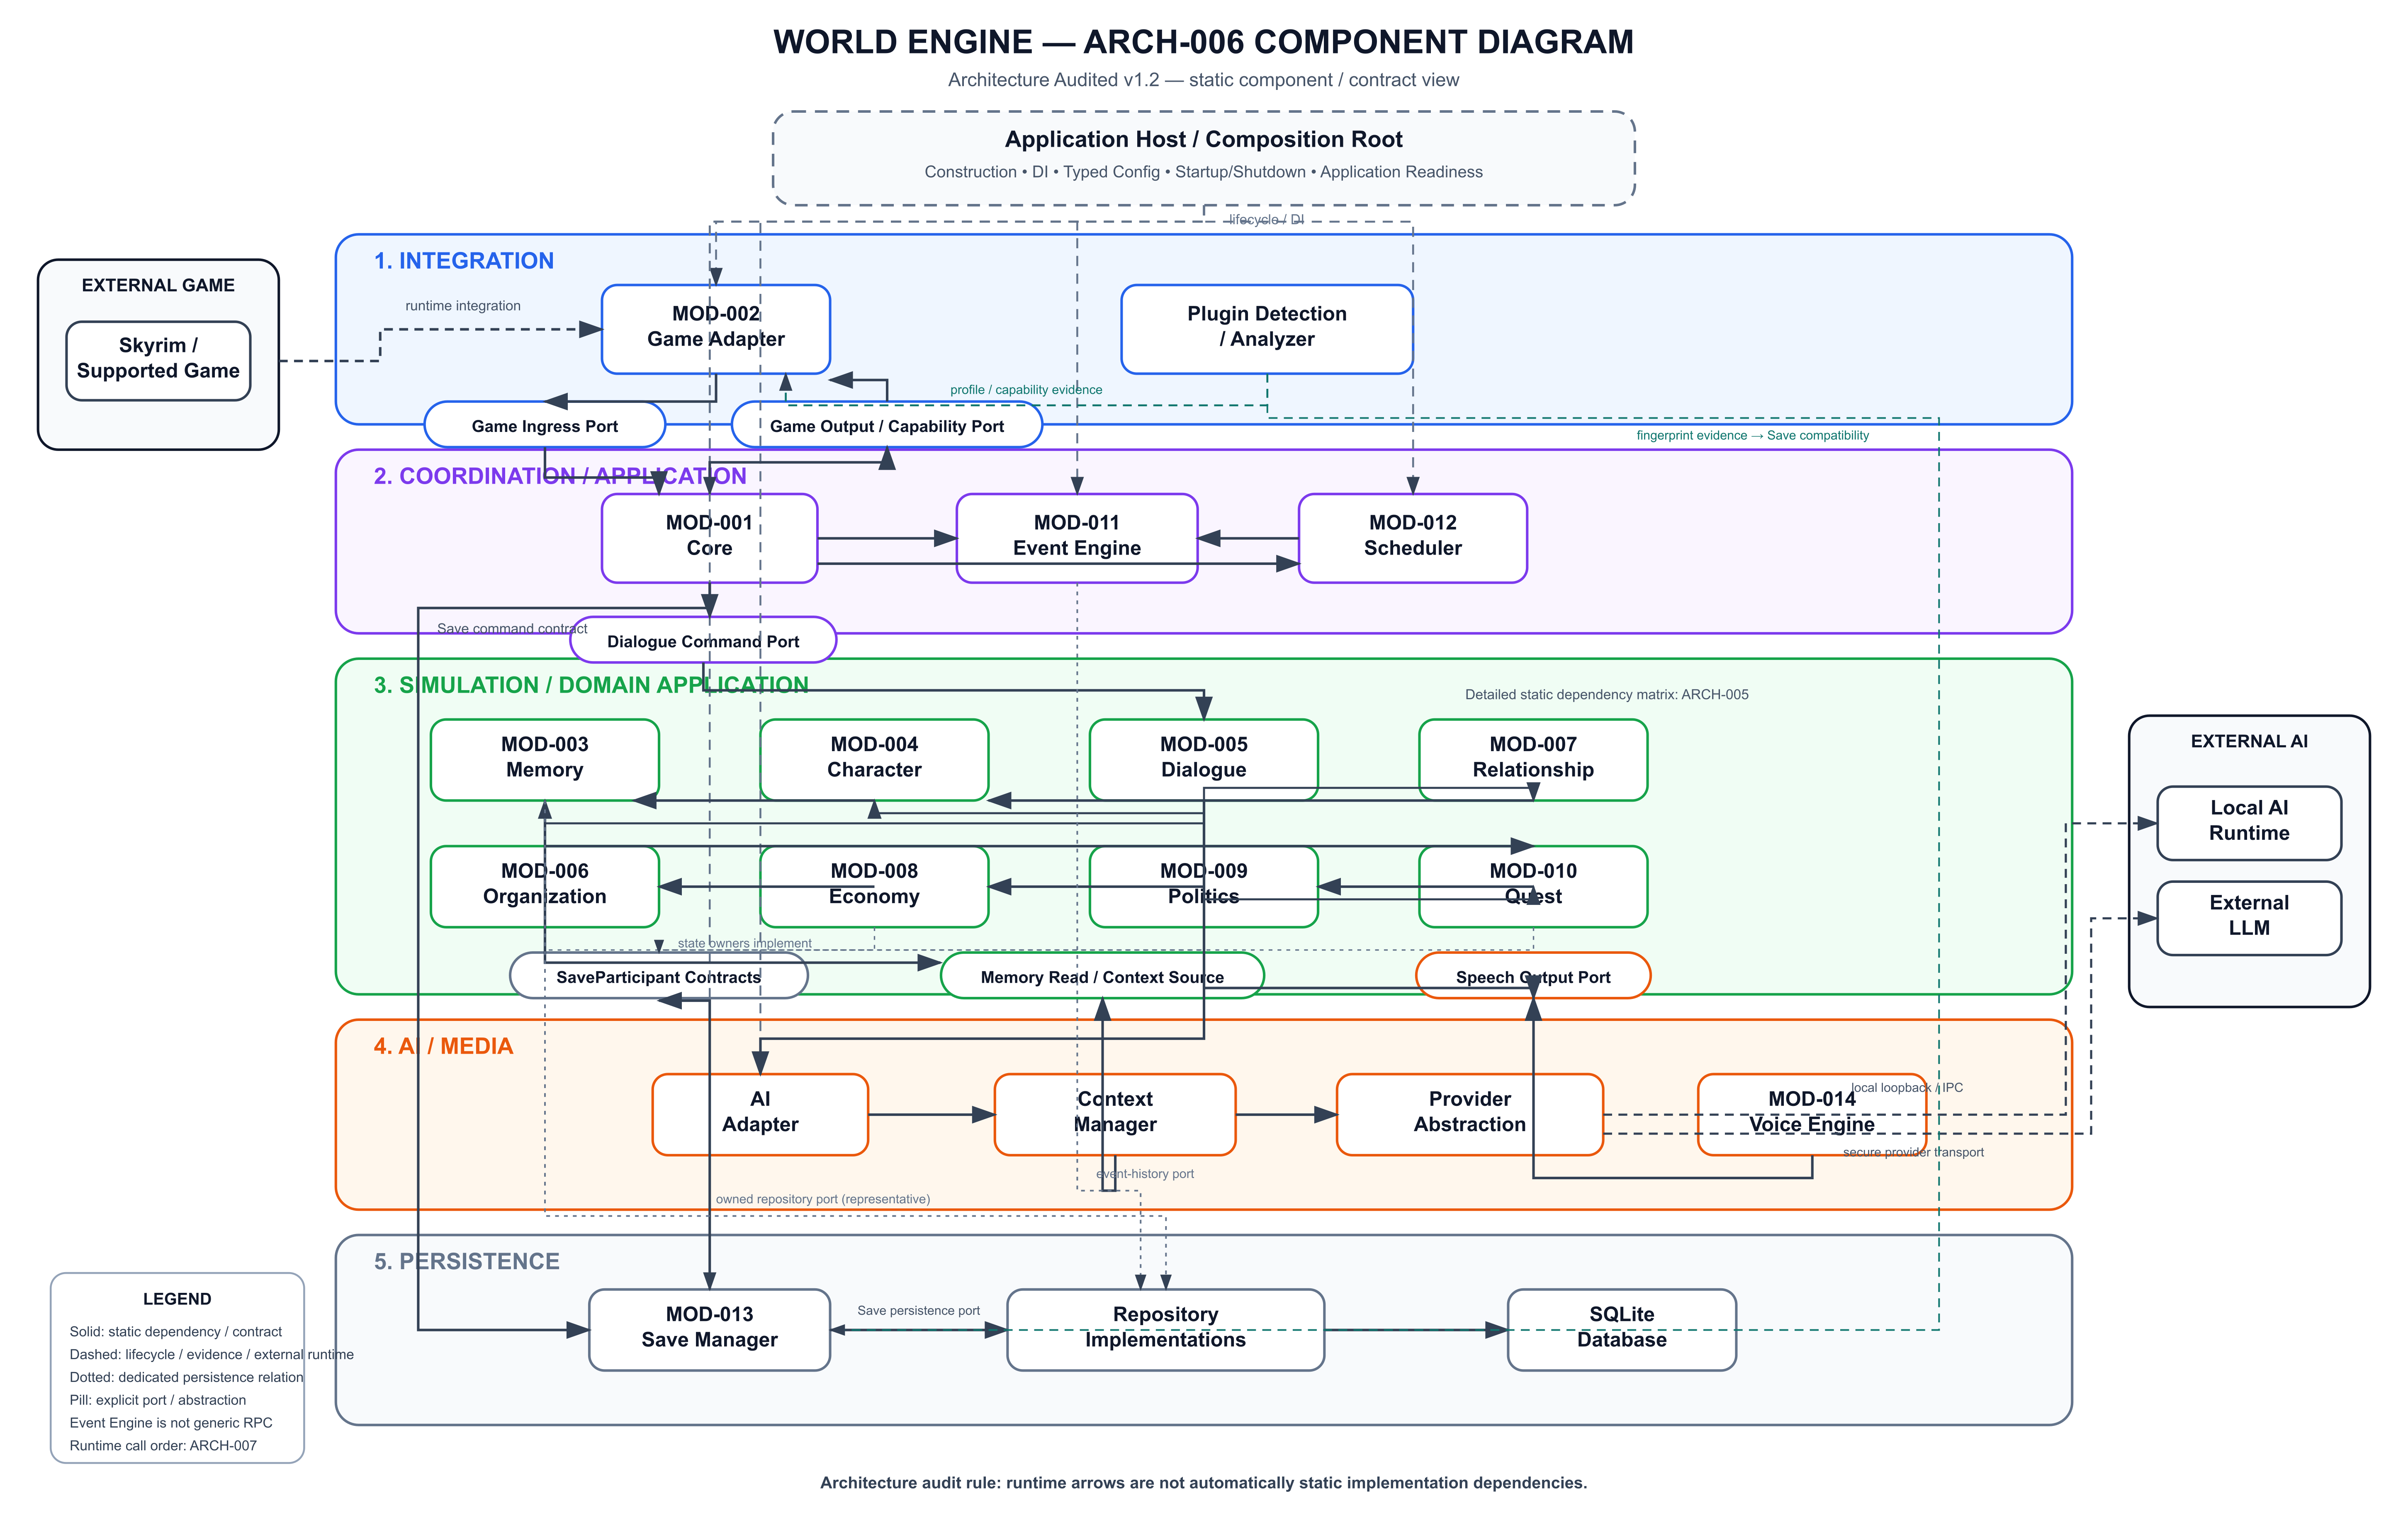
ARCH-006_Component_Diagram_v1_2_Architecture_Audited.svg

Источник: ARCH-006_World_Engine_Component_Diagram_v1_0.jpg
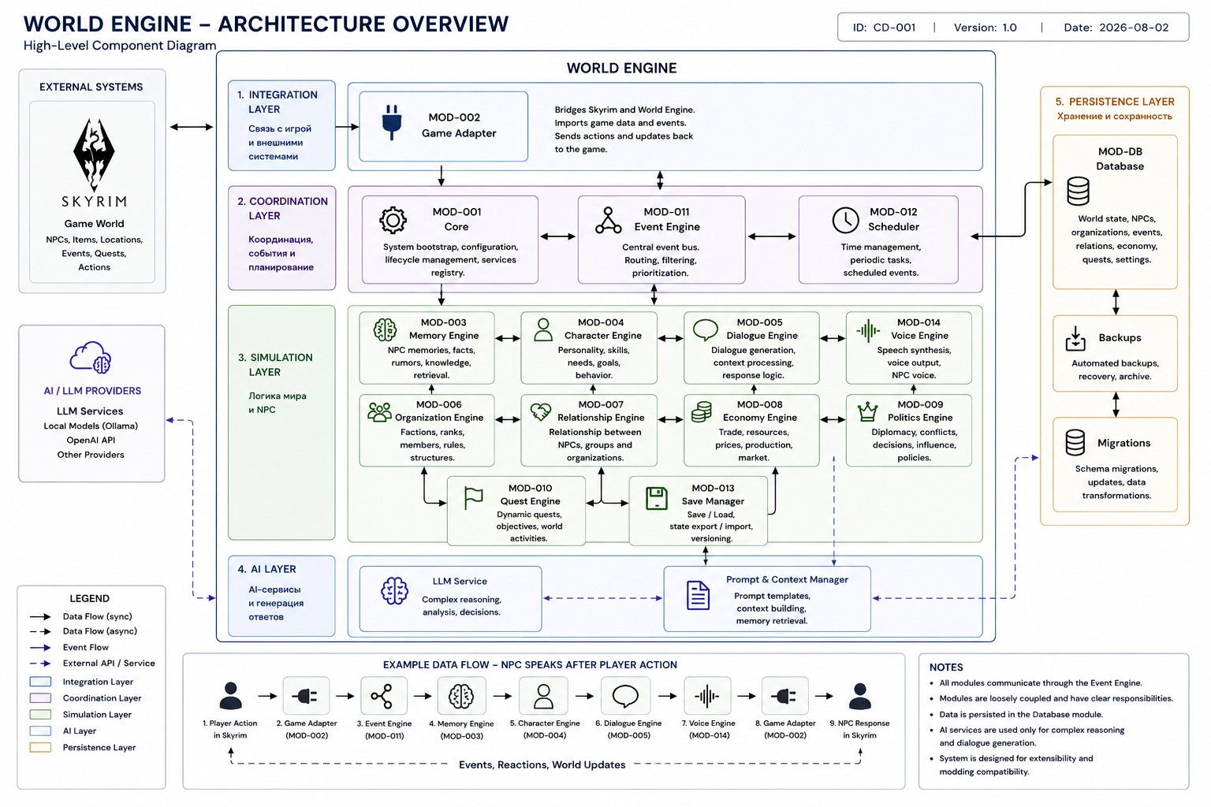
ARCH-006_World_Engine_Component_Diagram_v1_0.jpg

Реестр использованных источников
Путь | Роль | SHA-256
docs/01_Architecture/ARCH-006_Component_Diagram/ARCH-006_Component_Diagram_Audited_Source_v1_2.md | Проверенный текстовый источник | 78a5232a5c2cb8de
docs/99_Archive/01_Architecture/ARCH-006_Component_Diagram/ARCH-006_Component_Diagram_Audited_Source_v1_1.md | Проверенный текстовый источник | 3e1af62d0cc3e52d
docs/01_Architecture/ARCH-006_Component_Diagram/ARCH-006_Component_Diagram_v1_2_Architecture_Audited.svg | Diagram / Abbildung | 89278869acc0e7d2
docs/99_Archive/01_Architecture/ARCH-006_Component_Diagram/ARCH-006_World_Engine_Component_Diagram_v1_0.jpg | Diagram / Abbildung | aa8535efa6d4934d

