|  |  |  |  |
| --- | --- | --- | --- |
| ***Design Document Ver 1.0 Date : 12/06/2019*** | | | |
| ***Database : PostgreSQL, .Net framework, C# , Dabase Server : Windows Server, IIS*** | | | |
| **Database Name : LAQ_Thane** | | | |
| ***Table Name*** | ***Field_Name*** | ***Type, Size*** | ***Remarks*** |
| **Village_Master** | Village_Code | Varchar(2) | Unique Key is Village_Code  Hard coded values for District Name and Taluka Name so not to be considered as part of database |
| Village_Name_Marathi | Varchar(100) |
| Village_Name_English | Varchar(100) |
|  |  |  |  |
| **Family_Master** | Village_Code | Varchar(2) | Unique Key is Village_Code + Family_No |
| Family_No | Varchar(3) |
| Family_Total_area | Numeric, 4 decimal | Total Area of Survey Number |
| Family_Area_Status | Varchar(1) | Acquisition Status (Y/N) |
|  |  |  |  |
| **Family-survey-no** | Village_Code | Varchar(2) |  |
|  | Family_No | Varchar(3) |  |
| Survey_No | Varchar(50) | Survey Number |
| Survey_Rate | Numeric, 2 decimal | Rate offered for survey number |
| Survey_Area | Numeric, 4 decimal | Area of survey Number |
|  |  |  |  |
| **Family-Details** | Village_Code | Varchar(2) |  |
|  | Family_No | Varchar(3) | Unique Number given to each family |
| Survey_No | Varchar(50) | Survey Number |
| Survey_Rate | Numeric, 2 decimal | Rate offered for survey number |
| Survey_Area | Numeric, 4 decimal | Area of survey Number |
| Holder_Name | Varchar(100) | Holders Name |
| Holder_Area | Numeric, 4 decimal | Area owned by Holder in that Survey |
| Holder_Mobile_No | Varchar(10) | Mobile Number (Optional) |
| Holder_Aadhar_No | Varchar(14) | Aadhar Card Xerox (Must) |
| Holder_PAN_No | Varchar(10) | PAN Card Xerox (Must) |
| Holder_RationCard_No | Varchar(10) | Ration Card |
| Holder_VoterID_No | Varchar(10) | VoterID |
| Area-Acquired | Numeric, 4 decimal | Area acquired till now |
| Payment_Status | Varchar(1) | (T-Token, S-Settlement, M-Mutation) |
| MR_No | Varchar(30) | Mutation Register |
| DR_No | Varchar(30) | Deed Registration Number |
| PN_No | Varchar(30) | Public Notice Number |
| FR_No | Varchar(30) | Final Remark Number |
| **Note : Update table Document_Status whenever above mentioned registers are uploaded.** | | | |
| **Document_Execution** | Village_Code | Varchar(2) | Unique Key is Village_Code + Family_No+DEN_No |
| Family_No | Varchar(3) | Family_Number |
| DEN_No | Varchar(10) | Document Execution Search Number will be running in the village i.e. serial generation |
| Survey_No | Varchar(50) | Survey_Number |
| URV_No | Varchar(30) | Unregistered Visarpavti |
| ATS_No | Varchar(30) | Agreement to Sale |
| ATS_Area_Purchased | Numeric, decimal 4 | Area purchased by ATS |
| RSD_No | Varchar(30) | Registered Sale Deed |
| RSD_Area_Purchased | Numeric, decimal 4 | Area purchased by RSD |
| POA_No | Varchar(30) | Power of Attorney |
| GP_No | Varchar(30) | Ghoshana Patra |
| TP_No | Varchar(30) | Tabe Pavati |
| HP_No | Varchar(30) | Hami Patra |
|  | Other_Area_Purchased | Numeric, decimal 4 | Area purchased by Other Doc. Type |
| **Note : Update table Document_Status whenever above mentioned registeres are uploaded.** | | | |
| **Payment_Details** | Village_Code | Varchar(2) | Unique Key is Village_Code + Family_No+DEN_No |
| TS_No | Varchar(10) | Title Search Number |
| DEN_No | Varchar(10) | DEN_No will come from Document Execution. |
| Family_No | Varchar(3) | Family_Number |
| Survey_No | Varchar(50) | Survey Number |
| Holder_Name | Varchar(100) | Name of Holder |
| Payment_Voucher_No | Varchar(10) | Payment Voucher No |
| Payment_Voucher_Dt | Date | Payment Date |
| Cash_Paid_Amt | Numeric,2 decimal | Cash Paid Amount |
| Cash_Paid_Dt | Date | Cash Paid Date |
| Check_DD_Amt | Numeric,2 decimal | Check-DD Amount |
| Check_DD_Dt | Date | Check-DD Date |
| Check_DD_No | Varchar(20) | Check-DD Number |
| Bank_Details | Varchar(100) | Bank-Branch Details |
| Client ID |  |  |
| Purchaser ID |  |  |
| Remark | Varchar(50) |  |
| Transaction_Flag | Varchar(1) | Token / Settelment / Mutation Flag |
| **Note : Payment Details are linked with Title search (Token Amount) & Document Execution – Part or Full payment can be done** | | | |
|  |  |  |  |
| **Document_Status** | Village_Code | Varchar(2) | Unique Key is Village_Code + Family_No+TSN_No |
| Family_No | Varchar(3) | Family Number |
| TS_No | Varchar(10) | Title search no |
| Survey_No | Varchar(50) | Survey Number |
| MR_No | Varchar(30) | PDF File Name from Title_Search |
| DR_No | Varchar(30) |
| PN_No | Varchar(30) |
| FR_No | Varchar(30) |
| URV_No | Varchar(30) | PDF File Name from Document_Execution |
| ATS_No | Varchar(30) |
| RSD_No | Varchar(30) |
| POA_No | Varchar(30) |
| GP_No | Varchar(30) |
| TP_No | Varchar(30) |
| HP_No | Varchar(30) |
|  |  |  |  |
| **Final_Data** | Village_Code |  | Village_Code |
| Total_Village_Area |  | Total Area of Village |
| Proposed_Area_Acq |  | Proposed Area to be Acquired |
| DEN_No | Varchar(10) | DEN_Number will come from Document Execution. |
| ATS_Area_Purchased | Numeric, decimal 4 | Area purchased by ATS |
| RSD_Area_Purchased | Numeric, decimal 4 | Area purchased by RSD |
| Total_Area_Acq | Numeric, decimal 4 | Total Area Acquired |
| Temp_ATS_Area | Numeric, decimal 4 | Temp. Area under ATS |
| Temp_RSD_Area | Numeric, decimal 4 | Temp. Area under RSD |
| Balance_Area_Acq | Numeric, decimal 4 | Balance Area to be Acq. |
|  |  |  |  |
| **Mutation_Final** | Village_Code | Varchar(2) | Village Code |
|  | Mutation_No | Integer | Mutation Number |
| Mutation_Date | Date | Mutation Date |
| Survey_No | Varchar(50) | Survey Number |
| Remarks | Varchar(100) | Comments |
| Mutation_Order_Rec | Varchar(1) | Confirm M.O. |
| Mutated_712_Rec | Varchar(1) | Confirm updated 7/12 |
|  |  |  |  |
| Mutation_Register  (Master Table) | Village_Code | Varchar(2) | Village Code |
| Mutation_Number | Varchar(6) | Mutation Number |
| Mutation_Date | Date | Dd/MM/yyyy |
| Mutation_Details | Varchar(2000) | Mutation Deal – Details (may go one page) |
|  |  |  |  |
| Mutation_SurveyNo  (Transaction Table) | Village_Code | Varchar(2) | Village Code |
| Mutation_Number | Varchar(6) | Mutation Number |
| Survey_No | Varchar(50) | Survey Number |

**Note :**

* Create Database by name LAQ-Thane
* Create Tables as per structures above
* Sample data for Village_Master and Family_Master is given in Excel file (you can import it in PostgreSQL Table)
* You have to write Data capturing screen for Title Search with functionality ADD/Modify/Delete/View.
* Presently if needed you can hardcode the village_code as ‘01’

**SCREEN LAYOUT (You may design your own)**

**TITLE SEARCH**



**Button : Field search report (Family Tree, Consent Letter, Check List (…))**



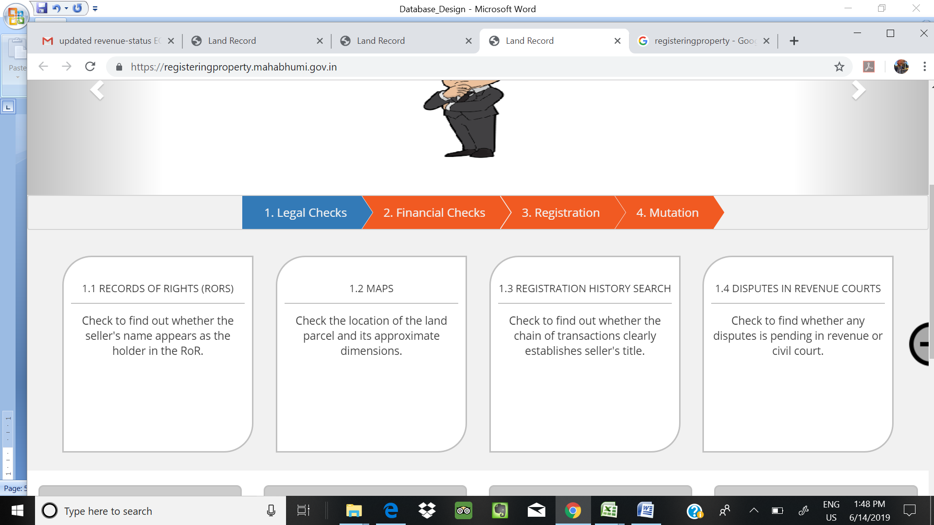

**You can think of Tabs like this**

1. **Master Data Entry (Area of Interest)**
2. **Title Search**
3. **Document Execution**
4. **Payments**
5. **Reports & Query**

**User registration with OTP for login is must**

**SMS integration**

**On Landing page itself you can provide Graphical representation (Pi chart) progress report type for few tables – parameters at least for Admin login**

**Example**

**Pi chart for**

**Data hirerchi**

**Village – Document No – Family No – Survey number**

**1 document corresponds to one family**

**1 family may have multiple documents depending on area**

**We need buyer master also as in this case minimum 4 buyers will be present**

**Data Entry , Query and Report**

**Platform :**

Database : MSSQL database,

Framework : ASP .net C#, IIS .net 4.6 (If not available let us know)

**Create Database Name : LAQ-Thane**

**Create following Tables**

1. **Village_Master primary key (Village_Code)**
2. **Mutation_Register Primary Key (Village_Code + Mutation_No)**
3. **Mutation_SurveyNo (Primary Key (Village_Code + Mutation_No)**

**All Data should be captured in Unicode Marathi font, Numbers like mutation number, date can be in english**

|  |  |  |  |
| --- | --- | --- | --- |
| Table Name | Fields | Type | Description |
| **Village_Master** | Village_Code | Varchar(2) | Unique Key is Village_Code  Hard coded values for District Name and Taluka Name so not to be considered as part of database |
| Village_Name_Eng | Varchar(100) | Village Name English |
| Village_Name_Mar | Varchar(100) | Village Name Marathi |
|  |  |  |  |
| Mutation_Register  (Master Table) | Village_Code | Varchar(2) | Village Code |
| Mutation_Number | Varchar(6) | Mutation Number |
| Mutation_Date | Date | Dd/MM/yyyy |
| Mutation_Details | Varchar(2000) | Mutation Deal – Details (may go one page) |
|  |  |  |  |
| Mutation_SurveyNo  (Transaction Table) | Village_Code | Varchar(2) | Village Code |
| Mutation_Number | Varchar(6) | Mutation Number |
| Survey_No | Varchar(50) | Survey Number |

**Functionality :**

* **Search by Mutation Number, Search by Survey_No**
* **Add, EDIT, Delete**
* **Generate report : (a) For all mutations (b) For all mutations for a specified Survey Number**
* **Export – Save as PDF / Excel**

**Sample Village_Master**

**Village_Code Village_Name_Eng Village_Name_Marathi**

**01 Arjunali अर्जुनली**

**02 Talavali Turf Sonale तळवली तर्फे सोनाळे**