Anal Fissure.
Stem: 23-year-old male comes to your office with a 3-week history of a painful bowel movements, a symptom of pruritis ani and periodic BRBPR. he is otherwise healthy; he tries to stay constipated to avoid the pain. he reports he is experimenting with anal unprotected sex. Any further information you want?

- Hisotry :
  - Family hisotry of cancer ? IBD? No.
  - Social? Smokes few cigareetes a day, drink soclailly, works two part time jobs and mainly eats fast food.
- Prior colonoscopy? No
What is your differential diagnosis?
- Anal fissure.
- Hemorrhoids.
- Anal cancer.
- Inflammatory bowel disease.
- Condylomas.
- STD.
What would you do for this patient, what is your work up diagnosis and management?
- Physical exam?
  - Rectal exam, posterior midline you see a small tear in the anoderm, with exposed muscle fiber. Patient is squeezing hard. (With acute anal fissure resident should not do digital rectal exam or anoscopy , if resident tries, patient refuses and screams)
  - HIV test. / Anal pap smear.
- Diet modifications (fiber BID); warm daily Sitz baths, bowel regimen.
Patient comes for a 1 month follow up, HIV came back negative, he had not had sex during this time period, he increased fiber intake and is compliant with stool softeners, pain improved but still there after bowel movements and lasts for about 30 min to an hour , he is distressed because of the ongoing pain, asks if there is anything else you can do?
- Non operative medical treatment (Now fissure is chronic, medical management is indicated but ok also if resident gave that earlier)
  - Calcium channel blocker compound creams. (first line instead of nitroglycerin)
  - Botox injection
Patient comes back after 6 weeks, complaint with the treatment , still symptomatic?
- Lateral internal sphincterotomy.
Describe?
- Radial incision in the anoderm laterally exposing the internal sphincter muscle fibers.
- Under direct vision, the internal sphincter muscle is divided with a scalpel or scissors.
- The wound can be left open or closed primarily
- extent of sphincterotomy – up to the level of the fissure.

Scenario: Your patient heels well, pain resolves but still complains of episodic bleeding, you decide to proceed with a colonoscopy, describe?

Scenario: Patient is a 27-year-old female presenting with bright red blood present on her stools for the past 2 weeks. Physical exam demonstrates a fissure along the lateral wall. How does your management change?
Assess for atypical causes (IBD, STD, HIV, cancer)

Rectal Prolapse
Stem: You are seeing a 60 year old woman in the office who complains of a tissue which protrudes from her anus during and after defecation which she manually reduces after each stool. Discharges are occasional, both mucus and blood. She denies a history of constipation, stating she is able to pass stool daily without difficulty. She has had two prior vaginal deliveries. She has no significant previous medical history.Family history negative for colorectal cancer.

Any further infomrations you want?!
- Colonoscopy: 5 years ago.
- Fecal urgency / incontinence? Sometimes, wears a pad.
- Obstetrical Injury? She was told she needed stitches after her first child.
- Any other pelvic organ prolapses (Uterus / bladder?) No, but she feels pelvic pressure and fullness
What is your Differential Diagnosis?
- Rectal Prolapse.
- Hemorrhoidal prolapse.
- Neoplasim
- Pelvic organs prolapse.
How are you going to examine her ?
-Left lateral or prone Jackknife
- Digital rectal exam / assess Rectal tone.
- Assess the other pelvic organs for prolapse.
(You notice patulous anus, you notice external hemorrhoids but they appear benign, Tone very low. ). Patient tells you, it only comes out when she strains in the bathroom, she now remembers she took a picture? Now what?
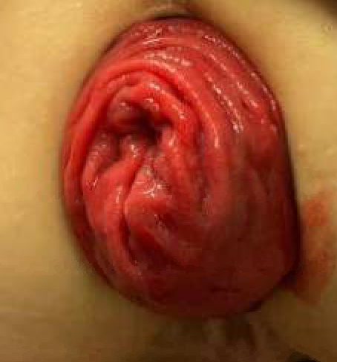
- Exam while sitting on commode: You notice concentric mucosal folds prolapsing , what is your diagnosis ? Rectal Prolapse
How do you differentiate that from Prolapsed hemorrhoids? radial Folds.
Now what’s next?
- Colonoscopy to assess for neoplasia as lead point: Who will do the colonoscopy (Resident must say I will do it) Describe?
- Manometry: Limited role
- Defecography: Why? Can help identify cystocele or vaginal vault prolapse / Allow for combo procedure with GYN.
What would you like to do now? Plan for surgery
How do you counsel the patient about her operative options and risks?
- Preoperative assessment for operative risk: To decide approach.
- Bowel prep
- Perineal Approach (Altemeyer, Delorme)
  - appropriate if multiple prior abdominal operations or poor candidate
  - Higher rates of recurrence
  - Contraindicated if any prior sigmoid or rectal resection.

- Anterior Abdominal approach: What types?
  - Stitch Rectopexy.
  - Resection Rectopexy.
  - Mesh Rectopexy. (Or ventral mesh rectopexy)

When do you offer Resection rectopexy? Sigmoidectomy indicated for patients with constipation.

(Examiner to pick one procedure to describe)

Describe Perineal proctosigmoidectomy?
- Lithotomy or Prone Jackknife position
- Recreate prolapse.
- Make circumferential incision above dentate line.
- Enter the peritoneal cavity through anterior cul-de-sac.
- Deliver the redundant rectum and sigmoid.
- Divide mesorectum/mesocolon.
- Transect colon
- Hand sewn anastomosis.
- +/- levatorplasty if indicated.

Describe a Laparoscopic or Robotic rectopexy?
- Lithotomy position
- port placement
- (If prescribing posterior approach)
  - Enter the posterior mesorectal fascial plane.
  - Avoid hypogastric nerves
  - Mobilize rectum to levators.
  - May divide or spare lateral rectal stalks.
  - Place sutures of rectum to anterior vertebral ligament (Sacral promontory)
- (If prescribing anterior rectopexy)
  - Dissection in the anterior mesorectal plane
  - Enter the rectovaginal space.
  - Mobilize rectum anteriorly all the way to the pelvic floor.
  - Protect the posterior vaginal wall.
  - Place (biologic or prolene mesh)
  - Place sutures of mesh to anterior vertebral ligament (Sacral promontory).
  - Close the peritoneum of pouch of douglas

Pitfalls:
- Not Performing colonoscopy preop.
- Not checking for other organs prolapse.
- Not attempting to change position to demonstrate the prolapse.
- Not knowing different approaches for repair and indications.

