Room 2 Question 2

Appendiceal Carcinoid
Stem: A previously healthy 68-year-old woman is seen in the ED with 18 hours of RLQ abdominal pain and CT findings showing acute appendicitis without perforation, abscess, or phlegmon. The patient has no contraindications to surgery.

What would you like to do now?
Laparoscopic or Open Appendectomy (Describe)
Path Returns with 6mm well circumscribed carcinoid tumor near tip of appendix with no lymphovascular invasion or evidence of perforation? Nothing further
Path Returns with 14mm well carcinoid tumor at mid appendix with lymphovascular invasion
- PET-Dotatate or Octreotide scan post op, with tumor markers
- Right Colectomy (Describe)
Path Returns with 34mm well-circumscribed carcinoid tumor at mid appendix without evidence of perforation or lymphovascular invasion.
1. Right colectomy
Scenario: At the time of surgery a 3cm tumor is identified in the mid appendix without evidence of perforation
1. Right colectomy
Scenario: At the time of surgery an approximately 18mm tumor is palpated during an appendectomy near the tip of the appendix after opening the appendix on the back table because of the firm palpable mass. Frozen specimen returns with likely carcinoid tumor.
1. No further surgery required.
Pathology returns with adenocarcinoma:
1. Right colectomy
Scenario: There is a mucinous mass involving the base of the appendix. During mobilization and right colectomy there is spillage of mucin. What next?
- referral for evaluation for HIPEC.
- if during appendectomy for mucinous mass there is evidence of mucin spillage consider peritoneal lavage/cytology

GIST.

Stem: A 70yoF presents to your office with complaints of 4 months of early satiety. He denies any nausea/emesis, constipation.. He denies hematechezia or hematemesis. Last colonoscopy 5 years ago, normal. He endorses a 10lb weight loss in the same amount of time

PMHx: hyperlipidemia, hypertension

PSHx: inguinal hernia repair 30 years ago

Meds: metoprolol, cholesterol med, baby aspirin

SocHx: social drinker; 20 pack year history smoker, quit 20 years ago

FH: Non-contributory

Vital Signs: BP 142/85 HR 75 99% on room air

PE: well-appearing male although thin. Abdomen soft, nontender with palpable left upper abdominal mass. No associated lymphadenopathy

How would you work up this patient?

CT abd/pelvis with IV/PO contrast – 7cm heterogenous mass associated with the gastric fundus without evidence of liver or peritoneal metastases or adenopathy
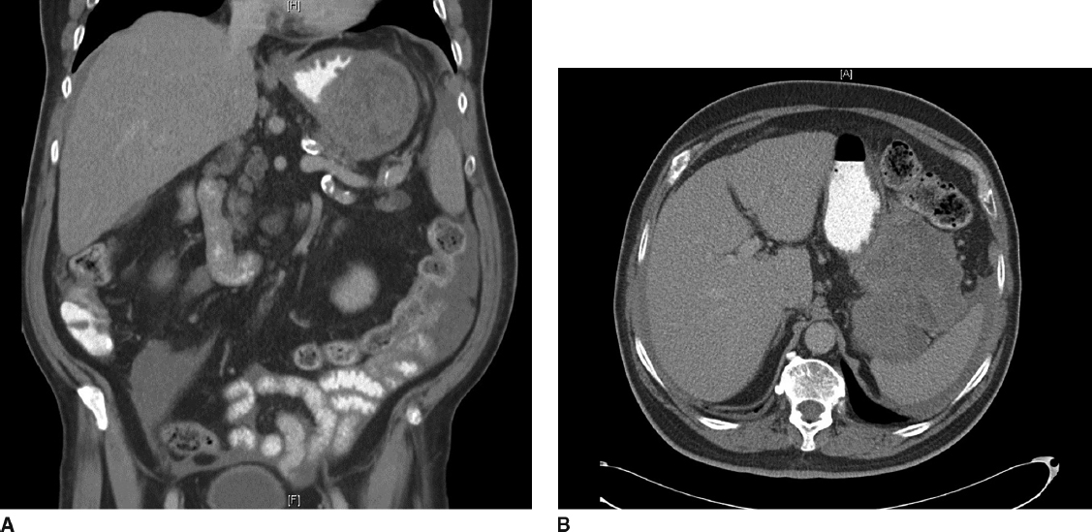
Diagnosis:
Gastrointestinal stromal tumor

What would you like to do next?
EGD

How would you perform that procedure?

Procedural sedation
Place in left lateral decubitus position
Insert scope into mouth under direct visualization
Pass the scope past the cricoarytenoid cartilage into the esophagus
Ensuring direct visualization, pass the scope through the esophagus with continuous insufflation in order to visualize the entire esophagus
Visualize the gastroesophageal junction and pass into the stomach

EGD demonstrates large submucosal mass without any ulceration.
If examinee asks for :
- biopsy: no pathologic abnormality
- EUS: large heterogenous mass contiguous with gastric wall without perigastric lymphadenopathy
- FNA: spindle cells, immunohistochemistry not performed. (FNA not necessary unless concerned for metastatic spread, unresectable or neoadjuvant therapy is planned)
- MRI or PET – not available

How would you treat this patient?
Resectable GIST. No neoadjuvant therapy is necessary

Describe operative approach:
Can perform laparoscopically or open.
- If laparoscopic need to describe position and port placement: lithotomy or supine position with 12mm port to the left of the umbilicus, 4 additional ports – right of umbilicus, right costal margin, left costal margin and liver retractor
- Open – supine position, upper midline celiotomy
Examine the abdomen for metastases
Resect the GIST with 1cm gross margin utilizing staple device, ensuring not to narrow the gastroesophageal junction.
Should use endoscopy or bougie to ensure against narrowing of stomach or GE junction. Should perform leak test
Ensure not to disrupt the pseudocapsule and cause spillage of tumor

Pathology returns 7cm gastrointestinal stromal tumor with mitotic rate >50/HPF
Any other recommendations for this patient’s care?

Imatanib for at least 3 years
H&P as well as CT scan every 6months-1 year for at least 10 years

Trauma MVC Pancreatic Injury
Stem: In the trauma bay, A 35-Year-old female, involved in a head on MVC. ATLS protocols are followed. You do primary and secondary surveys. IV access ensured, she is talking to you and is complaining of pain primarily in her chest and abdomen.
Vitals: HR of 130, BP 150/90, RR 18 and sating 99% on room air.
She is noted to have a seatbelt sign and. Her chest wall is mildly tender, her abdomen is peritonitic with severe epigastric tenderness.
Medical and Surgical history are unremarkable.
FAST / CXR are negative.

How are you going to manage this patient?
- ATLS
- Trauma panel (Labs are significant for WBC 16.0, Hgb 12.2, CMP is normal, and amylase is 300, lactate 1.0.
- CT scan shows a small amount of free fluid around the left upper quadrant and lesser sac, as well as a Grade 4 splenic laceration.
What is your differential diagnosis?
- Known splenic injury.
- Pancreatic Injury
- Perforated viscus (small bowel or stomach)

After CT scan, her BP trends down to 80/40, HR 140.
- Transfuse blood products (start with 2 units PRBCs)
- Ex.lap
  - Open / Explore
  - Pack 4 quadrants (Blood pressure responded to transfusion)
  - Splenectomy
  - Explore
Splenectomy was uncomplicated, hemostasis achieved, patient is hemodynamically stable.
You notice mild contusion of the pancreatic body, you can’t see obvious duct injury? What would you do?
Place Darin
You place a drain and conclude your operation, patient is closed, no packs left. Patient is clinically stable on POD 1 , on POD 2 you notice the drain is putting > 350 cc per day , output looks serosang. Your junior resident is asking you if they can obtain labs from the drain output, would you like to order specific labs?
Amylase from drain: > 2 times upper limit of normal
Next day drain is with higher output , what would you like to do?!
- MRCP with secretin stimulation for evaluation of main pancreatic duct (ERCP is an acceptable alternative, but risk of worsening pancreatitis in trauma patient): MRCP negative
- Consider octreotide.
- Repeat CT in 4-6 weeks?
What If persistent drainage , now a fistula? ERCP / Stent
What if when obtained MRCP earlier, it showed main pancreatic duct disruption?! ERCP/ Stent
ERCP attempted, Due to the patient’s anatomy, multiple attempts at pancreatic ductal cannulation were unsuccessful and the procedure was aborted. The patient continues to have high output of the LUQ drain despite being on octreotide How would you manage?

Ex lap for distal pancreatectomy.
- Attachments of spleen will already have been mobilized thus mobilize splenic flexure more if improved visualization needed.
- Open entirety of gastrocolic ligament.
- Mobilize tail of pancreas to confluence of SMV/Splenic vein and transect pancreas.
- Sharp division or division with energy device with oversewing of duct and gland. +/- oversewing.
- Can cover with omentum

Cholecystectomy Complications
Stem: Patient is a 65-year-old man who presents to the emergency department 3 days after laparoscopic cholecystectomy for acute, calculous cholecystitis. He has been having worsening epigastric and RUQ abdominal pain, PO intolerance, chills, fevers, jaundice, darkened urine.
He is otherwise without significant past medical or surgical history.
Exam: HR 114bpm, BP 94/37; 94% on RA, 38.8C, Ill appearing, lethargic, jaundice, scleral icterus Mildly distended, TTP in the RUQ and epigastrium.
Pertinent labs: WBC 16.4k; Tbili 4.3; AST 143; ALT157; ALK Phos 312; Creatinine 1.73 (normal 0.90)

What’s one initial study would you like to order now?
RUQ US –dilated intra and extrahepatic bile ducts with CBD measuring 1.1cm, mild RUQ fluid, and distal common bile duct stone.

How are you going to manage this patient.
- Sepsis workup.
- Resuscitation / hydration/ antibiotics.
- ERCP : You are not credentialed to do it and your GI colleague is on vacation.
- PTC: Your IR colleagues are not available
- Urgent CBD exploration:
  - Open CBD Exploration.
  - Kocherize the duodenum, palpation of the common bile duct to assess location/mobility of the stone, exposure of anterior CBD
  - Place sutures at the 10 and 2 positions and make an anterior vertical ductotomy.
  - Flush duct with small diameter red rubber and pass a biliary Fogarty catheter proximally and distally until all stones are removed.
  - Choledochoscope can be used with wire basket to retrieve challenging stones.
  - Close ductotomy over a 14 fr T-tube
  - Perform completion cholangiogram.
  - Leave JP drain.

Scenario 2: Same patient arrives, RUQ US notes intra and extra hepatic ductal dilation, mild fluid, no stone is appreciated. You are now in a tertiary center with all images and expertise available.
- ERCP or MRCP or advanced imaging to delineate etiology → 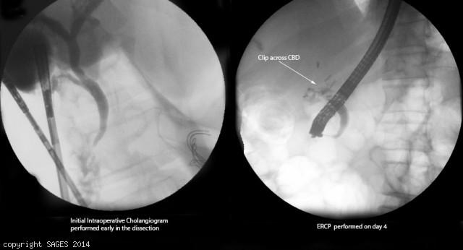
Concern for clip across CBD
- Antibiotics
- IR consultation for PTC.
You take the patient to the OR for repair, how do you repair the following?
- Injury < 50% circumference, not caused by cautery - Repair over T tube.
- Transection < 1 cm in size and away from bifurcation - End to end anastomosis.
- More severe injury, or close to the bifurcation: Hepaticojejunostomy -- Describe.
Scenario 3: Same patient however with AST/ALT and Alk phos within normal limits, Tbili slightly elevated to 2.4. RUQ US shows concern for large fluid collection in the RUQ.
1. HIDA: Shows biliary leak.
2. ERCP obtained → cystic duct stump leak confirmed → Sphincterotomy and Stent
3. IR for drainage of RUQ fluid collection if symptoms do not resolve, persistent leakage or septic.

