Room 5Question 1
Volvulus
Stem: ER calls you to see an 83-year-old male presenting with severe, persistent upper abdominal pain, and multiple episodes of emesis over the past 48hr. He has dementia and lives in a nursing facility, so history is difficult to obtain.
Vitals: Tachycardic at 105, normotensive, afebrile.
Exam: His abdomen is distended and TTP in the LLQ but without guarding or rigidity.
Labs: WBC 12k, lactic of 2.0.
KUB is obtained, interpreted as “Grossly dilated colon. No evidence of pneumoperitoneum”

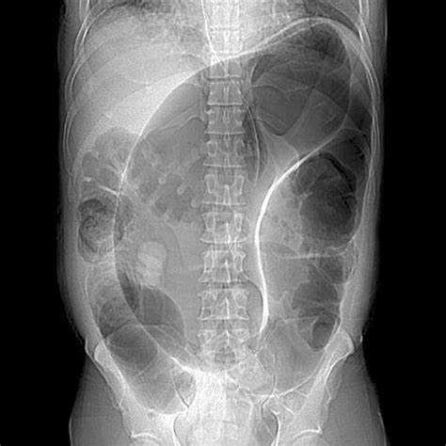

What is your differential diagnosis?
- Sigmoid Volvulus.
- Large bowel obstruction
- Cancer.
- IBD.
- Pseudo obstruction
What would you do for this patient, what is your work up diagnosis and management?
- Resuscitation
- CT abdomenomenomen / pelvis with IV contrast→demonstrates sigmoid volvulus
- Sigmoidoscopy for decompression(Resident must say they will do it themselves, not consult GI)
You successfully detorse the patient and he begins feeling better. Now what?
- -Admit.
- - Bowel prep.
- - Ostomy marking.
- - Plan Sigmoidectomy (Due to risk of recurrence)
  - All approaches acceptable, residents need to describe (open, lap, robotic . primary anastomosis +/- diversion versus end colostomy.
Scenario: This same patient arrives and is diffusely TTP with evidence of guarding. He is febrile to 102 and has leukocytosis to 17k. What would you do differently?
1. proceed directly to OR for Sigmoidectomy.
H e is now POD3. You are called to the bedside by the wound ostomy nurse and with concerns about the appearance of the ostomy. She says the “Ostomy is dusky in appearance with patchy areas of blackness”How do you proceed?
1. Insert test tube or flexible scope to assess if necrosis descends below the level of the fascia
2. if the necrotic tissue does descend below the level of the fascia?→Patient needs a revision of their ostomy in the operating room, otherwise observe.
Scenario 3: This patient is a 58-year-old female with hx of HTN, HLD, 5 vaginal deliveries presenting with acute abdominal pain, and KUB demonstrating a distended air-filled cecum within the central abdomen. What is your approach to this patient?
1. Operative; no role for non-operative management or endoscopic.

