GIST

A 70-year-old male presents to your office with complaints of 4 months of early satiety. He denies any nausea/emesis, constipation. He denies hematochezia or hematemesis. Last colonoscopy 5 years ago, normal. He endorses a 10lb weight loss in the same amount of time

PMHx: hyperlipidemia, hypertension

PSHx: inguinal hernia repair 30 years ago

Meds: metoprolol, statin, baby aspirin

SocHx: social drinker; 20 pack year history smoker, quit 20 years ago

FH: Noncontributory

Vital Signs: BP 142/85 HR 75 99% on room air

PE: well appearing male although thin. Abdomen soft, nontender with palpable left upper abdominal mass. No associated lymphadenopathy

How would you work up this patient?

Work up:

CT abd/pelvis with IV/PO contrast – 7cm heterogenous mass associated with the gastric fundus without evidence of liver or peritoneal metastases or adenopathy

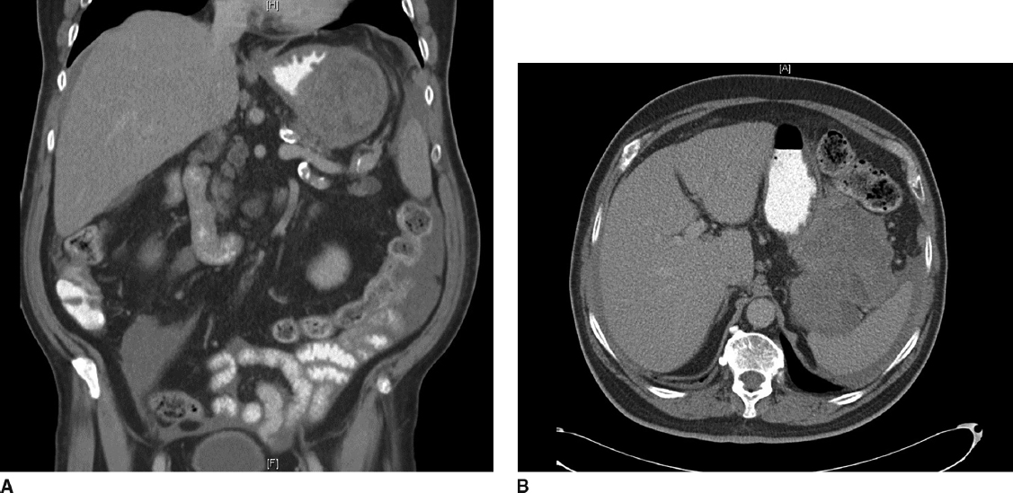

Diagnosis:

Gastrointestinal stromal tumor

What would you like to do next?

EGD

How would you perform that procedure?

Procedural sedation

Place in left lateral decubitus position

Insert scope into mouth under direct visualization

Pass the scope past the cricoarytenoid cartilage into the esophagus

Ensuring direct visualization, pass the scope through the esophagus with continuous insufflation in order to visualize the entire esophagus

Visualize the gastroesophageal junction and pass into the stomach

EGD demonstrates large submucosal mass without any ulceration.

If examinee asks for :
- biopsy: no pathologic abnormality
- EUS: large heterogenous mass contiguous with gastric wall without perigastric lymphadenopathy
- FNA: spindle cells, immunohistochemistry not performed. (FNA not necessary unless concerned for metastatic spread, unresectable or neoadjuvant therapy is planned)
- MRI or PET – not available

How would you treat this patient?

Resectable GIST. No neoadjuvant therapy is necessary

Describe operative approach:

Can perform laparoscopically or open.
- If laparoscopic need to describe position and port placement: lithotomy or supine position with 12mm port to the left of the umbilicus,4additional ports –right of umbilicus, right costal margin, left costal margin and liver retractor
- Open – supine position, upper midline celiotomy

Examine the abdomen for metastases

Resect the GIST with 1cm gross margin utilizing staple device, ensuring not to narrow the gastroesophageal junction.

Should use endoscopy or bougie to ensure against narrowing of stomach or GE junction. Should perform leak test

Ensure not to disrupt the pseudocapsule and cause spillage of tumor

Post operative care

Advance diet as tolerated

Pathology returns as below: Any other recommendations for this patient’s care?

7cm gastrointestinal stromal tumor with mitotic rate >50/HPF

Follow up:

Imatinib for at least 3 years

H&P as well as CT scan every 6 months to 1 year for at least 10 years

Pitfalls:

Performing total gastrectomy for GIST
performing lymphadenectomy without obvious evidence of involvement

Not placing patient on imatinib given pathology

