

**CLOUD COMPUTING**

**PROJECT REPORT**

**ON**

**“E-LEARNING PLATFORM”**

Pushpender Singh1, Manish Singh Bisht2

*Dept. of Computer Science Engineering*

Manav Rachna University

Faridabad, Haryana

[pstewatia6102@gmail.com](mailto:pstewatia6102@gmail.com)

[manish1singhbisht@gmail.com](mailto:manish1singhbisht@gmail.com)

Under the supervision of

Dr. Shalu

Assistant professor

*Dept. of Computer Science Engineering*

Manav Rachna University

Faridabad, Haryana

Table of Contents

**INTRODUCTION6**

**OBJECTIVE6**

**TECHNOLOGY USED6**

**USER SPECIFICATION7**

**APPLICATION OF PROJECT7**

**PROJECT VISION 7**

**DEPLOYMENT ON 000WEBHOST 8**

**CONCLUSION AND FUTURE SCOPE** 1**3**

**REFERENCES** 1**3**

**SUPERVISOR CERTIFICATE**

This is to certify that this report entitled “**E-Learning platform**” submitted by Mr. Pushpender Singh, Mr. Manish Singh Bisht Department of Computer Science & Engineering of Manav Rachna University of Science & Technology, Faridabad, Haryana.

In my opinion, this work fulfills the requirement for which it has been submitted. This thesis has not been submitted to any other university or institution for any degree.

**Dr. Shalu**

**(Supervisor)**

**CANDIDATE’S DECLARATION**

I hereby certify that the work which is being presented in this project entitled “**E-Learning Platform**” is an authentic record of our own work carried out under the supervision of Dr. Shalu, Assistant Professor. The matter presented in this report has not been submitted by me for the award of any other degree in any other Institute / University.

**Pushpender Singh**

**(2K20CSUN05016)**

**Manish Singh Bisht**

**(2K20CSUN05013)**

**ACKNOWLEDGEMENT**

We have taken a lot of effort into this project. However, completing this project would not have been possible without the support and guidance of a lot of individuals. We would like to extend our sincere thanks to all of them. We are highly indebted to Dr. Shalu for their guidance and supervision. We would like to thank him for providing the necessary information and resources for this project. We would like to express our gratitude towards our parents & our friends for their kind co-operation and encouragement which help us a lot in completing this project. Our thanks and appreciations also go to our colleague in developing the project. Thank you to all the people who have willingly helped us out with their abilities.

**1   Introduction**

With the advancement in technology, a huge change is happening in the education system. Nowadays with easy access to the internet and smartphones, everyone can connect and access online resources.

In this cloud computing project, we will develop an e-learning platform using cloud computing as cloud computing is widely used in various fields because of its various applications and easy deployment.

It is a method of learning that allows a person to study from anywhere in the world. We can store the study materials, books, and control information for this project on the project’s website, which will be organized with in different courses. The information from the website is then kept in the cloud.

**2. Objective of the Project**

The main objective of the E-Learning is to help the students with the notes that are easily available through various option of courses on the website through the internet. The information from the website is then kept in the cloud. A learning space where study materials and relevant videos are stored for the learner’s benefit. The learners can access them and use them as and when required by them. Learning new concepts, sharing study materials, and reusing resources are some major parts of the e-learning process.

Some more objectives are -

* to reduce the paperwork.
* Reduced manual effort.
* Reduced cost.

**3. Technology Used**

* **Front-end**
* HTML
* CSS
* Javascript
* **Back-end**
* MySQL
* **Platform for deployment**
* 000webhost

**4. Requirement Specification**

* The platform should be easy to use and navigate for learners of all ages.
* The platform should offer a variety of courses and study materials to cater to different learning needs and preferences.
* The platform should allow learners to interact with each other, share study materials, and collaborate on projects.
* The platform should have a search functionality to help learners quickly find the study materials they need.
* The platform should be accessible from any device with an internet connection.
* The platform should have a secure login system to protect user data and prevent unauthorized access.
* The platform should provide progress tracking and assessment tools to help learners monitor their learning.

**5. Applications of the Project**

* Any individual user
* Student
* Coaching institute
* Schools or colleges
* organizations

**6. Project Vision**

Our vision is to create a user-friendly and comprehensive e-learning platform that offers a wide range of courses and study materials to learners all over the world. By leveraging cloud computing, we aim to reduce the manual effort and cost associated with traditional education methods while providing a more flexible and accessible learning experience. We want to empower learners to take control of their education and learn at their own pace while still being able to interact with others and collaborate on projects.

**7. Deployment on 000webhost**

000webhost is a free web hosting service that allows users to deploy their websites without the need for a paid hosting plan. It offers a simple and user-friendly platform that enables individuals and small businesses to get their online presence up and running quickly and easily. With 000webhost, users can create and deploy websites using popular content management systems like WordPress, Joomla, and Drupal, or they can choose to build their websites from scratch using HTML, CSS, and JavaScript. Additionally, 000webhost provides tools for domain registration, website builder, and email services, making it a comprehensive solution for those looking to establish a professional online presence.

E-Learning Platform deployed on 000webhost:

Link for the website - **https://hellostudypoint.000webhostapp.com/**

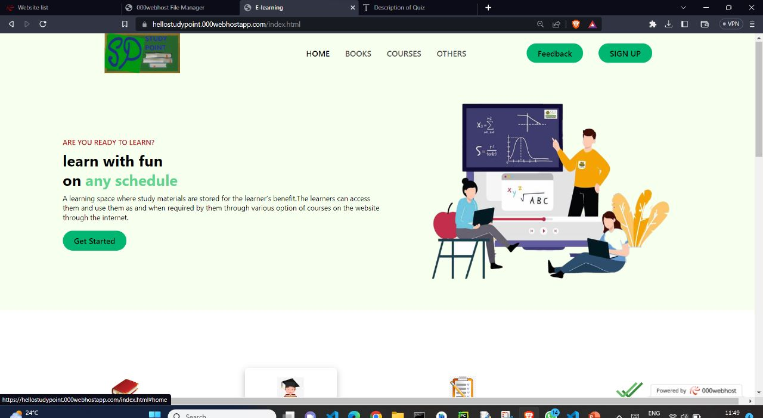

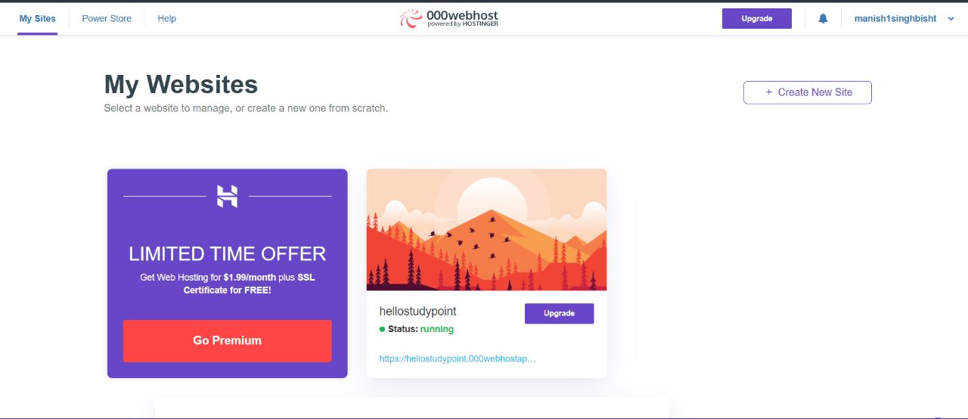

**Main Page:**

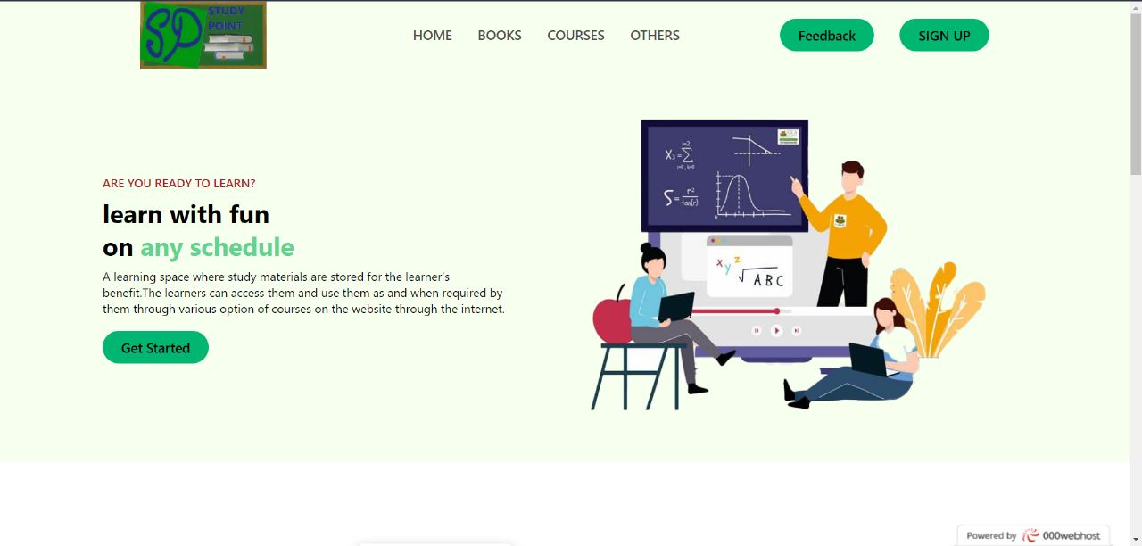

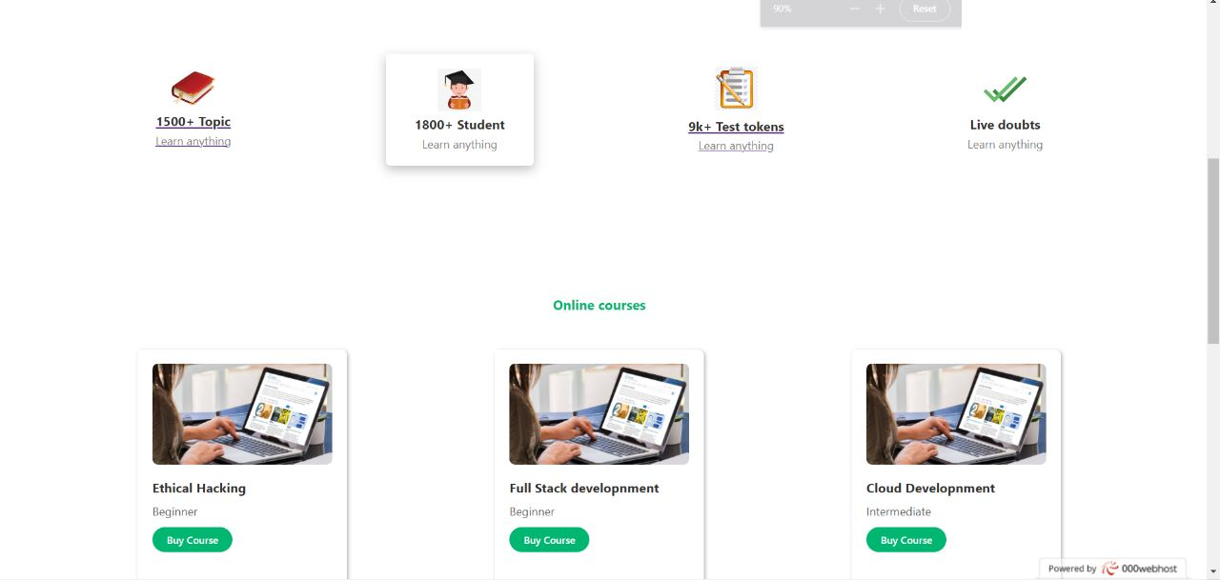

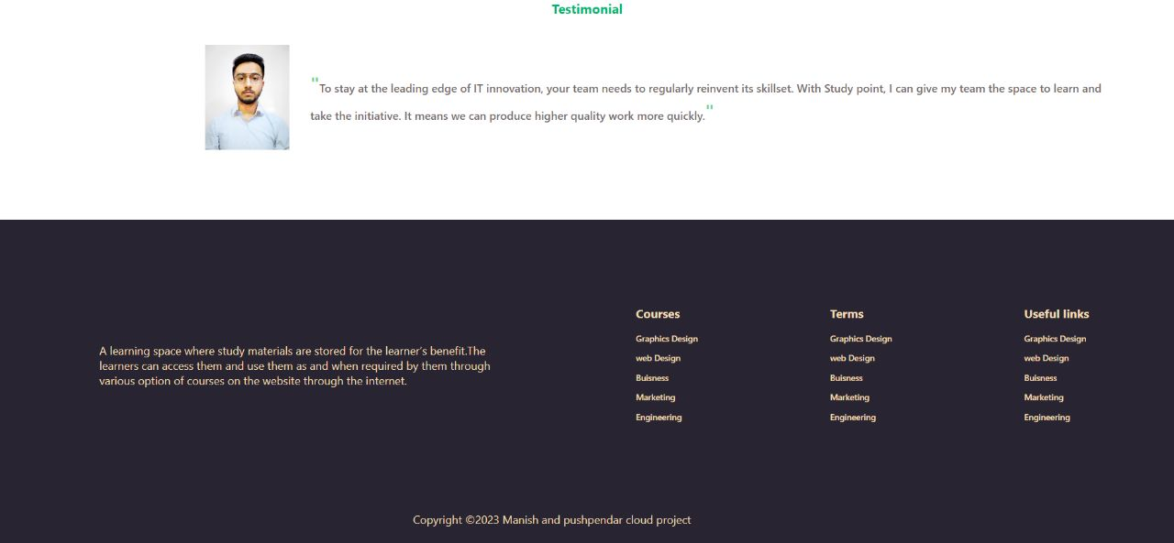

**Books/Notes Section:**

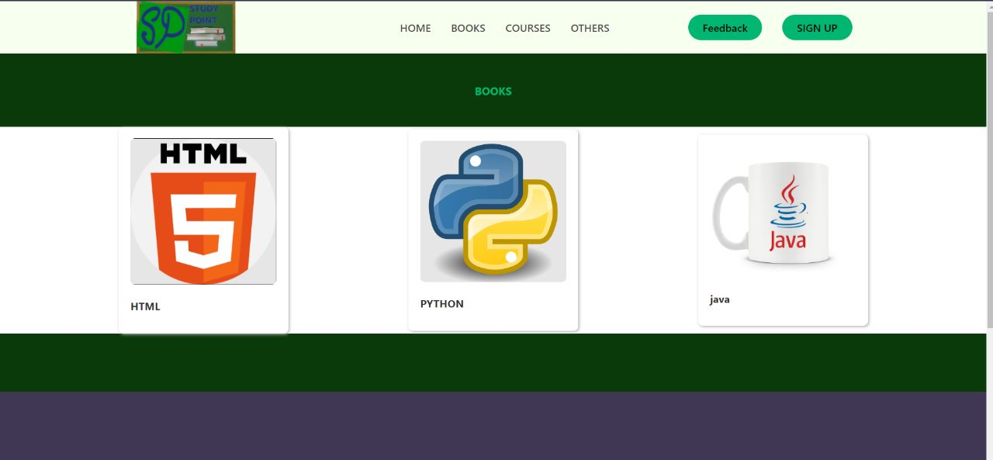

**HTML Notes:**

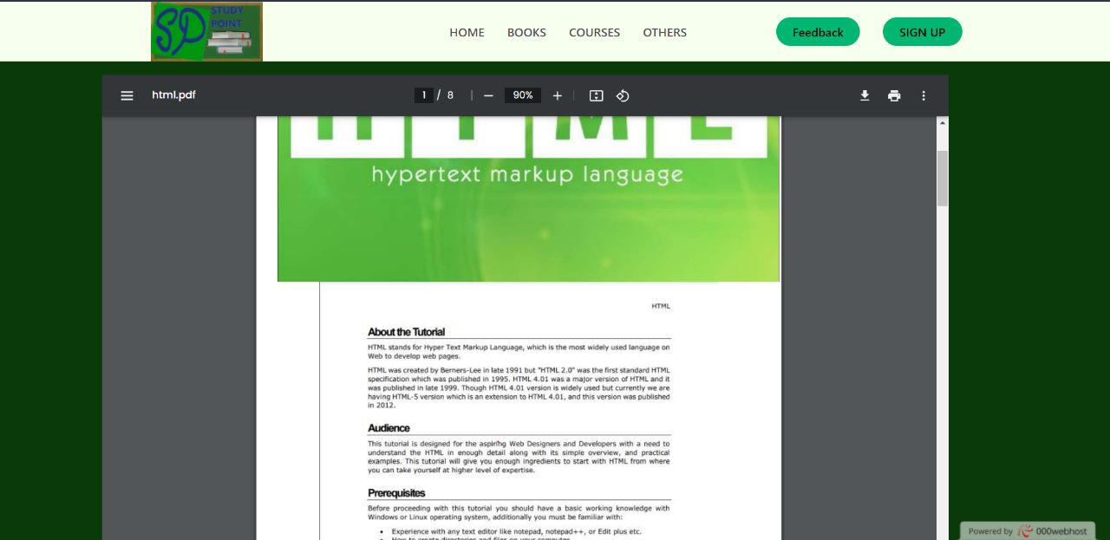

**Test Section:**

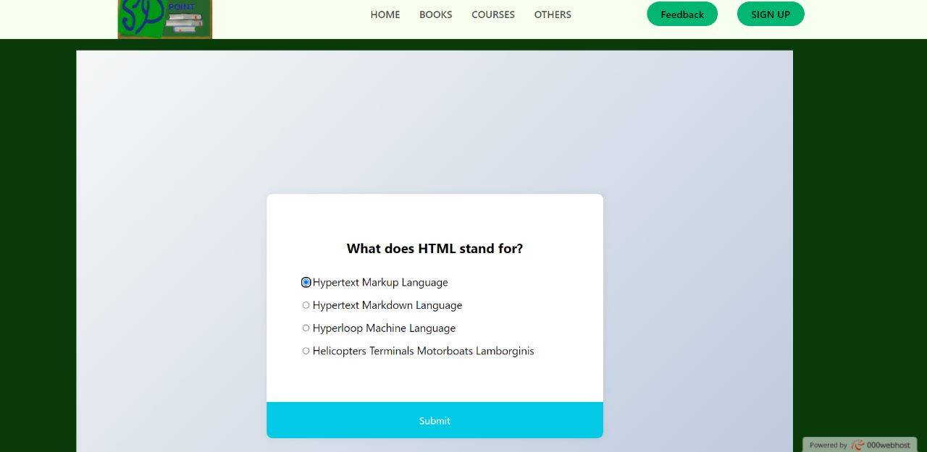

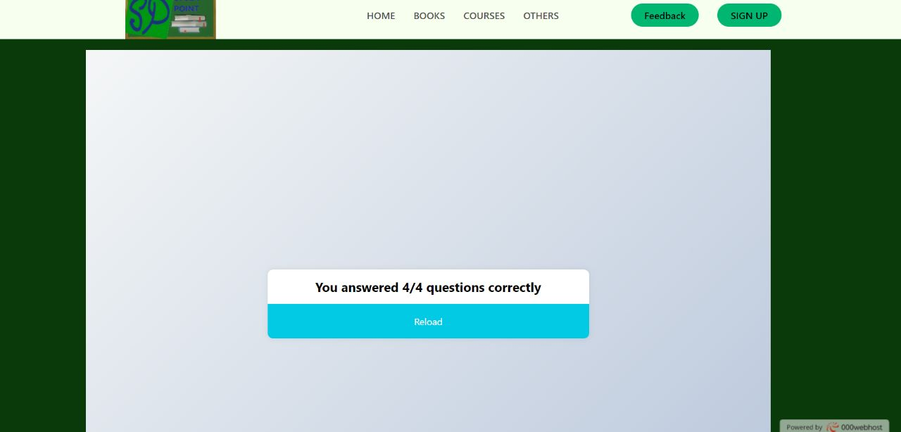

**Feedback Form with Database entries:**

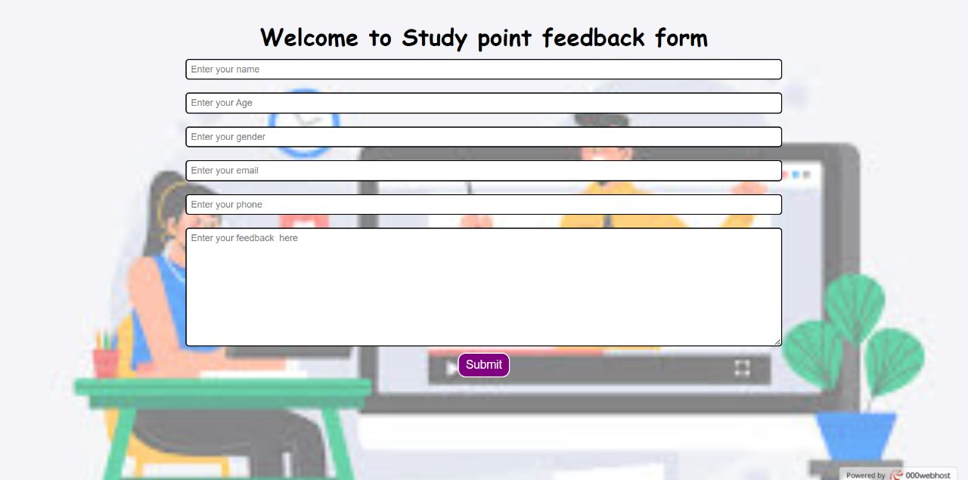

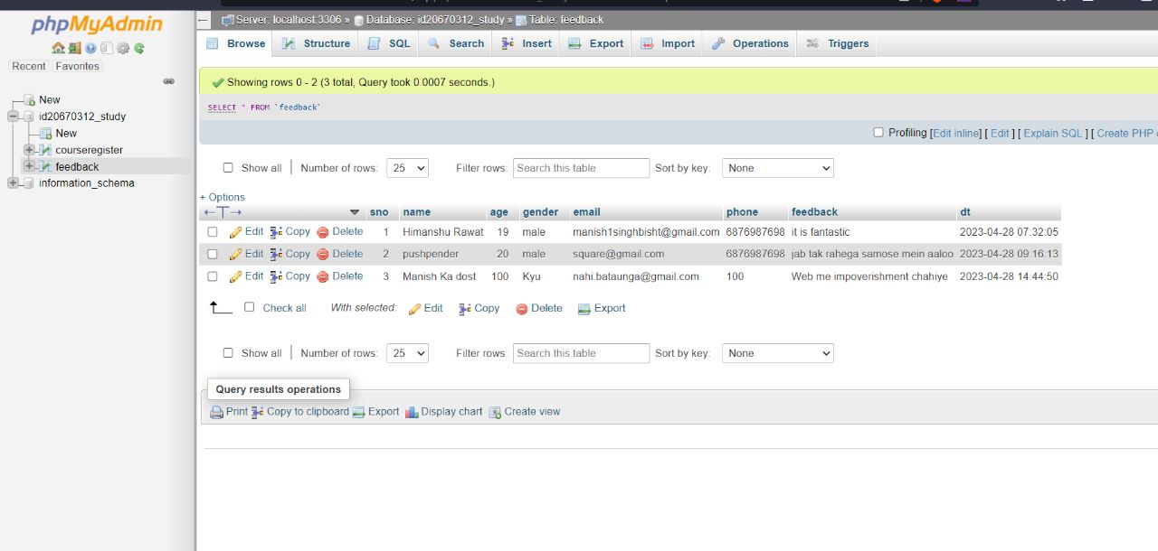

**Register Course Form with Database entries:**

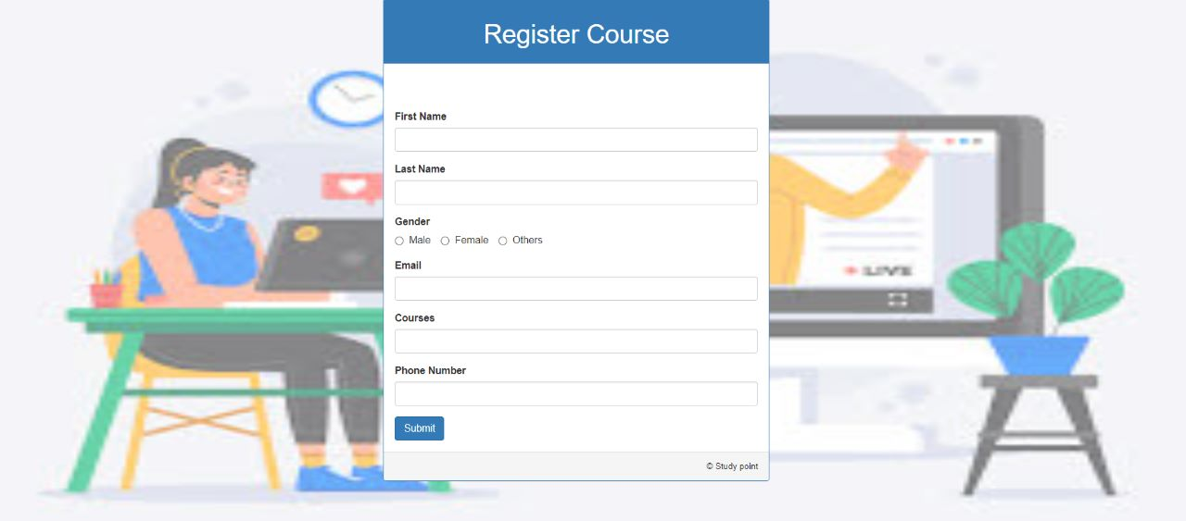

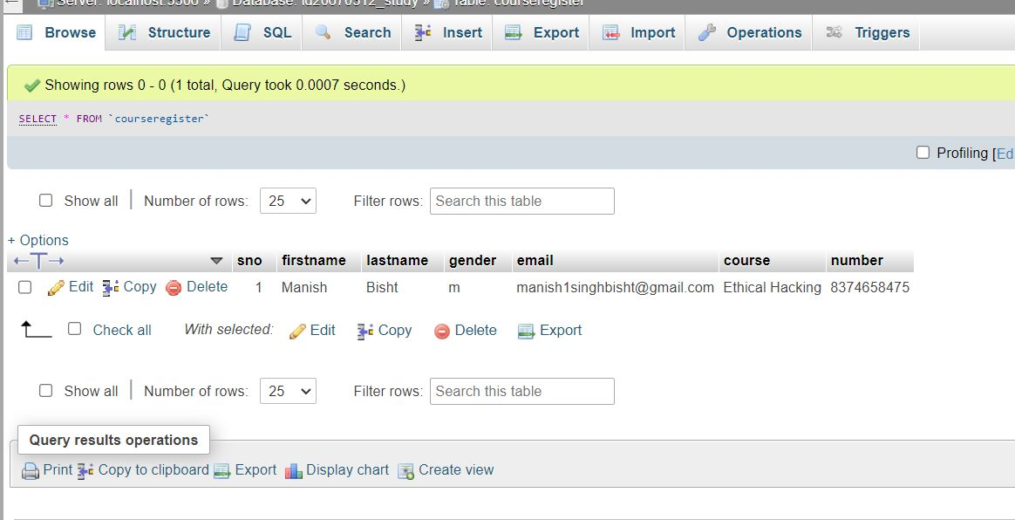

**8.Conclusion & Future Scope**

In conclusion, the e-learning platform we are developing using cloud computing has the potential to revolutionize the education system by making it more accessible, affordable, and flexible. By meeting the user requirements of ease of use, variety of courses and study materials, collaboration tools, accessibility, security, and progress tracking, we hope to create a platform that can cater to the diverse learning needs of people from all over the world. We believe that our platform can contribute to reducing the paperwork, manual effort, and cost associated with traditional education methods and create a more sustainable and equitable learning environment.

**References**

[1] Sourya, B. (2011). How Can Cloud Computing Help In Education? http://www.cloudtweaks.com/2011/02/how-can cloud-computing-help-ineducation/#.

[2] https://www.w3schools.com/

[3]https://www.tutorialspoint.com/latest/prime-packs?gclid=CjwKCAjwo7iiBhAEEiwAsIxQEUCNDGz9zPydEtpaO7p3akPFf3FseJ_EcJUxwCDppeFRso01_iit0xoCHxsQAvD_BwE

[4] <https://www.studocu.com/in/document/i-k-gujral-punjab-technical-university/project-ii/e-learning-website-project/42574508>

[5] https://www.slideshare.net/YashrajNigam/e-learning-project-report-yashraj-nigam

[6] <https://www.freeprojectz.com/e-learning> management system/1843

[7] <https://www.academia.edu/11193313/E_LEARNING_SYSTEM>

http://www.cgisecurity.com/ws/WestbridgeGuideToWebServicesSecurity.pdf

[8] https://en.wikipedia.org/wiki/Learning_management_system