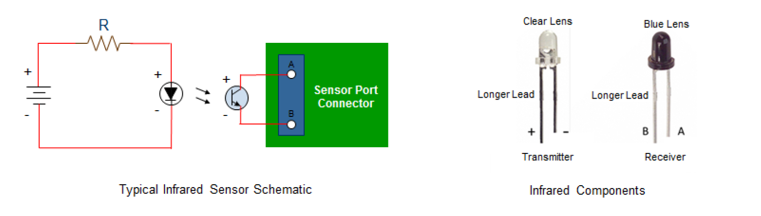

DETECTOR LED (BLACK)

3mm Phototransister filtered Lite-On

[Mouser p/n: 859-LTR-4206E

Sentry module common (b) - (green & black phone jack terminals) - detector long, (insulated; white stripe)

individual sentry ports (A) - (red & yellow phone jack) - detector short (bare, solid color)

***

***

INFRARED LED (CLEAR)

3mm IR LED - IR 940nm Emitter

C/V: 20 ma / 1.2 -1.5 v

Chanzon p/n: AA0190x100

Power+ - resistor(R1) - LED detector long (red, insulated)

Power- - LED detector short (bare, Black) [- LED detector2 long (red, insulated) - LED detector2 short (bare, Black), etc]

***

***

Resistor values:

|  |  |
| --- | --- |
| #led's | R1 value |
| 1 | 560 |
| 2 | 510 |
| 3 | 430 |
| 4 | 360 |
| 5 | 300 |
| 6 | 240 |
| 7 | 180 |
| 8 | 120 |
| 9 | 60 |

Note: Modular DATA cable, not Phone cable, is used to connect detector LEDs to Sensor module

