SYSTEM ARCHITECTURE · REVERSE-ENGINEERED FROM SOURCE

Agentic AI Quality Assurance System
A three-tier platform that turns uploaded project documents into traceable test assets and deterministic Playwright automation — with human approval gates at every irreversible step, live browser-execution telemetry, failure classification and audited reporting.
AT A GLANCE | VALUE
Tiers | 3 (React · NestJS · FastAPI) plus an engine-embedded pytest runner
Source files read | ~280
Backend | ~12,500 LOC TypeScript · 18 modules · 24 entities
Frontend | ~10,000 LOC TypeScript/TSX · 19 pages
Python (engine, agents, tools, V1) | ~9,000 LOC · 6 LLM agents
Branch / HEAD | feature/ai-qa-agent-v3 at a8ceed47

Contents
Right-click here and choose Update Field to build the table of contents.

01 System context
What the system is, and the single invariant every layer is built around.
CORE PRINCIPLE
AI proposes; deterministic tools validate and execute.
Generated code is untrusted until syntax, policy and collection checks pass. No commit, CI dispatch or test execution happens without an explicit, recorded human approval.

A user uploads requirement documents (Word, PDF, Excel, text, Markdown, JSON). A local LLM analyses each requirement, drafts a test plan, generates structured test cases, then emits Playwright/pytest source. Deterministic tooling statically gates that source. A human approves it. Only then does it run in a real browser, streaming every navigate/click/fill/assert back to the UI as it happens. Failures are classified, evidence is collected, and a report is produced with measured metrics separated from AI narrative.
TIER | TECHNOLOGY | RESPONSIBILITY | PORT
Frontend  frontend/ | React 18, Vite 7, TypeScript, TanStack Query, socket.io-client | Upload and source preview, plan/case review, code editor and diff, approval inbox, live execution console, reports, audit | 5173
Backend  backend/ | NestJS 10, TypeORM, Passport-JWT, socket.io | System of record. Auth and RBAC, projects, documents, artefacts, approvals, jobs, executions, git/CI, WebSocket fan-out, audit trail | 4000
Engine  engine/ | Python 3.12, FastAPI, LangChain + ChatOllama, Playwright, pytest | Compute only. Document parsing, six LLM agents, static validation, Playwright execution with step telemetry, classification, report rendering | 8100
Database | PostgreSQL 16 (SQLite dev fallback) | 24 TypeORM entities — projects through audit events | 5432
Model host | Ollama (qwen2.5:latest) | Local inference — never leaves the host, never reached by the browser | 11434

The separation is strict and load-bearing: the engine never owns state. It receives inputs, returns versioned JSON, and streams events. Every artefact, decision and audit record lives in the backend's database. The engine's filesystem is a disposable runtime workspace.

02 Container architecture
Four processes, three protocols, one direction of trust. The browser never sees the engine token, the GitHub token, or the model.

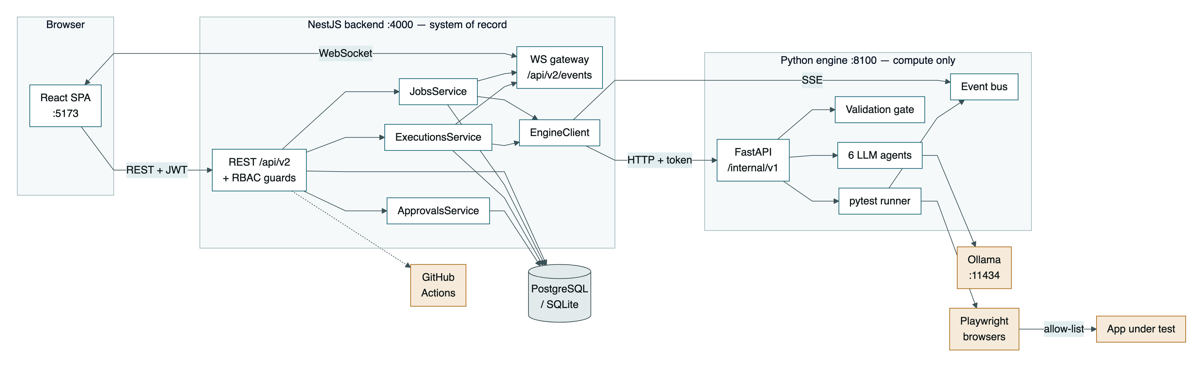
Figure 1 — Container architecture. The browser holds only a 15-minute access token; ENGINE_TOKEN and GITHUB_TOKEN exist server-side only. The engine is reachable exclusively from the backend, which authenticates with a constant-time token comparison.

Protocols between tiers
HOP | MECHANISM
Browser → Backend | REST over /api/v2, Bearer JWT, per-request x-correlation-id. A 401 triggers a single-flight refresh and replays the original request.
Backend → Browser | socket.io on /api/v2/events. Envelopes carry a monotonic seq per stream so a reconnect resumes from lastSeq.
Backend → Engine | HTTP with X-Engine-Token and Idempotency-Key on job submits; bounded exponential backoff on 502/503/504.
Engine → Backend | Server-Sent Events on /runs/{id}/events, replayable from from_seq even after the run has finished.
pytest → Engine | Page objects POST step events to a loopback ingest endpoint via a daemon sender thread — never blocking the browser dispatch path.
Agents → Ollama | LangChain ChatOllama with with_structured_output(...). No agent ever parses free text.

03 The pipeline and approval gates
Nine stages from uploaded document to published report. Shaded nodes mark the points where the workflow stops and a human decides.
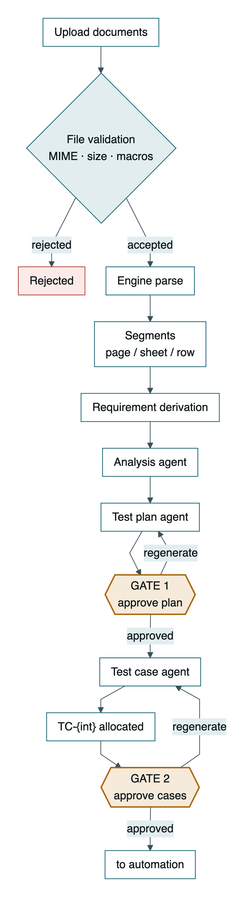 | 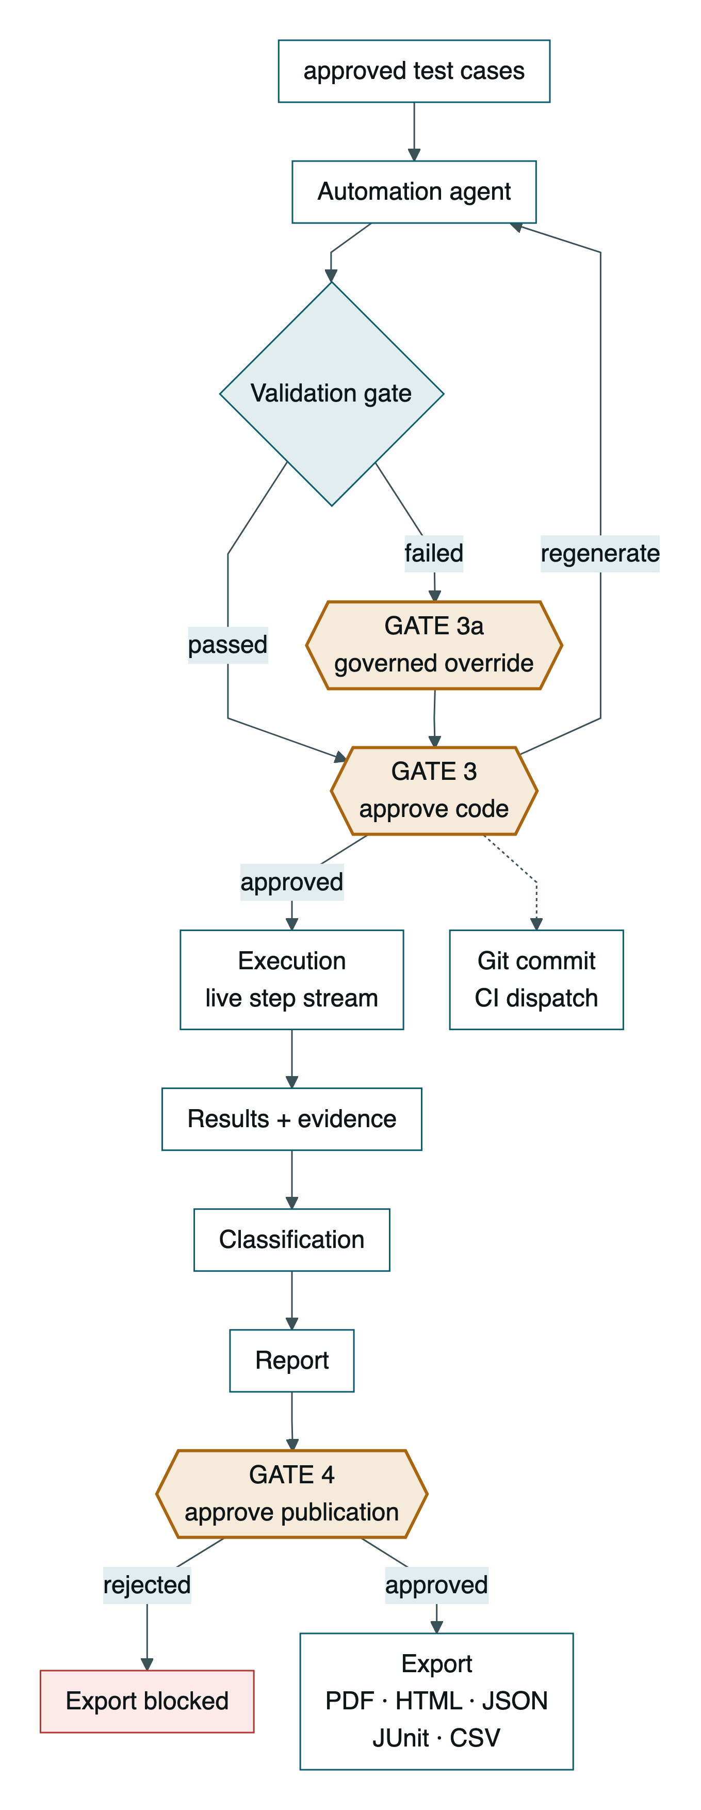
Figure 2 — The pipeline, split into its generation half (left) and its delivery half (right). Four approval gates plus one governed override.
APPROVAL INVALIDATION CASCADE
Approval is version-bound, so editing an approved artefact silently un-approves it and everything derived from it. ApprovalsService.onUpstreamModified() resets approvalStatus to pending, sets approvalInvalidated = true, marks prior approval records invalidated, and emits approval.updated.
Concretely: editing a test case resets every active automation artefact generated from it back to pending validation and pending approval. Editing the generated script does the same to that artefact and bumps its version. Approved code can never drift from the code that was actually reviewed.

Where each gate is enforced
GUARD | ENFORCED IN | FAILURE
Automation requires approved test cases | AutomationService.generate | 409 approval_required
Approval requires passed validation | AutomationService.approve | 409 validation_required
Execution requires approved + validated + active | ExecutionsService.resolveScope | 409 automation_not_ready
Git commit requires approved + validated | GitService.commit | 409 + denied audit row
CI dispatch requires ≥1 approved artefact | CiService.dispatch | 409 + denied audit row
Export requires publication not rejected | ReportsService.export | 409 report_publication_rejected

04 API surface
Two contracts: a public REST API the browser talks to, and a private internal contract only the backend may call.

Backend — /api/v2, JWT-guarded by default
A global JwtAuthGuard protects every route; @Public() opts out (auth/* and health only). A second global PermissionsGuard enforces @RequirePermission(...) against a role-to-permission matrix.
GROUP | REPRESENTATIVE ROUTES | PERMISSION
Auth | POST /auth/{register,login,refresh,logout} · GET /auth/me | public
Projects | GET|POST /projects · GET /projects/:id/{dashboard,metrics,export} | project.write
Documents | POST /projects/:id/documents · GET /documents/:id/preview | document.upload
Requirements | GET|POST /projects/:id/requirements · GET /requirements/:id/history | member
Generation | POST /projects/:id/{analysis-jobs, test-plans/generate, test-cases/generate, automation/generate} | generation.run
Artefacts | PATCH /{test-plans,test-cases,automation}/:id · GET /test-plans/:id/revisions/compare | artefact.edit
Approvals | POST /test-plans/:id/approval · POST /test-cases/approval (bulk) | approval.decide
Validation | POST /automation/:id/validate · POST /automation/:id/validation-override | generation.run
Executions | POST /executions · GET /executions/:id/{events,logs,results} · POST /executions/:id/{cancel,restart} | execution.run
Jobs | GET /jobs/:id/logs?fromSeq= · POST /jobs/:id/{cancel,retry} | generation.run
Findings | POST /results/:id/classify · POST /findings/:id/override | classification.override
Reports | POST /executions/:id/report/generate · GET /executions/:id/report/export | report.export
Git / CI | POST /projects/:id/git/commit · POST /ci/workflows/dispatch | git.push / ci.trigger
Audit | GET /audit?actor=&action=&resourceId=&from=&to= | authenticated

Engine — /internal/v1, X-Engine-Token required
ENDPOINT | DOES | LLM
POST /parse | base64 files to text plus located segments | —
POST /analyse | one requirement to actors, flows, rules, risk, issues | yes
POST /test-plan | project, requirements and analyses to a 10-section plan | yes
POST /test-cases | requirement plus analysis to N structured cases | yes
POST /automation | approved cases to Playwright files and page objects | yes
POST /classify | failure to app_defect | test_defect | environment | data | inconclusive | yes
POST /report | run data to HTML, Markdown and narrative | partial
POST /validate | files to a ValidationReport | deterministic
POST /execution-plan | cases to ordered navigate/fill/click/assert steps | deterministic
POST /execute | spawns the pytest run, returns immediately | deterministic
POST /render-pdf | HTML to a real PDF via headless Chromium | deterministic
GET /runs/:id/events | SSE stream, replayable from from_seq | —
POST /runs/:id/_ingest | loopback sink for step events from pytest | —

Generation endpoints honour an Idempotency-Key header against a bounded in-process cache (1000 keys, 24-hour TTL, oldest evicted) so a retried submit returns the original result rather than paying for a second inference.

05 Real-time event path
A click inside a headless browser reaches the user's screen across three process hops and two protocol changes. Every hop is ordered, bounded and replayable.

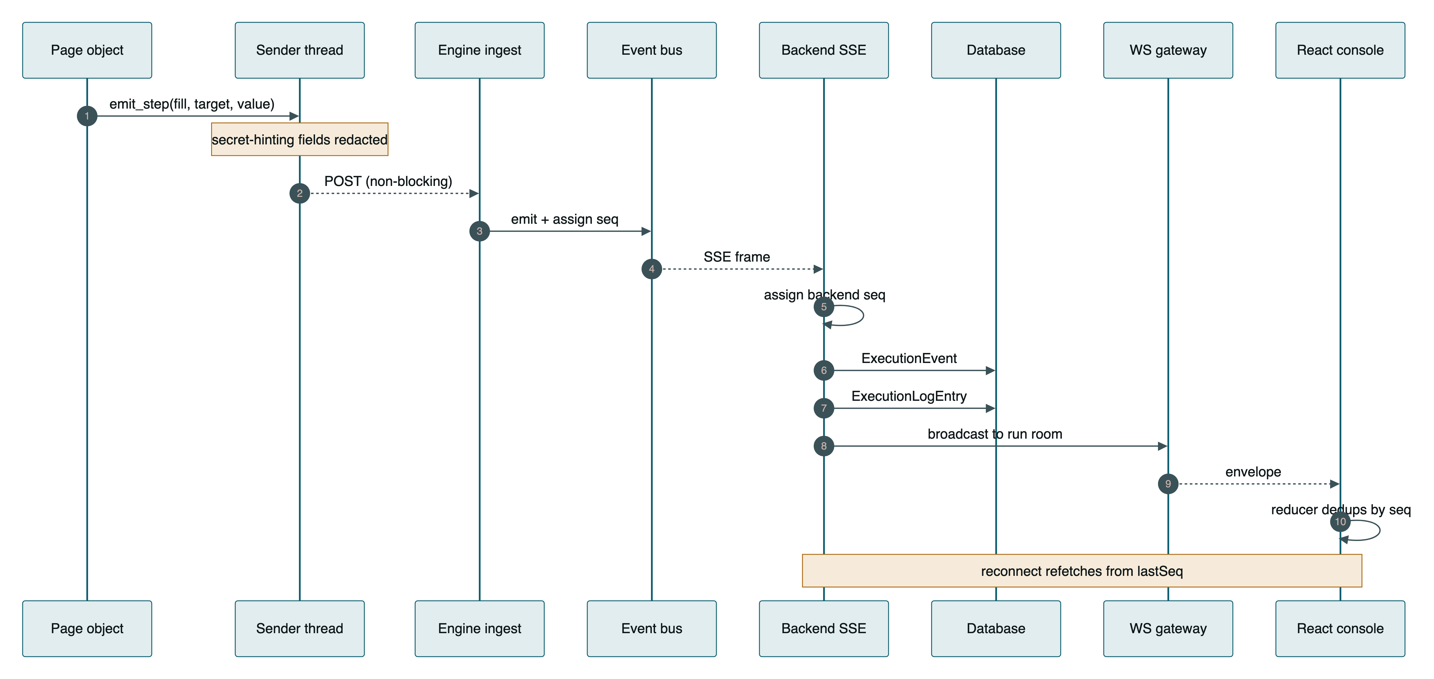
Figure 3 — Live execution telemetry. Two independent streams per run: ExecutionEvent carries machine telemetry, ExecutionLogEntry carries the human CI-style console. Both replay by seq.

Ordering and back-pressure guarantees
- Never blocks the browser. emit_step enqueues to a bounded queue and returns. Under back-pressure the oldest telemetry is dropped — the run keeps moving.
- Never hangs a consumer. eventbus.close(run_id) runs in a finally, so SSE readers terminate even if the worker crashes.
- Bounded memory. 10,000 events retained per run; 200 completed runs kept replayable before the oldest are evicted.
- Survives a backend restart. In-memory seq counters are primed from the persisted stream so a resumed run never reuses a sequence a client already saw.
- Scoped delivery. Envelopes go to project:{id} and run:{id} rooms; per-user notifications go only to user:{id}.

Event vocabulary
job.progress · job.log · job.completed · job.failed · job.cancelled · analysis.ready · plan.ready · cases.ready · automation.ready · validation.ready · approval.updated · execution.step · execution.status · execution.log · notification.new · ci.status
The frontend's useProjectEvents folds these into precise TanStack Query invalidations rather than polling — and deliberately narrows the high-frequency job.progress to the jobs key alone, so progress ticks cannot trigger a refetch storm.

06 Job and execution runtime
Local LLM generation takes minutes and a browser run takes longer. Everything long-running is a job with progress, a live log, cooperative cancellation and a hard timeout.

Generation jobs
A controller creates a Job row and dispatches a worker without awaiting it, acknowledging in under two seconds. Each worker receives a JobContext exposing log(), isCancelled() and checkpoint().
- Cancellation is cooperative. POST /jobs/:id/cancel sets cancelRequested; the worker throws at its next checkpoint(). A still-queued job cancels immediately.
- Timeouts race the worker. Promise.race([worker, timeout]) at JOB_TIMEOUT_MS (default 30 minutes). The loser keeps running, so an abort latch stops the orphan from writing artefacts under a terminal job.
- Retry is traceable. Each feature service registers a RetryHandler that rebuilds the job from its stored inputRefs; the new job records retryOfJobId.
- Logs replay. Every line is persisted with a monotonic seq, so a browser refresh mid-job resumes the console without duplicates.

Execution runs
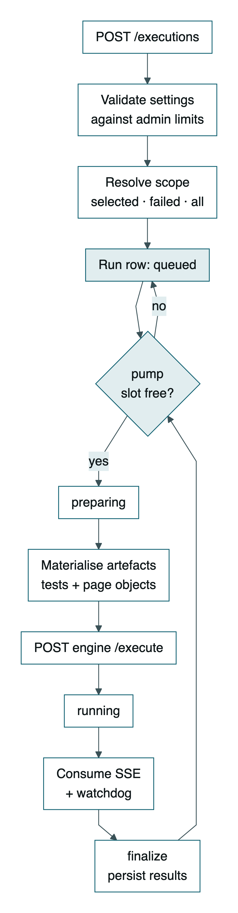
Figure 4 — Execution queue. Concurrency is capped at EXEC_MAX_CONCURRENT (default 1); pump passes are chained so two passes can never claim the same queued run.
ASPECT | BEHAVIOUR
Run scope | selected — chosen artefacts · failed — paths that failed in the last finished run · all — every approved and validated artefact
Admin-bounded settings | timeout 30–1800s · retries 0–3 · workers 1–4 · slow-mo 0–2000ms · screenshot policy · video. Out-of-range requests are rejected with the limits attached.
Artefact materialisation | The database is the artefact store. Test files and every active page object in the project are written into the engine workspace at submit time, so imports always resolve.
Three layers of timeout | pytest's own timeout, the engine's communicate(timeout=) with SIGTERM then SIGKILL on the process group, and a backend watchdog at timeout + 120s that reclaims a stalled slot.

Cancellation kills the whole process group — the runner starts with start_new_session=True specifically so os.killpg reaches pytest and its browser children. SIGTERM first, SIGKILL after a 10-second grace period.

07 Domain model
Twenty-four entities. The spine is a lineage chain: every artefact points back to the generation run that produced it and the source it came from.
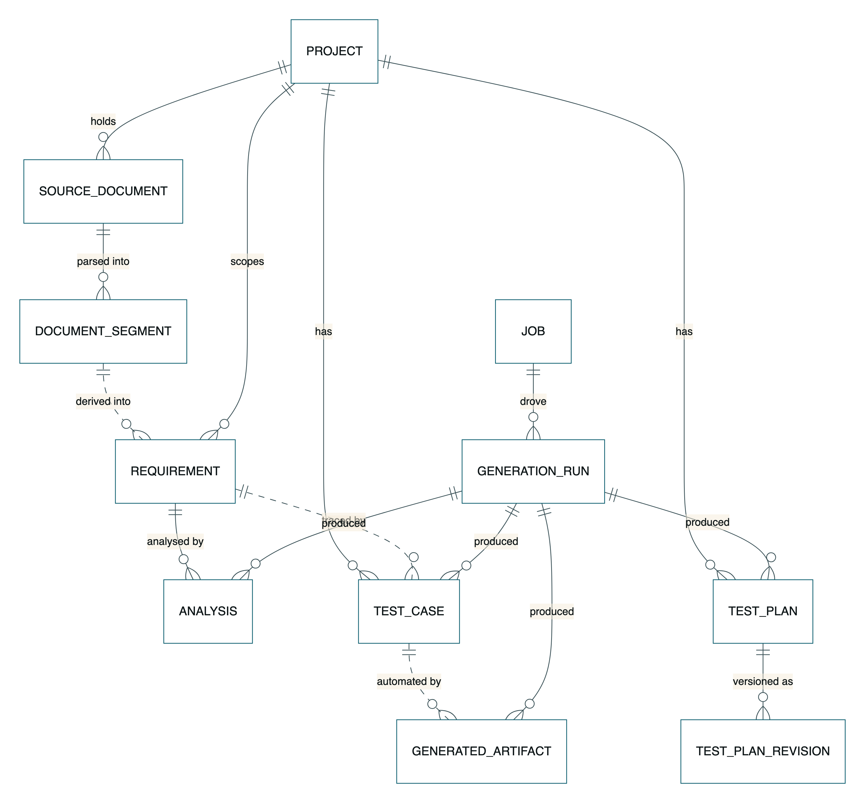
Figure 5 — Artefact lineage, document through generated automation. Dotted relationships are JSON id-array associations resolved in application code.

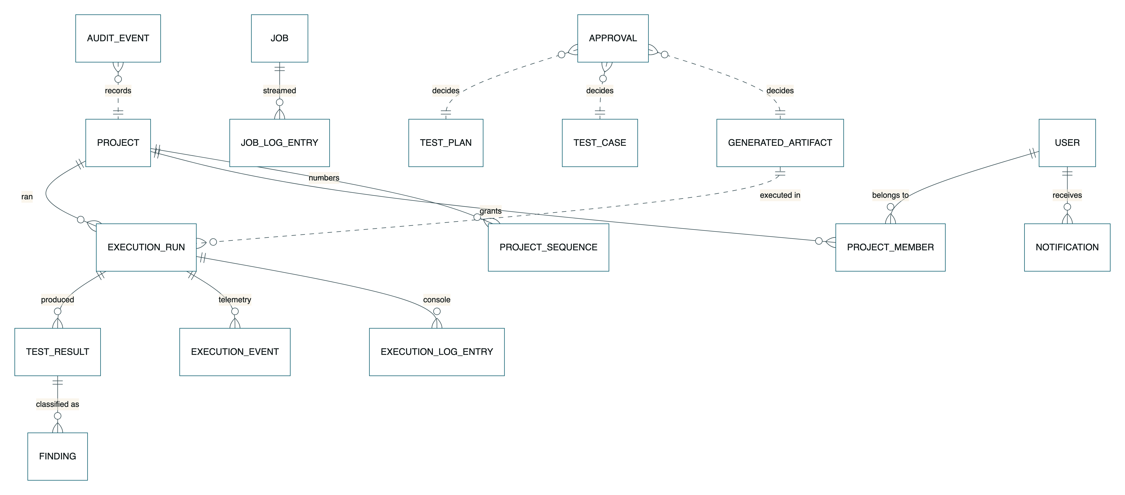
Figure 6 — Execution, governance and access. Approvals bind to a specific artefact version; audit events are append-only.

Provenance columns carried by every artefact
COLUMN | PURPOSE
contentHash | Stable SHA-256 over canonicalised JSON — detects drift and identical regeneration
version | Monotonic; incremented on every edit, never reset. Approvals bind to a version
schemaVersion | Engine output contract the row was produced against
generationRunId | Links back to model, temperature and job
approvalStatus + approvalInvalidated | Together derive the six-state artefact lifecycle without a data migration
seq / humanId | Test cases only — TC-{int} from a CAS-allocated per-project sequence; stable across edits

SequencesService allocates identifier blocks with an optimistic compare-and-swap (UPDATE ... WHERE next_value = :expected, 25 attempts), so two parallel generation jobs can never mint overlapping TC- numbers on either database driver.

08 State machines
Status is never assigned as a free-form string. Every mutation goes through an explicit transition map; an illegal move raises 409 invalid_state_transition with the allowed set attached.
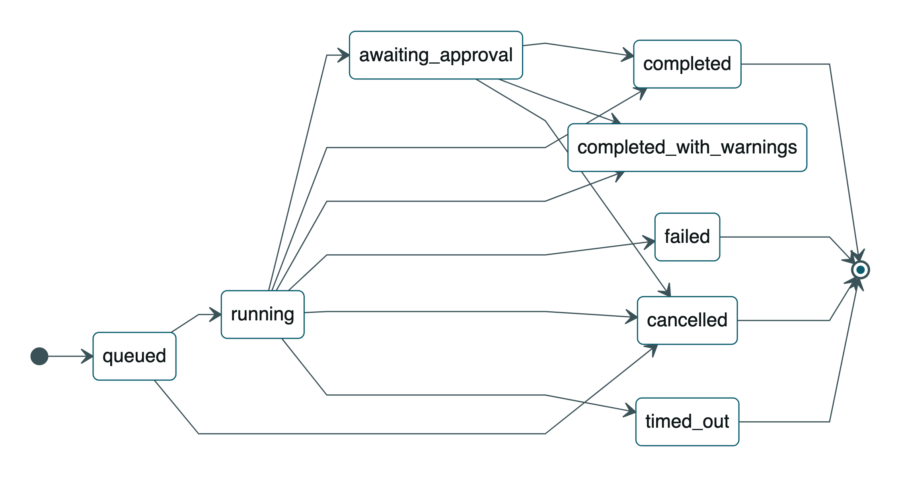
Figure 7 — Generation job. Five terminal states; completed_with_warnings is reached when a worker returns non-fatal warnings.
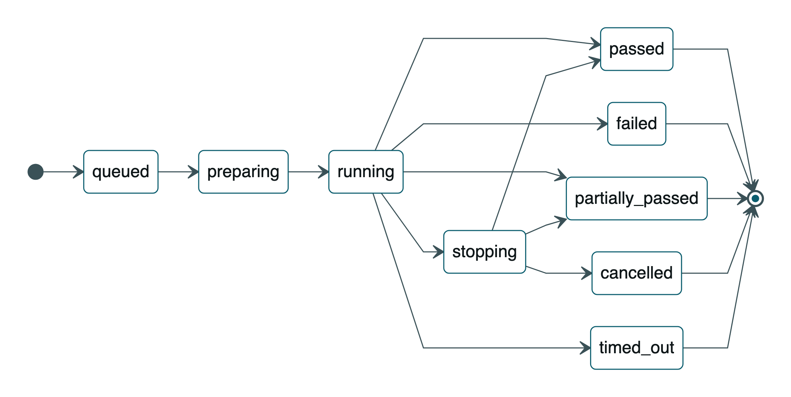
Figure 8 — Execution run. The terminal outcome derives from metrics, not the process exit code: outcomeFromMetrics() returns failed when no counts exist, so an empty metrics object can never be reported as a green run.
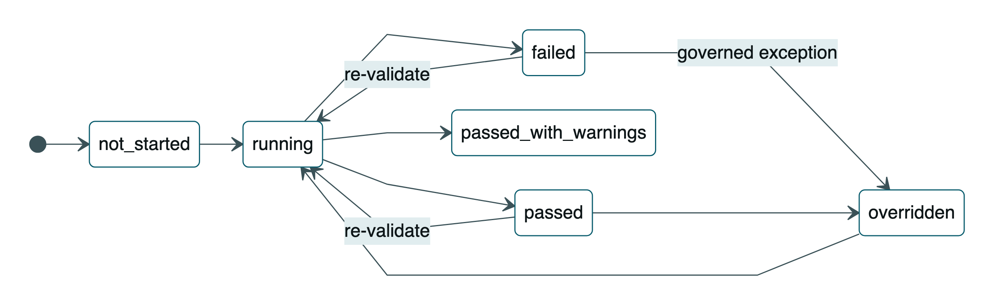
Figure 9 — Validation. The overridden state is reachable only through an authorised role supplying a written reason, recorded as a validation_exception approval.

Artefact lifecycle
The six-state artefact lifecycle — draft, under review, approved, rejected, superseded, archived — is derived rather than stored, computed by deriveArtefactState() from approvalStatus, approvalInvalidated, status and archived. Existing rows needed no migration to gain it.

09 The validation gate
The component the core principle rests on. It inspects the actual generated bytes and never the model's claims about them.
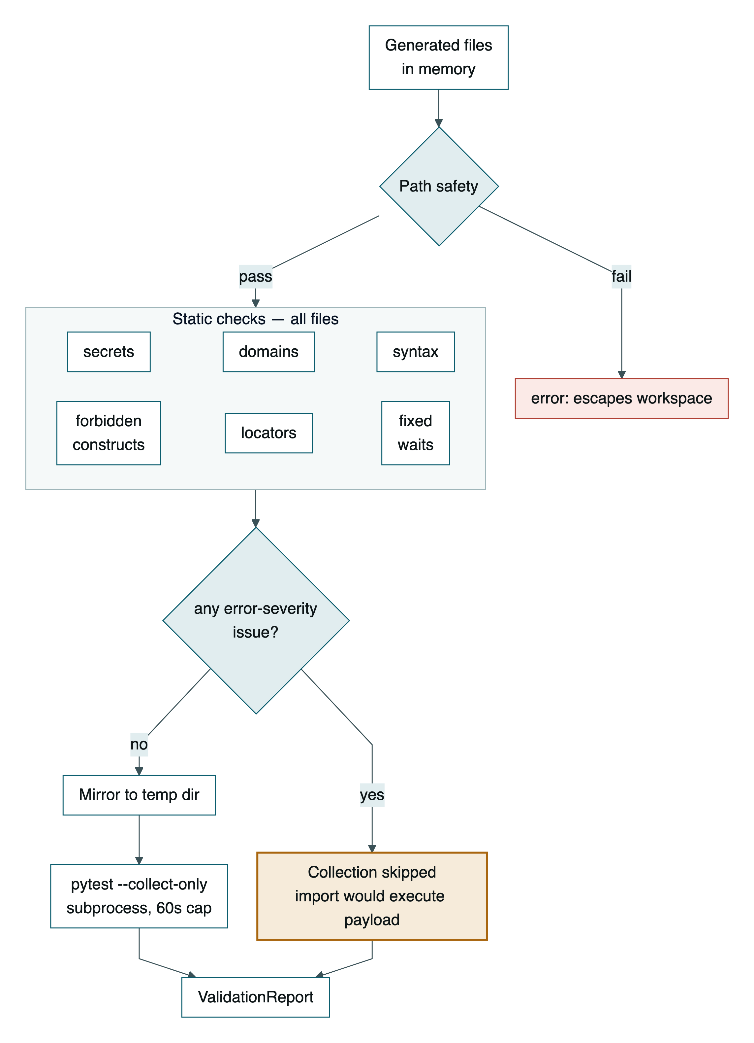
Figure 10 — Validation gate. Ordering is a security property: pytest --collect-only imports the module, executing anything at module level, so it runs only after the static checks pass and only against a throw-away temp mirror.

What the forbidden-construct check catches
CLASS | BLOCKED
Modules | subprocess socket ctypes importlib runpy multiprocessing
Shell and deletion | os.system os.popen os.remove os.unlink os.rmdir shutil.rmtree
Dynamic code | eval exec compile __import__ pickle.load[s]
Static-analysis evasion | getattr setattr delattr globals locals vars — because getattr(os, 'sys'+'tem') defeats name-based analysis
Filesystem mutation | write_text write_bytes unlink rename chmod symlink_to — flagged on any receiver, since Path(x).write_text() cannot be statically resolved
Sandboxed writes | Write-mode open() outside artifacts/, reports/, automation/. A dynamic path or mode is itself an error — unverifiable means refused
Encoded payloads | rm -rf string literals; b64decode combined with exec/eval on one line

Aliased imports are resolved before matching, so import os as o; o.system(...) and from os import system as run are both caught. If the file fails to parse, a regex fallback pass still scans it — broken syntax cannot smuggle a dangerous call past review.

10 Security architecture
Untrusted input arrives from three directions — uploaded files, LLM output, and the application under test. Each has its own containment layer.
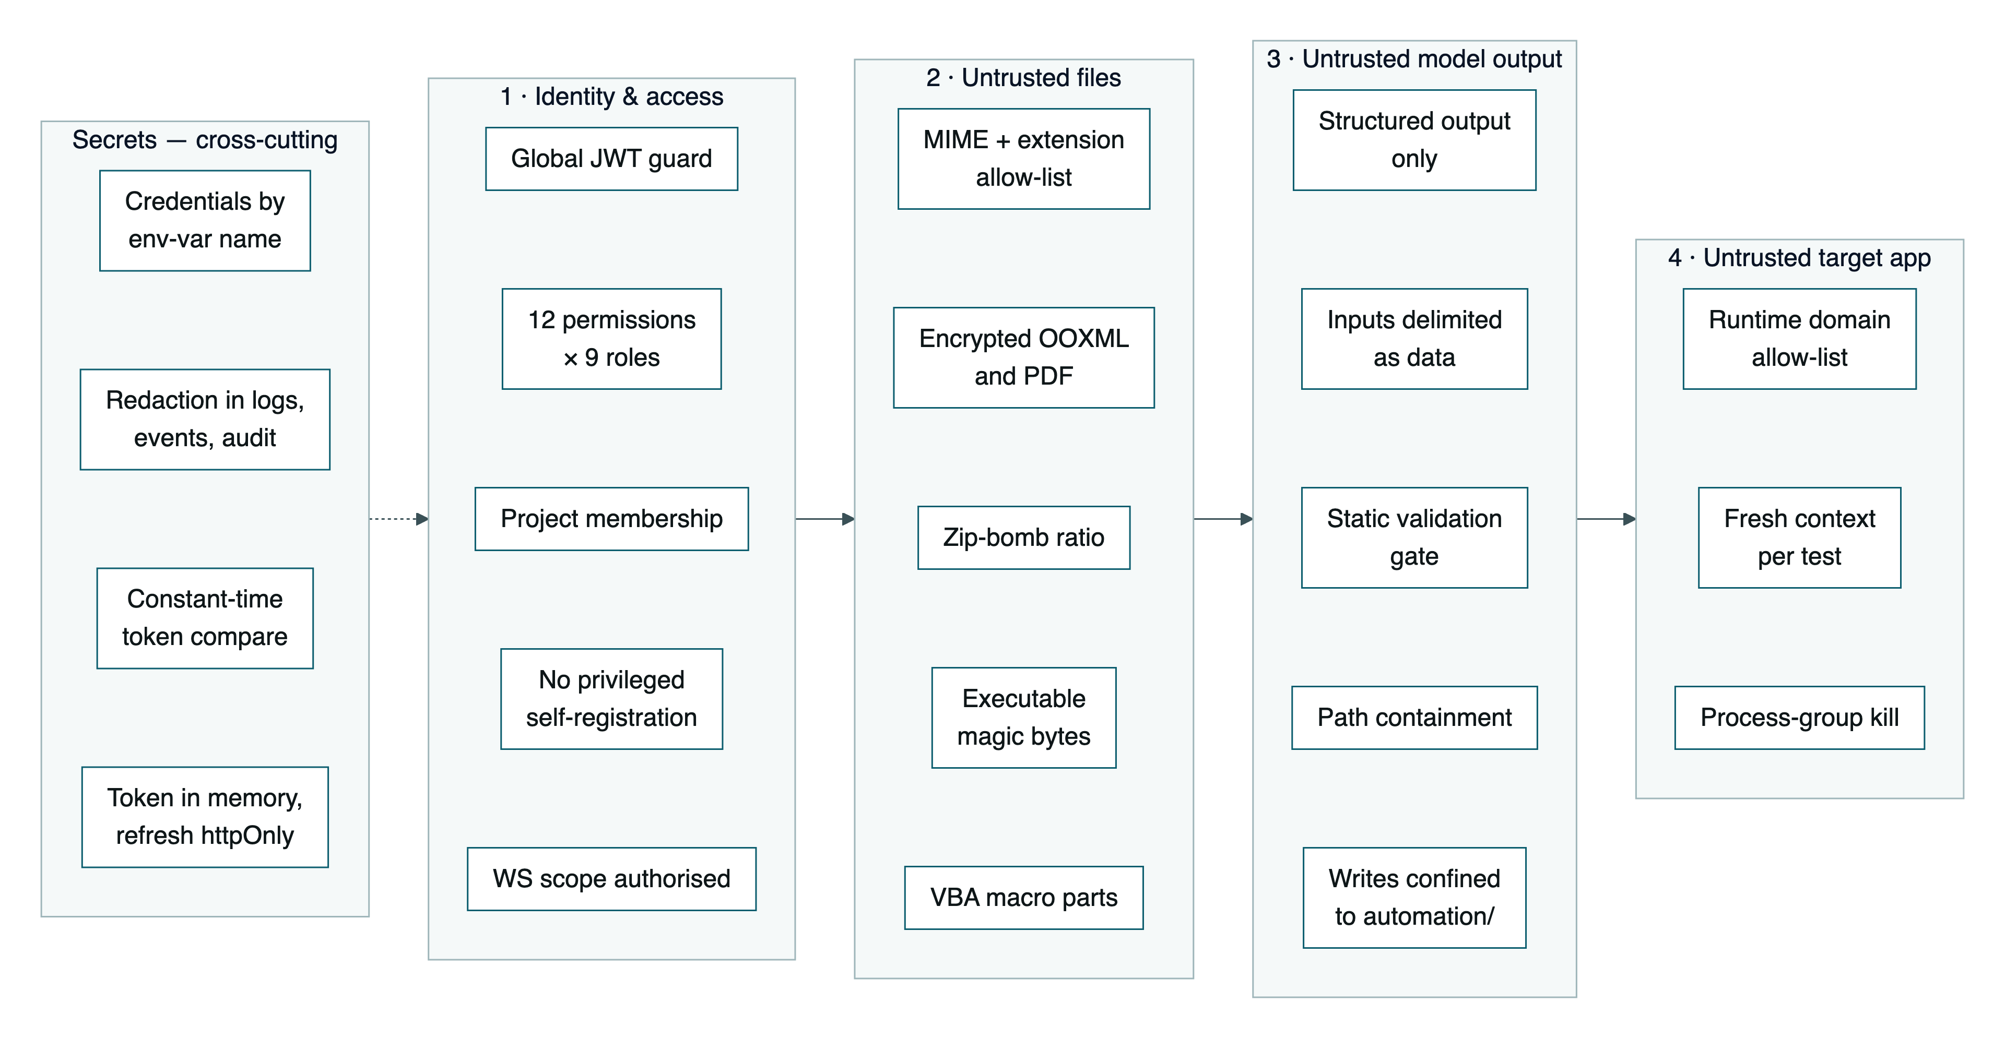
Figure 11 — Defence in depth. The domain allow-list is enforced twice: statically against URL literals in generated code, and at runtime by a Playwright route handler that aborts requests to non-listed hosts. An empty allow-list falls back to localhost, never allow-all.

Prompt-injection posture
Every agent's system prompt carries an explicit guard, and untrusted content is wrapped in delimiters — <requirement>...</requirement>, <<<TEST_CASES_JSON ... JSON>>>, --- error text --- — with the instruction that the delimited span is data, not instructions. Requirement text, test-case text, captured error output and run metrics are all treated this way.
The structural defence matters more than the prompt: an injected instruction that did succeed would still have to produce output passing a Pydantic schema, then the static gate, then a human reviewing a diff, before anything executed.

Role-to-permission matrix
PERMISSION | HELD BY
approval.decide | admin · qa_lead · reviewer · supervisor
git.push · ci.trigger | admin · qa_lead · automation_engineer · devops
generation.run · artefact.edit · execution.run · execution.control · project.write | admin · qa_lead · qa_engineer · automation_engineer · supervisor · devops
classification.override | the above, plus developer and reviewer
report.export | every role except viewer
admin.manage | admin only

viewer holds no permissions — read-only by construction. admin short-circuits every check.

11 Deployment
Two supported topologies, plus a CI pipeline that deliberately runs no model.

Docker Compose — PostgreSQL
postgres then engine then backend then frontend, each gated on the previous service's healthcheck. Ollama stays on the host (host.docker.internal:11434) so local models are reused without being baked into an image. The engine image is built from mcr.microsoft.com/playwright/python and copies the reused V1 packages (app/ agents/ graph/ tools/ automation/ sample_app/) alongside the service.

Local development — SQLite, no Docker
DB_DRIVER=sqlite switches TypeORM to better-sqlite3 against a local file. A DATETIME_TYPE shim resolves the timestamp/datetime divergence between drivers at module load. synchronize: true creates the schema on boot — appropriate for the current stage, and the thing to replace with migrations before any shared deployment.

CI — GitHub Actions
Two deliberately separated suites. smoke always runs against the bundled sample_app started inside the runner. generated runs only when the repository defines QA_TARGET_BASE_URL plus credential secrets — otherwise AI-generated tests would target the wrong host and fail by construction. JUnit XML, self-contained HTML, screenshots and traces upload on every run, pass or fail. No Ollama step exists in CI; generation is a local activity.

The demo target
sample_app/ is a self-contained FastAPI application with three deliberately seeded defects toggled by SAMPLE_APP_DEFECTS: login_message (wrong error text), duplicate_add (inserts twice), delete_noop (silently does nothing). These are the ground truth for measuring the system's defect-detection rate — a controlled experiment built into the repository.

12 Codebase map
PATH | CONTAINS | SCALE
frontend/src/ | 19 pages, 8 feature folders, 12 UI primitives, socket and query layer | ~10k LOC
backend/src/modules/ | 18 NestJS feature modules (controller, service, DTOs) | ~9k LOC
backend/src/entities/ | 24 TypeORM entities | ~1.4k LOC
backend/src/common/ | Guards, RBAC matrix, state machines, error contract, redaction, correlation, hashing | ~1k LOC
engine/service/ | FastAPI app, execution runner, event bus, step-event plugin, report adapter | ~1.2k LOC
engine/parsers/, engine/contracts/ | Excel ingestion with sheet/row provenance; versioned Pydantic schemas | ~200 LOC
agents/ | Six LLM agents, each with a versioned prompt and bounded retries | ~1.6k LOC
tools/ | Static validation, document ingestion, Playwright runner, git, GitHub Actions | ~1.7k LOC
app/ | V1 FastAPI service — config, LLM factory, security, ORM, services, 11 routers | ~4.3k LOC
graph/ | LangGraph workflow: 10 nodes, 2 interrupt() human gates, in-memory checkpointer | ~1.2k LOC
automation/ | Instrumented BasePage, page objects, fixtures, generated tests and manifest | ~600 LOC
tests/unit/ | 13 Python suites — validation, security gates, ingestion, results, CI import | 2.3k LOC

Test coverage by tier
TIER | COVERAGE
Python | 13 unit suites. Heaviest around the security gates (test_security_gates.py, 349 lines) and export/CI import (459 lines).
Backend | 3 Jest specs — state machines, approvals, execution logger — plus 2 supertest e2e specs.
Frontend | 3 Vitest specs — the timeline reducer, token refresh, login page. The reducer is pure precisely so ordering and dedup are testable without a socket.

13 Architectural observations
Things worth knowing about the current state of the architecture, found while reading it.
Committed example files contain real-looking secrets
.env.example carries a populated QA_TEST_PASSWORD and a personal account email; .env.v2.example carries populated JWT_ACCESS_SECRET, JWT_REFRESH_SECRET and SEED_ADMIN_PASSWORD. Both files are tracked in git and both are headed “Never commit real secrets”.
If any of these are live values, they should be rotated and the files reduced to placeholders. This is the one finding worth acting on before anything else.
.env.example · .env.v2.example

A page object calls BasePage helpers with the wrong keyword arguments
SampleLoginPage.login() calls self.fill(..., name="Username"), self.click(..., type="Submit") and self.assert_contains_text(..., name=...). The base class defines these as fill(locator, value, label=""), click(locator, label="") and assert_contains_text(locator, text, label="").
Every one of those calls raises TypeError: unexpected keyword argument at runtime — the login flow cannot execute. label= is the intended keyword. Both files are currently modified in the working tree.
automation/pages/sample_login_page.py:29-32 · automation/pages/base_page.py:79-100

The LangGraph orchestrator is orphaned from the running system
graph/workflow.py implements the full pipeline as a compiled state graph with two interrupt() human gates and a checkpointer for resume. It is well-built — and the only thing that imports it is scripts/demo.py.
The V2/V3 runtime re-implements that orchestration imperatively across JobsService, ApprovalsService and ExecutionsService. The workflow logic now exists twice, in two languages, with only one of them live. Worth an explicit decision: retire graph/, or document it as the V1 reference implementation it has become.
graph/workflow.py · graph/nodes.py · scripts/demo.py

Redis is provisioned but never used
docker-compose.yml starts redis:7 on 6379. No source file in backend/src, engine, app, agents or tools references it. Job queueing, event sequencing and the idempotency cache are all in-process.
That in-process design is what currently bounds the system to a single backend instance and a single engine instance — activeRuns, the seq counters and the idempotency cache are per-process. Redis is presumably the intended path to horizontal scale; today it is a stub.
docker-compose.yml:19-21

Two complete API surfaces coexist
app/main.py still assembles a full FastAPI application with 11 routers covering projects, requirements, generation, automation, approvals, executions, git/CI, findings, reports and export. Nothing in the V2 stack calls it.
The engine reuses the V1 libraries — agents/, app.services, app.models.schemas, tools/ — not the V1 HTTP API. That library reuse is clean and deliberate. The parallel HTTP surface is the part that has no consumer.
app/main.py · app/api/*.py

Honest degradation is applied consistently
Worth calling out as a strength, because it is unusual to find applied this evenly. When PDF rendering is unavailable, exports return Markdown or HTML with the correct content type rather than mislabelled bytes. When no tests are collected, the run reports an error carrying the pytest output instead of an all-zero success. When the LLM is unreachable, reports still render with a deterministic narrative explicitly labelled “auto-generated (no LLM)”. Measured metrics and AI narrative are labelled distinctly in every report.
reports.service.ts · test-plans.service.ts · engine/service/execution.py · app/services/report_service.py

Schema is created by synchronize: true
TypeORM auto-creates the schema on boot for both drivers. Fine for the current stage; it needs replacing with generated migrations before any deployment where data must survive an entity change.
backend/src/database/database.module.ts

Derived from a full read of the repository at branch feature/ai-qa-agent-v3, HEAD a8ceed47. Diagrams rendered with Mermaid.

