INTERNATION INSTITUTE OF PROFESSIONAL STUDIES, DAVV

SYSTEM ANALYSIS AD DESIGN

PROJECT REPORT-

**Software Design Description [SDD]**

**Online Food Ordering System**

**SUBMITTED BY-**

DRAKSHI CHOPRA

**IT-2K19-16**

MTECH V Sem

**SUBMITTED TO-**

Dr. SHALIGRAM PRAJAPAT

**TABLE OF CONTENTS**

1. SYSTEM DESIGN
   1. DATABASE AND THE THREE COMPONENTS
   2. WEB ORDERING SYSTEM COMPONETS
   3. MENU MANAGEMENT SYSTEM COMPONETS
   4. ORDER RETRIEVAL SYSTEM
2. USER INTERFACE DESIGN
3. HELP SYSTEM DESIGN

### Level 1: The Database & the 3 Components

The structure of the system can be divided into three main logical components. The first component must provide some form of menu management, allowing the restaurant to control what can be ordered by customers. The second component is the web ordering system and provides the functionality for customers to place their order and supply all necessary details. The third and final logical component is the order retrieval system. Used by the restaurant to keep track of all orders which have been placed, this component takes care of retrieving and displaying order information, as well as updating orders which have already been processed.

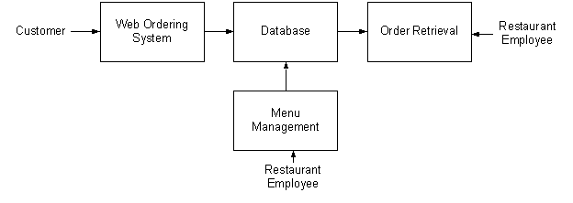

# 

## 

## 

### Level 2: Web Ordering System Components

The web ordering system is comprised of 6 major components. These are the login form, the main menu, the account management form, the order form, the shopping cart, and the checkout form. When the customer first arrives at the site, they are presented with the login form.

After either signing in or, if they do not yet have an account, first registering and then signing in, the user is taken to a welcome page with the main menu. From here, they have two options – they can either change their password and other preferences through the account management form, or they can select an order form and begin adding items to their order. If they choose the second path, they can navigate the numerous order forms using the main menu, each of which corresponds to a specific category of order items, adding items to their shopping cart along the way. At any time they can view and modify their shopping cart and when they are finally ready to place their order, they can proceed to the checkout form. The checkout form uses the contents of the shopping cart to present a summary of the order and to calculate the total cost, in addition to allowing the user to specify all of the necessary delivery details.

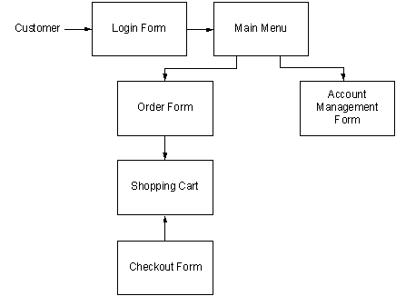

# 

# 

### 

### 

#### 

#### Level 3: The Login Form

The login form is standard for a form of this type. It provides text fields for username and password, which the user must enter before signing in. This form also gives the option for a user to register for the site if they have not yet done so.

#### Level 3: The Main Menu

The main menu, found at the top of the screen like in most applications, presents the user with two levels of selections. They must first choose the vendor they would like to view and then choose a category of food. Once they make these two selections, the application generates an order form specifically for that type of food, and displays this form to the user.

#### Level 3: The Account Management Form

Currently the account management form only offers the user the option to change their password.

#### Level 3: The Order Form

The order form, which is dynamically generated based on selections from the main menu,

#### Level 3: The Shopping Cart

The shopping cart performs much like a shopping cart in any other application. After an item is added to the order, it is displayed, along with its price, in the shopping cart. The shopping cart also keeps a running total of the current price of the whole order. By clicking on an item in he shopping cart, the user can review all of the details for that particular item. Finally, the shopping cart contains a button for the user to proceed to checkout.

#### Level 3: The Checkout Form

The checkout form is the user’s last chance to verify that the contents of their order are correct before actually placing it. This form also provides fields for the user to supply all of the necessary checkout and delivery details (payment type, delivery address, etc.).

### Level 2: Menu Management System Components

In order to make use of the menu management system, the user must interact with the navigation tree, which uses a hierarchical tree structure to display all of the vendors, categories of foods, and specific food items stored in the system. When the user selects an item from this tree, they are able to edit the item using the appropriate form – a Vendor Form if a vendor is selected, a Category Form if a category of foods is selected, and a Food Form if an individual food item is selected.

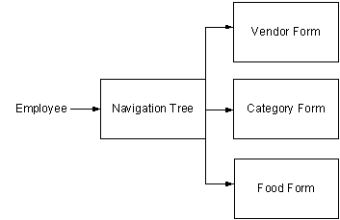

## 

## 

## 

## 

## 

#### Level 3: The Navigation Tree

The navigation tree is a 3-level (excluding the root) hierarchical arrangement, with each leaf corresponding to a form. At the first level are vendors, at level two categories of food, and at level 3 individual food items. When a leaf is selected, it brings up a form corresponding to the item at that leaf.

#### Level 3: The Forms

There are three types of forms in the menu management system - Vendor Forms, Category Forms, and Food Forms. The three forms are all similar, allowing the user to add, edit, and remove information relevant to the selected item. Where they differ is in the specific fields that the user is able to edit. After changes to any of the forms are saved, the necessary records in the database are updated.

### Level 2: Order Retrieval System Components

C:\Users\lenovo\AppData\Local\Temp\ksohtml\wpsD1D3.tmp.png

The simplest of the three components, the order retrieval system can be broken down into just two components. They are the summary panel, which displays a list of all currently active orders, and the order detail panel, which highlights just a single order. When the application first starts, the order details for the first order in the list are displayed. In order to view the details of a different order, the user must simply select it from the list in the summary panel.

### 

#### Level 3: Summary Panel

The summary panel, located on the left side of the screen, displays a list of all currently active orders, along with their delivery times and statuses. By changing the selected item in this list, the user is able to control the contents of the order detail panel.

#### Level 3: Order Detail Panel

The order detail panel which contains a hierarchical tree structure for viewing all of the details related to the order which is currently selected in the summary panel. This component also contains a button to mark the order as processed and remove it from the list of active orders.

## User Interface Design

The user interface design principles can be broken into two groups. The interface in the web application is designed to limit free form user input, using mostly drop down menus, radio buttons and check boxes. This is done for two reasons – to simplify the ordering process as much as possible, and to limit SQL injection attempts. Free form input is necessary in the menu management component, however, as all of the values must be user supplied. The interface for this component contains traditional forms comprised of text fields and corresponding labels, along with save and discard buttons for each form.

## Help System Design

Due to the form-based nature of the applications, the design of the help systems will be minimal. In both the desktop and web applications, it will be accessed from the application’s main menu and will open in a new window. Modeled after the typical help system design, it will be both searchable and include a navigation tree highlighting common topics. There will be a help page for each form type, describing the significance of each field on the page.