## Clearly what! Paper

# The State of Mental Digi-Therapeutics: A Systematic Assessment of Depression and Anxiety Apps Available for Arabic Speakers

## Abstract

**Background:** x.

**Objective:** Toconduct a systematic assessment of the features of Depression and Anxiety mobile apps available for Arabic speakers.

**Methods:** x.

**Results:** x.

**Conclusions:** x.

**Keywords:** mobile; smartphone; depression; anxiety; technology; applications

## Introduction

Mental disorders have become a major public health concern worldwide affecting around 450 million people and have a global economic burden of approximately USD$2.5 trillion [1]. The high prevelance of mental disorders negatively imposes enormous societal burdens and impacts individuals by limiting their interactions with family and society [2,3]. Recent evidence suggests that mental disorders are associated with substantial premature mortality, homelessness, addiction problems, poor physical health, and suicide [4]. The World Health Organization (WHO), reports that in the Eastern Mediterranean Region, which includes the Arab countries, the prevalence of mental disorders ranges between 11% and 40.1% [5]. This can be attributed to the exposure to wars, conflicts, and violence which in turn result in long-term damage physically and psychologically [6].

It is imperative that people suffering from a mental disorder have access to the required support in a timely manner [7]. The proliferation and ubiquity of smartphones, mobile applications, or “apps”, may be the long-awaited for digital therapeutic for mental health disorders [8]. Mental health apps provide several advantages for their users including the increased convenience with regards to travel effort and time, anonymity, and overall reduced expenses [9]. The WHO recognized this opportunity through establishing the Mental Health Global Action Programme (mhGAP), which an exemplar guide that aims to enhance care service using evidence-based interventions for prevention and management of priority mental neurological and substance conditions [9].

The Arab countries have a grand opportunity to leverage these “digital therapeutics” to combat mental disorders. In the Arab world, smartphones adoption has been rising rapidly; by 2021, it is projected that there will be 47 million new Internet users and 45 million new smartphone owners [10]. However, despite the prevalence of mental disorders among the population living in Arabic-speaking countries, the evidence about the availability and characteristics of mental health apps available to Arabic speakers remains poor. In this study, we focus on depression and anxiety as they are the two of the most common mental disorders globally [11]. These disorders range in severity from mild to severe and can affect all ages between childhood to late adulthood [12].

To address the paucity in the body of literature, this research aims to conduct a systematic assessment of the features of depression and anxiety mobile apps available for Arabic speakers.

## Methods

This research employs a critical review of all the currently available depression and anxiety apps, available to Arabic speakers. A systematic and exhaustive search of smartphone apps in the Apple App and the Google Play Stores was conducted in May 2018. Only apps available in the Arabic language or supporting it are considered. The apps are identified through searching both the web interface as well as the respective stores on Android and iPhone devices.

### Inclusion/Exclusion Criteria

The following characteristics are used to identify apps for inclusion in the study: (*i*) The words ‘depression’ or ‘anxiety’ present in the name or description of the product page, (*ii*) available in or supports the Arabic language, (*iii*) rated 4-stars or more[1], and (*iv*) installed at least 1,000 times at the time of data collection.[2] Apps about books or games were excluded.

### Screening Process

Several Arabic keywords are used to formulate the search terms (refer to Table 1). Translations of these keywords into the English language ensured full coverage of the search terms. Additionally, different spellings of words commonly used among public nowadays (even though some are misspelt) were also considered during the search process but not mentioned in the keywords table. To ensure comprehensive coverage, the identifying prefix “al” in the Arabic language is added to each of the keywords. Similarly, the different drawings of the combination of letter “a” and “hamza” in Arabic implies were considered to form a comprehensive search.

Table 1: Keywords used for searching apps in App Store and Google Play.

|  |  |
| --- | --- |
| English keywords | Arabic keywords |
| Mental Health | صحة عقلية/ صحة ذهنية |
| Anxiety | قلق |
| Depression | اكتئاب/ كآبة |
| Mental Disorders | أمراض عقلية |
| Happiness | سعادة |
| Joy | فرح |
| Stress | ضغط |
| Mood | مزاج |
| Psychological Health | صحة نفسية |
| Sadness | حزن |
| Psychological stress | ضغط نفسي |

After applying the inclusion/exclusion criteria, apps were screened by their product page and the following meta-data were recorded: Title, description, and price. Only unique apps are recorded for each keyword. All free apps were downloaded, and their functions were examined closely. Refer to Figure 1 for a flow diagram depicting the screening process for the apps.

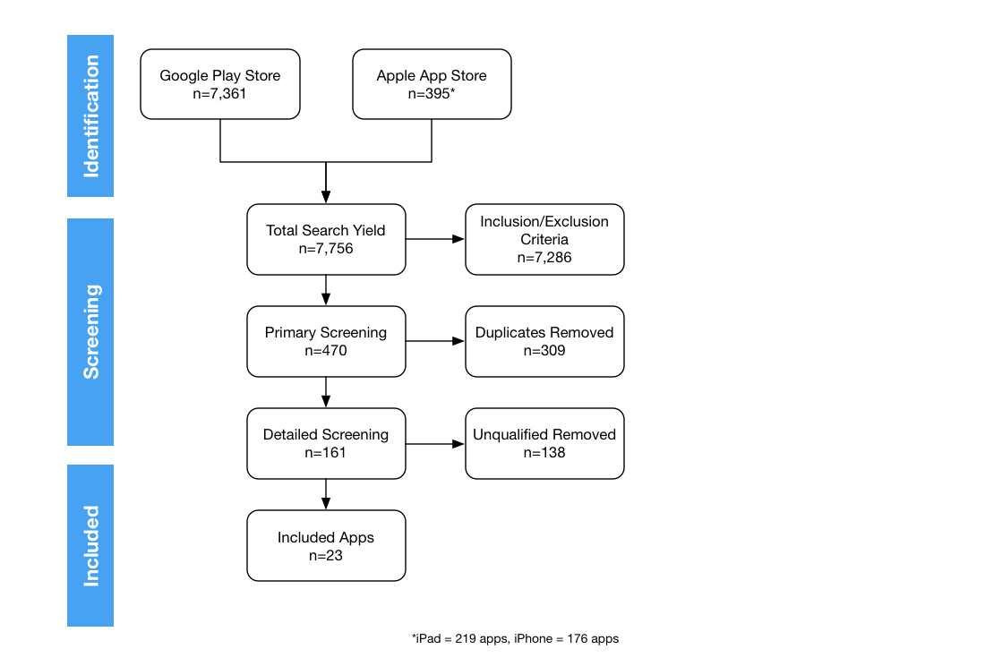

Figure 1: Flow diagram illustrating screening strategy followed in this study.

### Data Analysis

To evaluate the apps, a shared spreadsheet is used to record the results and pertinent information about the included apps. Each app is evaluated by at least two researchers. All free apps were downloaded for evaluation and those that were found to be duplicate of other apps or not meeting the inclusion/exclusion criteria were excluded from further analysis. A categorization of apps’ functions was developed by the researchers to classify the apps based on their main functions. This categorization is inspired by the mhGAP guidelines which suggest including features or activities to facilitate treatment of mental disorders. Examples include video-links, case scenario, role-play, group discussion, live interaction, informational materials, multiple choice questions and alternative relaxation exercises [13].

## Results

After thorough screening, a total of 23 apps were finally included in this study. Refer to Table 2 for a summary of each of the included apps. The following is an overview of the apps. Overall, there were far more apps available on the Google Android Play Store (n=21) versus only two apps on the iOS App Store. The majority of the apps (n=16) provide general information about either anxiety, depression, or both. Six apps are of spiritual nature mainly referring to the Islamic faith and the Holy Quran, with one app referring to the Christian faith. Another five apps provide advice on alternative treatments, mainly concerning herbal medicine recipes. Only two apps provided utilities for users, specifically about medication reminders.

Table 2: Overview of included mental health apps.

|  |
| --- |
| Table Goes Here |

In the following sections, we refer to the app by the number associated with it in Table 2.

#### Anxiety Apps

Only four apps are identified as anxiety apps. *Herbal Therapy New 2018- Without internet (18)* app includes herbal recipes that are claimed to help with many health disorders including anxiety. Both *Prayers for the Treatment of Anxiety and Negative Thinking (14)* and *Treat Yourself and Your Body Without a Doctor (17)* consist of Islamic dua’a that is claimed to help in curing anxiety but no references to any evidence. *Relaxation Techniques (8)* app provides relaxation exercises and methods that would help preventing anxiety.

#### Depression Apps

A total of 11 apps were identified as depression apps. *Herbal Therapy (19), Herbal Therapy 2018 (20),* and *Fenugreek is a Treatment for More than 50 Diseases (22)* are all apps with herbal recipes, and one of the recipes is claimed to help with depression. *Fenugreek is a Treatment for More than 50 Diseases (22)* is specifically about fenugreek. *Islamic Ecorcism- Mental illness and Depression (16) i*s an app with audio of Islamic rouqya shariyaa .T*reatment of Depression and Self Confidence(13), Treatment of Depression(1), Treat Yourself with Psychiatry(3),* and *Get Rid of Depression (9)* are all informational apps. Both Treatment *of Depression and Self Confidence (13)* and *Get Rid of Depression (9)* contains depression definition, causes, symptoms, and ways that would help in preventing depression. The Treatment of Depression (1)app is filed with solutions that are claimed to be helpful with depression. As for *Treat Yourself with Psychiatry (3)* it is an app that talks about mental disorders with a section about depression.

#### Overview of Apps that support both

A total of 10 apps were related to both depression and anxiety. *Medication Reminder & Pill Tracker (6)* and *Pill Reminder and Medication Tracker by Medisafe (23)* are both utility apps that provides reminder for users for the time of their medication, take measurements of blood test, cholesterol, and body temperature. Also, it allows users to write notes, book appointments and get a weekly report of patient status. *Pill Reminder and Medication Tracker by Medisafe (23)* is also evidence-based app*. Comprehensive Islamic Exorcism without internet (3)* is a faith-based app that have audio of Islamic rouqyaa that is said to help with depression and anxiety*. Treatment of Mental Disorders (3)* and *Psychiatric Disorders and their Treatment (9)* are both informational apps with the same exact content that is facts about both anxiety and depression. *Self and Life: Tareg Alhabeeb (5)* app is an informational app with audio from episodes of a famous psychiatrist (Dr Tariq Al-Habib) show. *Development of Personal Skills (18)* app is also informational apps with advices on how to get over depression and anxiety. *Discover Yourself (15)* app is informational and faith-based app that has an alternative relaxation exercise. *Your Doctor Journal (14)* is an informational medical app with a section about mental health that has content about depression and anxiety.

## Discussion

### Principal Findings

To our knowledge, no previous research has studied x

Duplication of apps, content

No evidence-based, references, citations to either science or faith/religion

can be a life-threatening disorder and

**Recommendations**

X

1. Call to action for healthcare experts, physiologist, and healthcare organizations to develop mental health apps for Arabic speakers

### Study Strength and Limitations

The previously illustrated procedure is an attempt to cover all targeted apps available on each store especially Google Play which contains a huge number of apps but only shows up to 250 apps as a maximum for one search result.

I think it is good to state that apps having no rate or no. of installs are excluded. (For Google Play store only.)

### Conclusion

x

### Acknowledgments

x

### Conflicts of Interest

None declared.

### Abbreviations

mhGAP: Mental Health Global Action Programme

WHO: World Health Organization

## References

1. Trautmann S, Rehm J, Wittchen H. The economic costs of mental disorders. EMBO Rep 2016 Sep;17(9):1245–1249. PMID:27491723

2. Huang H-Y, Bashir M. Users’ Adoption of Mental Health Apps: Examining the Impact of Information Cues. JMIR MHealth UHealth [Internet] 2017 Jun 28 [cited 2018 May 2];5(6). PMID:28659256

3. Fan L-B, Blumenthal JA, Watkins LL, Sherwood A. Work and home stress: associations with anxiety and depression symptoms. Occup Med Oxf Engl 2015 Mar;65(2):110–116. PMID:25589707

4. Furber G, Segal L, Leach M, Turnbull C, Procter N, Diamond M, Miller S, McGorry P. Preventing mental illness: closing the evidence-practice gap through workforce and services planning. BMC Health Serv Res [Internet] 2015 Jul 24;15. PMID:26205006

5. Charara R, Forouzanfar M, Naghavi M, Moradi-Lakeh M, Afshin A, Vos T, Daoud F, Wang H, El Bcheraoui C, Khalil I, Hamadeh RR, Khosravi A, Rahimi-Movaghar V, Khader Y, Al-Hamad N, Makhlouf Obermeyer C, Rafay A, Asghar R, Rana SM, Shaheen A, Abu-Rmeileh NME, Husseini A, Abu-Raddad LJ, Khoja T, Al Rayess ZA, AlBuhairan FS, Hsairi M, Alomari MA, Ali R, Roshandel G, Terkawi AS, Hamidi S, Refaat AH, Westerman R, Kiadaliri AA, Akanda AS, Ali SD, Bacha U, Badawi A, Bazargan-Hejazi S, Faghmous IAD, Fereshtehnejad S-M, Fischer F, Jonas JB, Kuate Defo B, Mehari A, Omer SB, Pourmalek F, Uthman OA, Mokdad AA, Maalouf FT, Abd-Allah F, Akseer N, Arya D, Borschmann R, Brazinova A, Brugha TS, Catalá-López F, Degenhardt L, Ferrari A, Haro JM, Horino M, Hornberger JC, Huang H, Kieling C, Kim D, Kim Y, Knudsen AK, Mitchell PB, Patton G, Sagar R, Satpathy M, Savuon K, Seedat S, Shiue I, Skogen JC, Stein DJ, Tabb KM, Whiteford HA, Yip P, Yonemoto N, Murray CJL, Mokdad AH. The Burden of Mental Disorders in the Eastern Mediterranean Region, 1990-2013. PLoS ONE 2017 Jan 17;12(1). PMID:28095477

6. Okasha A, Karam E, Okasha T. Mental health services in the Arab world. World Psychiatry Off J World Psychiatr Assoc WPA 2012 Feb;11(1):52–54. PMID:22295010

7. Lauder S, Chester A, Berk M. Net-effect? Online psychological interventions. Acta Neuropsychiatr 2007;19(6):386–388. [doi: 10.1111/j.1601-5215.2007.00261.x]

8. Donker T, Blankers M, Hedman E, Ljótsson B, Petrie K, Christensen H. Economic evaluations of Internet interventions for mental health: a systematic review. Psychol Med 2015 Dec;45(16):3357–3376. PMID:26235445

9. Musiat P, Goldstone P, Tarrier N. Understanding the acceptability of e-mental health--attitudes and expectations towards computerised self-help treatments for mental health problems. BMC Psychiatry 2014 Apr 11;14:109. PMID:24725765

10. Salem F. The Arab World Online 2017: Digital Transformations and Societal Trends in the Age of the 4th Industrial Revolution. (Vol. 3). Dubai: MBR School of Government; 2017.

11. World Health Organization. Depression and other common mental disorders: 2017 p. 7. Report No.: WHO/MSD/MER/2017.2.

12. Brigitta B. Pathophysiology of depression and mechanisms of treatment. Dialogues Clin Neurosci 2002 Mar;4(1):7–20. PMID:22033824

13. World Health Organization. mhGAP training manuals: The mhGAP intervention guide for mental, neurological and substance use disorders in non-specialized health settings – version 2.0. France; 2017. Report No.: WHO/MSD/MER/17.6.

# Appendix 1

Convert PPTX slides into something meaningful as an appendix?

1. iOS apps with less than 5 reviews will report as ‘Not Enough Rating’.
2. The Apple App Store does not report the number of install per app.