**Connecting to MongoDB Server:**

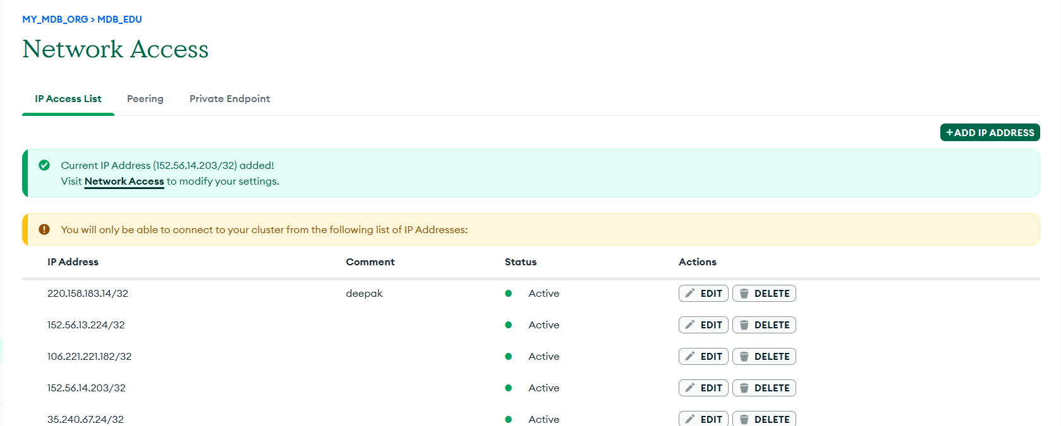

We add our current IP Address in MongoDB Cloud (Atlas) -> Network Access -> Add IP Address

**Open Command Prompt:**

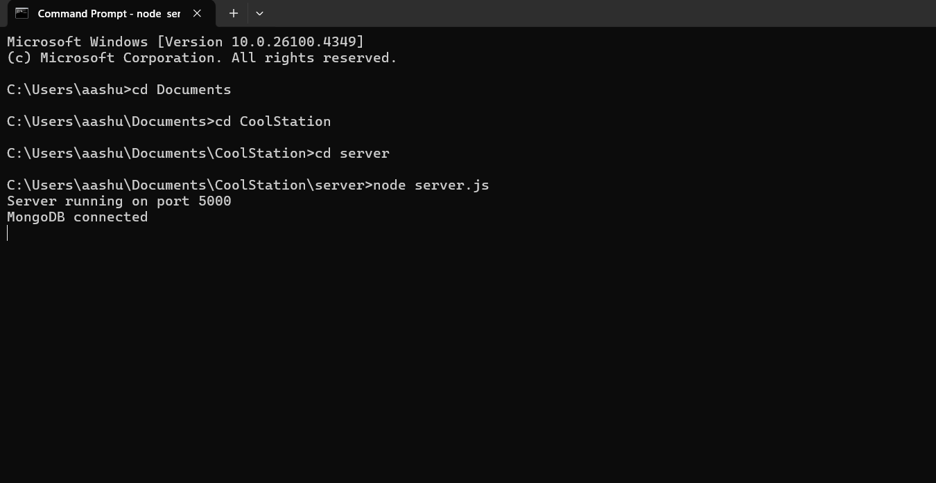

This displays that the MongoDB server is running on port 5000 and the server is connected successfully.

**MongoDB Connected**

**To Run Frontend Locally**

**Open Command Prompt:**

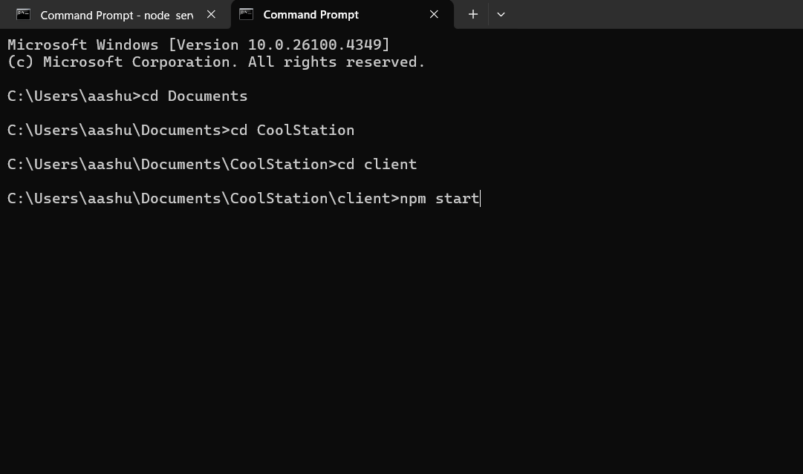

Press Enter -> Compilation Successful

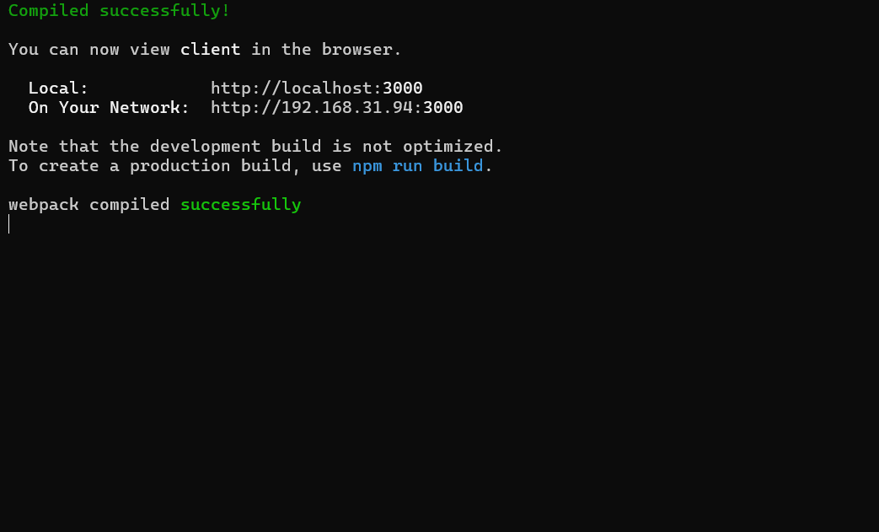

**Opens Login Page:**

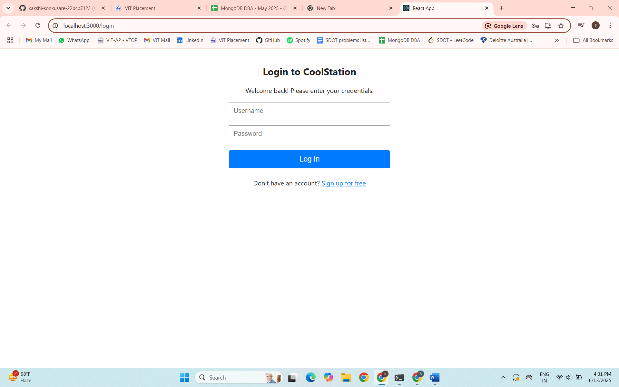

User can switch to sign up Page -> Don’t have an account?Sign up for free

**Opens Signup Page:**

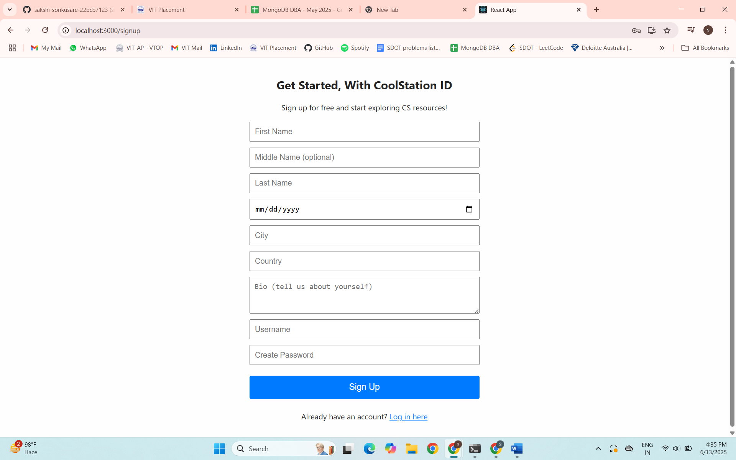

Similarly, User can switch to Login Page -> Already have an account?Log in here

**User Signup:**

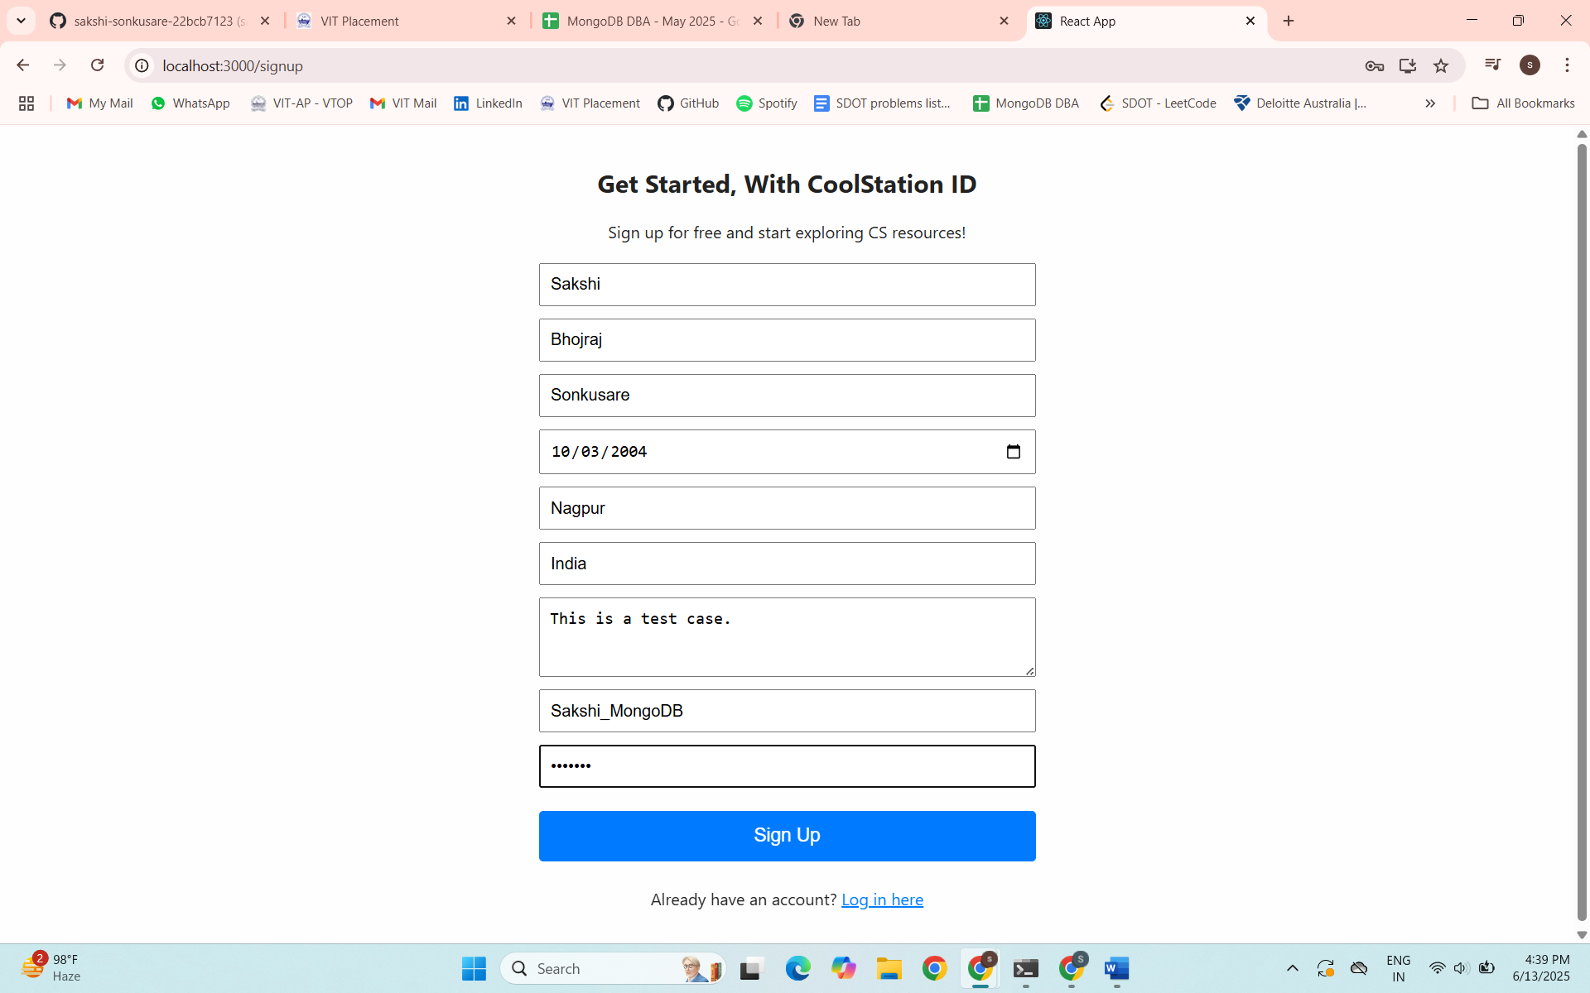

Filling up the Details… -> click Sign Up

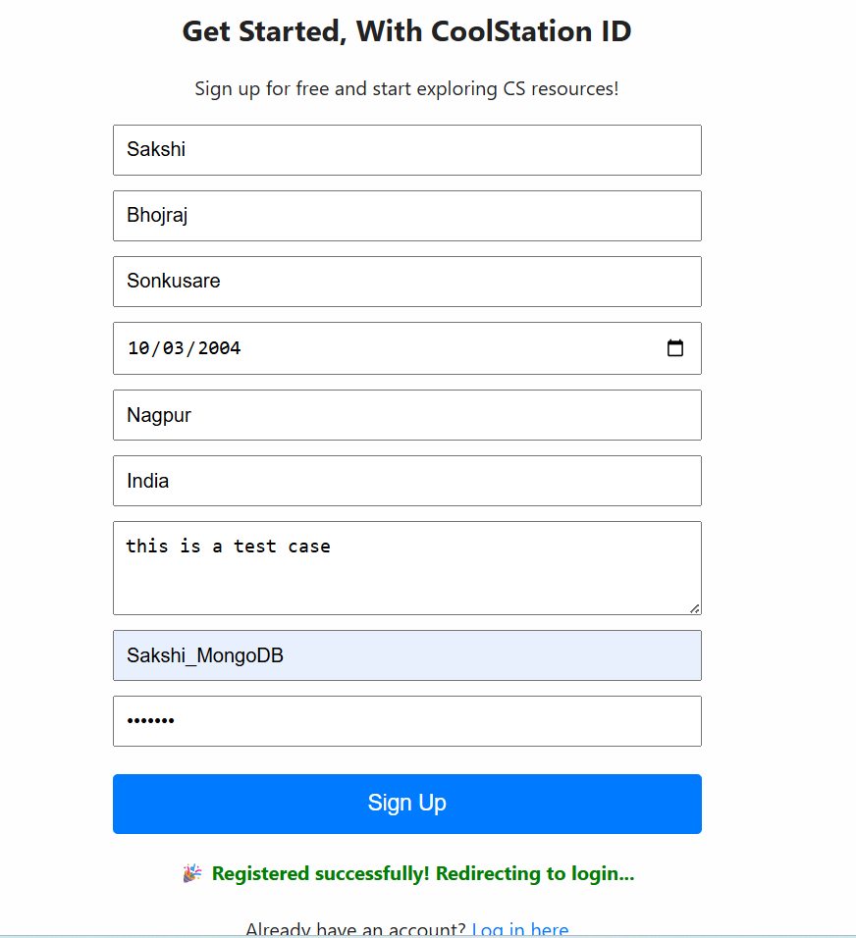

It redirects to the Login Page.

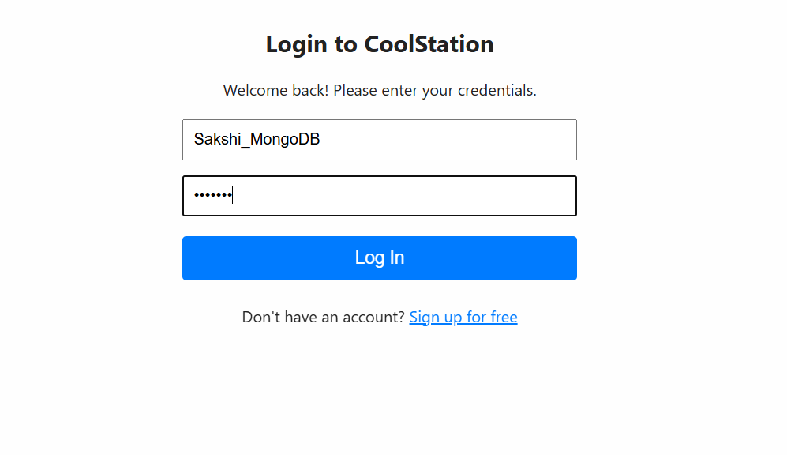

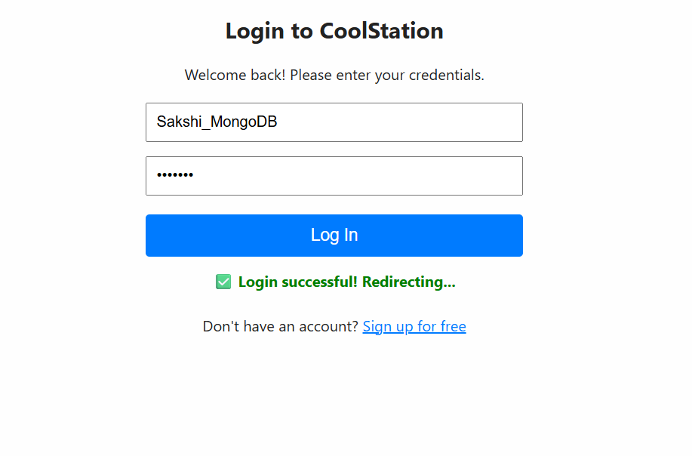

**Redirects to Dashboard -> CoolStation**

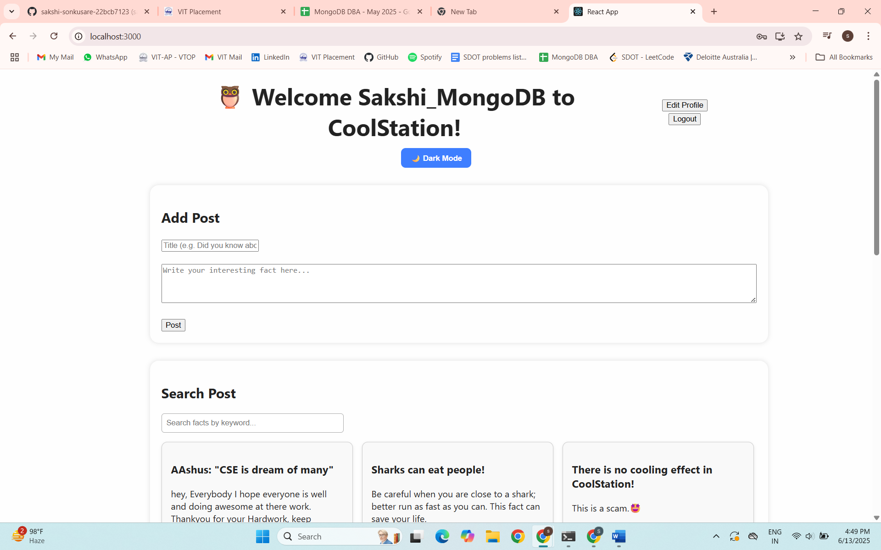

**Displays Welcome msg**: Welcome User_name to CoolStation!

**Adding up a Post:**

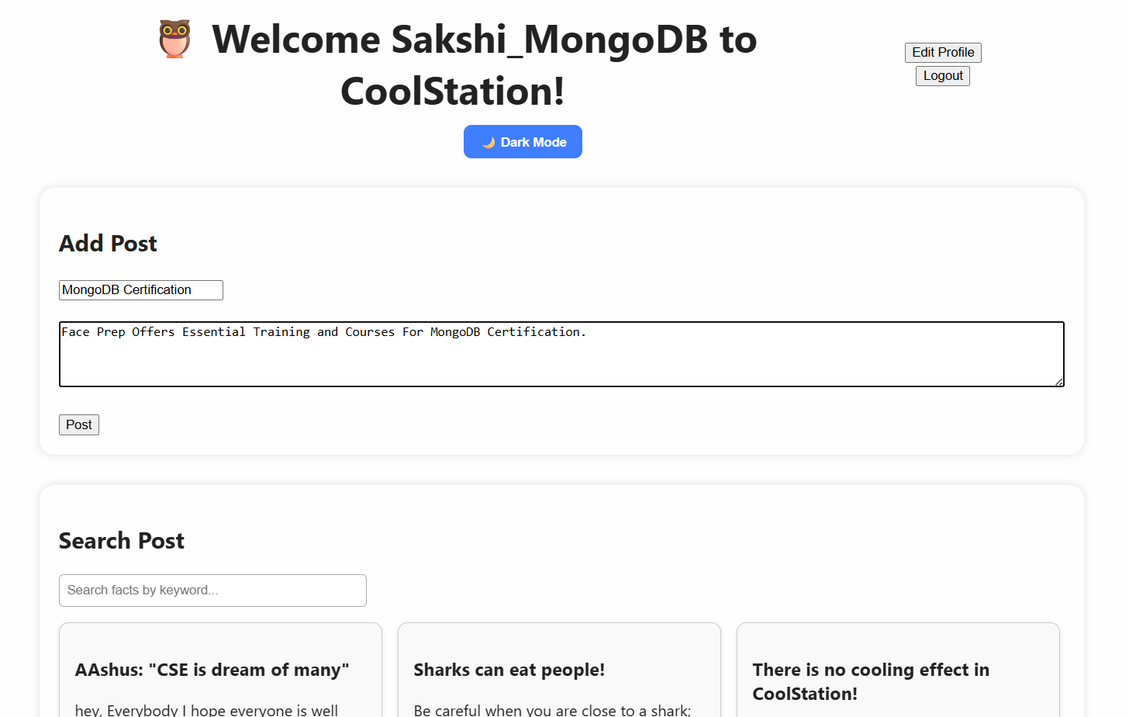

**Enter Title -> Enter Text -> Click Post**

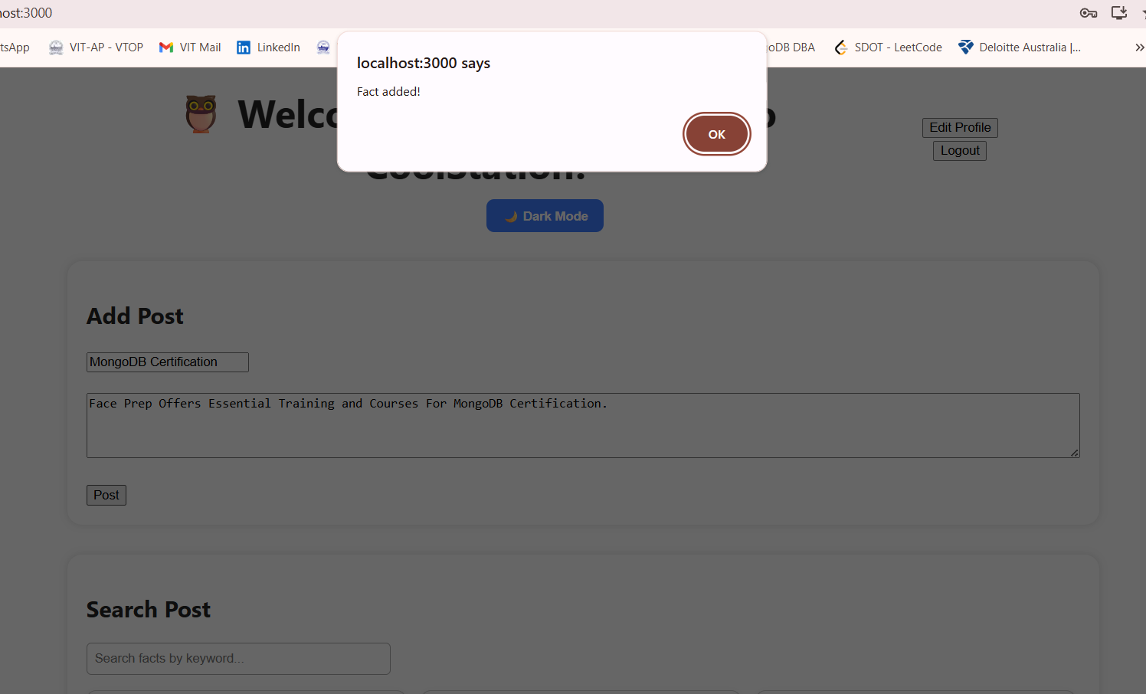

**To see the Fact/Post scroll down:**

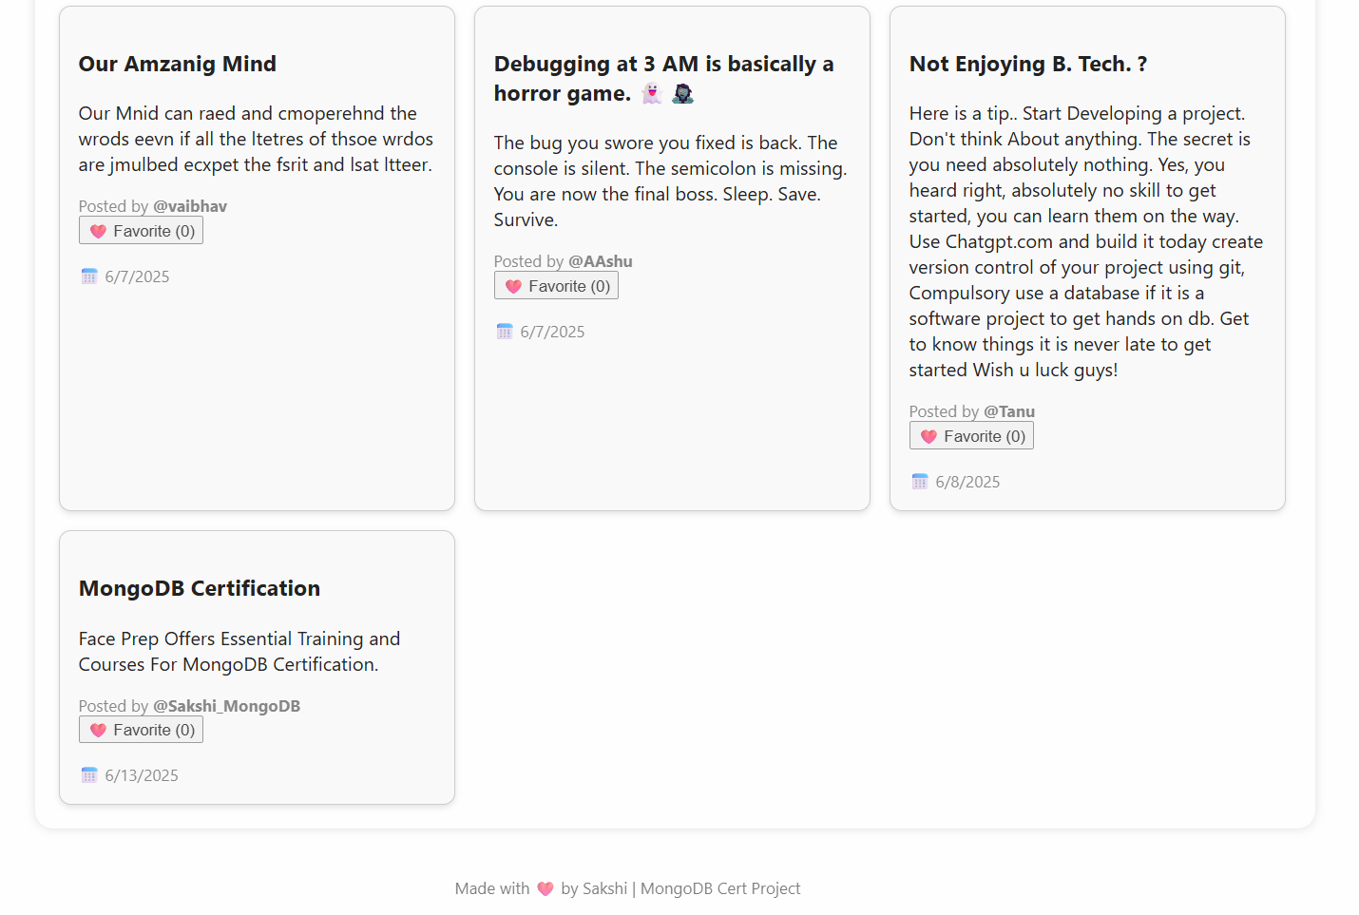

**Fact added Successfully**

**Search Post Section:**

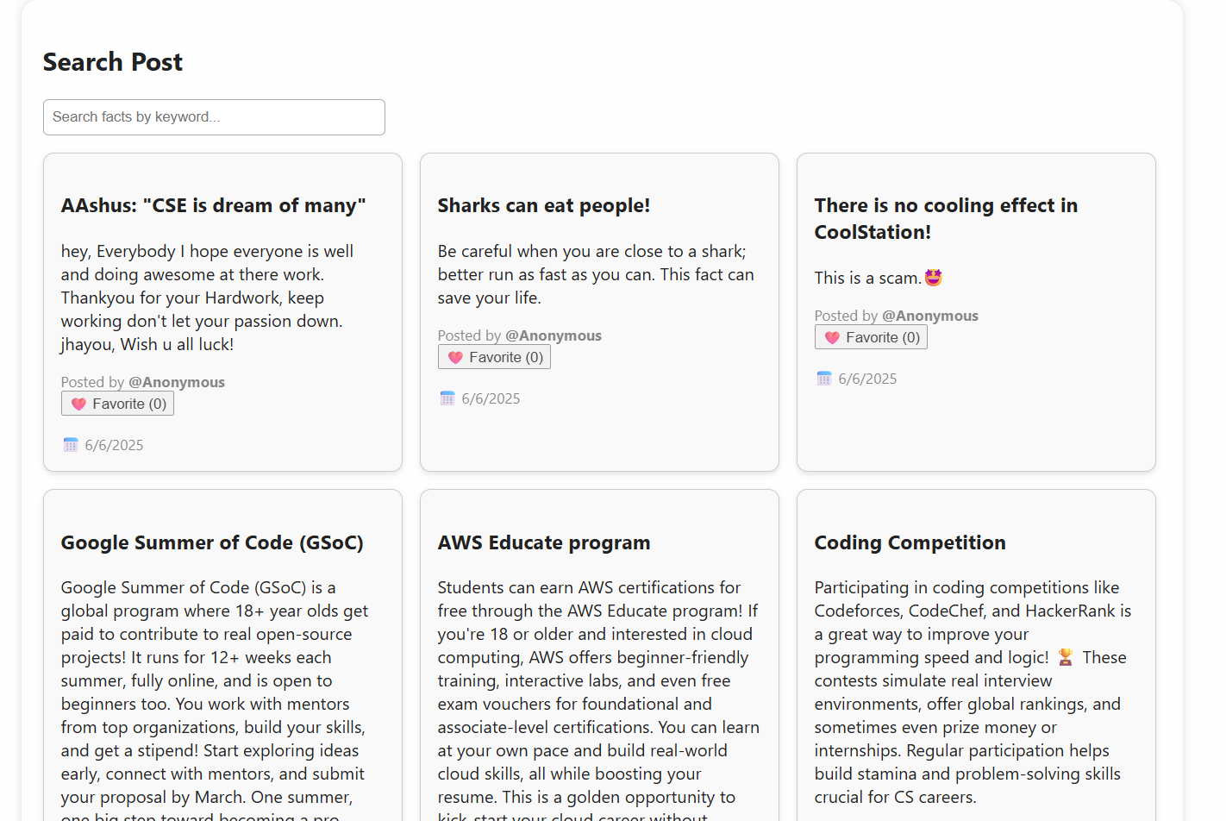

**Searching the post we just Added**

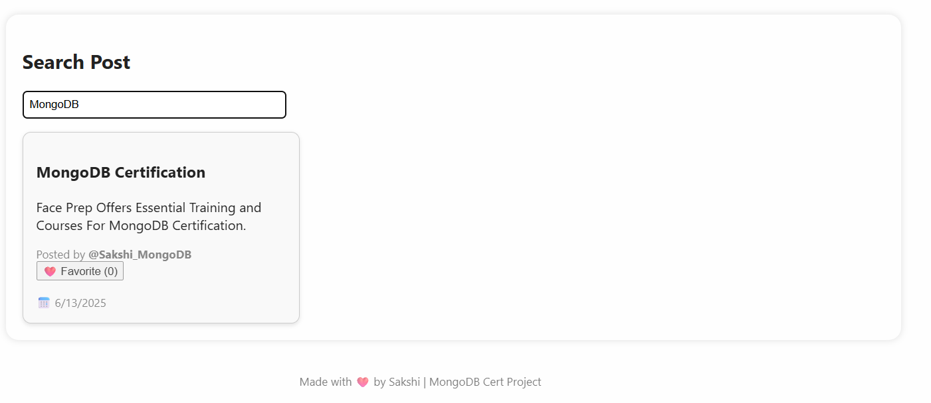

**Search Successful**

**Edit Profile: To Update the user details.**

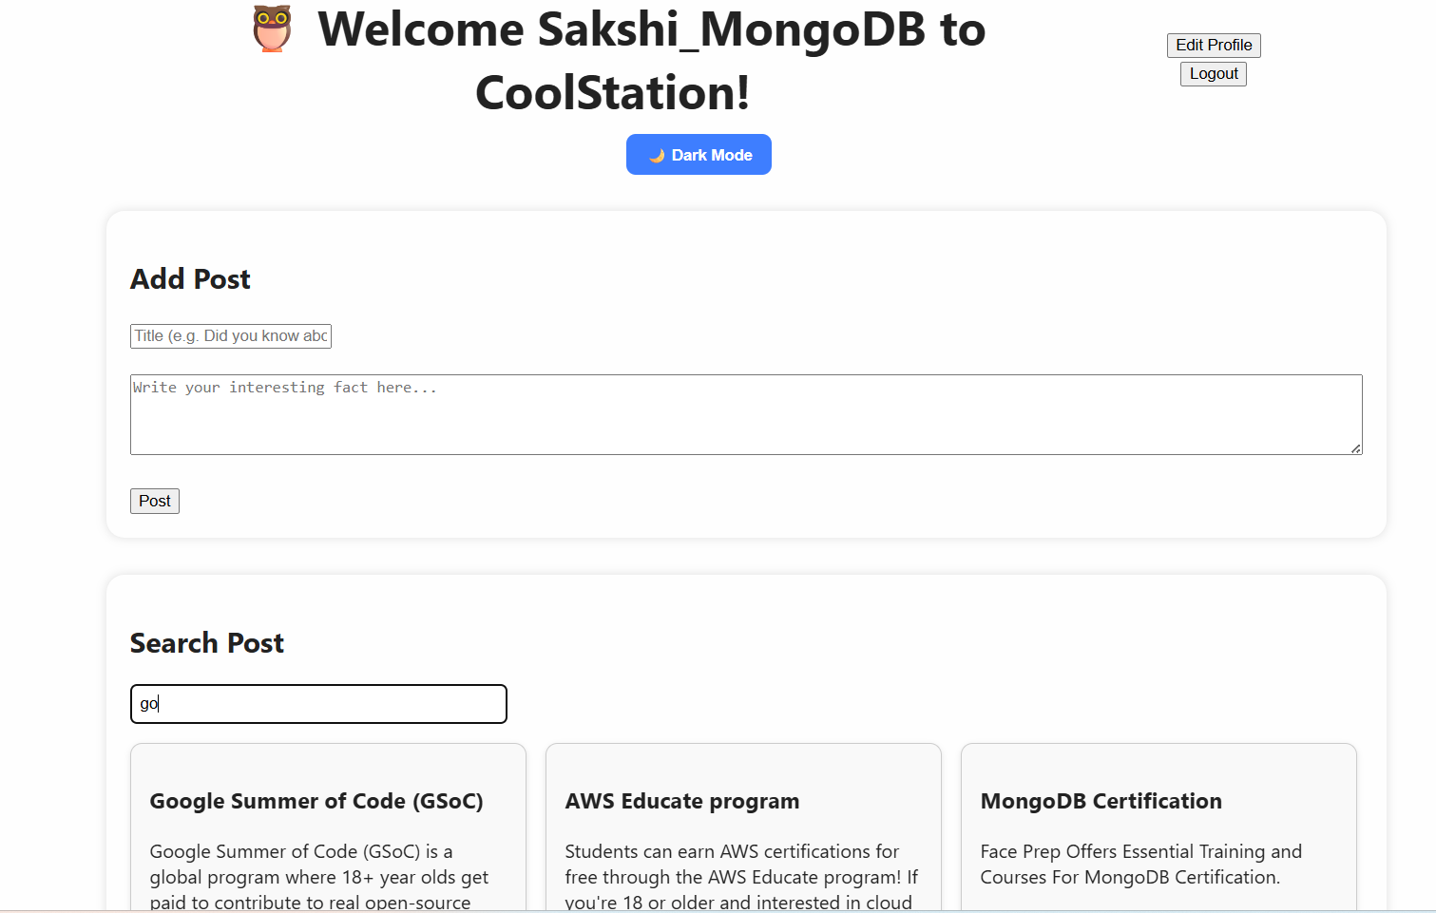

**Goto-> Edit Profile**

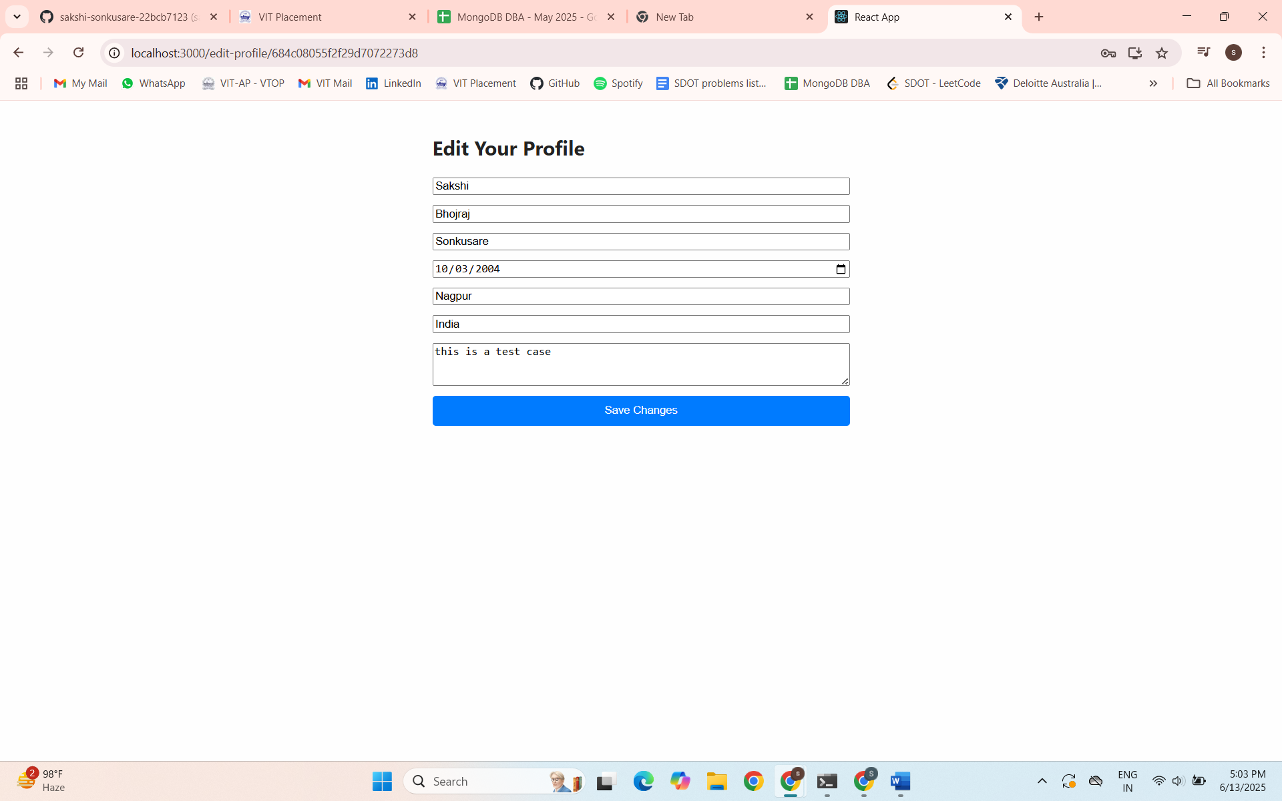

**It shows the details present from the database which the user Entered during sign up.**

**Let us Edit Bio:**

**this is a test case -> this is an update profile testcase.**

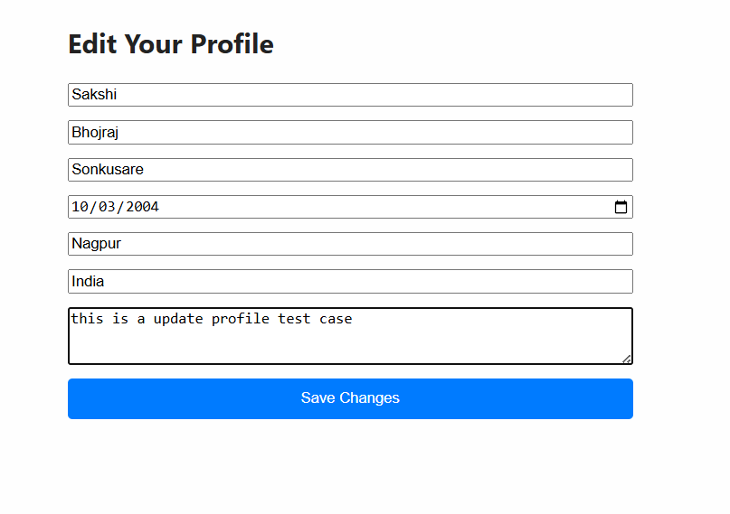

**Click -> Save Changes**

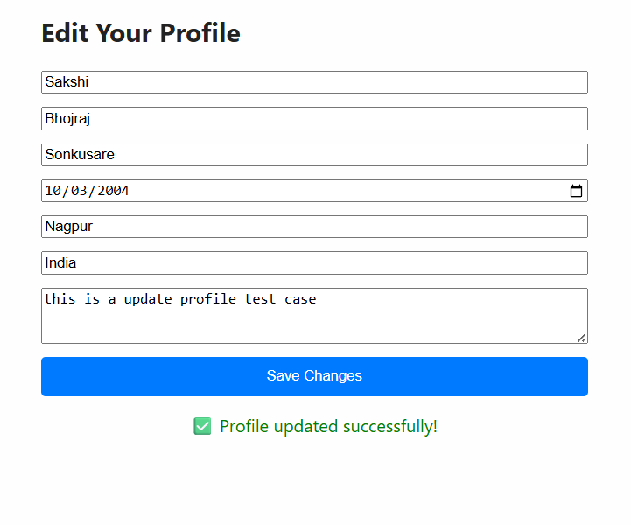

**It redirects Back to Dashboard.**

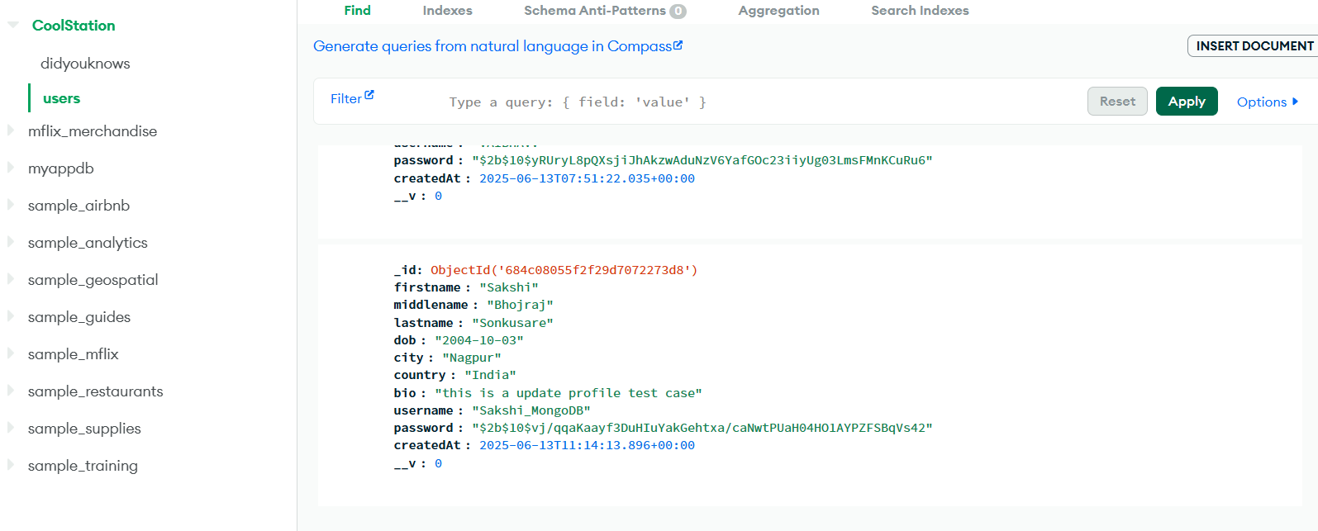

**We can see in the database also that it got updated.**

**Logout:**

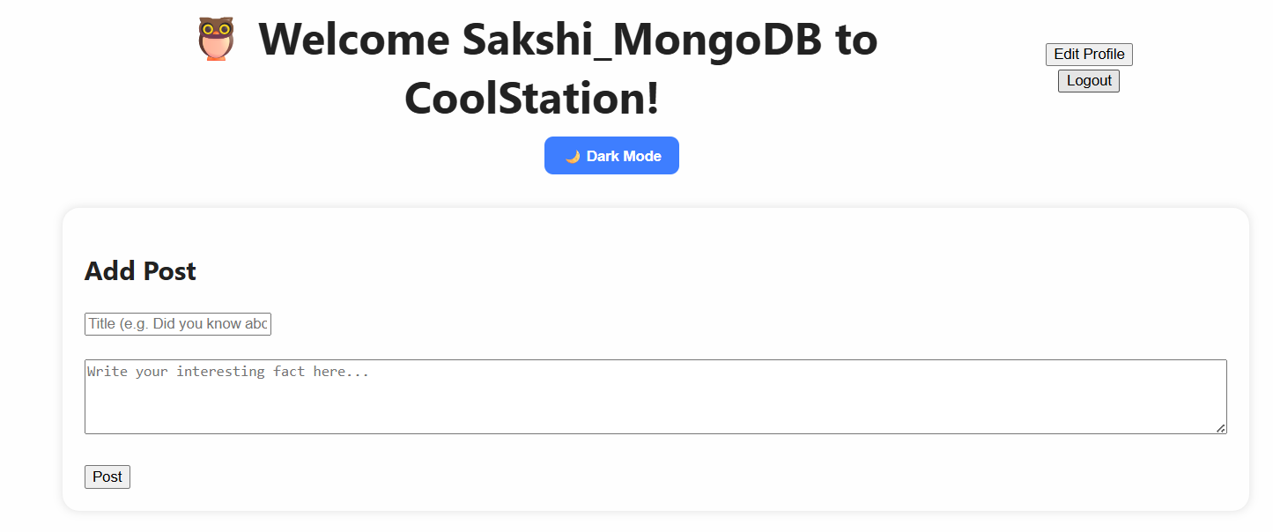

**Click Logout -> Redirects to Login page**

