WebDriver Dev Environment Setup: How to get started
1. Install JDK 1
2. Install Eclipse 2
3. Install TestNG Plug-in 2
4. Selenium Download…………………………………………………………………………………………4
5. Create Project in Eclipse…………………………………………………………………………………….4

Version | Author | Date
1.0 | Wenjuan Zhou | 2017-3-9

Install JDK
Download JDK&JRE
JDK: http://www.oracle.com/technetwork/java/javase/downloads/jdk8-downloads-2133151.html
JRE: http://www.oracle.com/technetwork/java/javase/downloads/jre8-downloads-2133155.html

Take example:
JDK Install Path: C:\Java\jdk1.7.0_25
JRE Install Path: C:\Java\jre7

Setup environment variable:
JAVA_HOME=C:\Java\jdk1.7.0_25
Please DO NOT include the bin folder like this : C:\Java\jdk1.6.0_17\bin

Path=<the original value of Path, do not change>;%JAVA_HOME%\bin;%JAVA_HOME%\jre\bin;
Environment parameter, Path, already exists in the list. System uses this parameter to configure any application that needs to run in background. So when you configure it, make sure do not change its existing value and append the JAVA settings behind.

CLASSPATH=.;%JAVA_HOME%\lib\dt.jar;%JAVA_HOME%\lib\tools.jar;
In the CLASSPATH, please make sure add the dot “.” in the first place, this make sure when any class is loaded, it will try to find the class in the local folder, and then look into the defined dt.jar and tools.jar

Or, you can install any JDK version later than jdk1.5.

Verify JDK is installed and configure correctly:
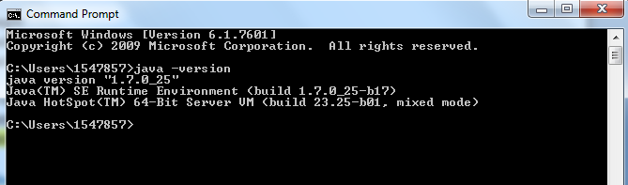

Install Eclipse
Download Eclipse and install. https://www.eclipse.org/downloads/

Install TestNG Plug-in
For the Eclipse plug-in, we can use the Eclipse Update Manager:

Open the eclipse, select Help -> Install New Software and open the install window.

Choose the TestNG different version from here:
http://beust.com/eclipse-old/

As we are going to install TestNG 6.9.13, just copy the link
http://beust.com/eclipse-old/eclipse_6.9.13.201609291640 and paste into eclipse install window and click enter.

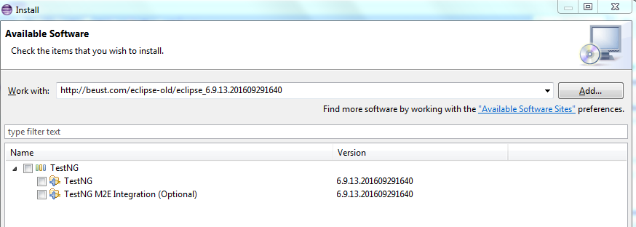

Select the TestNG and finish. Eclipse will automatically install it.

After install, click eclipse window -> Preference, you should see the preference setting for TestNG plug-in.

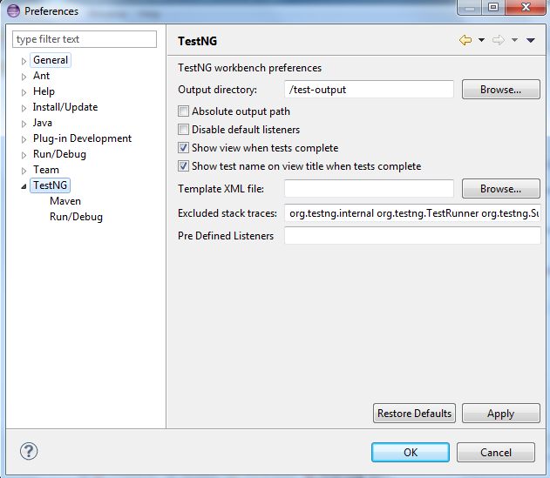

Selenium Download
Go to http://selenium-release.storage.googleapis.com/index.html and select folder 2.53
Select ‘selenium-java-2.53.1.zip’ and download.
Unzip the file to local.

Create Project in Eclipse
Create Project:
File->New->Java Project(test)

Create Package:
Src->New->Package(test)

Create Class:
Package->New->Class(TestHelloWorld.java)
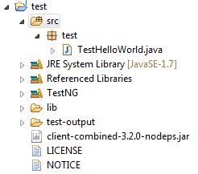
Add Build Path:
Add External JRAs from Selenium unzip folder in Step 4(Selenium Download)
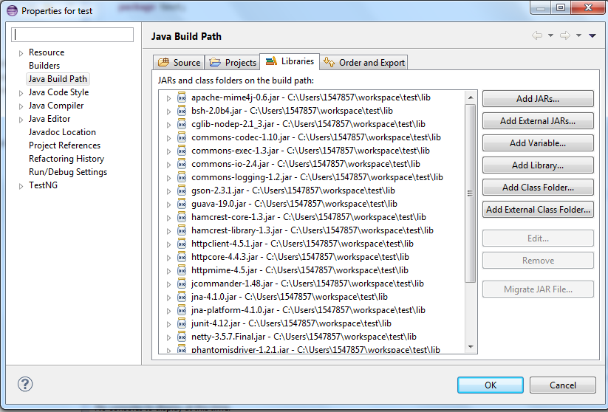

Create test script:
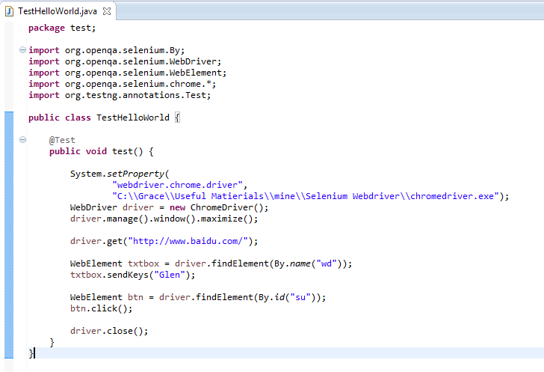

Now you can start the journey with:
Run as ‘TestNG Test’

If you are not using Maven then add following JAR files in your Java program's classpath
poi-3.11-beta2.jar
commons-codec-1.9.jar
poi-ooxml-3.11-beta2.jar
poi-ooxml-schemas-3.11-beta2.jar
xmlbeans-2.6.0.jar
stax-api-1.0.1.jar

