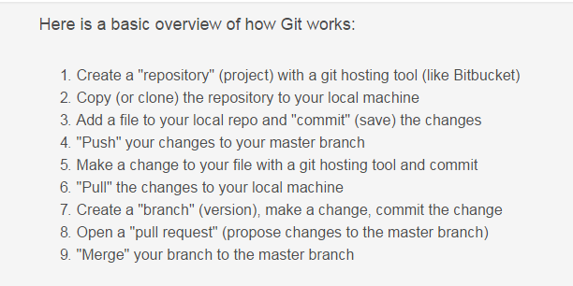

<https://www.atlassian.com/git/tutorials/learn-git-with-bitbucket-cloud>

git config --global user.name “Gao,Cerys Rui”

git config --global user.email “CerysRui.Gao@sc.com”

git clone <https://1478146@bitbucket.global.standardchartered.com/scm/~1478146/sg-mobile-2.0.git>

(click clone in left menu

<https://1539667@bitbucket.global.standardchartered.com/scm/~1410494/sc-mobile-automation.git>)

git status

git log

git add <filename>

git commit -m “commit comment”

git push -u origin master

git pull

git checkout develop

git branch

<https://www.atlassian.com/git/tutorials/learn-git-with-bitbucket-cloud>

<http://nvie.com/posts/a-successful-git-branching-model/>

<https://bitbucket.org/product>

<https://bitbucket.global.standardchartered.com/login>

git command:

cd C:\git\develop\AutoCucumber\src\test\resources\tests\HK

git clone “git URL”

git checkout develop ---switch to develop branch

git status

git add IBFT-CASA.feature ---add new file 到本地分支

git commit –m “add IBFT” -- add notes

git pull ---before push, need pull to update to latest files

git push origin develop --上传到远程分支

git stash list –显示垃圾桶状态