**Installation and Environment**

1. Please install the ruby and set the environment variable by following below:

Download Ruby 1.9.3-p551 and Development Kit from RubyInstaller.org and extract

Note: please note that the development kit must be match the special ruby version, you can check the match information from rubyInstaller website.

1. Setup environment variable for ruby and development kit.

Path as below:

C:\Develop\ruby-2.2.4-x64-mingw32\bin;

C:\Develop\AutomaticTest\DevKit-Ruby-64\bin;

C:\Develop\AutomaticTest\DevKit-Ruby-64\mingw\bin;

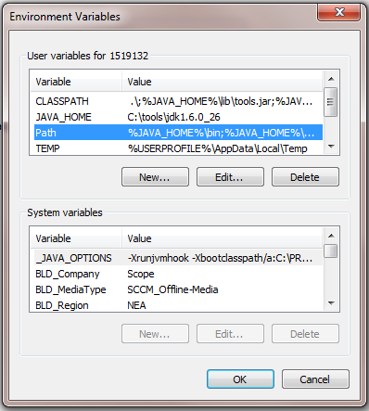

Validate the environment variable:

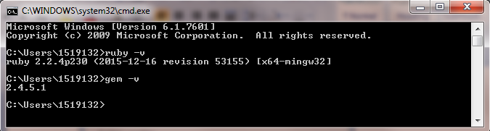

Run below commands in Ruby install folder:

ruby dk.rb init

(after the config.yml is generate, modify file like ‘- C:/Ruby224’)

ruby dk.rb install

gem install json –platform=ruby --verbose

1. Install gem bundler (Ruby Environmnent Path Required)

'gem' is a ruby command and all the artificates in ruby are called 'gem'. We will need a gem called bundler to execute command 'bundle install'. By command 'bundle install', it will download all the dependancy gem from internet which is require by the ruby project. Example our cucumber with ruby is one of the ruby project.

1. By using command prompt

2. Set Environment Path set http_proxy=<http://10.23.20.143:8080> if you're on SCB network.

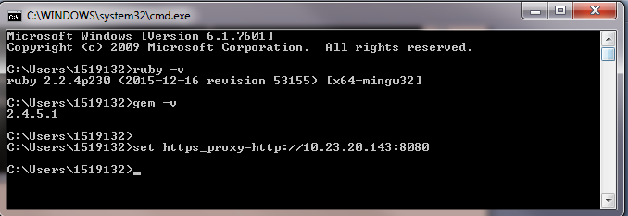

3. gem install bundler

If u hit below issue, please change the gem source and re-download, this issue is due to we cannot connect to the url which setup as default.

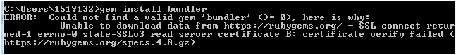

Change gem source:

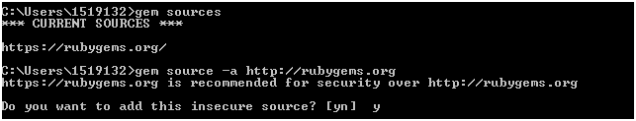

Install bundler successful:

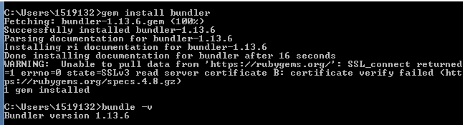

**Ruby Gems Installation**

1. Create the project folder for the capybara automation. Ex: Demo
2. Below is the sample hierarchy for running the cucumber- capybara scripts. Create the folder and file structure as below

Demo

features *Gemfile*

Step_definitions Support *sample.feature*

*sample.rb*

*Note : Highlighted in yellow are file names and rest all folder names*

1. Enter the gems to be installed in the Gemfile. The gems required are as follows.

# Encoding: utf-8

source 'http://rubygems.org'

gem 'require_all'

gem 'cucumber'

gem 'cucumber-api'

gem 'rspec'

gem 'rspec-rails'

gem 'httparty'

gem 'json'

gem "json-schema"

gem "rack-test", require: "rack/test"

gem 'chronic'

gem "sinatra"

gem "shotgun"

gem 'timecop'

gem 'selenium-webdriver'

gem 'capybara', '2.4.4'

gem 'pretty_face', '~> 0.10.3'

#gem 'ruby-oci8'

#gem 'dbi'

gem 'rails', '~> 4.2', '>= 4.2.5.1'

#gem 'activesupport', '~> 4.2', '>= 4.2.5.1'

5 .Install all gems with ‘bundle install’ command at the ruby environment.

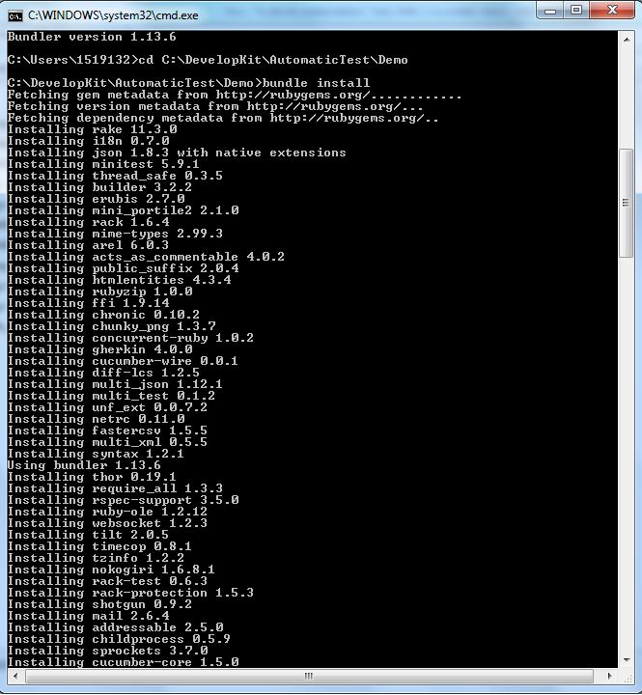

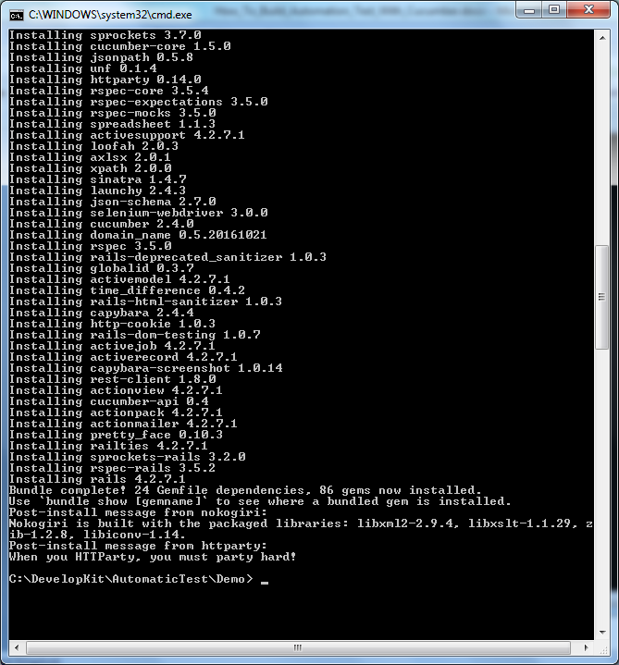

6. Install the ansicon with the command. ansicon –i from the ansicon folder path.

Please note that u need go to the folder x64/x86 to run the install command.

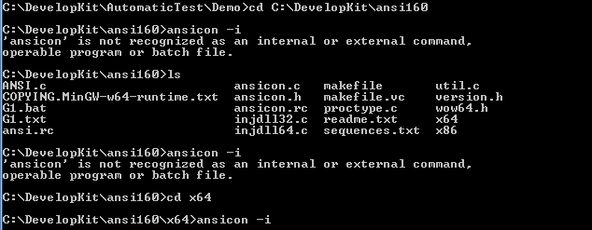

7. validate the environment is ready or not:

Run ‘cucumber –init’ in your project folder:

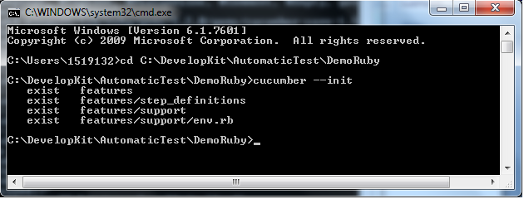

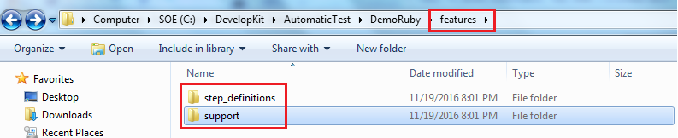

补一下cucumber执行命令语句

cd C:\Grace\Automation\Cucumber Test\Projects\OMF IN

cucumber "features/Login.feature" --format pretty --format html -o report.html browser=true

cucumber "features/RDC-2420_Login.feature" --format pretty --format html -o report.html browser=true

gem list webdriver

gem uninstall webdriver --version 1.1.9

cucumber eclipse plugin:

<http://cucumber.github.com/cucumber-eclipse/update-site>

cucumber "features/SearchGoogle.feature" --format pretty --format html -o report.html chrome=true

cucumber "features/Test.feature" --format pretty --format html -o report.html chrome=true