How to configure cucumber test script in Jenkins

1. if your project is maven project, it is easy to configure in Jenkins
2. Login in Jenkins address with valid credential : <http://10.25.136.12:8080/>
3. Under the Automation item, create one new job. Then select Maven project, and click ok.

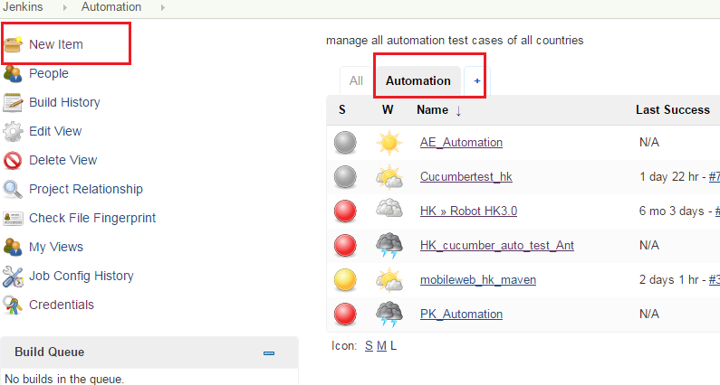

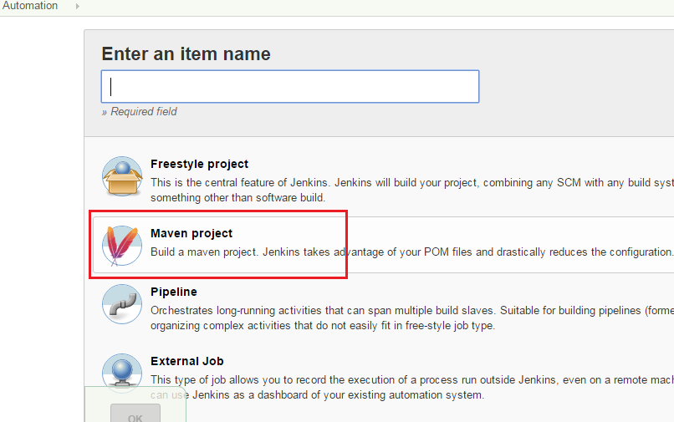

* 1. Enter details on configure page

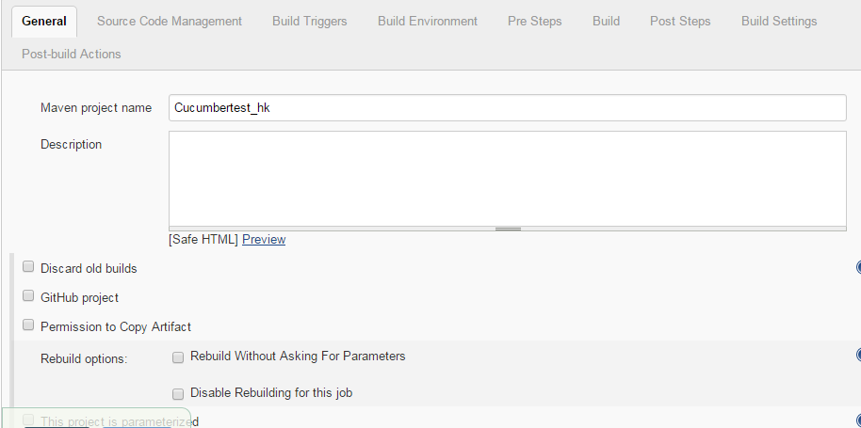

4.2 upload test script to SVN, then set source code management. Put svn path address in the field.

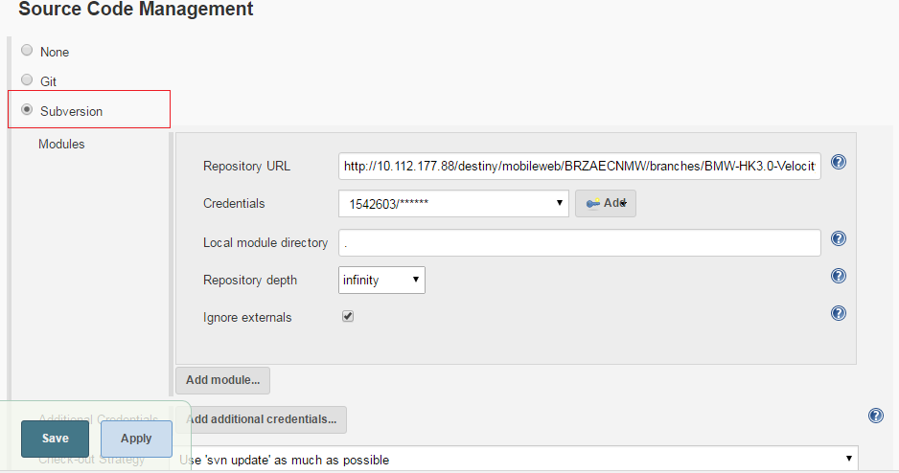

4.3 configure build steps. Pom.xml is in the test project. Before building, “clean test aims to clean some temporary files in previous buildings.

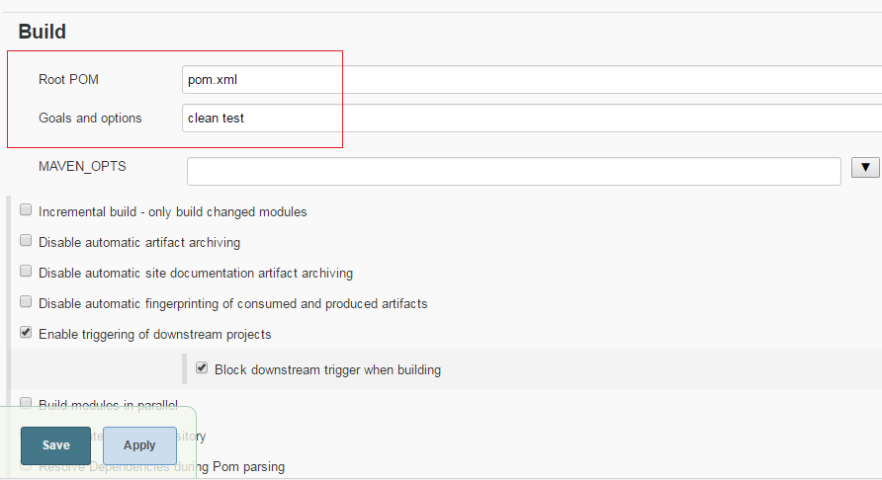

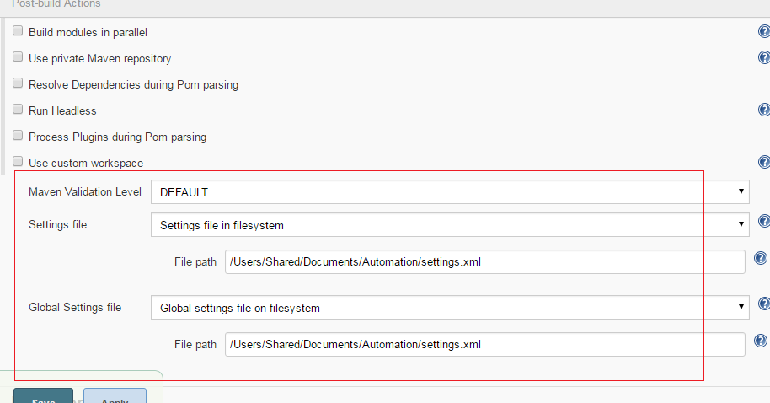

Note:

1. 开始build时，由于jenkins服务器连接的内网，一些依赖包不能下载。又上传了自己 的settings.xml文件（设置了网络代理）到jenkins服务器上，并在jenkins里 指定其路径（如果不指定，将用系统里的settings文件），这样通过settings文件里相关的网络代理等设置，使pom.xml文件里的依赖包按其路径顺利下载。Settings.xml在wiki上的下载地址：https://confluence.global.standardchartered.com/pages/viewpageattachments.action?pageId=105717213&metadataLink=true

4.4 构建后操作：compress the screenshot file to xxx.tar,

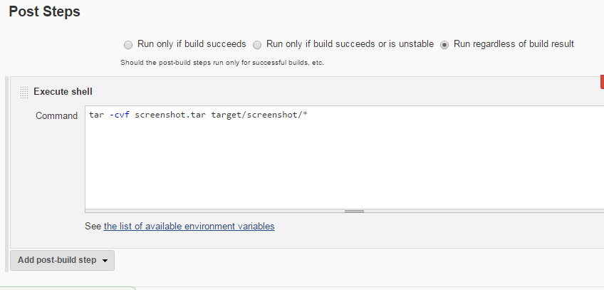

4.4.1 upload screenshot.tar to workspace in Jenkins server.

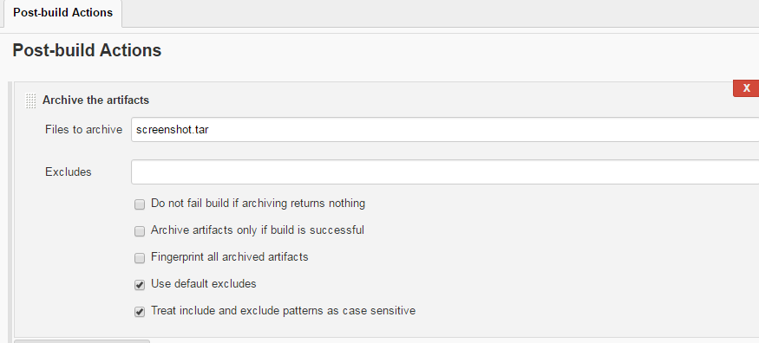

4.4.2 see screenshot.tar

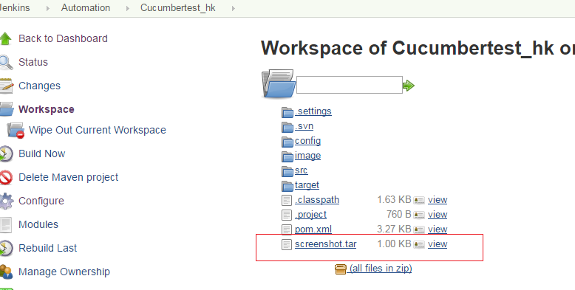

4.4.3 archive to artifacts:把每次构建历史记录里的 screenshot.tar文件标记为artifacts，方便查看和下载。

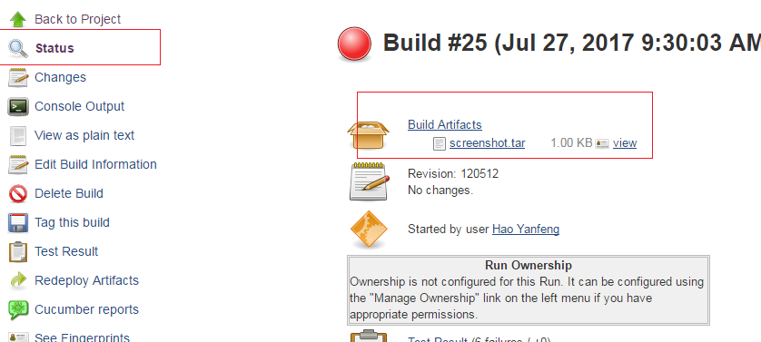

Note: before run build in Jenkins, can firstly run test script in local machine with command line.

Go to path of the project in CMD windows, e.g.:

cd C:\BMW_HK3.0_Velocity\test\Cucumbertest_hk

1. mvn clean
2. mvn build
3. mvn test
4. or mvn clean test

设置浏览器或者操作系统 ，可在pom.xml里设置。

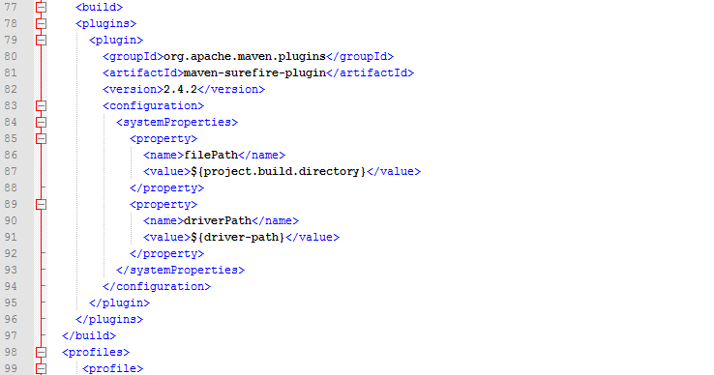

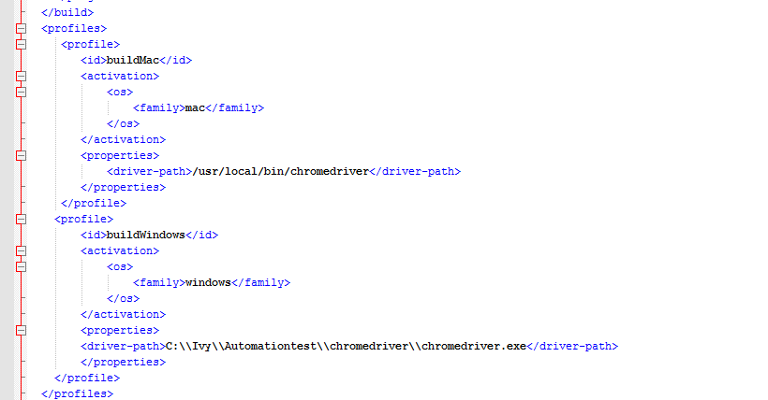

In code

//setting proxy

System.setProperty("webdriver.chrome.driver", System.getProperty("driverPath"));

如果用macbook跑脚本， chromedriver放在系统路径里。则无需code里指定。