|  |
| --- |
| Last modification: 18/02/2021 |
| Version: 1.0 |

IWAST Consumption

Current consumption

measurements

|  |
| --- |
| Author(s): |
| *Pierre VERHULST* |
|  |

Table of contents

1. The Motherboard 4

1.1 Description 4

1.2 Hardware analysis 4

ATSAMD21G18 - Main MCU 4

RN2483 - LoRa® chip 6

LED 7

Power Management 8

1.3 Measurements 9

Modus operandi 9

Results 11

1.4 Conclusion 16

2. The buttons board 17

2.1 Description 17

2.2 Hardware analysis 17

PIC16F18446 - Main MCU 17

LED 18

2.3 Measurements 19

Modus operandi 19

Results 21

2.2 Conclusion 25

3. The power board 26

2.1 Description 26

2.2 Hardware analysis 26

PIC16F18446 - Main MCU 26

BQ25570 - Boost charger and buck converter 27

BQ24040 - USB charger 28

TPS22860 - Switch 28

TPS705 - Low-Dropout Regulator 28

2.3 Measurements 29

Modus operandi 29

Results 31

3.1 Conclusion 40

4. The sound board 41

4.1 Description 41

4.2 Hardware analysis 41

PIC16F18446 - Main MCU 41

Amplifier and low-pass filter 42

Vesper VM1010 43

LED 44

4.3 Measurements 45

Modus operandi 45

Results 47

4.4 Conclusion 55

5. The environmental board 56

5.1 Description 56

5.2 Hardware analysis 56

5.3 Measurements 57

Modus operandi 57

Results 59

5.4 Conclusion 63

Annex A - Configuration of the *OTII ARC* 64

Annex B - Using the *IWAST Configurator* 65

# The Motherboard

## Description

|  |  |
| --- | --- |
| The motherboard represents the main part of the IWAST embedded system. It’s a necessary component used to connect all sensors and to collect all their data. These ones are then sent to TTN[1] by a LoRa chip. This board is based on a microcontroller ARM® Cortex®-M0+ which can manage all features of the system. It’s also the bridge between the computer and the IWAST system used to set up the IWAST configurations. So, we can configure the system via the QT-config app if we connect a USB wire between a computer and the motherboard. | Figure 1 The Motherboard |

We can list their main features:

* We can connect up to six sensors boards and collect data from them.
* We can set up several kinds of configurations for the connected sensor boards (polling and threshold).
* The motherboard sends a status message a few times after starting up.
* The only button present is used to restart the motherboard and to set a new configuration via the IWAST Configurator.

## Hardware analysis

### ATSAMD21G18 - Main MCU

|  |  |
| --- | --- |
| This board is built around a 32-bit ATSAMD21G18 microcontroller (48 MHz). Its wiring is classic and respects all specifications from the Datasheet. The power supply is set to 3.3 V and all decoupling capacitors respect the recommended values of the Datasheet.  We can quote the two pins PA23 and PA22 used to establish the I2C communications between this MCU (the master) and all the connected sensor boards (the slaves). This bus is built with pull-up resistors. | Figure 2 Schematic of the MCU's Motherboard |

This MCU allows us to select specific modes in order to control the power consumption of the chip. There is a normal mode (not efficient in terms of power consumption) and a sleep mode. With this chip, two possibilities are possible for the sleep mode: the IDLE mode and the STANDBY mode. This second option is the best if we want to consume the least amount of power. According to the Datasheet[2] :

Table 1 Current consumptions for several modes of ATSAMD21

This table is quite interesting for the analysis of the STANDBY mode. Indeed, all peripherals are disabled in this mode (except for the RTC if enabled by the software). It’s more complex to analyse the ACTIVE mode because it depends on the program. So, we need to know which peripherals are enabled/disabled in the code for the analysis of the active mode. We can estimate the consumption for each specific peripheral according to the Datasheet[3] data:

Table 2 Typical peripheral current consumption

### RN2483 - LoRa® chip

|  |  |
| --- | --- |
| This chip is used to transmit data from the main MCU to the TTN. The communication between both is done via UART protocol. The default baud rate is 57600 bps (important to know if we want to estimate the time of a transmission).  The wiring respects all specifications from the Datasheet. We don’t need to program this chip. So, the analysis of its current consumption is simpler than the MCU. | Figure 3 Wiring of the LoRa chip |

According to the Datasheet[4] :

Table 3 Current Consumption for the LoRa chip

So, according to the code of the MCU, we can estimate the current consumption of the chip depending on its mode.

### LED

The LED used for the debugging and the two LEDs used when we set up the configurations can consume a little power. We must therefore take them into consideration. To estimate their current consumption, we need to know their typical forward voltage.

The LED used for the debugging is a part of the short travel key switch from MARQUARDT®. We use a yellow LED and the Datasheet[5] gives us the forward voltage: 1.8 V. So, with the serial resistor R4 (1 kΩ) and the power supply (3.3 V), it’s easy to determine the current that will pass through when the LED is active:

The two LEDs used when we set up the configuration also have a typical forward voltage of 1.8 V. So, with the two resistor R2 and R3 (both 470 Ω), it’s easy to determine the current that will pass through each LED when they are active:

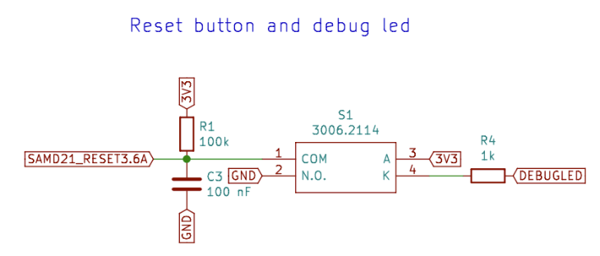

Figure 4 Reset button / Debug LED / LEDs for communications

### Power Management

Two solutions are possible to supply the system with the correct value of 3.3 V. The first is the easiest way. It consists to supply the system with Power module which directly delivers 3.3 V on the VBAT pin. The second solution is to supply the board thanks to the USB connection with a computer. This solution needs a regulator (TPS7A0533) to obtain an accurate value of 3.3 V and this part consumes also some current.

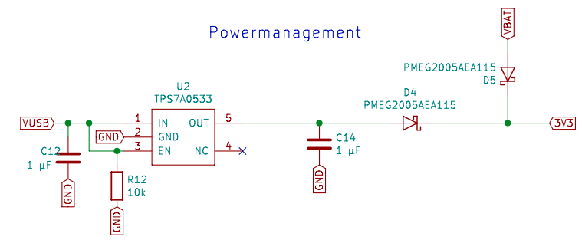

Figure 5 Power management of the motherboard

If we use this regulator, we normally use 10 nA for the enable pin (according to the Datasheet[6])

**N.B:** *The IWAST system aims to be self-sufficient thanks to the Power module. So, this regulator is useless with the Power module. Its current consumption must not be considered in the calculation.*

## Measurements

### Modus operandi

1. Plug the motherboard and the *Otii ARC* according to the scheme fig.6 (refer to annex A in order to understand how to configure the measuring device *Otii ARC*).

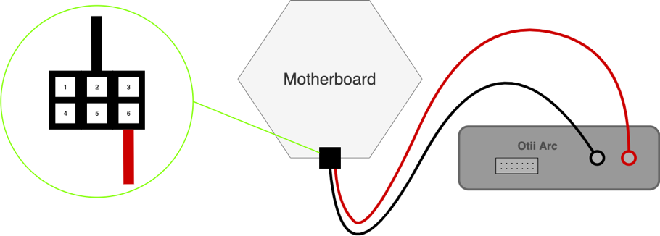

Figure 6 Connect the motherboard and the Otii ARC

1. Set the system configurations via the *IWAST configurator app* (refer to annex B in order to understand how to use this application). Several configurations must be set:
2. **Motherboard without accumulation data (ID 0)**:

* The accumulation data feature must be disabled

1. **Motherboard with accumulation data** **(ID 1)**:

* The accumulation data feature must be enabled

1. Collect the current measurements for each configuration at different moment. The test should last minimum 15 min to be relevant. With this physical configuration, we can collect the values of the current flowing between the power supply and the motherboard (location 1). Multiple scenarios must be analysed with this module:
2. When nothing happens (static power / sleep mode)
3. When motherboard wakes up each minute (dynamic power 0)
4. When data are sent by the motherboard (data sending power ➝ Status Message)
5. Collect measurements for special cases. Multiple scenarios must be analysed:

**Special Meas. 1.1 : *DATA_TX Time variation depending on the spreading factor (Status Message)***

This special measurement must be taken to determine if the LoRa airtime estimation (determined by an estimation online tool[7]) is correct or not. So we collect the airtime of the LoRa castle for each possible spreading factor (7 to 12) and we note the difference between the estimation and the reality. This test must be performed with the status message consisting of a 7-byte payload.

**Special Meas. 1.2 :** ***Average Current variation for six different motherboards (SF = 11 for each motherboards)***

This special measurement must be taken to evaluate the average consumption of the static power for multiple motherboards. In the static power mode, we noticed that the static current can vary greatly depending on several motherboard. So, to have a correct estimation of the static current, we must analyse multiple static current of multiple motherboards under the same conditions.

|  |
| --- |
| **Warning :** If we want to measure the currents of the motherboard and use these ones for the estimation, we must connect a sensor board during the configuration and disconnect it just before doing the measurements. When no sensor boards are connected during the configuration, it seems that motherboard consumes ± 10 uA less. So, to do measurements with motherboard alone, respect this specific modus operandi :   * Connect the motherboard and a sensor board together. * Use the IWAST Configurator but don’t set any kinds of configurations related to the sensor board. Just click on the disconnect button. * Disconnect the USB cable and the sensor board to have a correct current measurement of the motherboard alone. |

### Results

#### Configuration 2.1 : Motherboard without accumulation data (ID 0)

|  |  |  |  |  |  |  |  |  |
| --- | --- | --- | --- | --- | --- | --- | --- | --- |
| **Scenario A - Nothing happens (static power / sleep mode)** | | | | | | | | |
| *Location 1* | | Average | |  | | | | |
| Maximum Value | | 388.6 μA | |
| Minimum Value | | 26.74 μA | |
| Average Value | | 27.94 μA | |
|  | | | |
| Remarks :  *This average value is correct. However, it must be taken into account that this value can vary greatly depending on the chosen motherboard (probably due to welding). So we must take measurements with multiple motherboards to obtain a correct average value and to determine an error level.* | | | | | | | | |
| Measure | 1 | | 2 | | 3 | 4 | 5 |
| Max. Value | 387 | | 403 | | 405 | 408 | 340 |
| Min. Value | 26.9 | | 26.8 | | 26.7 | 26.7 | 26.6 |
| Aver. Value | 28.1 | | 28 | | 27.9 | 27.9 | 27.8 |

|  |  |  |  |  |  |  |  |  |
| --- | --- | --- | --- | --- | --- | --- | --- | --- |
| **Scenario B – Motherboard wakes up (dynamic power 0)** | | | | | | | | |
| *Location 1* | | Average |  | | | | | |
| Maximum Value | | 9154 µA |
| Minimum Value | | -267.8 µA |
| Average Value | | 8044 µA |
| Energy | | 0.611 μWh |
| Interval Time | | 82.88 ms |
|  | | |
| Remarks : | | | | | | | | |
| Measure | 1 | | | 2 | 3 | 4 | 5 |
| Max. Value | 9140 | | | 9170 | 9140 | 9130 | 9190 |
| Min. Value | -270 | | | -270 | -286 | -242 | -271 |
| Aver. Value | 8040 | | | 8060 | 8050 | 8040 | 8030 |
| Energy | 0.611 | | | 0.611 | 0.611 | 0.611 | 0.611 |
| Interval Time | 82.9 | | | 82.8 | 82.8 | 82.9 | 83 |

|  |  |  |  |  |  |  |  |
| --- | --- | --- | --- | --- | --- | --- | --- |
| **Scenario C - Data sent by the motherboard (data sending power -> Status Message)** | | | | | | | |
| *Location 1* | | Average | |  | | | |
| WUT_ST Time | | 82.22 ms | |
| WUT_ST Energy | | 1.094 µWh | |
| DATA_TX Time | | 744.62 ms | |
| DATA_TX Aver. Cur | | 47300 µA | |
| DATA_RX Time | | 2299.66 ms | |
| DATA_RX Energy | | 39.06 µWh | |
|  | | | |
| Remarks :  *We are supposed to have DATA_TX Time = 495.62 ms (airtime LoRa calculator/Spreading Factor = 11)*  *Δ = 249 ms* | | | | | | | |
| Measure | 1 | | 2 | | 3 | 4 | 5 |
| WUT_ST Time | 82 | | 81.9 | | 82.5 | 82.6 | 82.1 |
| WUT_ST Energy | 1.09 | | 1.09 | | 1.1 | 1.1 | 1.09 |
| DATA_TX Time | 745 | | 745.1 | | 744 | 744 | 745 |
| DATA_TX Aver. Cur | 47100 | | 47400 | | 47200 | 47300 | 47500 |
| DATA_RX Time | 2299.2 | | 2299.9 | | 2299.7 | 2299.8 | 2299.7 |
| DATA_RX Energy | 39.1 | | 39 | | 39 | 39.1 | 39.1 |

#### Configuration 2.2 : Motherboard with accumulation data (ID 1)

|  |  |  |  |  |  |  |  |  |
| --- | --- | --- | --- | --- | --- | --- | --- | --- |
| **Scenario A - Nothing happens (static power / sleep mode)** | | | | | | | | |
| *Location 1* | | Average | |  | | | | |
| Maximum Value | | 388.6 μA | |
| Minimum Value | | 26.62 μA | |
| Average Value | | 27.9 μA | |
|  | | | |
| Remarks :  *This average value is correct. However, it must be taken into account that this value can vary greatly depending on the chosen motherboard (probably due to welding). So we must take measurements with multiple motherboards to obtain a correct average value and to determine an error level.* | | | | | | | | |
| Measure | 1 | | 2 | | 3 | 4 | 5 |
| Max. Value | 400 | | 403 | | 403 | 399 | 338 |
| Min. Value | 26.6 | | 26.6 | | 26.7 | 26.6 | 26.6 |
| Aver. Value | 28 | | 27.9 | | 27.9 | 27.9 | 27.8 |

|  |  |  |  |  |  |  |  |  |
| --- | --- | --- | --- | --- | --- | --- | --- | --- |
| **Scenario B – Motherboard wakes up (dynamic power 0)** | | | | | | | | |
| *Location 1* | | Average | |  | | | | |
| Maximum Value | | 9212 µA | |
| Minimum Value | | -252.4 µA | |
| Average Value | | 8158 µA | |
| Energy | | 0.6112 μWh | |
| Interval Time | | 81.76 ms | |
|  | | | |
| Remarks : | | | | | | | | |
| Measure | 1 | | 2 | | 3 | 4 | 5 |
| Max. Value | 9150 | | 9160 | | 9340 | 9180 | 9230 |
| Min. Value | -277 | | -284 | | -215 | -263 | -223 |
| Aver. Value | 8140 | | 8160 | | 8190 | 8140 | 8160 |
| Energy | 0.611 | | 0.611 | | 0.612 | 0.611 | 0.611 |
| Interval Time | 81.9 | | 81.8 | | 81.5 | 81.9 | 81.7 |

|  |  |  |  |  |  |  |  |
| --- | --- | --- | --- | --- | --- | --- | --- |
| **Scenario C - Data sent by the motherboard (data sending power -> Status Message)** | | | | | | | |
| *Location 1* | | Average |  | | | | |
| WUT_ST Time | | 82.34 ms |
| WUT_ST Energy | | 1.098 µWh |
| DATA_TX Time | | 745.14 ms |
| DATA_TX Aver. Cur | | 47600 µA |
| DATA_RX Time | | 2300.24 ms |
| DATA_RX Energy | | 39.06 µWh |
|  | | |
| Remarks :  *We are supposed to have DATA_TX Time = 495.62 ms (airtime LoRa calculator/Spreading Factor = 11)*  *Δ = 249.52 ms* | | | | | | | |
| Measure | 1 | | 2 | 3 | 4 | 5 |
| WUT_ST Time | 82.5 | | 82.5 | 82.2 | 82 | 82.5 |
| WUT_ST Energy | 1.1 | | 1.1 | 1.1 | 1.09 | 1.1 |
| DATA_TX Time | 745 | | 745 | 743.9 | 744.9 | 746.9 |
| DATA_TX Aver. Cur | 47700 | | 47000 | 47900 | 47400 | 48000 |
| DATA_RX Time | 2298.8 | | 2300.6 | 2302.4 | 2299.9 | 2299.5 |
| DATA_RX Energy | 39.1 | | 39 | 39.1 | 39 | 39.1 |

#### Special Measurements

|  |  |  |  |  |
| --- | --- | --- | --- | --- |
| **Special Measurement 1.1 - DATA_TX Time variation depending on the spreading factor (Status Message)** | | | | |
| *Location 1* | Measure | Theory | Delta |  |
| DATA_TX Time (SF = 7) | 60.23 ms | 36.10 ms | 24.13 ms |
| DATA_TX Time (SF = 8) | 107.87 ms | 72.19 ms | 35.68 ms |
| DATA_TX Time (SF = 9) | 189.10 ms | 123.9 ms | 65.2 ms |
| DATA_TX Time (SF = 10) | 374.13 ms | 247.81 ms | 126.32 ms |
| DATA_TX Time (SF = 11) | 744.62 ms | 495.62 ms | 249 ms |
| DATA_TX Time (SF =12) | 1486.86 ms | 991.23 ms | 495.63 ms |
|  | | | |
| Remarks : | | | | |

|  |  |  |  |  |  |  |  |  |
| --- | --- | --- | --- | --- | --- | --- | --- | --- |
| **Special Measurement 1.2 - Average Current variation for six different motherboards (SF = 11 for each motherboards)** | | | | | | | | |
| *Location 1* | | Average | |  | | | | |
| Maximum Value | | 379.5 µA | |
| Minimum Value | | 26.53 µA | |
| Average Value | | 27.89 µA | |
| Extensive | | 2.52 µA | |
|  | | | |
| Remarks : | | | | | | | | |
| Measure | Aver. MB 1 | | Aver. MB 2 | | Aver. MB 3 | Aver. MB 4 | Aver. MB 5 | Aver. MB 6 | |
| Max. Value | 401.6 | | 398.6 | | 365 | 358.4 | 388.6 | 364.8 | |
| Min. Value | 26.44 | | 27.34 | | 25.16 | 26.56 | 26.74 | 26.94 | |
| Aver. Value | 27.86 | | 28.94 | | 26.42 | 27.8 | 27.94 | 28.36 | |

## Conclusion

At the end of the tests, **no major differences were noticed between ID0 and ID1**. Therefore, we can conclude that the enabling/disabling of the data accumulation feature has no influence on the motherboard consumption. For the total estimation, it’s not valuable to keep the two configuration so we keep the first: ID0.

About the LoRa message, we notice a **major difference between the estimation of the airtime and the reality** of this metric. The special measurement 1.1 has also demonstrated that this error varies according to the spreading factor parameter. We definitely must take into account this information for the total estimation.

As expected, **the static current varies depending on the motherboard**. The special measurement 1.2 allows us to obtain an average value of the static current and a value for the error (= ±1.26 μA).

Date of measurements : 20/01/2021

# The buttons board

## Description

|  |  |
| --- | --- |
| The buttons board is a sensor fitted with four buttons. When the board is connected to the motherboard, a press on one of the buttons provokes an interrupt towards the motherboard. According to the button pushed, the motherboard can send a message to the TTN console. This board is based on the microcontroller PIC16F18446. | Une image contenant équipement électronique  Description générée automatiquement  Figure 7 The buttons board |

This board requires no specific configurations via the IWAST configurator. We can’t set a polling interval and there are no thresholds.

## Hardware analysis

### PIC16F18446 - Main MCU

|  |  |
| --- | --- |
| This sensor board is built around the 16-bit PIC16F18446. Its wiring is classic and respects all specifications from the Datasheet. The power supply is set to 3.3 V and all decoupling capacitors respect the recommended values of the Datasheet. | Une image contenant texte, équipement électronique, circuit  Description générée automatiquement  Figure 8 PIC16F18446 |

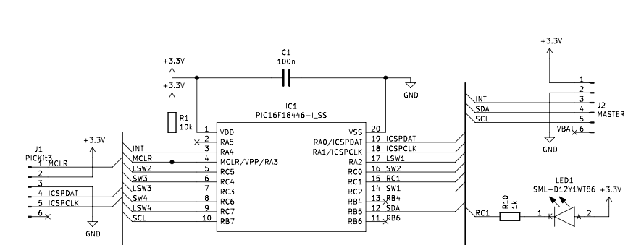

Figure 9 Wiring of the PIC16F18446

We can estimate the current consumption of the MCU depending on the power mode. In the code, we quote that the bit VREGCON in the register VREGPM is set to 1. So, the Low-Power sleep mode is enabled when the MCU pass to the sleep mode. We can determine the total current consumption according to the Datasheet[8] :

Table 4 Typical Current Consumption in Power-Down mode

The current consumption for the active mode is more difficult to estimate due to the particular clock using. We need to analyse the code to evaluate which peripherals are enabled, when and how much time they are active. Outside of the sleep mode, the Datasheet is not very clear about the current consumption of each peripherals. We definitely need to analyse this mode with real measurements.

### LED

|  |  |
| --- | --- |
| The LEDs used for the four buttons are part of the short travel key switch from MARQUARDT®. We use yellow LEDs and the Datasheet[9] gives us the forward voltage: 1.8 V. So, with serial resistors R3, R5, R7 and R9 (each 1 kΩ) and the power supply (3.3 V), it’s easy to determine the current that will pass through when the LED is active: | Figure 10 Wiring of the four buttons |

## Measurements

### Modus operandi

1. Plug the motherboard, the buttons board and the *Otii ARC* according to the scheme fig. 11 (refer to annex A in order to understand how to configure the measuring device *Otii ARC*).

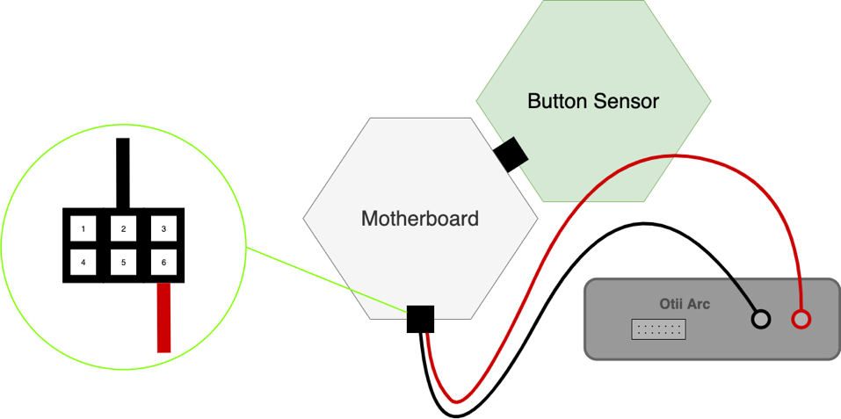

Figure 11 Connect the motherboard, the buttons board and the Otii Arc (LOC 1)

1. Set the system configurations via the *IWAST configurator app* (refer to annex B in order to understand how to use this application). One configuration must be set:
2. **Buttons without accumulation data (ID 2)**:

* The accumulation data feature must be disabled
* The polling interrupts must be disabled
* The thresholds (high and low) must be disabled

1. Collect the current measurements for each configuration at different moment. The test should last 15 min to be relevant. With this physical configuration, we can collect the values of the current flowing between the power supply and the motherboard (location 1) and between the power supply and the buttons module (location 2) (Figure 12). Multiple scenarios must be analysed with this module:
2. When nothing happens (static power / sleep mode)
3. When there is a push on a button (dynamic power 2)
4. When data are sent by the motherboard (data sending power -> Normal Message)

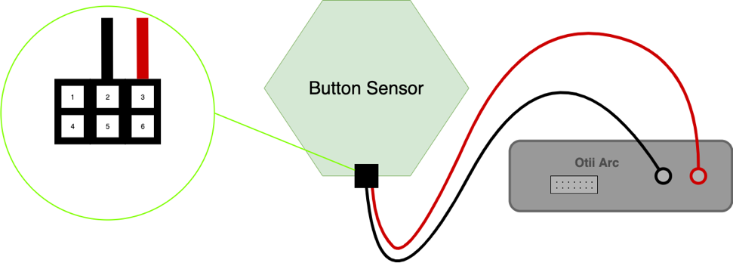

Figure 12 Connect the button sensor and the Otii Arc (LOC 2)

1. Collect measurements for special cases. Multiple scenarios must be analysed:

**Special Meas. 2.1 : *Accumulated message save (for one metric)***

This special measurement must be taken to determine the power consumption characteristic of a saving operation for data accumulation. We analyse the power consumption for the saving of one metric (after a push on a button).

**Special Meas. 2.2 :** ***Data sent by the motherboard (accumulated message)***

This special measurement must be taken to determine the power consumption when data are sent by the motherboard if the data accumulation is enable. We need to analyse the same parameters than a normal message.

**Special Meas. 2.3:** ***DATA_TX Time variation depending on the spreading factor (Normal Message) -> Payload length = 4 bytes***

This special measurement must be taken to determine if the LoRa airtime estimation (determined by an estimation online tool[10]) is correct or not. So we collect the airtime of the LoRa castle for each possible spreading factor (7 to 12) and we note the difference between the estimation and the reality. This test must be performed with a normal message consisting of a 4-byte payload.

**Special Meas. 2.4:** ***DATA_TX Time variation depending on the spreading factor (Accumulated Message) -> Payload length = 30 bytes***

This special measurement must be taken to determine if the LoRa airtime estimation (determined by an estimation online tool) is correct or not. So we collect the airtime of the LoRa castle for each possible spreading factor (7 to 12) and we note the difference between the estimation and the reality. This test must be performed with an accumulated message consisting of a 30-byte payload.

### Results

#### Configuration 2.1 : Buttons without accumulation data (ID 2)

|  |  |  |  |  |  |  |  |
| --- | --- | --- | --- | --- | --- | --- | --- |
| **Scenario A - Nothing happens (static power / sleep mode)** | | | | | | | |
| *Location 2* | | Average |  | | | | |
| Maximum Value | | 1.104 μA |
| Minimum Value | | -0.4932 μA |
| Average Value | | 0.2982 μA |
|  | | |
| Measure | 1 | | 2 | 3 | 4 | 5 |
| Max. Value | 1.15 | | 1.11 | 1.14 | 1.08 | 1.04 |
| Min. Value | -0.524 | | -0.524 | -0.572 | -0.397 | -0.449 |
| Aver. Value | 0.321 | | 0.293 | 0.283 | 0.308 | 0.286 |
| Remarks :  *This value is correct but we can’t take it for the estimations. As a matter of fact, we measure a static current of 26,6 μA for the motherboard alone and 27,4 μA with the two boards connected. So we are supposed to have a static current of 0,8 μA for the sensor board alone. We must use this value (0,8) if we want a correct estimation of the total consumption.* | | | | | | | |

|  |  |  |  |  |  |  |  |  |
| --- | --- | --- | --- | --- | --- | --- | --- | --- |
| **Scenario B - Push on a button (dynamic power 2)** | | | | | | | | |
| *Location 1* | | Average | |  | | | | |
| Maximum Value | | 12740 µA | |
| Minimum Value | | -292.8 µA | |
| Average Value | | 6658 µA | |
| Energy | | 10.286 µWh | |
| Interval Time | | 1687.54 ms | |
|  | | | |
| Measure | 1 | | 2 | | 3 | 4 | 5 |
| Max. Value | 14000 | | 13100 | | 13100 | 11300 | 12200 |
| Min. Value | -294 | | -295 | | -295 | -291 | -289 |
| Aver. Value | 6930 | | 6860 | | 6870 | 6220 | 6410 |
| Energy | 10.7 | | 10.6 | | 10.6 | 9.62 | 9.91 |
| Interval Time | 1688.8 | | 1688.5 | | 1686.5 | 1687 | 1686.9 |
| Remarks : | | | | | | | | |

|  |  |  |  |  |  |  |  |  |
| --- | --- | --- | --- | --- | --- | --- | --- | --- |
| **Scenario C - Data sent by the motherboard (data sending power -> Normal Message)** | | | | | | | | |
| *Location 1* | | Average |  | | | | | |
| WUT_ST Time | | 77.3 ms |
| WUT_ST Energy | | 1.05 µWh |
| DATA_TX Time | | 662.82 ms |
| DATA_TX Aver. Cur | | 47080 µA |
| DATA_RX Time | | 2257.3 ms |
| DATA_RX Energy | | 37.36 µWh |
|  | | |
| Remarks :  *We are supposed to have DATA_TX Time = 413.7 ms (airtime LoRa calculator/Spreading Factor = 11)*  *Δ = 249.12 ms* | | | | | | | | |
| Measure | 1 | | | 2 | 3 | 4 | 5 |
| WUT_ST Time | 77.2 | | | 78.3 | 76.9 | 77.3 | 76.8 |
| WUT_ST Energy | 1.05 | | | 1.06 | 1.05 | 1.05 | 1.04 |
| DATA_TX Time | 662 | | | 663.2 | 663 | 662.8 | 663.1 |
| DATA_TX Aver. Cur | 47100 | | | 47100 | 47100 | 47100 | 47000 |
| DATA_RX Time | 2257.9 | | | 2255.7 | 2259.4 | 2256.6 | 2257.12 |
| DATA_RX Energy | 37.4 | | | 37.3 | 37.4 | 37.3 | 37.4 |

#### Special Measurements

|  |  |  |  |  |  |  |  |  |
| --- | --- | --- | --- | --- | --- | --- | --- | --- |
| **Special Measurement 2.1 - Accumulated message save (for one metric)** | | | | | | | | |
| *Location 1* | | Average | |  | | | | |
| Maximum Value | | 16320 µA | |
| Minimum Value | | -228.6 µA | |
| Average Value | | 9208 µA | |
| Energy | | 0.3714 µWh | |
| Interval Time | | 44.02 ms | |
|  | | | |
| Measure | 1 | | 2 | | 3 | 4 | 5 |
| Max. Value | 16300 | | 16300 | | 16400 | 16300 | 16300 |
| Min. Value | -161 | | -231 | | -283 | -168 | -300 |
| Aver. Value | 9200 | | 9250 | | 9230 | 9200 | 9160 |
| Energy | 0.371 | | 0.374 | | 0.369 | 0.371 | 0.372 |
| Interval Time | 44 | | 44.1 | | 43.7 | 44 | 44.3 |
| Remarks :  *There are strange effect before the first event WUM. The time to save data is multiplied by 2 so the energy too. It only happens a few moment so we can neglect this side effect.* | | | | | | | | |

|  |  |  |  |  |  |  |  |  |
| --- | --- | --- | --- | --- | --- | --- | --- | --- |
| **Special Measurement 2.2 - Data sent by the motherboard (accumulated message)** | | | | | | | | |
| *Location 1* | | Average | |  | | | | |
| WUT Time | | 134.24 ms | |
| WUT Energy | | 1.876 µWh | |
| DATA_TX Time | | 1237.46 ms | |
| DATA_TX Aver. Cur | | 47060 µA | |
| DATA_RX Time | | 2255.2 ms | |
| DATA_RX Energy | | 38.7 µWh | |
|  | | | |
| Remarks :  *We are supposed to have DATA_TX Time = 905.22 ms (airtime LoRa calculator/Spreading Factor = 11)*  *Δ = 332.24 ms* | | | | | | | | |
| Measure | 1 | | 2 | | 3 | 4 | 5 |
| WUT_ST Time | 134.5 | | 134.3 | | 134.4 | 133.2 | 134.8 |
| WUT_ST Energy | 1.88 | | 1.88 | | 1.88 | 1.86 | 1.88 |
| DATA_TX Time | 1237 | | 1237.1 | | 1237.2 | 1237.9 | 1238.1 |
| DATA_TX Aver. Cur | 47500 | | 47700 | | 47400 | 46700 | 46000 |
| DATA_RX Time | 2251.7 | | 2257.2 | | 2257.2 | 2252.77 | 2257.1 |
| DATA_RX Energy | 38.8 | | 38.8 | | 38.7 | 38.7 | 38.5 |

|  |  |  |  |  |
| --- | --- | --- | --- | --- |
| **Special Measurement 2.3 - DATA_TX Time variation depending on the spreading factor (Normal Message) -> Payload length = 4 bytes** | | | | |
| *Location 1* | Measure | Theory | Delta |  |
| DATA_TX Time (SF = 7) | 55.1 ms | 30.98 ms | 24.12 ms |
| DATA_TX Time (SF = 8) | 97 ms | 61.95 ms | 35.05 ms |
| DATA_TX Time (SF = 9) | 169.4 ms | 123.9 ms | 45.5 ms |
| DATA_TX Time (SF = 10) | 333 ms | 206.85 ms | 126.15 ms |
| DATA_TX Time (SF = 11) | 662.82 ms | 413.7 ms | 249.12 ms |
| DATA_TX Time (SF =12) | 1323 ms | 827.39 ms | 495.61 ms |
| Remarks : | | | | |

|  |  |  |  |  |
| --- | --- | --- | --- | --- |
| **Special Measurement 2.4 - DATA_TX Time variation depending on the spreading factor (Accumulated Message) -> Payload length = 30 bytes** | | | | |
| *Location 1* | Measure | Theory | Delta |  |
| DATA_TX Time (SF = 7) | 102 ms | 71.94 ms | 30.06 ms |
| DATA_TX Time (SF = 8) | 179.1 ms | 123.39 ms | 55.71 ms |
| DATA_TX Time (SF = 9) | 333.3 ms | 226.3 ms | 107 ms |
| DATA_TX Time (SF = 10) | 579.9 ms | 452.61 ms | 127.29 ms |
| DATA_TX Time (SF = 11) | 1237.46 ms | 905.22 ms | 332.24 ms |
| DATA_TX Time (SF =12) | 2307.9 ms | 1646.59 ms | 661.31 ms |
| Remarks : | | | | |

## Conclusion

The remark from the measurement of the scenario A (collect the static current) has shown that we can’t just measure the static current of the buttons board alone.

About the LoRa message, we notice again that the LoRa airtime estimation is not correct. For the special measurement 2.3, we have approximately the same result than the special measurement 1.1. It’s probably due to the payload lengths which are quite similar (difference of 3 byte). However, the special measurement 2.4 with a payload length of 30 byte has shown that the delta error changes significantly.

To conclude these series of tests on LoRa messages (1.1, 2.3 and 2.4), we must take into account the delta error of the tests 1.1 and 2.3 for a normal message estimation and the delta error of the test 2.4 for an accumulated message estimation. In other words, when we need to calculate the LoRa airtime for the total estimation, we can calculate the airtime with the estimation tool (from the website) and just add the delta error to obtain a value close to what can be observed on IWAST.

Date of measurements : 20/01/2021

# The power board

## Description

|  |  |
| --- | --- |
| The power board allows the IWAST system to be self-sufficient thanks to a battery and a solar panel combined on a single board. This board has the same size as a common sensor board and permanently delivers 3,3 V directly to the motherboard via the VBAT pin. This board is based on the microcontroller PIC16F18446.  To obtain a correct voltage output value, the chip BQ25570 is used to extract all the power from the solar panel and to regulate this one to a constant voltage of 3,3 V. Nevertheless, if the battery is completely discharged, there is still a possibility to charge it by a micro USB port. This solution is possible thanks to the chip BQ24040 that convert a 5V supply to a proper battery voltage. | Une image contenant texte, jaune  Description générée automatiquement  Figure 13 The Power board |

Multiple configurations can be set via the IWAST configurator to obtain data from the power board. We can have the voltage of the battery or get a measure of the light that coming on the board thanks to a measure of a Light Dependent Resistor (LDR) voltage (included on the board). These data can be acquired thanks to a polling interruption (sent by the motherboard) or by setting threshold levels (high and low).

For the battery voltage, we must multiply the value of the voltage thresholds by a factor 10 000 in the IWAST configurator. For instance, if we want to set the high threshold level to 3,7 V, we have to encode 37000. For the LDR voltage, multiple “lux” values depending on luminosity situations are described in the IWAST documentation[11].

## Hardware analysis

### PIC16F18446 - Main MCU

|  |  |
| --- | --- |
| This sensor board is built around the 16-bit PIC16F18446. Its wiring is classic and respects all specifications from the Datasheet. The power supply is set to 3.3 V and all decoupling capacitors respect the recommended values of the Datasheet. | Figure 14 Wiring of the PIC16F18446 |

We can estimate the current consumption of the MCU depending on the power mode. In the code, we quote that the bit VREGCON in the register VREGPM is set to 1. So, the Low-Power sleep mode is enabled when the MCU pass to the sleep mode. We can determine the total current consumption according to the Datasheet[12] :

Table 5 Typical Current Consumption in Power-Down mode

The current consumption for the active mode is more difficult to estimate due to the particular clock using. We need to analyse the code to evaluate which peripherals are enabled, when and how much time they are active. Outside of the sleep mode, the Datasheet is not very clear about the current consumption of each peripherals. We definitely need to analyse this mode with real measurements.

### BQ25570 - Boost charger and buck converter

|  |  |
| --- | --- |
| Figure 15 Wiring of the BQ25570 | This component is used by the Power module to collect the energy from the solar panel, to charge the battery and to generate a regulated voltage source of 3.3 V from the battery output. It is possible to set the output voltage thanks to the two resistors ROUT1 and ROUT2. |

The other resistors are used to set the other parameters: the battery overvoltage protection (ROV1 et ROV2) and the operating range of the battery voltage (ROK1, ROK2 et ROK3).

It consists of a nano power boost charger and buck converter in charge of supplying all the energy for the Power board (and the complete IWAST system). According to the datasheet[13], this chip has a **typical quiescent current of 488 nA during its full operating mode**.

### BQ24040 - USB charger

|  |  |
| --- | --- |
| This unit is used if we want to charge the battery directly from a USB connection. It is specifically designed to properly charge Li-Ion and Li-Pol Battery. The two associated LEDs are used to notify the users if the battery is charging or has finishing charging. This chip is supposed to be useless during normal operation of the IWAST system (the battery must be charged only by the solar panel). | Figure 16 Wiring of the BQ24040 |

According to the Datasheet[14], the typical active supply current for the chip is equal to 0.8 mA.

### TPS22860 - Switch

The power board possess three switches in order to disabled some part of the board. The first is used to enable/disable the power supply that come from the BQ25570 chip. If the solar panel can provide enough energies to allow the BQ25570 to produce 3.3 V, the switch is enabled. The second switch is used to enable/disable the possibility to measure the voltage of the battery. The last provides the ability to enable/disable the measurement of the LDR voltage (LDR = Light Dependant Resistor).

The special feature of these switches is that they are “ultra-low leakage”. It seems that they consume very little power when they are ON. We can notice this behaviour in the Datasheet[15]:

Table 6 Electrical characteristics of the switch TPS22860

### TPS705 - Low-Dropout Regulator

This Low-Dropout Regulator was placed on the board to regulate the voltage output of the battery if the BQ25570 doesn’t work. It was used for the development part of the board and shouldn’t be present for the final version of the system. So, we don’t need to take it into account for the estimation of the power consumption.

## Measurements

### Modus operandi

1. Plug the motherboard, the power board and the *Otii ARC* according to the scheme fig. 17 (refer to annex A in order to understand how to configure the measuring device *Otii ARC*). With this sensor board, we must remove the solar panel and the battery (the battery is replaced by the *Otii ARC*).

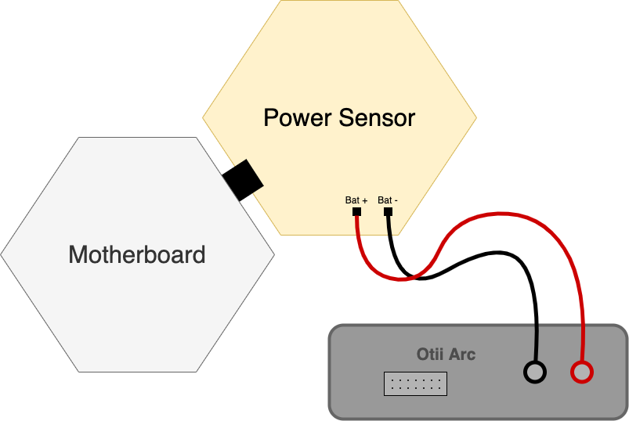

Figure 17 Connect the motherboard, the power sensor and the Otii Arc

1. Set the system configurations via the *IWAST configurator app* (refer to annex B in order to understand how to use this application). Several configurations must be set:
2. **Power board without accumulation data, without polling and without thresholds (ID 3)**:

* The accumulation data feature must be disabled
* The polling interrupts must be disabled
* The thresholds (high and low) must be disabled

1. **Power board without accumulation data, without polling but with thresholds (ID 4)**:

* The accumulation data feature must be disabled
* The polling interrupts must be disabled
* The thresholds (high and low) must be enabled
* The threshold high for the metric 1 must be equal to 36000
* The threshold low for the metric 1 must be equal to 31000
* The threshold high for the metric 2 must be equal to 2000
* The threshold low for the metric 2 must be equal to 0
* We must set the power supply from the *Otii ARC* at 3.3 V
* The system must be placed in a normally lighted room (not in the sunshine)

1. **Power board without accumulation data, without thresholds but with polling (ID 5):**

* The accumulation data feature must be disabled
* The polling interrupts must be enabled and set to 2 min
* The thresholds (high and low) must be disabled

1. **Power board with accumulation data, polling and thresholds (ID 6):**

* The accumulation data feature must be enabled
* The polling interrupts must be enabled and set to 2 min
* The thresholds (high and low) must be enabled
* The threshold high for the metric 1 must be equal to 36000
* The threshold low for the metric 1 must be equal to 31000
* The threshold high for the metric 2 must be equal to 2000
* The threshold low for the metric 2 must be equal to 0
* We must set the power supply from the *Otii ARC* at 3.3 V
* The system must be placed in a normally lighted room (not in the sunshine)

1. Collect the current measurements for each configuration at different moment. The test should last 15 min to be relevant. With this physical configuration, we can collect the values of the current flowing between the power supply provided by the *Otii ARC* and the power board (location 1). Multiple scenarios must be analysed with this module (depending on the configuration, multiple scenarios cannot be analysed):
2. When nothing happens (static power / sleep mode)
3. When a threshold event (not exceeded) occurs (dynamic power 1)
4. When a threshold event (exceeded) occurs (dynamic power 2)
5. When a polling interrupt occurs (dynamic power 3)
6. When data are sent by the motherboard (data sending power -> Normal Message)
7. Collect measurements for special cases. Multiple scenarios must be analysed:

**Special Meas. 3.1 : *Accumulated message save (for two metrics)***

This special measurement must be taken to determine the power consumption characteristic of a saving operation for data accumulation. We analyse the power consumption for the saving of two metrics (after an event like a threshold exceeded or a polling interrupt).

**Special Meas. 3.2 :** ***Data sent by the motherboard (accumulated message)***

This special measurement must be taken to determine the power consumption when data are sent by the motherboard if the data accumulation is enable. We need to analyse the same parameters than a normal message.

**Special Meas. 3.3:** ***Static Power of the Power Module alone***

This special measurement must be taken to evaluate the difference between the results from all scenarios A and the static current from the power board alone.

### Results

#### Configuration 2.1 : Power board without accumulation data, without polling and without thresholds (ID 3)

|  |  |  |  |  |  |  |  |  |
| --- | --- | --- | --- | --- | --- | --- | --- | --- |
| **Scenario A - Nothing happens (static power / sleep mode)** | | | | | | | | |
| *Location 1* | | Average | |  | | | | |
| Maximum Value | | 320.6 μA | |
| Minimum Value | | -13.6 μA | |
| Average Value | | 29.86 μA | |
|  | | | |
| Measure | 1 | | 2 | | 3 | 4 | 5 |
| Max. Value | 349 | | 346 | | 281 | 289 | 338 |
| Min. Value | -9.27 | | -24.8 | | -9.43 | -9.61 | -15 |
| Aver. Value | 29.9 | | 29.9 | | 29.8 | 29.8 | 29.9 |
| Remarks :  *So, to obtain the static value of the power board alone, we can do 29,86 μA -27,2 μA and we obtain* ***2,66 μA*** *for the static current of the power board alone. (27,2 μA is the static current of the motherboard used for this test)* | | | | | | | | |

#### Configuration 2.2 : Power board without accumulation data, without polling but with thresholds(ID 4)

|  |  |  |  |  |  |  |  |  |
| --- | --- | --- | --- | --- | --- | --- | --- | --- |
| **Scenario A - Nothing happens (static power / sleep mode)** | | | | | | | | |
| *Location 1* | | Average | |  | | | | |
| Maximum Value | | 244.6 μA | |
| Minimum Value | | -8.734 μA | |
| Average Value | | 30.6 μA | |
|  | | | |
| Measure | 1 | | 2 | | 3 | 4 | 5 |
| Max. Value | 293 | | 288 | | 148 | 146 | 348 |
| Min. Value | -10.2 | | -8.18 | | -8.41 | -8.53 | -8.35 |
| Aver. Value | 30.5 | | 30.6 | | 30.6 | 30.7 | 30.6 |
| Remarks :  *So, to obtain the static value of the power board alone, we can do 30,6 μA - 27,2 μA and we obtain* ***3,4 μA*** *for the static current of the power board alone. (27,2 μA is the static current of the motherboard used for this test)* | | | | | | | | |

|  |  |  |  |  |  |  |  |  |
| --- | --- | --- | --- | --- | --- | --- | --- | --- |
| **Scenario B - Threshold event (not exceeded) (dynamic power 1)** | | | | | | | | |
| *Location 1* | | Average | |  | | | | |
| Maximum Value | | 9802 μA | |
| Minimum Value | | -678.4 μA | |
| Average Value | | 5988 μA | |
| Energy | | 0.179 µWh | |
| Interval Time | | 32.46 ms | |
|  | | | |
| Measure | 1 | | 2 | | 3 | 4 | 5 |
| Max. Value | 9250 | | 8920 | | 12800 | 10100 | 7940 |
| Min. Value | -895 | | -603 | | -627 | -701 | -566 |
| Aver. Value | 6050 | | 5920 | | 6240 | 5850 | 5880 |
| Energy | 0.18 | | 0.178 | | 0.18 | 0.179 | 0.178 |
| Interval Time | 32.3 | | 32.6 | | 31.3 | 33.2 | 32.9 |
| Remarks : | | | | | | | | |

|  |  |  |  |  |  |  |  |  |
| --- | --- | --- | --- | --- | --- | --- | --- | --- |
| **Scenario C - Threshold event (exceeded) (dynamic power 2)** | | | | | | | | |
| *Location 1* | | Average | |  | | | | |
| Maximum Value | | 9250 μA | |
| Minimum Value | | -18.84 μA | |
| Average Value | | 7154 μA | |
| Energy | | 0.184 µWh | |
| Interval Time | | 27.9 ms | |
|  | | | |
| Measure | 1 | | 2 | | 3 | 4 | 5 |
| Max. Value | 10600 | | 8350 | | 7610 | 11100 | 8590 |
| Min. Value | -35 | | -35 | | 45.8 | -35 | -35 |
| Aver. Value | 7140 | | 7140 | | 7120 | 7220 | 7150 |
| Energy | 0.186 | | 0.185 | | 0.184 | 0.18 | 0.185 |
| Interval Time | 28.2 | | 28 | | 28 | 27.1 | 28.2 |
| Remarks : | | | | | | | | |

|  |  |  |  |  |  |  |  |
| --- | --- | --- | --- | --- | --- | --- | --- |
| **Scenario E - Data sent by the motherboard (data sending power -> Normal Message)** | | | | | | | |
| *Location 1* | | Average | |  | | | |
| WUT Time | | 77.104 ms | |
| WUT Energy | | 1.066 µWh | |
| DATA_TX Time | | 745.38 ms | |
| DATA_TX Aver. Cur | | 46860 µA | |
| DATA_RX Time | | 2257.98 ms | |
| DATA_RX Energy | | 38.66 µWh | |
|  | | | |
| Remarks :  *We are supposed to have DATA_TX Time = 495.62 ms (airtime LoRa calculator/Spreading Factor = 11)*  *Δ = 249.76 ms* | | | | | | | |
| Measure | 1 | | 2 | | 3 | 4 | 5 |
| WUT Time | 77.38 | | 77.25 | | 76.84 | 76.18 | 77.87 |
| WUT Energy | 1.07 | | 1.07 | | 1.06 | 1.06 | 1.07 |
| DATA_TX Time | 745.3 | | 745.2 | | 745.6 | 745 | 745.8 |
| DATA_TX Aver. Cur | 46000 | | 47000 | | 47200 | 47100 | 47000 |
| DATA_RX Time | 2260 | | 2259 | | 2258.7 | 2251.71 | 2260.5 |
| DATA_RX Energy | 38.6 | | 38.6 | | 38.7 | 38.7 | 38.7 |

#### Configuration 2.3 : Power board without accumulation data, without thresholds but with polling (ID 5)

|  |  |  |  |  |  |  |  |  |
| --- | --- | --- | --- | --- | --- | --- | --- | --- |
| **Scenario A - Nothing happens (static power / sleep mode)** | | | | | | | | |
| *Location 1* | | Average | |  | | | | |
| Maximum Value | | 386.8 μA | |
| Minimum Value | | -8.794 μA | |
| Average Value | | 30.48 μA | |
|  | | | |
| Measure | 1 | | 2 | | 3 | 4 | 5 |
| Max. Value | 385 | | 386 | | 385 | 392 | 386 |
| Min. Value | -8.16 | | -8.2 | | -8.42 | -8.79 | -10.4 |
| Aver. Value | 30.6 | | 30.5 | | 30.5 | 30.4 | 30.4 |
| Remarks :  *So, to obtain the static value of the power board alone, we can do 30,48 μA -27,89 μA and we obtain* ***2,59 μA*** *for the static current of the power board alone. (27,89 μA is the static current of the motherboard used for this test)* | | | | | | | | |

|  |  |  |  |  |  |  |  |  |
| --- | --- | --- | --- | --- | --- | --- | --- | --- |
| **Scenario D - Polling interrupt (dynamic power 3)** | | | | | | | | |
| *Location 1* | | Average | |  | | | | |
| Maximum Value | | 9698 μA | |
| Minimum Value | | 42.36 μA | |
| Average Value | | 6640 μA | |
| Energy | | 0.044 µWh | |
| Interval Time | | 7.18 ms | |
|  | | | |
| Measure | 1 | | 2 | | 3 | 4 | 5 |
| Max. Value | 9800 | | 9840 | | 9210 | 9860 | 9780 |
| Min. Value | 42.1 | | 46.2 | | 43.5 | 45.5 | 34.5 |
| Aver. Value | 6840 | | 6500 | | 6240 | 6880 | 6740 |
| Energy | 0.045 | | 0.04 | | 0.044 | 0.045 | 0.046 |
| Interval Time | 7.1 | | 6.8 | | 7.6 | 7 | 7.4 |
| Remarks :  *Polling without data accumulation doesn’t work well…* | | | | | | | | |

|  |  |  |  |  |  |  |  |
| --- | --- | --- | --- | --- | --- | --- | --- |
| **Scenario E - Data sent by the motherboard (data sending power -> Normal Message)** | | | | | | | |
| *Location 1* | | Average | |  | | | |
| WUT_ST Time | | 77.06 ms | |
| WUT_ST Energy | | 1.084 µWh | |
| DATA_TX Time | | 744.62 ms | |
| DATA_TX Aver. Cur | | 47500 µA | |
| DATA_RX Time | | 2257.59 ms | |
| DATA_RX Energy | | 39 µWh | |
|  | | | |
| Remarks :  *We are supposed to have DATA_TX Time = 495.62 ms (airtime LoRa calculator/Spreading Factor = 11)*  *Δ = 249 ms* | | | | | | | |
| Measure | 1 | | 2 | | 3 | 4 | 5 |
| WUT_ST Time | 77.06 | | 77.06 | | 77.09 | 77 | 77.09 |
| WUT_ST Energy | 1.09 | | 1.07 | | 1.08 | 1.09 | 1.09 |
| DATA_TX Time | 744 | | 745.5 | | 745.3 | 743.2 | 745.1 |
| DATA_TX Aver. Cur | 47700 | | 47800 | | 47300 | 47100 | 47600 |
| DATA_RX Time | 2253.06 | | 2257.7 | | 2259 | 2260 | 2258.2 |
| DATA_RX Energy | 39 | | 39 | | 39 | 39 | 39 |

#### Configuration 2.4 : Power board with accumulation data, polling and thresholds (ID 6)

|  |  |  |  |  |  |  |  |  |
| --- | --- | --- | --- | --- | --- | --- | --- | --- |
| **Scenario A - Nothing happens (static power / sleep mode)** | | | | | | | | |
| *Location 1* | | Average | |  | | | | |
| Maximum Value | | 627 μA | |
| Minimum Value | | -9.89 μA | |
| Average Value | | 31.36 μA | |
|  | | | |
| Measure | 1 | | 2 | | 3 | 4 | 5 |
| Max. Value | 999 | | 403 | | 1000 | 400 | 333 |
| Min. Value | -10.4 | | -8.48 | | -12.1 | -10 | -8.45 |
| Aver. Value | 31.5 | | 31.4 | | 31.4 | 31.3 | 31.2 |
| Remarks :  *So, to obtain the static value of the power board alone, we can do 31,36 μA -27,89 μA and we obtain* ***3,47 μA*** *for the static current of the power board alone. (27,89 μA is the static current of the motherboard used for this test)* | | | | | | | | |

|  |  |  |  |  |  |  |  |  |
| --- | --- | --- | --- | --- | --- | --- | --- | --- |
| **Scenario B - Threshold event (not exceeded) (dynamic power 1)** | | | | | | | | |
| *Location 1* | | Average | |  | | | | |
| Maximum Value | | 11250 μA | |
| Minimum Value | | -733 μA | |
| Average Value | | 6385 μA | |
| Energy | | 0.181 µWh | |
| Interval Time | | 30.85 ms | |
|  | | | |
| Measure | 1 | | 2 | | 3 | 4 | 5 |
| Max. Value | 10200 | | 12300 | | / | / | / |
| Min. Value | -731 | | -735 | | / | / | / |
| Aver. Value | 6370 | | 6400 | | / | / | / |
| Energy | 0.181 | | 0.181 | | / | / | / |
| Interval Time | 30.9 | | 30.8 | | / | / | / |
| Remarks :  *It’s difficult to collect correct data for this event. In the test, we had only two relevant measurement* | | | | | | | | |

|  |  |  |  |  |  |  |  |  |
| --- | --- | --- | --- | --- | --- | --- | --- | --- |
| **Scenario C - Threshold event (exceeded) (dynamic power 2)** | | | | | | | | |
| *Location 1* | | Average | |  | | | | |
| Maximum Value | | 9058 μA | |
| Minimum Value | | 89.62 μA | |
| Average Value | | 7178 μA | |
| Energy | | 0.182 µWh | |
| Interval Time | | 27.54 ms | |
|  | | | |
| Measure | 1 | | 2 | | 3 | 4 | 5 |
| Max. Value | 12000 | | 8240 | | 8730 | 8160 | 8160 |
| Min. Value | 107 | | 93.6 | | 92.5 | 130 | 25 |
| Aver. Value | 7310 | | 7040 | | 7160 | 7180 | 7200 |
| Energy | 0.183 | | 0.182 | | 0.179 | 0.185 | 0.182 |
| Interval Time | 27.1 | | 28.1 | | 27.1 | 28 | 27.4 |
| Remarks : | | | | | | | | |

|  |  |  |  |  |  |  |  |  |
| --- | --- | --- | --- | --- | --- | --- | --- | --- |
| **Scenario D - Polling interrupt (dynamic power 3)** | | | | | | | | |
| *Location 1* | | Average | |  | | | | |
| Maximum Value | | 9786 μA | |
| Minimum Value | | 78.22 μA | |
| Average Value | | 6868 μA | |
| Energy | | 0.046 µWh | |
| Interval Time | | 7.21 ms | |
|  | | | |
| Measure | 1 | | 2 | | 3 | 4 | 5 |
| Max. Value | 9740 | | 9800 | | 9760 | 9820 | 9810 |
| Min. Value | 89.9 | | 97.4 | | 31.4 | 68.4 | 104 |
| Aver. Value | 7010 | | 7060 | | 6670 | 6790 | 6810 |
| Energy | 0.047 | | 0.047 | | 0.045 | 0.045 | 0.046 |
| Interval Time | 7.2 | | 7.18 | | 7.22 | 7.22 | 7.25 |
| Remarks : | | | | | | | | |

#### Special Measurements

|  |  |  |  |  |  |  |  |  |
| --- | --- | --- | --- | --- | --- | --- | --- | --- |
| **Special Measurement 3.1 - Accumulated message save (for two metrics)** | | | | | | | | |
| *Location 1* | | Average |  | | | | | |
| Maximum Value | | 18480 μA |
| Minimum Value | | -810.6 μA |
| Average Value | | 9284 μA |
| Energy | | 0.770 µWh |
| Interval Time | | 90.52 ms |
|  | | |
| Measure | 1 | | | 2 | 3 | 4 | 5 |
| Max. Value | 18500 | | | 18500 | 18400 | 18500 | 18500 |
| Min. Value | -683 | | | -924 | -787 | -768 | -891 |
| Aver. Value | 9260 | | | 9260 | 9300 | 9280 | 9320 |
| Energy | 0.768 | | | 0.769 | 0.773 | 0.769 | 0.772 |
| Interval Time | 90.5 | | | 90.7 | 90.6 | 90.5 | 90.3 |
| Remarks : | | | | | | | | |

|  |  |  |  |  |  |  |  |
| --- | --- | --- | --- | --- | --- | --- | --- |
| **Special Measurement 3.2 - Data sent by the motherboard (accumulated message)** | | | | | | | |
| *Location 1* | | Average | |  | | | |
| WUT Time | | 121.6 ms | |
| WUT Energy | | 1.734 µWh | |
| DATA_TX Time | | 1155.08 ms | |
| DATA_TX Aver. Cur | | 47320 µA | |
| DATA_RX Time | | 2259.32 ms | |
| DATA_RX Energy | | 39.06 µWh | |
|  | | | |
| Remarks :  *We are supposed to have DATA_TX Time = 905.22 ms (airtime LoRa calculator/Spreading Factor = 11)*  *Δ = 249.86 ms* | | | | | | | |
| Measure | 1 | | 2 | | 3 | 4 | 5 |
| WUT_ST Time | 121.7 | | 121.8 | | 121.8 | 121.9 | 120.8 |
| WUT_ST Energy | 1.74 | | 1.74 | | 1.74 | 1.74 | 1.71 |
| DATA_TX Time | 1155.4 | | 1155.3 | | 1155.5 | 1153.9 | 1155.3 |
| DATA_TX Aver. Cur | 48000 | | 47100 | | 47100 | 47200 | 47200 |
| DATA_RX Time | 2258.1 | | 2260.3 | | 2259.1 | 2260.5 | 2258.6 |
| DATA_RX Energy | 39.1 | | 39.1 | | 39 | 39.1 | 39 |

|  |  |  |  |  |  |  |  |  |
| --- | --- | --- | --- | --- | --- | --- | --- | --- |
| **Special Measurement 3.3 – Static Power of the Power Module alone** | | | | | | | | |
| *Location 1* | | Average | |  | | | | |
| Maximum Value | | 41.52 μA | |
| Minimum Value | | -5.16 μA | |
| Average Value | | 1.25 μA | |
|  | | | |
| Measure | 1 | | 2 | | 3 | 4 | 5 |
| Max. Value | 41.9 | | 41.7 | | 41.4 | 41.5 | 41.1 |
| Min. Value | -5.19 | | -5.1 | | -5.13 | -5.19 | -5.2 |
| Aver. Value | 1.26 | | 1.26 | | 1.26 | 1.25 | 1.25 |
| Remarks :  *Data not relevant if we consider motherboard + power board* | | | | | | | | |

## Conclusion

At the end of the tests, **no major differences were noticed between ID3 and ID5**. Therefore, we can conclude that the enabling/disabling of the polling feature has no influence on the static current. However, when we enable/disable the threshold feature, we can notice a major difference for the static current. For the total estimation, we need to create two sections : “Power with no thresholds” (ID3 and ID5) and “Power with thresholds” (ID4 and ID6).

For the total estimation, it’s not valuable to keep these four configurations so **we keep the ID5 (which becomes ID 2 in the excel file) and the ID6 (which becomes ID 3 in the excel file)**.

As expected, data are not relevant if we measure the static current of the power module alone. So we need to measure the static current of the motherboard alone and the static current of the two boards connected to determine the static current of the power module.

At the end of the ID 5 test, we also noticed that the polling doesn’t work very well without the data accumulation feature. So, it’s recommended to always use this option when the power module is used.

Date of measurements : 20/01/2021 - 21/01/2021

# The sound board

## Description

|  |  |
| --- | --- |
| The sound board is fitted with a microphone to measure the intensity of ambient noise. To limit the power consumption of the sensor, the microphone Vesper VM1010 has been chosen (particularly for its good performance). The microcontroller used for the sensor is a PIC16F18446. We can easily set thresholds levels (high and low) in order to generate interrupts to the motherboard when thresholds are exceeded. | Une image contenant équipement électronique  Description générée automatiquement  Figure 18 Sound board |

When thresholds are enabled, the microphone is ON and sends a message with the noise measure to the microcontroller. If the measure exceeds the threshold level (high or low), an interrupt is generated to the motherboard and the microphone is switched OFF for one minute (to avoid generating a lot of interrupts during a small interval of time). When thresholds are disabled, the microphone is always switched OFF (except if a polling interrupt appears).

We can set a polling interval and two thresholds level (high or low) via the IWAST configurator. However, setting a low threshold is not relevant with this sensor according to the interest of this sensor (so, all measurements describe below is done with a low threshold level equal to 0 dB).

## Hardware analysis

### PIC16F18446 - Main MCU

|  |  |
| --- | --- |
| This sensor board is built around the 16-bit PIC16F18446. Its wiring is classic and respects all specifications from the Datasheet. The power supply is set to 3.3 V and all decoupling capacitors respect the recommended values of the Datasheet. | Une image contenant texte, équipement électronique, circuit  Description générée automatiquement  Figure 19 PIC16F18446 |

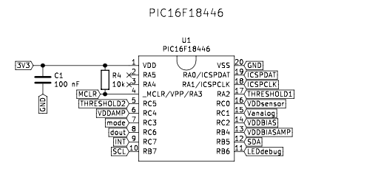

Figure 20 Wiring of the PIC16F18446

We can estimate the current consumption of the MCU depending on the power mode. In the code, we quote that the bit VREGCON in the register VREGPM is set to 1. So, the Low-Power sleep mode is enabled when the MCU pass to the sleep mode. We can determine the total current consumption according to the Datasheet[16] :

Table 7 Typical Current Consumption in Power-Down mode

The current consumption for the active mode is more difficult to estimate due to the clock using. We need to analyse the code to evaluate which peripherals are enabled, when and how much time they are active. Outside of the sleep mode, the Datasheet is not very clear about the current consumption of each peripherals. We need to analyse this mode with real measurements.

### Amplifier and low-pass filter

The non-inverting amplifier (placed after the high-pass filter) is used to amply the signal with 30 dB. After that, we have a *Sallen-Key* low-pass filter used to reduce the amplitude of the unwanted ultrasonic sound (there is also an amplification of 2,73 dB to amplify the signal to an amplitude which is appropriate for the ADC. All these elements used three TLV341A which are used as operational amplifiers.

|  |  |  |
| --- | --- | --- |
| Figure 21 Non-inverting amplifier | Figure 22 Low-pass filter | Figure 23 Bias voltage setting |

The recommended supply voltage of these op-amps must be between 1,5 V and 5,5 V. According to the schematic of the board, we can determine power supply is set to 2,6 V (voltage from MCU pin). The three op-amps are only active when a measure is done. So, we save a certain amount of current consumption when measurements are disabled. According to the datasheet[17], the current consumption for each op-amp is between 75 and 150 μA. In the shutdown mode, the consumption falls between 10 nA and 1 μA.

### Vesper VM1010

|  |  |  |
| --- | --- | --- |
| This microphone chip is quite particular due to its low-power feature. According to the datasheet[18], it can work in two modes : “Normal” mode (current consumption between 85 and 100 μA) and “Wake on Sound” mode (current consumption between 10 and 14 μA).  The power supply is set to 2,6 V (voltage from MCU pin) and the decoupling capacitor respects the recommended value of the datasheet. | | Figure 24 Wiring of the Vesper VM1010 |
| Figure 25 Wiring of the analog switch | We set the threshold levels on pins GA1 and GA2 thanks to multiple values of a resistor. This choice can be achieved with an analog switch, the TSA52066DCUR. According to the datasheet[19], the supply current of this chip is between 0,1 et 1 μA.  The power supply is set to 3,3 V and the decoupling capacitor respects the recommended value of the datasheet. | |

### LED

|  |  |
| --- | --- |
| The LED used for the debugging feature of the board is blue and connected in serial with a 470 Ω resistor. The typical forward voltage for this kind of LED is equal to 3,2 V and the power supply is set to 3,3 V (voltage from MCU pin). So we can easily determine the maximum current consumption of the LED : | Figure 26 Wiring of the debug LED |

## Measurements

### Modus operandi

1. Plug the motherboard, the sound board and the *Otii ARC* according to the scheme fig. 27 (refer to annex A in order to understand how to configure the measuring device *Otii ARC*).

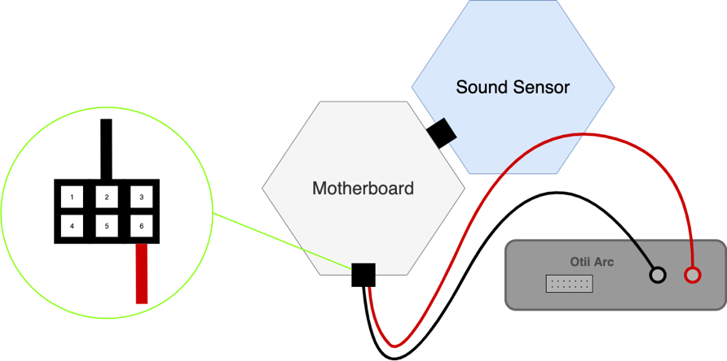

Figure 27 Connect the motherboard, the sound board and the Otii Arc (LOC 1)

1. Set the system configurations via the *IWAST configurator app* (refer to annex B in order to understand how to use this application). Several configurations must be set:
2. **Sound board without accumulation data, without polling and without thresholds (ID 7)**:

* The accumulation data feature must be disabled
* The polling interrupts must be disabled
* The thresholds (high and low) must be disabled

1. **Sound board without accumulation data, without polling but with thresholds (ID 8)**:

* The accumulation data feature must be disabled
* The polling interrupts must be disabled
* The thresholds (high and low) must be enabled
* The threshold high for the metric 1 must be equal to 80
* The threshold low for the metric 1 must be equal to 0

1. **Sound board without accumulation data, without thresholds but with polling (ID 9):**

* The accumulation data feature must be disabled
* The polling interrupts must be enabled and set to 2 min
* The thresholds (high and low) must be disabled

1. **Sound board with accumulation data, polling and thresholds (ID 10):**

* The accumulation data feature must be enabled
* The polling interrupts must be enabled and set to 2 min
* The thresholds (high and low) must be enabled
* The threshold high for the metric 1 must be equal to 80
* The threshold low for the metric 1 must be equal to 0

1. Collect the current measurements for each configuration at different moment. The test should last 15 min to be relevant. With this physical configuration, we can collect the values of the current flowing between the power supply and the motherboard (location 1). Multiple scenarios must be analysed with this module:
2. When nothing happens (static power / sleep mode)
3. When a threshold event (not exceeded) occurs (dynamic power 1)
4. When a threshold event (exceeded) occurs (dynamic power 2)
5. When a polling interrupt occurs (dynamic power 3)
6. When data are sent by the motherboard (data sending power -> Normal Message)
7. Collect measurements for special cases. Multiple scenarios must be analysed:

**Special Meas. 4.1 : *Accumulated message save (for one metric)***

This special measurement must be taken to determine the power consumption characteristic of a saving operation for data accumulation. We analyse the power consumption for the saving of one metric (after an event like a threshold exceeded or a polling interrupt).

**Special Meas. 4.2 :** ***Data sent by the motherboard (accumulated message)***

This special measurement must be taken to determine the power consumption when data are sent by the motherboard if the data accumulation is enable. We need to analyse the same parameters than a normal message.

### Results

#### Configuration 2.1 : Sound board without accumulation data, without polling and without thresholds (ID 7)

|  |  |  |  |  |  |  |  |  |
| --- | --- | --- | --- | --- | --- | --- | --- | --- |
| **Scenario A - Nothing happens (static power / sleep mode)** | | | | | | | | |
| *Location 1* | | Average | |  | | | | |
| Maximum Value | | 375.8 μA | |
| Minimum Value | | 27.38 μA | |
| Average Value | | 28.68 μA | |
|  | | | |
| Measure | 1 | | 2 | | 3 | 4 | 5 |
| Max. Value | 401 | | 400 | | 402 | 338 | 338 |
| Min. Value | 27.6 | | 27.4 | | 27.4 | 27.2 | 27.3 |
| Aver. Value | 28.9 | | 28.7 | | 28.7 | 28.6 | 28.5 |
| Remarks :  *So, to obtain the static value of the sound board alone, we can do 28,68 μA -27,89 μA and we obtain* ***0,79 μA*** *for the static current of the sound board alone. (27,89 μA is the static current of the motherboard used for this test)* | | | | | | | | |

#### Configuration 2.2 : Sound board without accumulation data, without polling but with thresholds(ID 8)

|  |  |  |  |  |  |  |  |  |
| --- | --- | --- | --- | --- | --- | --- | --- | --- |
| **Scenario A - Nothing happens (static power / sleep mode)** | | | | | | | | |
| *Location 1* | | Average | |  | | | | |
| Maximum Value | | 294.4 μA | |
| Minimum Value | | 49.3 μA | |
| Average Value | | 50.5 μA | |
|  | | | |
| Measure | 1 | | 2 | | 3 | 4 | 5 |
| Max. Value | 518 | | 235 | | 239 | 240 | 240 |
| Min. Value | 49.4 | | 49.1 | | 49.3 | 49.4 | 49.3 |
| Aver. Value | 50.7 | | 50.4 | | 50.4 | 50.5 | 50.5 |
| Remarks :  ***CAUTION !*** *When an exceeded threshold event occurs, the microphone is switched OFF. The average current consumption switches from 50.5 µA to 28.9 µA during 64000 ms.*  *So, to obtain the static value of the sound board alone, we can do 50,5 μA -27,89 μA and we obtain* ***22,61 μA*** *for the static current of the sound board alone. (27,89 μA is the static current of the motherboard used for this test)* | | | | | | | | |

|  |  |  |  |  |  |  |  |  |
| --- | --- | --- | --- | --- | --- | --- | --- | --- |
| **Scenario B - Threshold event (not exceeded) (dynamic power 1)** | | | | | | | | |
| *Location 1* | | Average |  | | | | | |
| Maximum Value | | 7032 µA |
| Minimum Value | | -47.1 µA |
| Average Value | | 4068 µA |
| Energy | | 1.734 µWh |
| Interval Time | | 464.98 ms |
|  | | |
| Measure | 1 | | | 2 | 3 | 4 | 5 |
| Max. Value | 6980 | | | 7040 | 7080 | 7070 | 6990 |
| Min. Value | -41.5 | | | -61.1 | -26.3 | -49.1 | -57.5 |
| Aver. Value | 4060 | | | 4060 | 4070 | 4080 | 4070 |
| Energy | 1.74 | | | 1.73 | 1.74 | 1.73 | 1.73 |
| Interval Time | 466.4 | | | 465 | 466.3 | 462.5 | 464.7 |
| Remarks | | | | | | | | |

|  |  |  |  |  |  |  |  |  |
| --- | --- | --- | --- | --- | --- | --- | --- | --- |
| **Scenario C - Threshold event (exceeded) (dynamic power 2)** | | | | | | | | |
| *Location 1* | | Average |  | | | | | |
| Maximum Value | | 7026 µA |
| Minimum Value | | 52.54 µA |
| Average Value | | 4130 µA |
| Energy | | 1.684 µWh |
| Interval Time | | 445.48 ms |
|  | | |
| Measure | 1 | | | 2 | 3 | 4 | 5 |
| Max. Value | 6990 | | | 7020 | 6980 | 7090 | 7050 |
| Min. Value | 84.6 | | | 58.1 | 50.3 | 19.6 | 50.1 |
| Aver. Value | 4140 | | | 4140 | 4130 | 4120 | 4120 |
| Energy | 1.69 | | | 1.69 | 1.68 | 1.68 | 1.68 |
| Interval Time | 444.9 | | | 446.6 | 445.4 | 444.7 | 445.8 |
| Remarks | | | | | | | | |

|  |  |  |  |  |  |  |  |
| --- | --- | --- | --- | --- | --- | --- | --- |
| **Scenario E - Data sent by the motherboard (data sending power -> Normal Message)** | | | | | | | |
| *Location 1* | | Average | |  | | | |
| WUT Time | | 77.06 ms | |
| WUT Energy | | 1.066 µWh | |
| DATA_TX Time | | 663.46 ms | |
| DATA_TX Aver. Cur | | 47880 µA | |
| DATA_RX Time | | 2257.48 ms | |
| DATA_RX Energy | | 39.12 µWh | |
|  | | | |
| Remarks :  *We are supposed to have DATA_TX Time = 413.7 ms (airtime LoRa calculator/Spreading Factor = 11)*  *Δ = 249.76 ms* | | | | | | | |
| Measure | 1 | | 2 | | 3 | 4 | 5 |
| WUT Time | 76.5 | | 77.1 | | 79.2 | 76.2 | 76.3 |
| WUT Energy | 1.06 | | 1.06 | | 1.1 | 1.05 | 1.06 |
| DATA_TX Time | 664.6 | | 663.1 | | 663.3 | 663.4 | 662.9 |
| DATA_TX Aver. Cur | 48000 | | 48000 | | 47900 | 47700 | 47800 |
| DATA_RX Time | 2257.2 | | 2258.3 | | 2255.9 | 2257.3 | 2258.7 |
| DATA_RX Energy | 39.1 | | 39.1 | | 39.1 | 39.2 | 39.1 |

#### Configuration 2.3 : Sound board without accumulation data, without thresholds but with polling (ID 9)

|  |  |  |  |  |  |  |  |  |
| --- | --- | --- | --- | --- | --- | --- | --- | --- |
| **Scenario A - Nothing happens (static power / sleep mode)** | | | | | | | | |
| *Location 1* | | Average | |  | | | | |
| Maximum Value | | 411.8 µA | |
| Minimum Value | | 27.36 µA | |
| Average Value | | 28.64 µA | |
|  | | | |
| Measure | 1 | | 2 | | 3 | 4 | 5 |
| Max. Value | 401 | | 413 | | 413 | 414 | 418 |
| Min. Value | 27.5 | | 27.4 | | 27.3 | 27.3 | 27.3 |
| Aver. Value | 28.7 | | 28.7 | | 28.6 | 28.6 | 28.6 |
| Remarks :  *So, to obtain the static value of the sound board alone, we can do 28,64 μA -27,89 μA and we obtain* ***0,75 μA*** *for the static current of the sound board alone. (27,89 μA is the static current of the motherboard used for this test)* | | | | | | | | |

|  |  |  |  |  |  |  |  |  |
| --- | --- | --- | --- | --- | --- | --- | --- | --- |
| **Scenario D - Polling interrupt (dynamic power 3)** | | | | | | | | |
| *Location 1* | | Average |  | | | | | |
| Maximum Value | | 15500 µA |
| Minimum Value | | 59.7 µA |
| Average Value | | 5352 µA |
| Energy | | 2.3 µWh |
| Interval Time | | 468.83 ms |
|  | | |
| Measure | 1 | | | 2 | 3 | 4 | 5 |
| Max. Value | 15500 | | | 15500 | 15500 | 15500 | 15500 |
| Min. Value | 54.7 | | | 41.7 | 53.9 | 78 | 70.2 |
| Aver. Value | 5360 | | | 5350 | 5350 | 5350 | 5350 |
| Energy | 2.3 | | | 2.3 | 2.3 | 2.3 | 2.3 |
| Interval Time | 468.95 | | | 467 | 469.8 | 470 | 468.4 |
| Remarks | | | | | | | | |

|  |  |  |  |  |  |  |  |
| --- | --- | --- | --- | --- | --- | --- | --- |
| **Scenario E - Data sent by the motherboard (data sending power -> Normal Message)** | | | | | | | |
| *Location 1* | | Average | |  | | | |
| WUT Time | | 77.27 ms | |
| WUT Energy | | 1.078 µWh | |
| DATA_TX Time | | 662.62 ms | |
| DATA_TX Aver. Cur | | 47400 µA | |
| DATA_RX Time | | 2257.82 ms | |
| DATA_RX Energy | | 39.1 µWh | |
|  | | | |
| Remarks :  *We are supposed to have DATA_TX Time = 413.7 ms (airtime LoRa calculator/Spreading Factor = 11)*  *Δ = 248.92 ms* | | | | | | | |
| Measure | 1 | | 2 | | 3 | 4 | 5 |
| WUT_ST Time | 78.07 | | 78.25 | | 76.4 | 76.95 | 76.7 |
| WUT_ST Energy | 1.08 | | 1.1 | | 1.07 | 1.07 | 1.07 |
| DATA_TX Time | 661.98 | | 663.2 | | 663 | 662 | 662.9 |
| DATA_TX Aver. Cur | 47400 | | 47400 | | 47500 | 47200 | 47500 |
| DATA_RX Time | 2258.3 | | 2256.9 | | 2258.4 | 2257.9 | 2257.6 |
| DATA_RX Energy | 39.1 | | 39.1 | | 39.1 | 39.1 | 39.1 |

#### Configuration 2.4 : Sound board with accumulation data, polling and thresholds (ID 10)

|  |  |  |  |  |  |  |  |  |
| --- | --- | --- | --- | --- | --- | --- | --- | --- |
| **Scenario A - Nothing happens (static power / sleep mode)** | | | | | | | | |
| *Location 1* | | Average | |  | | | | |
| Maximum Value | | 385 µA | |
| Minimum Value | | 49.2 µA | |
| Average Value | | 50.38 µA | |
|  | | | |
| Measure | 1 | | 2 | | 3 | 4 | 5 |
| Max. Value | 449 | | 448 | | 218 | 521 | 289 |
| Min. Value | 49.2 | | 49.2 | | 49.2 | 49.2 | 49.2 |
| Aver. Value | 50.4 | | 50.4 | | 50.3 | 50.4 | 50.4 |
| Remarks :  ***CAUTION !*** *When an exceeded threshold event occurs, the microphone is switched OFF. The average current consumption switches from 50.38 µA to 28.9 µA during 64000 ms.*  *So, to obtain the static value of the sound board alone, we can do 50,38 μA -27,89 μA and we obtain* ***22,49 μA*** *for the static current of the sound board alone. (27,89 μA is the static current of the motherboard used for this test)* | | | | | | | | |

|  |  |  |  |  |  |  |  |  |
| --- | --- | --- | --- | --- | --- | --- | --- | --- |
| **Scenario B - Threshold event (not exceeded) (dynamic power 1)** | | | | | | | | |
| *Location 1* | | Average |  | | | | | |
| Maximum Value | | 6982 µA |
| Minimum Value | | -22.15 µA |
| Average Value | | 4058 µA |
| Energy | | 1.734 µWh |
| Interval Time | | 466.2 ms |
|  | | |
| Measure | 1 | | | 2 | 3 | 4 | 5 |
| Max. Value | 6990 | | | 6930 | 6960 | 7030 | 6930 |
| Min. Value | -50.8 | | | -42 | -19.9 | -8.23 | 10.2 |
| Aver. Value | 4060 | | | 4060 | 4040 | 4070 | 4060 |
| Energy | 1.73 | | | 1.73 | 1.74 | 1.74 | 1.73 |
| Interval Time | 465.3 | | | 466.2 | 469.3 | 465.9 | 464.4 |
| Remarks | | | | | | | | |

|  |  |  |  |  |  |  |  |  |
| --- | --- | --- | --- | --- | --- | --- | --- | --- |
| **Scenario C - Threshold event (exceeded) (dynamic power 2)** | | | | | | | | |
| *Location 1* | | Average |  | | | | | |
| Maximum Value | | 6982 µA |
| Minimum Value | | 63.62 µA |
| Average Value | | 4128 µA |
| Energy | | 1.682 µWh |
| Interval Time | | 445.24 ms |
|  | | |
| Measure | 1 | | | 2 | 3 | 4 | 5 |
| Max. Value | 6930 | | | 6990 | 6950 | 7100 | 6940 |
| Min. Value | 50.4 | | | 85.5 | 61.8 | 70.5 | 49.9 |
| Aver. Value | 4110 | | | 4130 | 4130 | 4130 | 4140 |
| Energy | 1.68 | | | 1.69 | 1.67 | 1.68 | 1.69 |
| Interval Time | 446.4 | | | 446.4 | 442.8 | 444.9 | 445.7 |
| Remarks | | | | | | | | |

|  |  |  |  |  |  |  |  |  |
| --- | --- | --- | --- | --- | --- | --- | --- | --- |
| **Scenario D - Polling interrupt (dynamic power 3)** | | | | | | | | |
| *Location 1* | | Average |  | | | | | |
| Maximum Value | | 15600 µA |
| Minimum Value | | 85.68 µA |
| Average Value | | 5356 µA |
| Energy | | 2.29 µWh |
| Interval Time | | 466.98 ms |
|  | | |
| Measure | 1 | | | 2 | 3 | 4 | 5 |
| Max. Value | 15600 | | | 15700 | 15600 | 15600 | 15500 |
| Min. Value | 66.7 | | | 112 | 102 | 73.3 | 74.4 |
| Aver. Value | 5360 | | | 5350 | 5360 | 5360 | 5350 |
| Energy | 2.29 | | | 2.3 | 2.29 | 2.29 | 2.29 |
| Interval Time | 465.8 | | | 467 | 467.4 | 467.3 | 467.4 |
| Remarks | | | | | | | | |

#### Special Measurements

|  |  |  |  |  |  |  |  |  |
| --- | --- | --- | --- | --- | --- | --- | --- | --- |
| **Special Measurement 4.1 - Accumulated message save (for one metric)** | | | | | | | | |
| *Location 1* | | Average |  | | | | | |
| Maximum Value | | 17540 µA |
| Minimum Value | | -276.2 µA |
| Average Value | | 9626 µA |
| Energy | | 0.38 µWh |
| Interval Time | | 43.1 ms |
|  | | |
| Measure | 1 | | | 2 | 3 | 4 | 5 |
| Max. Value | 17500 | | | 17600 | 17600 | 17500 | 17500 |
| Min. Value | -288 | | | -267 | -278 | -260 | -288 |
| Aver. Value | 9670 | | | 9600 | 9650 | 9550 | 9660 |
| Energy | 0.383 | | | 0.377 | 0.379 | 0.378 | 0.383 |
| Interval Time | 43.2 | | | 42.9 | 42.9 | 43.2 | 43.3 |
| Remarks  ***CAUTION!*** *A data saving from an exceeded threshold provokes this kind of power consumption. A data saving from a polling interrupt provokes a power consumption multiplied by 2 (like a power consumption for a two-metric data saving)* | | | | | | | | |

|  |  |  |  |  |  |  |  |
| --- | --- | --- | --- | --- | --- | --- | --- |
| **Special Measurement 4.2 - Data sent by the motherboard (accumulated message)** | | | | | | | |
| *Location 1* | | Average | |  | | | |
| WUT Time | | 133.94 ms | |
| WUT Energy | | 1.906 µWh | |
| DATA_TX Time | | 1236.96 ms | |
| DATA_TX Aver. Cur | | 47120 µA | |
| DATA_RX Time | | 2255.72 ms | |
| DATA_RX Energy | | 39.3 µWh | |
|  | | | |
| Remarks :  *We are supposed to have DATA_TX Time = 905.22 ms (airtime LoRa calculator/Spreading Factor = 11)*  *-> Δ = 331.74 ms* | | | | | | | |
| Measure | 1 | | 2 | | 3 | 4 | 5 |
| WUT_ST Time | 133.2 | | 134 | | 134.7 | 134 | 133.8 |
| WUT_ST Energy | 1.9 | | 1.91 | | 1.92 | 1.9 | 1.9 |
| DATA_TX Time | 1237.4 | | 1237.2 | | 1235.9 | 1237 | 1237.3 |
| DATA_TX Aver. Cur | 47300 | | 47300 | | 45500 | 47800 | 47700 |
| DATA_RX Time | 2253.7 | | 2252.4 | | 2258.7 | 2257.4 | 2256.4 |
| DATA_RX Energy | 39.2 | | 39.1 | | 40 | 39.1 | 39.1 |

## Conclusion

At the end of the tests, **no major differences were noticed between ID7 and ID9**. Therefore, we can conclude that the enabling/disabling of the polling feature has no influence on the static current. However, when we enable/disable the threshold feature, we can notice a major difference for the static current. For the total estimation, we need to create two sections : “Sound with no thresholds” (ID7 and ID9) and “Sound with thresholds” (ID8 and ID10).

For the total estimation, it’s not valuable to keep these four configurations so **we keep the ID9 (which becomes ID 4 in the excel file) and the ID10 (which becomes ID 5 in the excel file)**.

We notice the effect of disabling the microphone during one minute after an exceeded threshold occurs. This effect must be taken into account for the total estimation of the consumption. Also, after the special measurement 4.1, we notice a strange effect when data are saved in the motherboard. Indeed, a data saving from an exceeded threshold has a normal behaviour but it’s not the same with a data saving from a polling interrupt. It provokes the same behaviour than a saving operation for two metrics. Again, we need to take into account this strange effect in the total estimation.

Date of measurements : 21/01/2021

# The environmental board

## Description

## Hardware analysis

## Measurements

### Modus operandi

1. Plug the motherboard, the environmental board and the *Otii ARC* according to the scheme X.X (refer to annex A in order to understand how to configure the measuring device *Otii ARC*).
2. Set the system configurations via the *IWAST configurator app* (refer to annex B in order to understand how to use this application). Several configurations must be set:
3. **Environmental board without accumulation data, without polling and without thresholds (ID 11)**:

* The accumulation data feature must be disabled
* The polling interrupts must be disabled
* The thresholds (high and low) must be disabled

1. **Environmental board without accumulation data, without polling but with thresholds (ID 12)**:

* The accumulation data feature must be disabled
* The polling interrupts must be disabled
* The thresholds (high and low) must be enabled
* The threshold high for the metric 1 must be equal to XX
* The threshold low for the metric 1 must be equal to XX
* The threshold high for the metric 2 must be equal to XX
* The threshold low for the metric 2 must be equal to XX
* The threshold high for the metric 3 must be equal to XX
* The threshold low for the metric 3 must be equal to XX
* The threshold high for the metric 4 must be equal to XX
* The threshold low for the metric 4 must be equal to XX

1. **Environmental board without accumulation data, without thresholds but with polling (ID 13):**

* The accumulation data feature must be disabled
* The polling interrupts must be enabled and set to 2 min
* The thresholds (high and low) must be disabled

1. **Environmental board with accumulation data, polling and thresholds (ID 14):**

* The accumulation data feature must be enabled
* The polling interrupts must be enabled and set to 2 min
* The thresholds (high and low) must be enabled
* The threshold high for the metric 1 must be equal to XX
* The threshold low for the metric 1 must be equal to XX
* The threshold high for the metric 2 must be equal to XX
* The threshold low for the metric 2 must be equal to XX
* The threshold high for the metric 3 must be equal to XX
* The threshold low for the metric 3 must be equal to XX
* The threshold high for the metric 4 must be equal to XX
* The threshold low for the metric 4 must be equal to XX

1. Collect the current measurements for each configuration at different moment. The test should last 15 min to be relevant. With this physical configuration, we can collect the values of the current flowing between the power supply and the motherboard (location 1). Multiple scenarios must be analysed with this module:
2. When nothing happens (static power / sleep mode)
3. When a threshold event (not exceeded) occurs (dynamic power 1)
4. When a threshold event (exceeded) occurs (dynamic power 2)
5. When a polling interrupt occurs (dynamic power 3)
6. When data are sent by the motherboard (data sending power -> Normal Message)

### Results

#### Configuration 2.1 : Environmental board without accumulation data, without polling and without thresholds (ID 11)

#### Configuration 2.2 : Environmental board without accumulation data, without polling but with thresholds(ID 12)

#### Configuration 2.3 : Environmental board without accumulation data, without thresholds but with polling (ID 13)

#### Configuration 2.4 : Environmental board with accumulation data, polling and thresholds (ID 14)

## Conclusion

# Annex A - Configuration of the *OTII ARC*

The Otii Arc is a powerful tool designed to analyse the energy consumption of embedded systems. It was specifically developed to design energy efficient IoT products. Its use is very simple. First of all, you must download and install the associated software available for free on the website <https://www.qoitech.com/download/>. After that, follow the modus operandi bellow to collect measurements on the IWAST system :

1. Connect the Otii ARC to your computer and start a new project
2. Configure the new project with a power supply of 3.3 V
3. Connect the motherboard and the Otii ARC together
4. Enable the power supply via the application and start a new recording

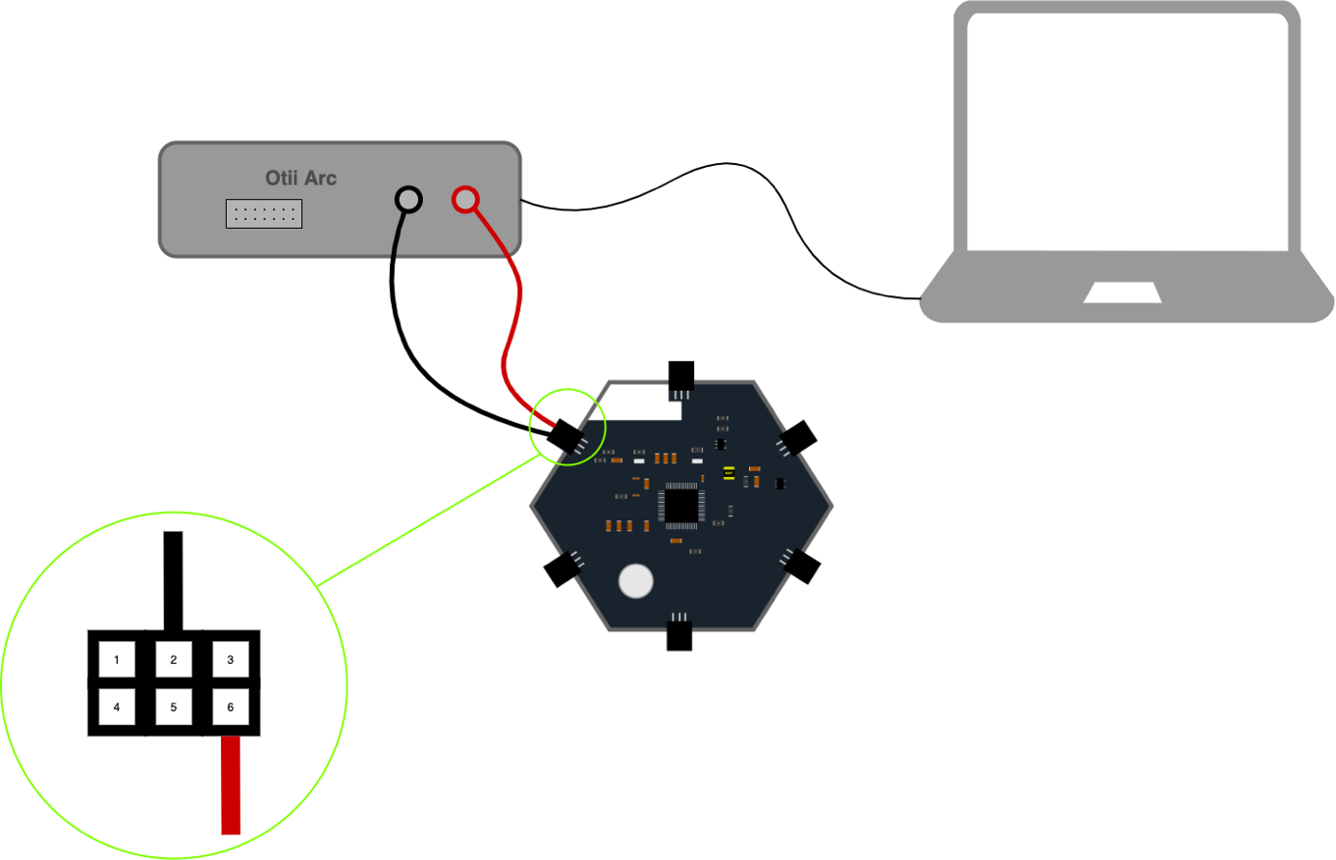

Figure 28 Configure and connect the Otii Arc

|  |  |
| --- | --- |
| **Pins Motherboard** | **Description** |
| 3 | External interrupt (for polling) |
| 2 | Ground |
| 1 | Sensor Power 3.3 V |
| 6 | Power Supply of the system |
| 5 | SCL pin (I2C) |
| 4 | SDA pin (I2C) |

Table 8 Pin description of the motherboard

# Annex B - Using the *IWAST Configurator*

The *IWAST Configurator* is the application made by *DRAMCO* to easily configure the *IWAST* system. First of all, you must download the installation file accessible directly on the GitHub page of IWAST <https://github.com/dramco-iwast/qt-config/tree/master/target> (choose the last version if possible). The installation is very easy and does not require too much storage space. When the app is correctly installed, you can start a configuration by following this modus operandi :

1. Open the application.
2. Connect the IWAST system to your computer with the USB cable. Make sure that all sensor boards you wish to use are connected to the motherboard before connecting the system to your computer.
3. Click on the “Refresh” button until “Arduino Zero” appears in the drop-down list of COM Ports.
4. Select the “Arduino Zero” port in the list and click on the “Connect” button.
5. Configure the sensor boards by clicking on the “Load” button of each sensor board. When you have chosen all the parameters you want for a sensor board, click on the “Save” button. Repeat this step for each sensor boards.
6. When the sensor board configurations are finished, click on the “Disconnect” button.
7. You can start again a complete configuration for a new IWAST system by clicking on the “New” button. In this case, go back to the step 2.

Figure 29 Configuration example

1. TTN = *The Thing Network*
2. Table from the Datasheet “*SAM D21/DA1 Family Low-Power, 32-bit Cortex-M0+ MCU with Advanced Analog and PWM*” - p. 869-870
3. Table from the Datasheet “*SAM D21/DA1 Family Low-Power, 32-bit Cortex-M0+ MCU with Advanced Analog and PWM*” – p. 873
4. Table from the Datasheet “*RN2483 Low-Power Long Range LoRa® Technology Transceiver Module*” - p. 7
5. From the Datasheet “*MARQUARDT® Technical Specification K30062000*” - p.17
6. From the Datasheet “*TPS7A05 1-μA Ultralow IQ, 200-mA, Low-Dropout Regulator in a Small-Size Package*” - p.8
7. Link for the tool: <https://www.loratools.nl/#/airtime>
8. Table from the Datasheet “*PIC16(L)F18426/46 - 14/20-Pin Full-Featured, Low Pin Count Microcontrollers with XLP*” – p. 636
9. From the Datasheet “MARQUARDT® Technical Specification K30062000” - p.17
10. Link for the tool: <https://www.loratools.nl/#/airtime>
11. Address : <https://dramco-iwast.github.io/docs/sensor-boards/powermodule.html>
12. Table from the Datasheet “*PIC16(L)F18426/46 - 14/20-Pin Full-Featured, Low Pin Count Microcontrollers with XLP*” – p. 636
13. From the Datasheet “*bq25570 nano power boost charger and buck converter for energy harvester powered applications*” - p. 6
14. From the Datasheet “*BQ2404x 1A, Single-Input, Single Cell Li-Ion and Li-Pol Battery Charger With Auto Start*” - p. 7
15. Table from the Datasheet “*TPS22860 Ultra-Low Leakage Load Switch*” - p. 4
16. Table from the Datasheet “*PIC16(L)F18426/46 - 14/20-Pin Full-Featured, Low Pin Count Microcontrollers with XLP*” – p. 636
17. From the Datasheet “TLV34xxLow-VoltageRail-to-Rail Output CMOSOperational Amplifiers WithShutdown” – p. 7-8
18. From the Datasheet “VM1010 Low Noise Bottom Port Analog Piezoelectric MEMS Microphone with Wake on Sound” - p. 4
19. From the Datasheet “TS5A2066 Dual-Channel 10-Ω SPST Analog Switch” - p. 8