School of Information Sciences

MANIPAL UNIVERSITY, MANIPAL

Seminar Report

Submitted by

Anand D R

171041004

Computing Technologies and Virtualization

Submitted on

28 February 2018

Table of Content

|  |  |  |
| --- | --- | --- |
|  | Introduction | 4 |
|  | Hyper-Converged Infrastructure | 8 |
|  | Storage Virtualization with HCI | 13 |
|  | VMware Approach to HCI | 15 |
|  | Getting started with HCI | 20 |
|  | Future Scope | 24 |
|  | References | 25 |

Table of Figures

|  |  |  |
| --- | --- | --- |
|  | Traditional Infrastructure | 5 |
|  | Converged Infrastructure | 5 |
|  | Hyper-Converged Infrastructure | 6 |
|  | Hyper-Converged Infrastructure | 8 |
|  | VMware-powered HCI | 16 |
|  | VMware vSAN | 17 |
|  | HCI deployment model | 20 |

Introduction

In the enterprise IT landscape, maintaining an agile data center infrastructure tends to be a source of headaches for IT leaders and administrators. Without fundamental changes, the pain will only get worse, as business moves further into the world of digital everything. That’s because the demands on infrastructure are exploding.

This problem affects more than one part of a business. The coin has two sides:

1. On one side, virtually every part of every organization is pushing the limits. They’re generating more information, demanding new kinds of access, and planning to keep it forever (or nearly so). In some cases, the need to acquire and harness information drives entire business models.
2. On the flip side, cloud‐savvy end users are increasing their expectations. They expect ever‐better performance for their applications, lower‐cost infrastructure, and ever-faster responses from the IT organization.

# Software-defined Data Center

The SDDC promises to change how IT services are delivered. What was once static, inflexible, and inefficient becomes dynamic, agile, and optimized. In other words, the SDDC builds on the success of server virtualization to evolve the data center from the past to the future.

In this new, software‐defined world, all IT infrastructure elements (including compute, storage, management, and networking) are virtualized and delivered as a service on industry-standard servers and components. Resources are automatically deployed, with little (or no) human involvement. Everything is highly automated, controlled by software, and governed by policies that incorporate the logic of business requirements for IT.

In an SDDC, you don’t spend weeks provisioning the infrastructure to support a new application. You can get an application running in minutes.

# Evolution to Modern Data Center: Hyper Converged Infrastructure(HCI)

HCI is the natural evolution of data center architectures. This ongoing evolution first moved us from traditional silo‐based infrastructure to converged infrastructure. And now it’s moving us to HCI.

1. Traditional Infrastructure

The traditional infrastructure model relies on proprietary, purpose‐built hardware for storage and networking. These components form separate silos with their own management software from numerous vendors. They work best when optimized and managed by dedicated specialists. Furthermore, because performance is set at the hardware layer, resources are not properly optimized and overprovisioning often occurs.

*Figure 1* shows the traditional approach as an expensive solution to a general‐purpose IT need. It results in an increased footprint, increased complexity, and increased staffing and specialization. Worse, today’s dynamic applications and virtualized workloads require provisioning flexibility that hardware‐centric approaches aren’t designed to deliver. It’s the opposite of simple and streamlined.

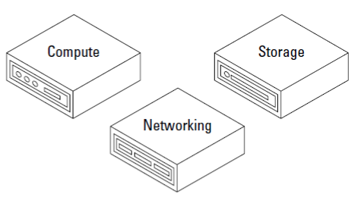

Figure :Traditional Infrastructure.

1. Converged Infrastructure

A converged infrastructure improves on the traditional model by bringing compute, storage, management, and networking into a single rack, as shown in *Figure 2*. Different specialty vendors typically still provide these elements. The overall management may be integrated and optimized, but separate systems, workflows, and management platforms are still required for many operations and troubleshooting tasks.

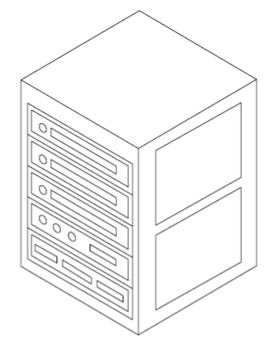

Figure :Converged Infrastructure.

In addition, the hardware bundles are preconfigured to run specific workloads and can’t be easily altered — resulting in a loss of flexibility. The physical boundaries may have been eliminated, but provisioning and operational challenges remain.

1. Hyper Converged Instructure

Hyper‐converged solutions take the next step. Hyper converged infrastructure (HCI) converges traditional IT infrastructure silos onto industry-standard servers and virtualizes physical infrastructure. HCI originally included just virtual compute and virtual storage, but it can now be extended with full virtualized network solutions for a complete software defined data center. This flexible, software-based approach is well suited for today’s IT challenges.

The secret sauce of HCI lies in the hypervisor (the source of the “hyper” in hyper‐convergence). As shown in Figure 1‐4, key data center functions — compute, storage, storage networking, and management — are now running as software on the hypervisor, enabling efficient operations, streamlined and speedy provisioning, and cost‐effective growth.

HCI is the IT building block that enables a differentiated, competitive business through the software-defined, cloud-enabled data center of the future.

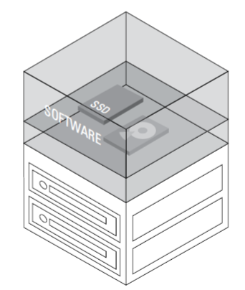

Figure :Hyper-Converged Infrastructure

When you deploy HCI, you’re clearing your path to the SDDC. HCI natively integrates compute, storage, and storage networking functions, running them all in software on a virtualized platform along with common management tools. You can then build on your HCI foundation by adding automation and complete network virtualization capabilities to create your full SDDC.

Even better, you can extend your hyper‐converged environment to your existing external storage arrays supported by vSphere to protect your current investments. Arrays that support VMware vSphere Virtual Volumes can be managed under the same storage policy‐based management framework. Virtual Volumes is an industry‐wide initiative supported by all major storage vendors that can coexist with VMware vSphere–based HCI solutions. This initiative allows you to leverage the unique capabilities of your current storage investments in a software‐defined storage (SDS) environment or to simplify the modernization of your data center with non-disruptive migration based on proven features like VMware vSphere vMotion and Storage vMotion.

vSphere Virtual Volumes is an API integration framework that exposes virtual machine (VM) disks as native storage objects. This enables array‐based operations at the virtual disk level. In other words, Virtual Volumes makes storage area network (SAN) and network‐attached storage (NAS) devices VM‐aware.

The Virtual Volumes framework also allows your storage arrays to integrate with the VMware SDS control plane, known as VMware Storage Policy‐Based Management (SPBM). Through vSphere Virtual Volumes, you can then control your existing storage arrays via the VM‐level policy mechanism. This means you can now transition easily, without disruption, to a simpler and more efficient operational model that’s optimized for virtual environments and works across all storage types.

Hyper-Converged Infrastructure

Hyper‐converged infrastructure, as shown in Figure 4, collapses compute, storage (including storage networking), and management onto virtualized, standard hardware, enabling a building‐block approach to infrastructure with scale‐out capabilities. HCI originally included just virtual compute and virtual storage, but it can now be extended with full virtualized network resources for a complete software-defined data center.

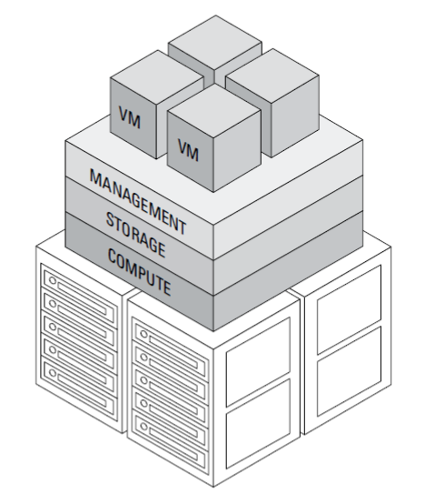

Figure :Hyper-Converged Infrastructure

In HCI, all key data center functions run as software on the hypervisor in a tightly integrated software layer. HCI is fundamentally about this final architecture; as a result, there are different paths to the same end — from turnkey appliances to flexible hardware platforms installed with the hyper‐converged infrastructure software.

# Trends Driving Hyper-Convergence

The hyper‐converged engine is fueled by many key technology trends

1. Higher‐density flash technologies that deliver higher performance at lower costs.
2. More powerful servers, thanks to advances in central processing unit (CPU) and memory densities.
3. Widespread adoption of server virtualization for most workloads.
4. Influence of cloud principles, economics, and cloud‐native applications demanding an updated approach to IT.

# Ingredients for Success

1. A proven hypervisor

In an HCI solution, the hypervisor forms your foundation — it’s the “hyper” in hyper converged, and plays a key role in ensuring data availability, storage efficiency, application performance, and flexible scalability. Given that the benefits of virtualization — from operational efficiency to increased availability — all stem from the hypervisor, choosing the right hypervisor is critical. The more capable and feature‐rich your hypervisor, the better your results.

1. Simple, hyper-converged storage

In a hyper‐converged solution, storage and storage networking are collapsed into the server and virtualized. This streamlines operations, costs, and overall physical footprint. However, not all approaches to software‐defined storage in an HCI environment are created equal.

Next‐generation HCI solutions deliver extremely tight integration between the server and storage virtualization software. The tight integration eliminates the need for a separate virtual storage appliance deployed on each server, which leads to lower resource utilization and lower VM densities.

Unlike hardware‐centric solutions, hyper‐converged infrastructure software pools server‐attached storage to create high‐performance, resilient, shared storage that’s optimized for VMs. What was previously complicated and expensive becomes just the opposite: simple, powerful, streamlined, and intelligent.

1. Unified Management

When selecting a management solution, you’ll want to avoid creating a learning curve for users, or worse, multiple management silos that you must juggle when managing or monitoring the different layers in the HCI.

What you do want is a familiar interface, one you already know how to use. And because simplicity and ease are also vital, look for a unified platform that manages the entire stack and seamlessly integrates all your workflows.

1. Flexible Deployment Choices

Software can’t run on software — you need to put it on something. To ease your path forward, look for an HCI platform that gives you the broadest possible choices for the hardware platform. This flexibility helps you build an HCI environment that matches your needs and preferences exactly.

It allows you to leverage the x86 infrastructure you already know — cost‐effective, industry‐standard, networking and storage products from a wide variety of computer manufacturers. This means no new hardware to learn, no new purchasing process, and no new support model to navigate.

# Use cases of Hyper-Converged Infrastructure

1. Business-critical applications

Traditional infrastructure makes BCAs slow to provision and complicated to manage. Tasks like database processing, email server management, and Web 2.0 workloads require high levels of performance, availability, and reliability. Older architectures simply can’t deliver without overprovisioned storage, expensive purpose‐built hardware, and siloed management tools.

Hyper‐converged infrastructure overcomes these challenges with a simple, distributed scale‐out architecture, often optimized for high‐performance flash devices, that puts IT back in charge of the applications that are so important to the business.

1. Virtual desktop infrastructure/end-user computing

With so many end‐user devices in play, the need for VDI has grown, but legacy systems make deployment a challenge. VDI requires a combination of high IOPs and low latency to ensure a “just‐like‐physical” user experience. It also needs to maintain low capital and operational costs to justify the return on investment (ROI).

Using traditional infrastructure, VDI is expensive to deploy and maintain, with high upfront capital requirements, as well as the high maintenance costs necessary to provide adequate performance and scale for virtual desktops and applications.

HCI delivers the perfect solution to these VDI challenges. It provides a high‐performance and low‐cost solution for a more consistent, predictable user experience, a lower CapEx requirement, and a simpler operational model.

1. Distributed IT and remote office/branch offices

Many organizations have distributed computing and remote offices/branch offices that rely on local IT infrastructure managed by IT staff at another location. This remote, distributed architecture presents a host of challenges that range from unpredictable performance to management complexity to poor reliability and availability.

IT teams need better visibility from a distance, along with tools that will make administration and management simpler and less time‐consuming. And as their businesses grow, they need the ability to scale without breaking the bank. HCI is a perfect match for edge computing and remote office/branch office deployment: It delivers a single, low‐cost infrastructure solution with compute, storage, management, and networking integrated. In addition, the right HCI solution can be easily scaled up or down, and is flexible enough to accommodate changing needs — exactly what companies with remote offices need.

1. Disaster Recovery

The cost of a disaster recovery site can be prohibitive for many organizations. As a result, many businesses have an inadequate or no disaster recovery plan, which introduces considerable risk. One of the more significant costs of a disaster recovery site is the IT systems infrastructure including server hardware, storage, and replication software.

Because HCI provides a complete, natively integrated platform consisting of compute, network, and storage resources, it is an ideal solution for the disaster recovery use case. Deploy on inexpensive industry-standard x86 server components to remove large, upfront investments. Because direct attached drives are used to create the shared storage, there is no dependency on external shared storage hardware. This helps reduce the total cost of the solution while providing sufficient capacity, reliability, and performance.

Software-based replication can provide asynchronous virtual machine replication with low recovery point objectives (RPOs). Replication can be configured on a per-virtual machine basis, enabling precise control over which workloads are protected.

1. Management clusters

Business‐critical applications may get most of the attention but management clusters play a critical, behind‐the‐scenes role in keeping the overall IT environment running smoothly. A management cluster is a dedicated group of hosts reserved for running VMs that provides management services to infrastructure environments, which can include directory services, domain name system (DNS), Dynamic Host Configuration Protocol (DHCP), and VMware vCenter Server.

Their vital role makes it imperative that management clusters are always available and always have adequate resources. In the case of a site‐wide failure, they must be brought online first, as quickly as possible. It’s important to keep them in an isolated environment and sized to allow you to bring them up rapidly.

Traditionally, these clusters resided on expensive hardware to ensure high availability and high performance. If they lived on shared resources for reducing costs, they had to compete with business workloads for compute and storage resources and made recovery more challenging. HCI helps you manage these challenges. It enables simplified management, faster restoration, and disaster recovery, and allows you to isolate infrastructure without high capital costs.

# Benefits of Hyper-Converged Infrastructure

1. Simplicity
2. Provides a single, integrated software stack that runs on industry‐standard servers.
3. Delivers ease of deployment and maintenance, with policy‐driven automation.
4. Reduces physical components to manage, monitor, and maintain.
5. Cost
6. Generates cost and storage efficiency.
7. Leverages technical resources and expertise you already have.
8. Eliminates overprovisioning with granular grow‐as‐you‐go scaling.
9. Security
10. Protects information with native data-at-rest encryption that eliminates drive disposal risks and overhead.
11. Eliminates the costs and complexities of deploying specialized hardware, like self-encrypting drives.
12. Meets strict compliance and security regulations for many industries, like government, finance, and healthcare.
13. Agility
14. Offers broad deployment choice — no hardware vendor lock‐in.
15. Enables a future‐proof IT environment, with support for today’s traditional applications, as well as new cloud native applications and container technologies.
16. Allows you to scale up and scale out to easily meet specific application needs.
17. Performance
18. Delivers all‐flash optimizations for application fast response times.
19. Enables easy scale‐out and scale‐up capabilities.
20. Ensures predictable performance to keep users happy.
21. Availability
22. Ensures predictable performance with quality of service (QoS).
23. Delivers high availability and resiliency with no single point of failure.
24. Builds confidence on the foundation of a proven, industry‐leading hypervisor.

Storage Virtualization with HCI

HCI reinvents the storage model by eliminating legacy silos and enabling the true pooling of storage resources. The hypervisor brings to storage the same operational efficiency that server virtualization brings to compute.

To enable this shift, HCI puts the application and its requirements at the top of the IT food chain, enabling storage resources to respond to the dynamic changes in application requirements. Now the application is the boss; the supporting resources are the workers who make sure the boss gets what the boss needs when the boss needs it.

This is a change from the conventional bottom‐up hardware centric approach. This approach usually requires your storage admins to create static pools of storage resources, and then hope for alignment between the application’s needs and the pre-provisioned storage services. This timeworn tactic leads to wasted resources (because of overprovisioning to ensure against future growth).

In an HCI environment, the x86 server platform runs a hypervisor and includes virtualized storage devices. HCI implements shared storage by pooling the storage resources distributed across multiple server nodes. You essentially end up with a storage area network (SAN) inside an x86 server system.

# A modern infrastructure based on HCI delivers the following benefits:

1. It enables application‐centric storage services

HCI enables storage services to be tailored to the precise requirements of an application and adjusted as needed for each application, without affecting neighboring applications. Storage services become fluid — a little more for this application, a little less for that one.

1. It enables policy‐driven automation

IT admins set policies for requesting, monitoring, and adjusting storage services for specific applications. HCI then enables the storage layer to figure out how best to satisfy those requirements.

1. It enables dynamic storage services

Most of today’s storage products use a static model to deliver storage services. All classes of service are physically pre-provisioned in storage volumes or logical unit numbers (LUNs). HCI uses a dynamic model, as with virtualized compute. IT admins can precisely match demand and supply, according to specific application requirements, in the exact time the resources are needed.

1. It supports conventional storage arrays

When IT organizations bring in new technologies, they put a premium on the ability to continue to use existing investments. And that’s the case with VMware’s approach to HCI. Existing SAN and network‐attached storage (NAS) storage systems can coexist with server‐attached storage pools or can leverage the storage‐policy based management system with VMware Virtual Volumes.

# Driving Storage innovation through the Hypervisor

The hypervisor has a long track record when it comes to storage innovation. In the specific case of VMware, the hypervisor has enabled all kinds of capabilities in the VMware for vSphere environment to improve the management of storage systems.

A few examples:

1. vSphere Thin Provisioning allows you to over‐allocate storage capacity to increase utilization and simplify capacity management.
2. vSphere Storage DRS (Distributed Resource Scheduler) continuously balances storage space usage and storage I/O load to help you prevent resource bottlenecks and meet your targeted application service levels.
3. vSphere Replication enables you to replicate VMs across any kind of storage system for data protection and disaster recovery.

With HCI, VMware continues along this path of driving storage transformation through the hypervisor. The goal is to bring to storage the same level of operational efficiency that server virtualization brought to compute. And this big step forward begins with the hypervisor.

VMware Approach to HCI

# Two different routes to HCI

From a storage architecture standpoint, there are two common paths to delivering HCI. Although they may seem similar, these approaches deliver fundamentally different experiences and capabilities:

1. Bolting storage software onto a hypervisor.
2. Building storage software into the hypervisor.

Although it enables hyper‐convergence, the bolt‐on architecture approach has some distinct disadvantages. These limitations stem from the creation of a separate storage layer that runs as a guest VM on each server that consumes dedicated resources from each server.

Some of the biggest disadvantages of bolt‐on hyper-convergence are:

1. Excessive resource use.
2. Lower performance and longer latencies.
3. Limited integration with the existing management and multiple operational environments.

The VMware approach to HCI is “built in.” In this innovative approach, the storage software is native, or built directly into the hypervisor. This means convergence does not happen on the hypervisor using a virtual appliance, but instead happens inside the hypervisor.

The advantages of the hyper‐converged approach are compelling:

1. Reduced resource use.
2. Better performance and lower latencies.
3. Tight integration enabling end‐to‐end management from a single tool and a simplified operational model.

Here are a few examples of the advantages of built‐in hyper-converged storage:

1. There’s no need to dedicate certain virtual central processing units (vCPUs) to a virtual storage appliance (VSA) on a per‐host basis.
2. CPU resources are used only when they’re needed. You don’t need to reserve CPUs for the worst‐case scenario.
3. You save CPU cycles by going through one stack (hypervisor), not two (hypervisor plus a guest operating system[OS] of the VSA). It’s plain math.

With hyper‐converged storage, convergence takes place in the hypervisor, not in a VM that runs on the hypervisor.

# VMware-Powered HCI

To enable HCI solutions, VMware converges traditional IT infrastructure silos onto industry-standard Intel-based hardware, as shown in Figure 4‐1. VMware-powered HCI solutions virtualize physical infrastructure to help customers evolve their infrastructure without risk, improve TCO over traditional resource silos, and scale to tomorrow with timely support for new hardware, applications, and cloud strategies. HCI originally included virtual compute, virtual storage (with storage networking), and unified management, but can now be optionally extended with advanced virtualized network resources for a fully software-defined data center.

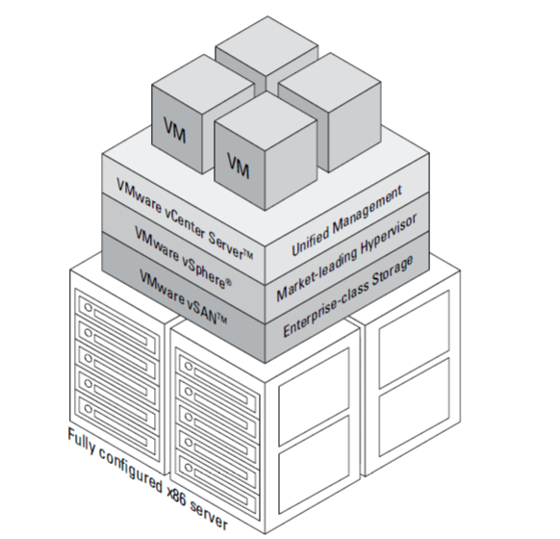

Figure :VMware-powered HCI.

You can enjoy cost-effective, high‐performance compute and storage powered by VMware’s natively integrated software and Intel processors and solid‐state drives (SSDs). It is the ideal combination of proven Intel hardware and VMware software for high performance and exceptional reliability.

The VMware Hyper‐Converged Infrastructure software stack is composed of three widely trusted solutions:

1. VMware vSphere
2. VMware vSAN
3. VMware vCenter Server

# VMware vSAN

The VMware implementation of hyper‐converged storage, VMware vSAN, pools together server‐attached storage (SSDs, HDDs, or other flash devices), as shown in Figure 6. It creates a shared datastore with advanced data services designed for virtual environments. This datastore is highly resilient with no single point of failure and optimized for the latest flash technologies.

vSAN supports both all-flash and hybrid (a mix of flash devices and HDDs) configurations with Intel‐based servers to deliver enterprise‐class storage for virtualized applications. This is high‐performance storage with powerful software based encryption that’s built for the challenges of your business‐ critical applications.

Even better, vSAN seamlessly works with the rest of the VMware software stack. Management is simplified by using standard hardware and common VMware tools and interfaces across compute, storage, and networking. This makes vSAN the simplest storage platform for your VMs.

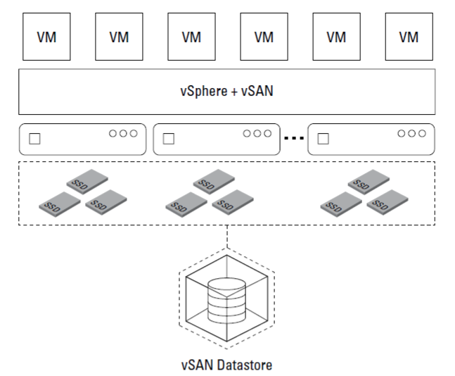

Figure :VMware vSAN.

Attributes of VMware vSAN

1. Native Integration

Hyper‐converged solutions use the hypervisor to support and deliver storage functions and storage networking in software. There’s no need for dedicated storage hardware, such as a storage array, or for complex storage networking, such as a Fiber Channel switch.

Because vSAN is embedded inside the vSphere kernel, vSAN can deliver the highest levels of performance without taxing the CPU with additional overhead. In addition, the native architecture simplifies management and eliminates risk associated with extra components and points of integration. This is a major difference from the many virtualized storage appliances that run separately on top of the hypervisor.

1. Flash-optimized performance

Because software‐defined storage depends on the hypervisor, the hypervisor is like the engine that moves the load along. So top‐notch hypervisor performance is key to top‐notch storage performance.

In the case of the VMware vSphere virtualization environment, the ESXi hypervisor is specifically designed to offer great storage performance on flash hardware. This didn’t happen by chance. The ESXi hypervisor has been optimized for more than ten years. With hyper‐converged designs, the functionality that used to be implemented by the disk array moves onto the same hosts where the workloads or VMs run.

vSAN extends this performance advantage at the hypervisor layer with a distributed storage system architected from the ground up to streamline storage operations and utilize the capabilities of the latest flash technologies. As a result, applications benefit from fast response times and IT administrators enjoy higher levels of VM density.

In addition, vSAN benefits from a powerful ecosystem of hardware partners, ensuring rapid adoption of the latest flash technologies. The vSAN ReadyLabs is a dedicated vSAN engineering team that works hands-on with vSAN and the latest hardware technologies to ensure predictable hardware experience on Day 0 with tested and certified vSAN ReadyNodes.

1. Native HCI security

Security is becoming a top priority for all CIOs as the value of data, and the cost of a security breach, continues to increase. VMware offers the first software-defined, data-at-rest encryption solution built for HCI. Customers from financial markets to federal governments can mitigate security risks for greater peace of mind.

With vSAN Encryption, customers can deploy the storage hardware of their choice, avoiding the hefty premium charged for self-encrypting drives (SEDs). vSAN encryption is completely hardware-agnostic. In addition, key management is greatly simplified with support for all leading key management servers and simple 1-click enablement for the entire cluster.

1. Efficiency Advantages

In addition, advanced storage efficiency features include deduplication, compression, and erasure coding. These data efficiency and reduction technologies run inline before any data is written to the capacity tier of vSAN. These features drastically improve the storage utilization rate (meaning you need less physical storage to store the same amount of data).

And thanks to integration, those features — which can consume a significant amount of CPU and memory overhead on VSA‐based HCI solutions — have minimal impact on the compute overhead. This means you can turn them on and forget them, even for mixed workload environments. No complicated planning, no tough decisions, no need to monitor or adjust the environment based on changing workloads.

1. Operational advantages

Operational advantages are perhaps the biggest win of the hyper‐converged approach. A hyper‐converged storage approach is built from the ground up to integrate and leverage all the functionality of the hypervisor, without more operational overhead or any reduction of core functionality.

If you run a vSphere environment, you probably appreciate the functionality of your virtualization layer (including such things as vSphere High Availability and vSphere vMotion). Presto! Now you can have the same functionality in vSphere based hyper‐converged storage, because it’s all embedded in the hypervisor.

As customers deploy these HCI solutions at scale, vSAN offers extensive support for public APIs/SDK and PowerCLI for advanced automation and scripting. The day-to-day management and monitoring capabilities of compute and storage — including checking alerts, viewing capacity usage, upgrading controller drivers with 1-click (a new feature in vSAN 6.6), and more — can all be performed with the familiar vCenter tools. Administrators using vRealize Operations for rapid monitoring and troubleshooting of their larger environments can benefit from native vSAN integration in vRealize Operations where they can easily monitor multiple vSAN clusters, perform advanced capacity planning, and leverage customer vSAN dashboards on health and performance.

Getting Started with HCI

# Implementing VMware-Powered HCI: Deployment Choices

You have two main options for implementing VMware‐based HCI, as shown in Figure 6‐1:

1. Certified solutions based on VMware vSAN ReadyNodes.
2. Integrated systems in the form of the turnkey Dell EMC VxRail HCI Appliances.

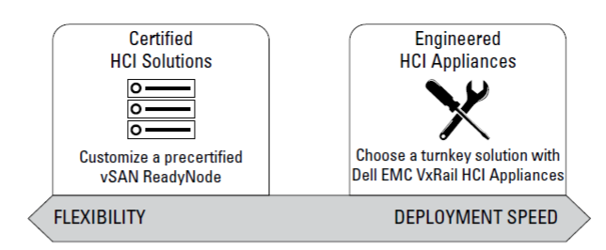

Figure :HCI Deployment Models.

Either of these options will help streamline your data center and deliver low‐cost, high‐performance compute and storage powered by VMware vSAN along with solid state drives (SSDs). The natively integrated software combines vSAN, vSphere, and vCenter with HCI deployment choices on industry‐standard x86 architectures.

VMware vSAN offers proven, high-performance storage that allows you to extend your existing virtualization skill sets, reduce infrastructure and management costs, and scale to tomorrow’s new hardware, application, and cloud technologies.

By being software‐defined and delivered from the hypervisor, vSAN is completely hardware independent; it works with any x86 vSphere‐compatible server. This means that, when you’re ready to get rolling with HCI, you have a broad range of VMware and third‐party components and options for configuring and deploying vSAN nodes, whether you’re looking for maximum flexibility or the fastest time to market.

Regardless of the deployment model you choose, with vSAN you gain server‐side economics. You can lower your storage capital expenses by taking advantage of lower‐cost, industry standard x86 architectures storage components — while gaining all the other benefits of the SDS operational model.

# Certified Solutions: vSAN ReadyNodes

You can deploy vSAN with a certified hardware platform from the original equipment manufacturer (OEM) vendor of your choice. These pre-certified platforms, called vSAN ReadyNodes, include a full hardware stack composed of the server, controller, and drives. VMware vSAN ReadyLabs and server OEMs have jointly validated numerous server configurations that are ready to run vSAN.

This approach allows you to build vSAN nodes that cater to different workload capacity and performance needs, by selecting the ReadyNode of your choice from the menu of options that are provided by each vendor. The ReadyNodes can be purchased as is or further customized to meet your needs — for example, including more memory, central processing units (CPUs), or drives.

# Benefits of vSAN ReadyNode

vSAN ReadyNodes help you simplify the buying decision, take control of your HCI, and accelerate time to value by providing the following benefits:

1. Choice of hardware

Select a server OEM of your choice and choose from more than 250 pre-certified ReadyNodes

designed for your workload needs. Each solution profile provides a different price/performance focus.

1. Elimination of silos

Deploy your HCI environment on the x86 platforms you already know and use. This means

no new hardware to learn, no new procurement process to establish, and no new support model to manage.

1. Ease of order and customization

Purchase a single stock keeping unit (SKU) preconfigured with CPU, memory, network, I/O controller, hard disk drives (HDDs), and SSDs, and optionally preloaded with vSphere and vSAN. Buy as is or customize to your specific needs.

1. Licensing options

Leverage your existing enterprise license agreements or simplify procurement of licenses as a new customer.

# Choosing the right vSAN ReadyNode

Here’s how to choose the right vSAN ReadyNode:

1. Refer to the vSAN Hardware Quick Reference Guide for pointers on how to identify the hardware requirements for your workload profile and the category of ReadyNode that meets your needs: www.vmware.com/resources/compatibility/vsan_profile.html.
2. Visit the vSAN ReadyNode Configurator for step by‐step help picking a profile and identifying the options from your vendor of choice: http://vsanreadynode.vmware.com/RN/RN.

# Implementing vSAN ReadyNode

Here are some tips for implementing vSAN ReadyNode:

1. Follow the vSphere Compatibility Guide.

Be sure to follow the guidelines and advice in the vSphere Compatibility Guide for vSAN. This online tool (available at “https://www.vmware.com/resources/ compatibility/search.php?deviceCategory=vsan”) is regularly updated to provide the latest guidance from VMware. Follow it precisely. Always verify that VMware supports any hardware components you plan to use for your vSAN deployment.

1. Create balanced configurations.

As a best practice, deploy ESXi hosts with similar or identical configurations across all cluster members, including similar or identical storage configurations. This ensures an even balance of virtual machine (VM) storage components across the disks and hosts cluster.

1. Design for the life cycle of the vSAN cluster

For both hybrid and all‐flash configurations, it’s important to scale in a way that enables an adequate amount of cache and capacity for your workloads. Consider choosing hosts that have disk slots for additional capacity and provide an easy way to install additional devices into these slots.

1. Size for capacity, maintenance, and availability

A configuration with four nodes (or more) provides more availability options than a three‐node configuration. Be sure you have enough storage capacity to not only meet your availability requirements but also allow for a rebuild of components after a failure.

1. Migrate data and VMs from existing infrastructure

Transitioning to HCI systems powered by vSAN is also extremely easy. Once a new ReadyNodes-based vSAN cluster is brought up in your existing instance of vCenter, you can use the built-in migration capabilities that are based on proven vMotion and Storage vMotion technologies. With a few clicks through the migration wizard, both your data and workloads can be migrated without disruption from your traditional compute and storage environment to a new HCI environment.

# Integrated Systems: Dell EMC VxRail HCI Appliances

The Dell EMC VxRail Appliance is a fully integrated, preconfigured, and pretested VMware HCI appliance family. Built on VMware vSphere and vSAN, VxRail delivers an all‐in‐one information technology (IT) infrastructure transformation solution by leveraging a known and proven building block for the software‐defined data center (SDDC).

1. Storage area network power in just two racks

With the power of a whole storage area network (SAN) in just two rack units, these appliances provide a simple, cost effective hyper‐converged solution for a wide variety of applications and workloads. VxRail Appliances deliver features for resiliency, quality of service (QoS), and centralized management functionality, enabling faster, better, and simpler management of consolidated workloads, virtual desktops, business‐critical applications, and remote office infrastructure.

1. A familiar experience

Built on the foundation of VMware vSAN and managed through the familiar VMware vCenter Server, Dell EMC VxRail Appliances provide current VMware customers with a familiar experience, plus the benefits of simplified operations, life-cycle management, and additional IT services.

VxRail Appliances are fully loaded with integrated Dell EMC mission‐critical data services, including replication, backup, and cloud tiering, at no additional charge. As a VMware‐based solution, the appliances also integrate with VMware’s cloud management platform and end‐user computing solutions. VxRail is also a platform for introducing advanced SDDC offerings like VMware NSX, vRealize Air Automation, and Horizon Air Hybrid Mode.

HCI capabilities are also available in Integrated Systems from VMware. These systems are powered by VMware’s hyper-converged software, vSphere for virtualization, and vSAN for storage. Integrated Systems combine VMware compute, storage, and networking with certified partner hardware into HCI appliances. The result is an all‐in‐one, easy‐to‐deploy, simple to‐manage data center systems.

Future Scope

A new style of application is becoming more common in IT environments as organizations look to deploy developer ready infrastructure. Whether it’s a mobile application, big data analytics, or new cloud‐native applications, these newer applications are far more dynamic in their resource requirements than traditional enterprise applications. The rising popularity of containers and cloud applications is placing new demands on your IT infrastructure. For example, vSAN tightly integrates with Docker and Kubernetes to provide persistent storage, allowing for stateful applications and containers on proven infrastructure that is easy to manage, monitor, and maintain.

The old approach of making static upfront assumptions about an application’s requirements no longer flies. Instead, the underlying infrastructure should be poised to make automatic adjustments to answer the application’s changing needs. That’s HCI.

References

[1].Micheal Haag, "Hyper-Converged infrastructure for Dummies," A Wiley Brand.

[2].Hyper-Converged Infrastructure <https://www.vmware.com/in/products/hyper-converged-infrastructure.html>

[3].Hyper-Converged Infrastructure <https://en.wikipedia.org/wiki/Hyperconverged_infrastructure>