 

**实验报告二**

学生姓名： 甘志强 学 号： 6103114031 专业班级：计科141

实验类型：□验证 √ 综合 □设计□创新 实验日期： 2017.3.28 实验成绩：

1. 实验项目名称

JSP内置对象名称

1. 实验目的

通过JSP中的Request、Response、Session|、Application等内置对象，完成一个信息提交显示并能统计网站访问次数的功能。

1. 实验基本原理

通过访问[http://192.168.1.**:8080](http://192.168.1.**:8080)的方式出现首页，命名为RequestInfo.jsp，提交后跳转到ViewInfo.jsp，在这个页面汇总显示提交过来的相关信息，在每个页面的首部都显示 “张三，你好！您是本网站的第*个访问者。”其中的张三为RequestInfo.jsp页面输入的信息。访问次数统计的要求是在不同的客户端（包括不同浏览器、不同电脑）访问时次数要加1；同一个浏览器访问中新加选项卡时次数不变；同时还要满足如果是同一个ip访问，则20秒之内访问次数不加。

RequestInfo.jsp的页面大致如下：

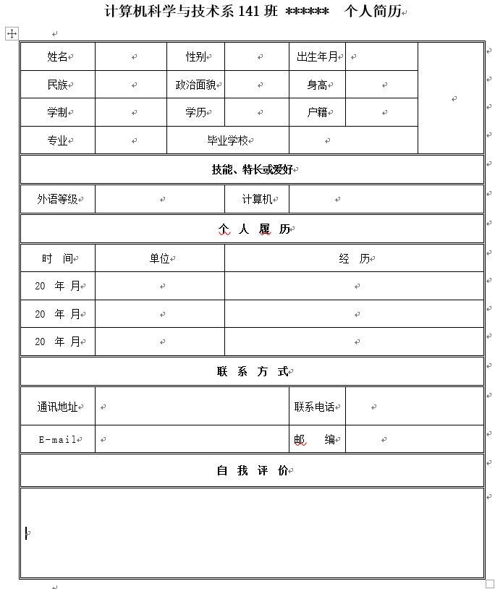

1. 主要仪器设备及耗材:idea
2. 实验步骤
3. 实验数据及处理结果

实验代码：index.jsp:

<%@ **page** import="java.util.ArrayList" %>  
<%--  
 Created by IntelliJ IDEA.  
 User: leon  
 Date: 17/3/28  
 Time: 下午3:14  
 To change this template use File | Settings | File Templates.  
--%>  
<%@ **page** contentType="text/html;charset=UTF-8" language="java" %>  
<html>  
<head>  
 <title>简历</title>  
 <style type="text/css">  
 td {  
 border-bottom: 1px solid #ddd;  
 border-right: 1px solid #ddd;  
 margin: 0;  
 width: 80px;  
 text-align: center;  
 }  
 td:nth-child(1) {  
 border-left:1px solid #ddd;  
 }  
 table {  
 border-top:1px solid #ddd;  
 }  
 tr:last-child>td {  
 border: none;  
 }  
 input:not([type="radio"]) {  
 border: none;  
 height: 30px;  
 margin:0;  
 width: 100%;  
 }  
 button {  
 padding: 10px 30px;  
 border: none;  
 color: #fff;  
 margin-top: 5px;  
 border-radius: 3px;  
 }  
 button[type="submit"] {  
 background: #286090;  
 }  
 button[type="reset"] {  
 background: #fff;  
 color: black;  
 border: 1px solid #ccc;  
 }  
 textarea {  
 height: 100%;  
 width:100%;  
 border: none;  
 resize: none;  
 }  
 </style>  
</head>  
<body style="display: flex; align-items: center; flex-direction: column;">  
**<%** int i = application.getAttribute("visit") == null ? -1 : (int)application.getAttribute("visit");  
 ArrayList ipList = application.getAttribute("ipList") == null ? new ArrayList() : (ArrayList)application.getAttribute("ipList");  
 ArrayList timeList = application.getAttribute("timeList") == null ? new ArrayList() : (ArrayList)application.getAttribute("timeList");  
 request.setCharacterEncoding("utf-8");  
 String ip = request.getRemoteAddr().toString();  
 long time = session.getLastAccessedTime();  
 long poorTime = 0;  
 if (session.isNew()) {  
 if(!ipList.contains(ip)) {  
 ipList.add(ip);  
 timeList.add(time);  
 i ++;  
 }else {  
 int index = ipList.indexOf(ip);  
 long prevTime = (long)timeList.get(index);  
 poorTime = time - prevTime;  
 timeList.set(index, time);  
 if (poorTime > 20000) i ++;  
 }  
 }  
  
 if (ipList.contains(ip)) {  
 int index = ipList.indexOf(ip);  
 timeList.set(index, time);  
 }  
  
 application.setAttribute("ipList", ipList);  
 application.setAttribute("timeList", timeList);  
 application.setAttribute("visit", i);  
  
**%>**<div>  
 <span id="target"></span>  
 <span>您好,您是第**<%=**i**%>**个访问用户</span>  
 <div>甘志强 6103114031</div>  
</div>  
<h2>填写简历</h2>  
<form action="./show.jsp" method="post">  
  
 <table cellspacing="0" border="0">  
  
 <tr>  
 <td>姓名</td>  
 <td>  
 <input id="name" type="text" value="甘志强  
  
  
" name="name">  
 </td>  
 <td>性别</td>  
 <td>  
 <input type="radio" name="sex" checked value="男">男  
 <input type="radio" name="sex" value="女">女  
 </td>  
 <td>出生年月</td>  
 <td>  
 <input type="text" name="birthday">  
 </td>  
 <td rowspan="4"></td>  
 </tr>  
 <tr>  
 <td>民族</td>  
 <td>  
 <input type="text" name="nation">  
 </td>  
 <td>政治面貌</td>  
 <td>  
 <input type="text" name="political">  
 </td>  
 <td>身高</td>  
 <td>  
 <input type="text" name="height">  
 </td>  
 <!-- <td></td> -->  
 </tr>  
 <tr>  
 <td>学制</td>  
 <td>  
 <input type="text" name="eductionSystem">  
 </td>  
 <td>学历</td>  
 <td>  
 <input type="text" name="eductionLevel">  
 </td>  
 <td>户籍</td>  
 <td>  
 <input type="text" name="household">  
 </td>  
 </tr>  
 <tr>  
 <td>专业</td>  
 <td>  
 <input type="text" name="professional">  
 </td>  
 <td colspan="2">毕业学校</td>  
 <td colspan="2">  
 <input type="text" name="school">  
 </td>  
 </tr>  
 <tr>  
 <td colspan="7">技能、特长或爱好</td>  
 </tr>  
 <tr>  
 <td>外语等级</td>  
 <td colspan="2">  
 <input type="text" name="EnglishLevel">  
 </td>  
 <td>计算机</td>  
 <td colspan="3">  
 <input type="text" name="computerLevel">  
 </td>  
 </tr>  
 <tr>  
 <td colspan="7">个人履历</td>  
 </tr>  
 <tr>  
 <td>  
 时间  
 </td>  
 <td colspan="2">  
 单位  
 </td>  
 <td colspan="4">  
 经历  
 </td>  
 </tr>  
 <tr>  
 <td>  
 <input type="text" name="time1">  
 </td>  
 <td colspan="2">  
 <input type="text" name="area1">  
 </td>  
 <td colspan="4">  
 <input type="text" name="experience1">  
 </td>  
 </tr>  
 <tr>  
 <td>  
 <input type="text" name="time2">  
 </td>  
 <td colspan="2">  
 <input type="text" name="area2">  
 </td>  
 <td colspan="4">  
 <input type="text" name="experience2">  
 </td>  
 </tr>  
 <tr>  
 <td>  
 <input type="text" name="time3">  
 </td>  
 <td colspan="2">  
 <input type="text" name="area3">  
 </td>  
 <td colspan="4">  
 <input type="text" name="experience3">  
 </td>  
 </tr>  
 <tr>  
 <td colspan="7">联系方式</td>  
 </tr>  
 <tr>  
 <td>通讯地址</td>  
 <td colspan="3">  
 <textarea name="address" style="height: 50px;"></textarea>  
 </td>  
 <td>联系电话</td>  
 <td colspan="2">  
 <input type="tel" name="phone">  
 </td>  
 </tr>  
 <tr>  
 <td colspan="7">自我评价</td>  
 </tr>  
 <tr>  
 <td colspan="7" style="height: 200px;">  
 <textarea name="selfIntroduce"></textarea>  
 </td>  
 </tr>  
 <tr>  
 <td colspan="4">  
 <button type="submit">提交</button>  
 </td>  
 <td colspan="3">  
 <button type="reset">重置</button>  
 </td>  
 </tr>  
 </table>  
 <%--<input name="visit" value="<%=i%>" style="display: none;">--%>  
</form>  
</body>  
<script>  
  
 window.onload = **function** () {  
 **var** elem = document.getElementById("name");  
 **var** target = document.getElementById("target");  
 elem.onporpertychange = **function** (e) {  
 console.log(elem.value);  
 }  
 elem.oninput = **function** (e) {  
 console.log(elem.value);  
 target.innerHTML = elem.value;  
 }  
 }  
</script>  
</html>

Show.jsp:<%@ **page** import="java.util.ArrayList" %>  
<%--  
 Created by IntelliJ IDEA.  
 User: leon  
 Date: 17/3/28  
 Time: 下午4:08  
 To change this template use File | Settings | File Templates.  
--%>  
<%@ **page** contentType="text/html;charset=UTF-8" language="java" %>  
<html>  
<head>  
 <title>展示</title>  
 <style>  
 td {  
 border-bottom: 1px solid #ddd;  
 border-right: 1px solid #ddd;  
 margin: 0;  
 width: 100px;  
 text-align: center;  
 height: 40px;  
 }  
 td:nth-child(1) {  
 border-left:1px solid #ddd;  
 }  
 table {  
 border-top:1px solid #ddd;  
 }  
 </style>  
</head>  
<body style="display: flex; align-items: center; flex-direction: column;">  
**<%** int i = application.getAttribute("visit") == null ? -1 : (int)application.getAttribute("visit");  
 ArrayList ipList = application.getAttribute("ipList") == null ? new ArrayList() : (ArrayList)application.getAttribute("ipList");  
 ArrayList timeList = application.getAttribute("timeList") == null ? new ArrayList() : (ArrayList)application.getAttribute("timeList");  
 request.setCharacterEncoding("utf-8");  
 String ip = request.getRemoteAddr().toString();  
 long time = session.getLastAccessedTime();  
 long poorTime = 0;  
 if (session.isNew()) {  
 if(!ipList.contains(ip)) {  
 ipList.add(ip);  
 timeList.add(time);  
 i ++;  
 }else {  
 int index = ipList.indexOf(ip);  
 long prevTime = (long)timeList.get(index);  
 poorTime = time - prevTime;  
 timeList.set(index, time);  
 if (poorTime > 20000) i ++;  
 }  
 }  
  
 if (ipList.contains(ip)) {  
 int index = ipList.indexOf(ip);  
 timeList.set(index, time);  
 }  
  
 application.setAttribute("ipList", ipList);  
 application.setAttribute("timeList", timeList);  
 application.setAttribute("visit", i);  
  
**%>**<div>  
 <span>**<%=**request.getParameter("name")**%>**</span>  
 <span>您好,您是第**<%=**i**%>**个访问用户</span>  
</div>  
<h2>**<%=**request.getParameter("name")**%>**个人简历</h2>  
<table cellspacing="0" border="0">  
  
 <tr>  
 <td>姓名</td>  
 <td>  
 **<%=**request.getParameter("name")**%>** </td>  
 <td>性别</td>  
 <td>  
 **<%=**request.getParameter("sex")**%>** </td>  
 <td>出生年月</td>  
 <td>  
 **<%=**request.getParameter("birthday")**%>** </td>  
 <td rowspan="4"></td>  
 </tr>  
 <tr>  
 <td>民族</td>  
 <td>  
 **<%=**request.getParameter("nation")**%>** </td>  
 <td>政治面貌</td>  
 <td>  
 **<%=**request.getParameter("political")**%>** </td>  
 <td>身高</td>  
 <td>  
 **<%=**request.getParameter("height")**%>** </td>  
 <!-- <td></td> -->  
 </tr>  
 <tr>  
 <td>学制</td>  
 <td>  
 **<%=**request.getParameter("eductionSystem")**%>** </td>  
 <td>学历</td>  
 <td>  
 **<%=**request.getParameter("eductionLevel")**%>** </td>  
 <td>户籍</td>  
 <td>  
 **<%=**request.getParameter("household")**%>** </td>  
 </tr>  
 <tr>  
 <td>专业</td>  
 <td>  
 **<%=**request.getParameter("professional")**%>** </td>  
 <td colspan="2">毕业学校</td>  
 <td colspan="2">  
 **<%=**request.getParameter("school")**%>** </td>  
 </tr>  
 <tr>  
 <td colspan="7">技能、特长或爱好</td>  
 </tr>  
 <tr>  
 <td>外语等级</td>  
 <td colspan="2">  
 **<%=**request.getParameter("EnglishLevel")**%>** </td>  
 <td>计算机</td>  
 <td colspan="3">  
 **<%=**request.getParameter("computerLevel")**%>** </td>  
 </tr>  
 <tr>  
 <td colspan="7">个人履历</td>  
 </tr>  
 <tr>  
 <td>  
 时间  
 </td>  
 <td colspan="2">  
 单位  
 </td>  
 <td colspan="4">  
 经历  
 </td>  
 </tr>  
 <tr>  
 <td>  
 **<%=**request.getParameter("time1")**%>** </td>  
 <td colspan="2">  
 **<%=**request.getParameter("area1")**%>** </td>  
 <td colspan="4">  
 **<%=**request.getParameter("experience1")**%>** </td>  
 </tr>  
 <tr>  
 <td>  
 **<%=**request.getParameter("time2")**%>** </td>  
 <td colspan="2">  
 **<%=**request.getParameter("area2")**%>** </td>  
 <td colspan="4">  
 **<%=**request.getParameter("experience2")**%>** </td>  
 </tr>  
 <tr>  
 <td>  
 **<%=**request.getParameter("time3")**%>** </td>  
 <td colspan="2">  
 **<%=**request.getParameter("area3")**%>** </td>  
 <td colspan="4">  
 **<%=**request.getParameter("experience3")**%>** </td>  
 </tr>  
 <tr>  
 <td colspan="7">联系方式</td>  
 </tr>  
 <tr style="height: 50px;">  
 <td>通讯地址</td>  
 <td colspan="3">  
 **<%=**request.getParameter("address")**%>** </td>  
 <td>联系电话</td>  
 <td colspan="2">  
 **<%=**request.getParameter("phone")**%>** </td>  
 </tr>  
 <tr>  
 <td colspan="7">自我评价</td>  
 </tr>  
 <tr>  
 <td colspan="7" style="height: 200px;">  
 **<%=**request.getParameter("selfIntroduce")**%>** </td>  
 </tr>  
</table>  
</body>  
</html>

实验截图：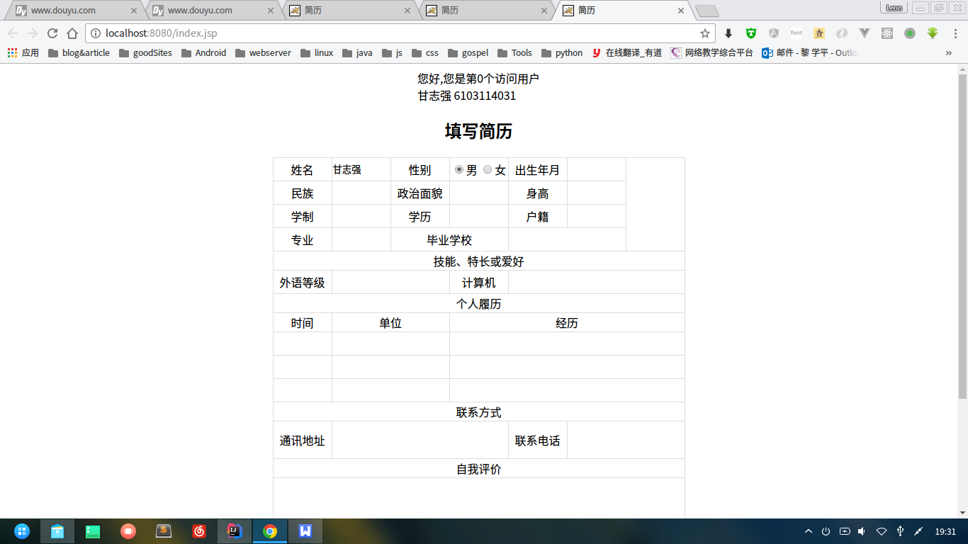

1. 思考讨论题或体会或对改进实验的建议

实验总结：通过本次实验，认识到了JSP，并且通过使用jsp中的Request、Response、Session|、Application等内置对象，完成一个信息提交显示并能统计网站访问次数的功能。

八、参考资料