Open note quiz # 2
Biochemistry

2-1 Table

Matching

- Ion
- Atomic number
- Mass number
- Isotope
- Protons
- Neutrons
- Electrons
- Compound
- Carbon
- Covalent
- ionic

- _____A positive or negative atom
- _____equal to the number of protons; the periodic table is arranged by this
- _____negatively charged part of the atom
- _____positively charged part of the atom
- _____neutral part of the atom
- _____bond in which atoms share electron
- _____bond in which atom gives away electrons
- _____an atom with 6 protons has 6 of these
- _____the sum of the protons and neutrons
- _____an atom that has 6 protons but 7 neutrons is called this
- ____ 2 or more different elements combined in definite proportions
- ____water is not considered living or organic because it does not contain this

Properties of Water Lab, Handout, and Notes

- Draw a water molecule and label the atoms that makeup water. Label which side is positively charged and which side is negatively charged.

Matching

  - Acidic
  - Basic
  - Cohesion
  - Adhesion
  - Polarity
  - Surface tension
  - hydrogen bond
  - covalent bond
  - surfactant
  - neutral
  - capillary action

- ______property of water in which water molecules cling to other water molecules
- ______a substance with a pH of 2 would be considered this

- ______property of water that produces a positive force on one end and a negative force on the other end
- _____a substance with a higher concentration of H⁺ ions is said to be this
- _____a substance with a higher concentration of OH⁻ ions is said to be this
- _____this property of water allows a paperclip to float on it’s surface
- _____this describes water’s pH which has an equal amount of H⁺ and OH⁻ ions.
- _____is also described as water having “skin”
- _____property of water in which water molecules are attracted to molecules of other substances
- ______all of water’s unique properties is because of this
- ______breaks hydrogen bonds on water molecules and disrupts surface tension
- ______this bond occurs between the hydrogen atom and the oxygen atom in a water molecule
- _____this property of water explains why there is a deeper meniscus in the water if the graduated cylinder made of glass rather than plastic
- _____water traveling upward in a small tube because of adhesion and cohesion is called this

Carbon compounds notecards, model questions, and 2-3 worksheet

Fill in the table
Name | Units | Function | Example
Protein | 30. | 32. | Hemoglobin
28. | Monosaccharide | Provide energy | 34.
Lipids | Glycerol & fatty acids | 33. | Cholesterol
29. | 31. | Genetic information | 35.

Answer the following questions about each carbon compound.

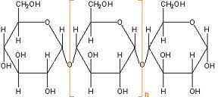
- Which of the 4 carbon compounds is this?

- Put a circle around a monosaccharide in the picture.

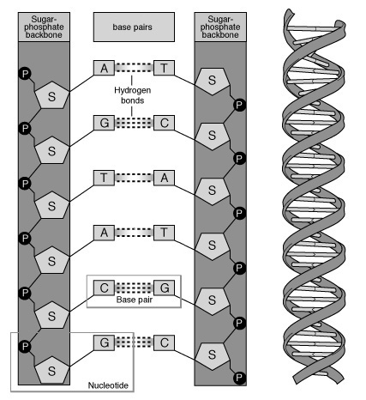
- Which of the 4 carbon compounds is this?

- Put a circle around the monomer that makes up this macromolecule.

40. List the components that make up the monomer.

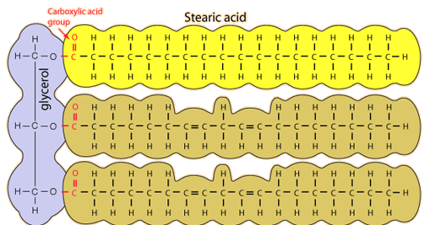
41. Which of the 4 organic compounds is this?

42. Label the 2 main parts of this macromolecule.

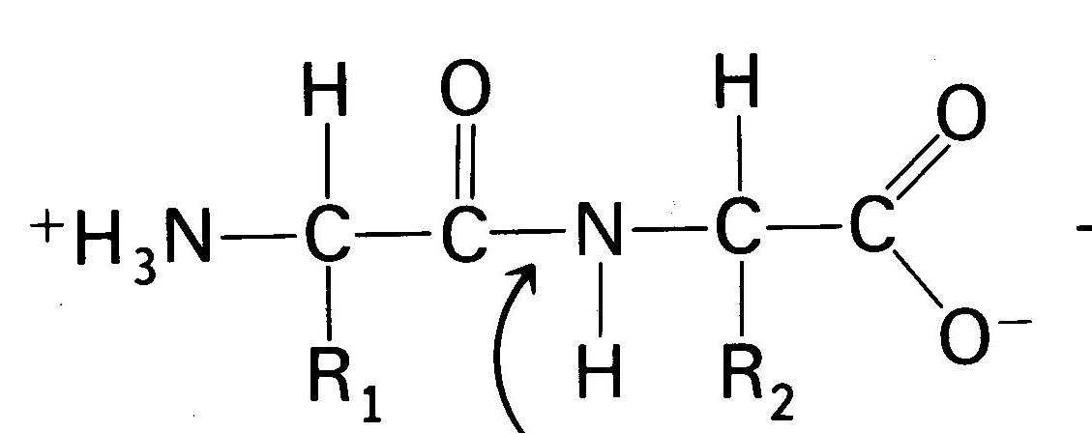
43. Which of the 4 organic compounds is this?

- What are the bonds called that hold these monomers together?

- What 2 parts do all these monomers have in common?

- What part of this monomer is different than all the others?

2-4 Enzyme powerpoint notes, toothpickase activity

  - Explain how an enzyme and its substrate are related to a lock and key.

  - Explain how an enzyme and its substrate are not like a lock and key.

Write EN for endergonic and EX for exergonic.

- ____energy releasing reaction
- ____photosynthesis is an example of this
- ____respiration is an example of this
- ____energy required in this reaction
- ____usually spontaneous
- ____not spontaneous

Multiple Choice-choose the best answer.
- An enzyme lowers this in a reaction
  - Temperature
  - pH
  - activation energy
  - all of the above
- The energy used to get a reaction started is called
  - Entropy
  - Endergonic
  - Exergonic
  - Activation energy
- Any substance that speeds up the rate of a chemical reaction by lowering the activation energy of a reaction is called
  - Catalyst
  - Protein
  - Carbohydrate
  - Amino acid
- Biological catalysts that speed up chemical reactions that take place in cells.
  - Lipid
  - Monosaccharide
  - Enzyme
  - Amino acid
- Enzymes can be affected by all these factors EXCEPT
  - pH
  - temperature
  - substrate concentration
  - lipid concentration
- Enzymes have all the following functions EXCEPT
  - Make materials that cells need
  - Release energy
  - Transfer information
  - Poison living things

