**Classification and Diversity of Life**

**Multiple Choice**

*Identify the choice that best completes the statement or answers the question.*

____ 1. Scientists assign each kind of organism a universally accepted name in the system known as

|  |  |  |  |
| --- | --- | --- | --- |
| a. | traditional classification. | c. | binomial nomenclature. |
| b. | the three domains. | d. | cladistics. |

____ 2. Several different classes make up a

|  |  |  |  |
| --- | --- | --- | --- |
| a. | kingdom. | c. | family. |
| b. | phylum. | d. | genus. |

____ 3. *Traditional* classifications tended to take into account primarily

|  |  |  |  |
| --- | --- | --- | --- |
| a. | extinct organisms. | c. | DNA similarities. |
| b. | RNA similarities. | d. | general similarities in appearance. |

____ 4. An analysis of derived characters is used to generate a

|  |  |
| --- | --- |
| a. | family tree based on external appearance. |
| b. | family tree based on DNA structure. |
| c. | cladogram. |
| d. | traditional classification system. |

____ 5. What is true about dissimilar organisms such as a cow and a yeast?

|  |  |
| --- | --- |
| a. | They are not related at all. |
| b. | Their degree of relatedness cannot be evaluated. |
| c. | Their degree of relatedness can be determined from their genes. |
| d. | They can interbreed and thus are the same species. |

____ 6. In binomial nomenclature, which of the two terms is capitalized?

|  |  |  |  |
| --- | --- | --- | --- |
| a. | the first term only | c. | both the first and second terms |
| b. | the second term only | d. | neither the first nor the second term |

____ 7. A genus is composed of a number of related

|  |  |  |  |
| --- | --- | --- | --- |
| a. | kingdoms. | c. | orders. |
| b. | phyla. | d. | species. |

____ 8. The procedure of grouping organisms based on their evolutionary history is called

|  |  |  |  |
| --- | --- | --- | --- |
| a. | traditional classification. | c. | derived characters. |
| b. | binomial nomenclature. | d. | evolutionary classification (phylogeny). |

____ 9. Similar genes are evidence of

|  |  |  |  |
| --- | --- | --- | --- |
| a. | binomial nomenclature. | c. | common ancestry. |
| b. | mutations. | d. | different anatomy. |

____ 10. What do all organisms have in common?

|  |  |
| --- | --- |
| a. | They use DNA and RNA to pass on information. |
| b. | They are all prokaryotes. |
| c. | They are all eukaryotes. |
| d. | They are genetically identical. |

____ 11. All organisms in the kingdoms Protista, Plantae, Fungi, and Animalia are

|  |  |  |  |
| --- | --- | --- | --- |
| a. | multicellular organisms. | c. | eukaryotes. |
| b. | photosynthetic organisms. | d. | prokaryotes. |

____ 12. Which kingdom contains heterotrophs with cell walls of chitin?

|  |  |  |  |
| --- | --- | --- | --- |
| a. | Protista | c. | Plantae |
| b. | Fungi | d. | Animalia |

____ 13. The domain that includes the kingdom Eubacteria is

|  |  |  |  |
| --- | --- | --- | --- |
| a. | Archaea. | c. | Eukarya. |
| b. | Bacteria. | d. | Fungi. |

____ 14. Prokaryotes are single-celled organisms that lack a

|  |  |  |  |
| --- | --- | --- | --- |
| a. | cell wall. | c. | definite shape. |
| b. | cell membrane. | d. | nucleus. |

____ 15. Which of the following statements is NOT true about archaebacteria?

|  |  |
| --- | --- |
| a. | They are thought to be ancestors of eukaryotes. |
| b. | Many live in harsh environments. |
| c. | They lack peptidoglycan in their cell wall. |
| d. | They make up the largest kingdom of prokaryotes. |

____ 16. Spherical prokaryotes are called

|  |  |  |  |
| --- | --- | --- | --- |
| a. | spirilla. | c. | cocci. |
| b. | flagella. | d. | bacilli. |

____ 17. Unlike photoautotrophs, chemoautotrophs obtain energy

|  |  |
| --- | --- |
| a. | directly from the sun. |
| b. | directly from chemical reactions. |
| c. | indirectly from carbon molecules. |
| d. | indirectly from other organisms. |

____ 18. Which of the following describes a role of bacteria in the environment?

|  |  |  |  |
| --- | --- | --- | --- |
| a. | carrying out photosynthesis | c. | fixing nitrogen |
| b. | recycling nutrients | d. | all of the above |

____ 19. Bacteriophages infect

|  |  |  |  |
| --- | --- | --- | --- |
| a. | other viruses. | c. | any available host cell. |
| b. | bacteria only. | d. | cells undergoing the lytic cycle. |

____ 20. What can a vaccine do when it is injected into the body?

|  |  |
| --- | --- |
| a. | prompt the body to produce immunity to a disease |
| b. | produce toxins that disrupt bacterial equilibrium |
| c. | use bacterial cells for food |
| d. | destroy new pathogens as they arise in the body |

____ 21. Which of the following are used to identify prokaryotes?

|  |  |  |  |
| --- | --- | --- | --- |
| a. | cell shape | c. | the way prokaryotes obtain energy |
| b. | the way prokaryotes move | d. | all of the above |

____ 22. Binary fission occurs when a bacterium

|  |  |
| --- | --- |
| a. | exchanges genetic information with another cell. |
| b. | forms an endospore to survive harsh conditions. |
| c. | forms a hollow bridge to another bacterial cell. |
| d. | replicates its DNA and divides in half. |

____ 23. Which of the statements is true about dinoflagellates?

|  |  |
| --- | --- |
| a. | They contain bright yellow pigments. |
| b. | They can be both photosynthetic and heterotrophic. |
| c. | Many species are luminescent. |
| d. | They possess pillbox-shaped cell walls of silica. |

____ 24. Some products derived from algae include

|  |  |
| --- | --- |
| a. | drugs for stomach ulcers and high blood pressure. |
| b. | thickeners for food. |
| c. | chemicals in plastics, waxes, paints, and lubricants. |
| d. | all of the above |

____ 25. Funguslike protists get nutrients by

|  |  |
| --- | --- |
| a. | photosynthesis. |
| b. | living as an animal parasite. |
| c. | absorbing them from dead or decaying matter. |
| d. | none of the above |

____ 26. A protist is any organism that is not a plant, an animal, a fungus, or a(an)

|  |  |  |  |
| --- | --- | --- | --- |
| a. | eukaryote. | c. | eubacterium. |
| b. | prokaryote. | d. | archaebacterium. |

____ 27. The switching back and forth between a diploid and haploid stage in a life cycle is called

|  |  |
| --- | --- |
| a. | alternation of generations. |
| b. | fusion of opposite mating types. |
| c. | sexual reproduction. |
| d. | asexual reproduction. |

____ 28. Which of the following groups includes only funguslike protists?

|  |  |
| --- | --- |
| a. | cellular slime molds, brown algae, water molds |
| b. | cellular slime molds, acellular slime molds, water molds |
| c. | cellular slime molds, acellular slime molds, animallike protists |
| d. | cellular slime molds, fungi, water molds |

____ 29. Fungi do NOT

|  |  |
| --- | --- |
| a. | carry out photosynthesis. |
| b. | grow on their food source. |
| c. | digest food outside their bodies. |
| d. | absorb food through their cell walls. |

____ 30. Fungi feed on

|  |  |
| --- | --- |
| a. | only living organisms. |
| b. | only dead organisms. |
| c. | both living and dead organisms. |
| d. | only other fungi. |

____ 31. Which statement about lichens is correct?

|  |  |
| --- | --- |
| a. | They are not tolerant of harsh conditions. |
| b. | They cannot make their own food. |
| c. | They grow only in soil. |
| d. | They are composed of an alga or a cyanobacterium and a fungus living together mutualistcally. |

____ 32. The association of plants and fungi in mycorrhizae illustrates a type of relationship called

|  |  |  |  |
| --- | --- | --- | --- |
| a. | parasitism. | c. | competition. |
| b. | mutualism. | d. | parallelism. |

____ 33. All fungi

|  |  |  |  |
| --- | --- | --- | --- |
| a. | make their food. | c. | produce mushrooms. |
| b. | absorb their food. | d. | have chlorophyll. |

____ 34. Most fungi reproduce

|  |  |  |  |
| --- | --- | --- | --- |
| a. | asexually only. | c. | both sexually and asexually. |
| b. | sexually only. | d. | by budding. |

____ 35. Bread rises because fermentation by yeast produces

|  |  |  |  |
| --- | --- | --- | --- |
| a. | spores. | c. | water. |
| b. | rhizoids. | d. | carbon dioxide. |

____ 36. Which statement about Penicillium is correct?

|  |  |  |  |
| --- | --- | --- | --- |
| a. | It produces mushrooms. | c. | It is the source of an antibiotic. |
| b. | It causes bread to rise. | d. | It causes athlete’s foot. |

____ 37. An important role of fungi in an ecosystem is

|  |  |  |  |
| --- | --- | --- | --- |
| a. | photosynthesis. | c. | making alcohol. |
| b. | breaking down dead organisms. | d. | killing bacteria. |

____ 38. The human disease ringworm is caused by

|  |  |  |  |
| --- | --- | --- | --- |
| a. | worms. | c. | a fungus. |
| b. | bacteria. | d. | yeasts. |

____ 39. The normal balance between bacteria and yeasts in the body can be upset by

|  |  |  |  |
| --- | --- | --- | --- |
| a. | eating yeast-leavened bread. | c. | using antibiotics. |
| b. | eating edible mushrooms. | d. | being exposed to mushroom spores. |

____ 40. Which of the following is NOT a characteristic of all plants?

|  |  |  |  |
| --- | --- | --- | --- |
| a. | are eukaryotic | c. | produce seeds |
| b. | have cell walls | d. | are multicellular |

____ 41. Without gas exchange, a plant would be unable to

|  |  |  |  |
| --- | --- | --- | --- |
| a. | make food. | c. | make minerals. |
| b. | absorb sunlight. | d. | absorb water from the soil. |

____ 42. Living on land required that plants

|  |  |
| --- | --- |
| a. | evolve photosynthetic pigments. |
| b. | conserve water. |
| c. | exchange gases. |
| d. | have cell walls. |

____ 43. Which of the following statements is true about bryophytes/nonvascular plants?

|  |  |
| --- | --- |
| a. | They have specialized tissues that conduct water. |
| b. | They draw up water by osmosis. |
| c. | They are not dependent on water. |
| d. | They are a group of plants made up of algae and mosses. |

____ 44. Xylem and phloem are NOT

|  |  |  |  |
| --- | --- | --- | --- |
| a. | transport subsystems. | c. | present in bryophytes/nonvascular plants. |
| b. | vascular tissues. | d. | present in ferns. |

____ 45. The most ancient surviving seed plants are the

|  |  |  |  |
| --- | --- | --- | --- |
| a. | mosses. | c. | ferns. |
| b. | liverworts. | d. | gymnosperms. |

____ 46. A plant is a

|  |  |  |  |
| --- | --- | --- | --- |
| a. | unicellular prokaryote. | c. | unicellular eukaryote. |
| b. | multicellular prokaryote. | d. | multicellular eukaryote. |

____ 47. Plants use the energy of sunlight to

|  |  |  |  |
| --- | --- | --- | --- |
| a. | exchange gases with the atmosphere. | c. | carry out cellular respiration. |
| b. | take in water from the soil. | d. | carry out photosynthesis. |

____ 48. The first plants evolved from

|  |  |
| --- | --- |
| a. | mosses. |
| b. | an organism similar to multicellular green algae. |
| c. | a protist that lived on land. |
| d. | photosynthetic prokaryotes. |

____ 49. Bryophytes (nonvascular plants) need water to

|  |  |  |  |
| --- | --- | --- | --- |
| a. | reproduce. | c. | undergo photosynthesis. |
| b. | draw up water by osmosis. | d. | grow tall. |

____ 50. Ground tissue is found in plant

|  |  |  |  |
| --- | --- | --- | --- |
| a. | stems only. | c. | roots and stems only. |
| b. | stems and leaves only. | d. | roots, stems, and leaves. |

____ 51. Which of the following should a student examine under a compound microscope to observe cell division?

|  |  |  |  |
| --- | --- | --- | --- |
| a. | epidermis of a leaf | c. | xylem from a tree trunk |
| b. | tip of a root | d. | phloem from the leaf of a plant |

____ 52. The vascular cylinder of a root consists of

|  |  |
| --- | --- |
| a. | xylem only. |
| b. | phloem only. |
| c. | xylem and phloem. |
| d. | xylem, phloem, and ground tissue. |

____ 53. Most of the photosynthetic activity in plants takes place in the

|  |  |  |  |
| --- | --- | --- | --- |
| a. | mesophyll. | c. | guard cells. |
| b. | stomata. | d. | xylem. |

____ 54. A seed plant is anchored in the ground by its

|  |  |  |  |
| --- | --- | --- | --- |
| a. | stems. | c. | leaves. |
| b. | roots. | d. | trichomes. |

____ 55. Figure 23-4 shows cross sections of monocot and dicot

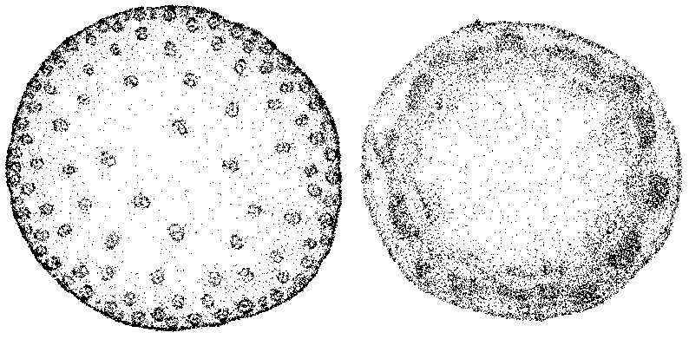

**Figure 23–4**

|  |  |  |  |
| --- | --- | --- | --- |
| a. | roots. | c. | root hairs. |
| b. | leaf veins. | d. | stems. |

____ 56. In Figure 23-5, the X points to a

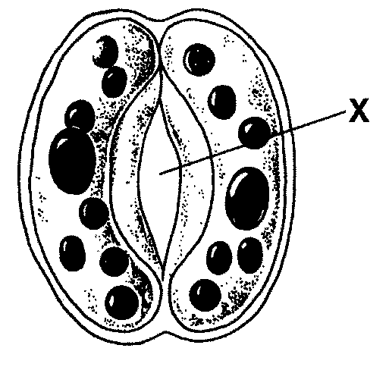

**Figure 23–5**

|  |  |  |  |
| --- | --- | --- | --- |
| a. | guard cell. | c. | vein. |
| b. | tracheid. | d. | stoma. |

____ 57. (eoc) As compared to bacteria and eukaryotes, species of archaea are considered to be the

**most**

|  |  |  |  |
| --- | --- | --- | --- |
| a. | ancient. | c. | complex. |
| b. | massive. | d. | common. |

____ 58. (eoc) Yeast, a common fungus, is economically important to the beverage industry because

when placed in grape juice, it

|  |  |  |  |
| --- | --- | --- | --- |
| a. | releases sugars that react with alcohol in the juice. | c. | ferments carbohydrates in the juice and releases alcohol. |
| b. | acts as an enzyme to break down juice into alcohol. | d. | produces starch that bonds with juice  sugars to form alcohol. |

____ 59. (eoc) What aspect of the structure of viruses is similar to all living things?

|  |  |  |  |
| --- | --- | --- | --- |
| a. | microscopic size | c. | presence of nucleic acid |
| b. | absence of nuclei | d. | requirement of host cell or body |

____ 60. (eoc) When referring to any taxonomically classified organism, scientists use only those

categories that differentiate an organism from any other, such as *Ursus horribilis* (grizzly

bear). Thus, scientists refer to an organism by its

|  |  |  |  |
| --- | --- | --- | --- |
| a. | order and family. | c. | species and order. |
| b. | family and genus. | d. | genus and species. |

____ 61. (eoc) In plants, stomata are tiny pores through which evaporated water escapes. To which

plant tissue do stomata directly relate?

|  |  |  |  |
| --- | --- | --- | --- |
| a. | vascular | c. | epidermal |
| b. | structural | d. | reproductive |

____ 62. (eoc) A certain microscopic single-celled organism is important to the dairy industry because when placed in milk, it consumes sugars in the milk and releases substances that react with the milk, adding flavor and thickening it. What kind of organism is this?

|  |  |  |  |
| --- | --- | --- | --- |
| a. | virus | c. | archaea |
| b. | fungus | d. | bacteria |

____ 63. (eoc) A certain kind of protist can digest wood. It lives in the intestines of insects that fly and

reproduce rapidly. This can cause problems for the

|  |  |  |  |
| --- | --- | --- | --- |
| a. | oil industry. | c. | construction industry. |
| b. | coal industry. | d. | transportation industry. |

____ 64. (eoc) Scientists originally classified certain kinds of fungi, such as mushrooms, into the plant

kingdom. This was discovered to be a mistake because fungi

|  |  |  |  |
| --- | --- | --- | --- |
| a. | cannot make their own food. | c. | are not considered to be living organisms. |
| b. | do not contain nuclei in their cells. | d. | do not survive in areas receiving much sunlight. |

____ 65. (eoc) Why do leaves tend to be flat?

|  |  |  |  |
| --- | --- | --- | --- |
| a. | so that water can easily be absorbed and carried to the rest of the plant | c. | so that nutrients can easily enter the  plant and be used for structure and  support |
| b. | so that sunlight can easily penetrate the leaf’s photosynthetic tissues | d. | so that plants can easily find balance due to the symmetrical nature of their  branches |

____ 66. 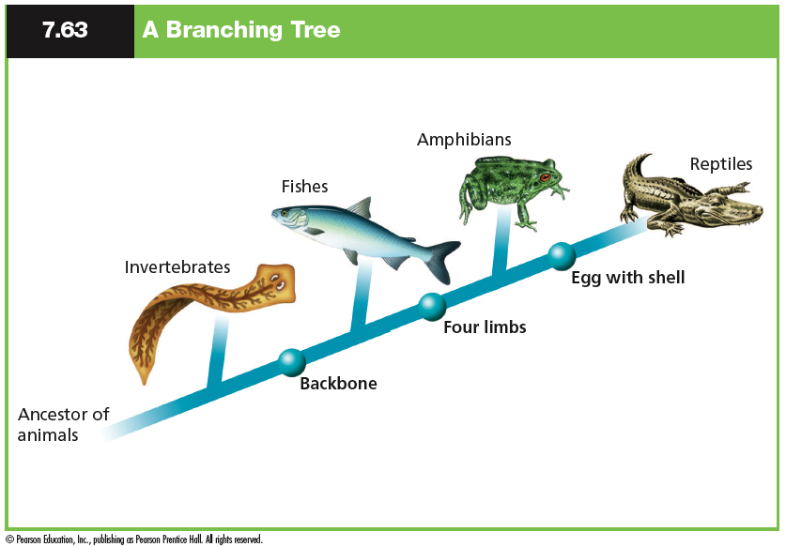

(eoc) Based on the cladogram above, which statement must be true?

|  |  |  |  |
| --- | --- | --- | --- |
| a. | Invertebrates and Fishes cannot have traits in common with Amphibians and Reptiles. | c. | Reptiles are more genetically similar to amphibians than to the other species |
| b. | Amphibians and Reptiles are found in different ecosystems than Invertebrates and Fish | d. | Invertebrates have a less direct relationship to the common ancestor than the other species. |

____ 67. 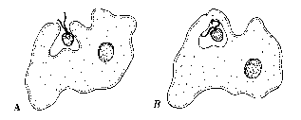

This protist eating food is shown above. This protist can be described as acting like a(n)

|  |  |  |  |
| --- | --- | --- | --- |
| a. | virus. | c. | fungus |
| b. | animal | d. | plant |

____ 68. (eoc) What is one evolutionary advantage angiosperms have over gymnosperms?

|  |  |  |  |
| --- | --- | --- | --- |
| a. | less genetic variation | c. | greater protection of seeds |
| b. | more nonvascular tissue | d. | decreased need to photosynthesize |

____ 69. (eoc) In the late 1890s, scientists discovered that a certain disease in plants was caused by

infective agents that were smaller than any known bacteria. This was the beginning of the

discovery of

|  |  |  |  |
| --- | --- | --- | --- |
| a. | fungi. | c. | protists. |
| b. | viruses. | d. | eukaryotes. |

____ 70. (eoc) In what way are bacteria extremely important to agriculture?

|  |  |  |  |
| --- | --- | --- | --- |
| a. | They fix nitrogen in the soil. | c. | They release water that is taken through plant roots. |
| b. | They provide oxygen for plants. | d. | They cause chemical change during photosynthesis. |

____ 71. 

(eoc) This type of organism shows what kind of body symmetry.

|  |  |  |  |
| --- | --- | --- | --- |
| a. | radial | c. | assymmetrical |
| b. | bilateral | d. | none of the above |

____ 72. (eoc) A plant that can be either male or female, lives mostly in the tropics, and bears large cones can be described as being both

|  |  |  |  |
| --- | --- | --- | --- |
| a. | a cycad and an angiosperm. | c. | a nonvascular plant and a gymnosperm. |
| b. | a gymnosperm and a cycad. | d. | an angiosperm and a nonvascular plant. |

____ 73. (eoc) In a fibrous root system, a plant produces a network of short and thin roots. Such a plant has adapted to

|  |  |  |  |
| --- | --- | --- | --- |
| a. | absorb water that is close to the ground’s surface. | c. | store large amounts of food made during photosynthesis in its roots. |
| b. | take in hard-to-reach nutrients that are deep underground. | d. | repel nitrogen-fixing bacteria that live near the ground’s surface. |

____ 74. (eoc) Which organisms can live in extreme conditions, such as hot springs that have high

concentrations of acid or salt, or hydrothermal vents?

|  |  |  |  |
| --- | --- | --- | --- |
| a. | Fungi | c. | Archaea |
| b. | Protista | d. | Bacteria |

____ 75. (eoc) To which kingdom does one type of common bread mold belong if it has cell walls,

membrane-bound organelles, and obtains its energy from decomposing bread?

|  |  |  |  |
| --- | --- | --- | --- |
| a. | Fungi | c. | Archaea |
| b. | Plantae | d. | Animalia |

____ 76. (eoc) What is one way viruses are similar to all nonliving things?

|  |  |  |  |
| --- | --- | --- | --- |
| a. | They are microscopic. | c. | They do not reproduce on their own. |
| b. | They are not contagious. | d. | They do not contain their own genetic material. |

____ 77. (eoc) Which taxonomic category is **most** appropriately described as a group of

individuals that can successfully interbreed?

|  |  |  |  |
| --- | --- | --- | --- |
| a. | class | c. | family |
| b. | order | d. | species |

____ 78. (eoc) Which structure is found in **most** gymnosperms and has the same function as

the flower in angiosperms?

|  |  |  |  |
| --- | --- | --- | --- |
| a. | sori | c. | cones |
| b. | roots | d. | needles |

____ 79. (eoc) How are bacteria **different** from viruses?

|  |  |  |  |
| --- | --- | --- | --- |
| a. | Bacteria lack a nucleus. | c. | Bacteria are classified as living things. |
| b. | Bacteria are microscopic. | d. | Bacteria can cause human diseases. |

____ 80. (eoc) What is the main function of epidermal plant tissue?

|  |  |  |  |
| --- | --- | --- | --- |
| a. | to provide support | c. | to carry on photosynthesis |
| b. | to prevent water loss | d. | to transport water and nutrients |

____ 81. (eoc) Lycopods have strands of tissue which allow water to flow from roots to leaves. What term describes this characteristic?

|  |  |  |  |
| --- | --- | --- | --- |
| a. | asexual | c. | prokaryotic |
| b. | vascular | d. | microscopic |

____ 82. (eoc) A lemon tree is a type of seed plant. What makes a lemon tree **different** from cycads and gymnosperms?

|  |  |  |  |
| --- | --- | --- | --- |
| a. | It has seeds. | c. | It produces pollen. |
| b. | It forms fruit. | d. | It has vascular tissue. |

____ 83. (eoc) Which adaptation allowed plants such as pine trees to have an increased height over smaller plants like moss?

|  |  |  |  |
| --- | --- | --- | --- |
| a. | vascular tissue | c. | production of a seed |
| b. | sexual reproduction | d. | alternation of generations |

____ 84. (eoc) Which **correctly** describes fungi?

|  |  |  |  |
| --- | --- | --- | --- |
| a. | multicellular autotrophic eukaryotes that get their energy from sunlight and can only reproduce asexually | c. | multicellular heterotrophic eukaryotes  that get their energy from consuming  other organisms and can only reproduce sexually |
| b. | unicellular autotrophic eukaryotes that  get their energy from sunlight and can  reproduce both sexually and asexually | d. | multicellular or unicellular heterotrophic eukaryotes that get their energy from absorption and can reproduce both sexually and asexually |

____ 85. Which invertebrate group has an exoskeleton and jointed appendages?

|  |  |  |  |
| --- | --- | --- | --- |
| a. | Cnidaria | c. | Arthropoda |
| b. | Nematoda | d. | Platyhelminthes |

____ 86. Malaria causes over one million deaths per year. The disease is transmitted by female

mosquitoes carrying the protist Plasmodium. Why was it important for scientists to discover

the cause of this disease?

|  |  |  |  |
| --- | --- | --- | --- |
| a. | to develop a more effective means of  prevention | c. | to accurately estimate the number of  people affected |
| b. | to fully describe the symptoms seen in  the patients | d. | to determine the areas of the world  where the infections occur |

____ 87. Which set of taxonomic categories is ordered from largest to smallest?

|  |  |  |  |
| --- | --- | --- | --- |
| a. | species, genus, order, class | c. | genus, family, class, kingdom |
| b. | class, order, phylum, species | d. | kingdom, class, family, genus |

____ 88. The H1N1 Virus, commonly known as the swine flu, was declared a pandemic by the

World Health Organization in 2009. Which approach is most effective in preventing the spread of the virus?

|  |  |  |  |
| --- | --- | --- | --- |
| a. | vaccination | c. | use of antibiotics |
| b. | sterilization | d. | use of fungicides |

____ 89. Animals and plants are classified into which domain?

|  |  |  |  |
| --- | --- | --- | --- |
| a. | Archaea | c. | Eukarya |
| b. | Bacteria | d. | Prokarya |

____ 90. During the growth and development of an insect, the developing larva may look

completely different from the adult. What name is given to the process in which form

and shape change completely between stages of development?

|  |  |  |  |
| --- | --- | --- | --- |
| a. | molting | c. | evolution |
| b. | mutation | d. | metamorphosis |

____ 91. Streptococci are the organisms that cause strep throat. Strep throat can be successfully

treated with antibiotics. Which type of organisms are streptococci?

|  |  |  |  |
| --- | --- | --- | --- |
| a. | fungi | c. | protists |
| b. | viruses | d. | bacteria |

____ 92. What type of symmetry does the human body have?

|  |  |  |  |
| --- | --- | --- | --- |
| a. | bilateral | c. | radial |
| b. | assymetrical | d. | spherical |

____ 93. Which is the function of the epidermal layer of a plant?

|  |  |  |  |
| --- | --- | --- | --- |
| a. | prevent water loss | c. | prohibit gas exchange |
| b. | preserve extra food | d. | protect reproductive organs |

____ 94. The presence of vertebrae is found in which kingdom?

|  |  |  |  |
| --- | --- | --- | --- |
| a. | Plantae | c. | Archaea |
| b. | Protista | d. | Animalia |

____ 95. What occurs during the life-cycle stage known as metamorphosis?

|  |  |  |  |
| --- | --- | --- | --- |
| a. | Male and female haploid cells join to  form a zygote. | c. | Hormones are released, causing a  mammal to undergo growth spurts. |
| b. | An immature organism undergoes  distinct anatomical changes. | d. | Sexual reproduction is followed by a  period of asexual reproduction. |

____ 96. What is one evolutionary advantage angiosperms have over gymnosperms?

|  |  |  |  |
| --- | --- | --- | --- |
| a. | less genetic variation | c. | greater protection of seeds |
| b. | more nonvascular tissue | d. | decreased need to photosynthesize |

____ 97. What structural change makes the heart of a mammal more efficient than the heart of an

amphibian?

|  |  |  |  |
| --- | --- | --- | --- |
| a. | The mammalian heart has a single  atrium, and the amphibian heart has  two atria. | c. | The mammalian heart has four  chambers, and the amphibian heart has three chambers. |
| b. | The mammalian heart has three  chambers, and the amphibian heart has two chambers. | d. | The mammalian heart has a single  ventricle, and the amphibian heart has  two ventricles. |

____ 98. One difference between reptiles and

amphibians is that reptiles

|  |  |  |  |
| --- | --- | --- | --- |
| a. | can live on land. | c. | lay eggs with shells.. |
| b. | are cold-blooded. | d. | prey on other animals |

____ 99. Based on the figure and key below, what sequence of steps is needed to identify OrganismA?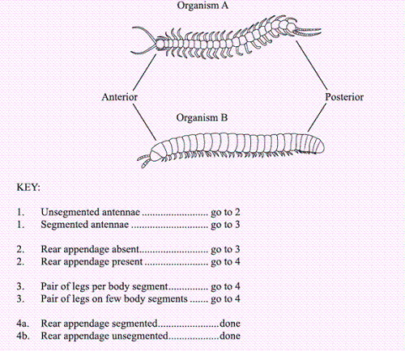

|  |  |  |  |
| --- | --- | --- | --- |
| a. | 1 - 2 - 4a | c. | 1 - 3 - 4a |
| b. | 1 - 2 - 4b | d. | 1 - 3 - 4b |

____ 100. How is the respiratory system of most frogs **different** from that of a mammal?

|  |  |  |  |
| --- | --- | --- | --- |
| a. | Most frogs have gills during their entire lifetime. | c. | Most frogs have gills when they hatch  and develop lungs as they get older. |
| b. | Most frogs breathe only through their  skin covering. | d. | Most frogs have lungs when they hatch and develop gills to live in the water. |

**Classification and Diversity of Life**

**Answer Section**

**MULTIPLE CHOICE**

1. ANS: C PTS: 1 REF: p. 448

2. ANS: B PTS: 1 REF: p. 449

3. ANS: D PTS: 1 REF: p. 451

4. ANS: C PTS: 1 REF: p. 453

5. ANS: C PTS: 1 REF: p. 454

6. ANS: A PTS: 1 REF: p. 448

7. ANS: D PTS: 1 REF: p. 448

8. ANS: D PTS: 1 REF: p. 452

9. ANS: C PTS: 1 REF: p. 454

10. ANS: A PTS: 1 REF: p. 454

11. ANS: C PTS: 1 REF: p. 458

12. ANS: B PTS: 1 REF: p. 459

13. ANS: B PTS: 1 REF: p. 459

14. ANS: D PTS: 1 REF: p. 471

15. ANS: D PTS: 1 REF: p. 471

16. ANS: C PTS: 1 REF: p. 473

17. ANS: B PTS: 1 REF: p. 474

18. ANS: D PTS: 1 REF: p. 476

19. ANS: B PTS: 1 REF: p. 479

20. ANS: A PTS: 1 REF: p. 486

21. ANS: D PTS: 1 REF: p. 473

22. ANS: D PTS: 1 REF: p. 475

23. ANS: C PTS: 1 REF: p. 508

24. ANS: D PTS: 1 REF: p. 515

25. ANS: C PTS: 1 REF: p. 516

26. ANS: B PTS: 1 REF: p. 497

27. ANS: A PTS: 1 REF: p. 512

28. ANS: B PTS: 1 REF: p. 516

29. ANS: A PTS: 1 REF: p. 527

30. ANS: C PTS: 1 REF: p. 537

31. ANS: D PTS: 1 REF: p. 540

32. ANS: B PTS: 1 REF: p. 541

33. ANS: B PTS: 1 REF: p. 527

34. ANS: C PTS: 1 REF: p. 528

35. ANS: D PTS: 1 REF: p. 533

36. ANS: C PTS: 1 REF: p. 536

37. ANS: B PTS: 1 REF: p. 538

38. ANS: C PTS: 1 REF: p. 539

39. ANS: C PTS: 1 REF: p. 539

40. ANS: C PTS: 1 REF: p. 551

41. ANS: A PTS: 1 REF: p. 552

42. ANS: B PTS: 1 REF: p. 554

43. ANS: B PTS: 1 REF: p. 556

44. ANS: C PTS: 1 REF: p. 560

45. ANS: D PTS: 1 REF: p. 566

46. ANS: D PTS: 1 REF: p. 551

47. ANS: D PTS: 1 REF: p. 552

48. ANS: B PTS: 1 REF: p. 553

49. ANS: A PTS: 1 REF: p. 556

50. ANS: D PTS: 1 REF: p. 582

51. ANS: B PTS: 1 REF: p. 582

52. ANS: C PTS: 1 REF: p. 585

53. ANS: A PTS: 1 REF: p. 596

54. ANS: B PTS: 1 REF: p. 579

55. ANS: D PTS: 1 REF: p. 590

56. ANS: D PTS: 1 REF: p. 597

57. ANS: A PTS: 1

58. ANS: C PTS: 1

59. ANS: C PTS: 1

60. ANS: D PTS: 1

61. ANS: C PTS: 1

62. ANS: D PTS: 1

63. ANS: C PTS: 1

64. ANS: A PTS: 1

65. ANS: B PTS: 1

66. ANS: C PTS: 1

67. ANS: B PTS: 1

68. ANS: C PTS: 1

69. ANS: B PTS: 1

70. ANS: A PTS: 1

71. ANS: B PTS: 1

72. ANS: B PTS: 1

73. ANS: A PTS: 1

74. ANS: C PTS: 1

75. ANS: A PTS: 1

76. ANS: C PTS: 1

77. ANS: D PTS: 1

78. ANS: C PTS: 1

79. ANS: C PTS: 1

80. ANS: B PTS: 1

81. ANS: B PTS: 1

82. ANS: B PTS: 1

83. ANS: A PTS: 1

84. ANS: D PTS: 1

85. ANS: C PTS: 1

86. ANS: A PTS: 1

87. ANS: D PTS: 1

88. ANS: A PTS: 1

89. ANS: C PTS: 1

90. ANS: D PTS: 1

91. ANS: D PTS: 1

92. ANS: A PTS: 1

93. ANS: A PTS: 1

94. ANS: D PTS: 1

95. ANS: B PTS: 1

96. ANS: C PTS: 1

97. ANS: C PTS: 1

98. ANS: C PTS: 1

99. ANS: A PTS: 1

100. ANS: C PTS: 1