**Background**

Players take on the role of skilled hunters, each accompanied by their top apprentice, arriving in a town in desperate need of help. The surrounding forest is infested with terrifying monsters, and the townspeople are living in fear. As many other hunters also flock to the town, they're not just there to help; they're also seeking fame and recognition. In this cutthroat environment, who will earn the public's acclaim?

**Objective**

The player with the highest score wins.

Game End Condition: The game ends at the conclusion of the round in which any player achieves a score of 50 or more.

**Rules**

The game is played over several rounds until the game end condition is triggered.

Each round consists of four phases:

1. Location Selection
2. Popularity Rewards
3. Resource Usage
4. Combat

**1. Location Selection**

All players simultaneously choose a location for their Hunter and Apprentice to visit. The number of available locations varies depending on the number of players. Once everyone has made their selections, place all tokens on the main board.

**The location chosen by Hunter represents the actions the player wants to take; the location chosen by Apprentice represents the player's prediction of where others want to go.**

When both the hunter and the apprentice choose the forest, the apprentice can deal 1 point of damage to the monster. In other situations, the apprentice going to the forest provides no benefits.

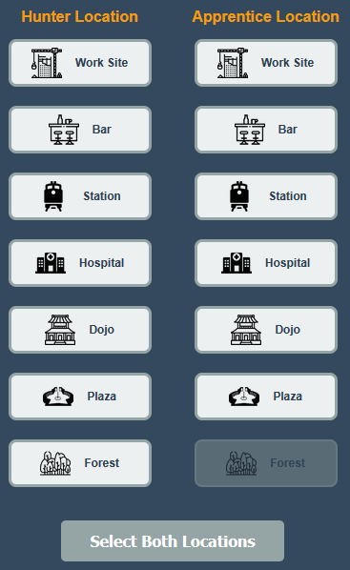

Different locations offer various benefits. **The more tokens in a location, the fewer benefits each player receives.**

* **Work Site:** Gain money.
* **Bar:** Gain beer (Beer restores the player's EP).
* **Hospital:** Gain blood bags (Blood bags restore the player's HP).
* **Dojo:** Gain EXP (EXP improves the player's combat skills).
* **Station:** Gain any resource of the player's choice.
* **Plaza:** Gain points.
* **Forest:** Battle monsters to gain points and resources.

**2. Popularity Rewards**

If a player's Hunter is in a location alone (without any other Hunters or Apprentices), they receive an extra Popularity reward. The Popularity track is divided into two parts: the right side for resource rewards and the left side for points. When a Hunter is alone in a location, the resource token on the right side moves up, and the player gains all rewards below it. If the point token on the left is lower, it moves to the same height, and the player immediately receives the points. **This does not apply to the Forest location**; **a Hunter in the Forest does not gain any popularity rewards.**

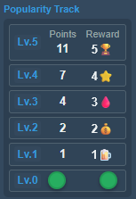

If a player's Hunter is in a location with others, their resource token will move down, and they will still receive the corresponding resources.

**3. Resource Usage**

In this phase, all players can use their resources.

* **Money:** Buy items. Every item has a specific size. If the sum of all item sizes exceeds the capacity limit, the player must decide whether to discard or use the overflow items at the end of this phase.

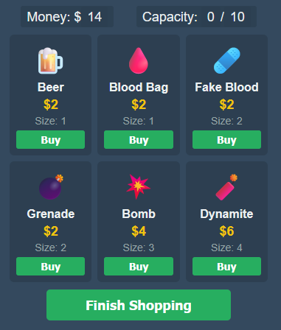

* **Beer:** Restore 1 EP or increase max EP.
* **Blood Bag:** Restore 1 HP or increase max HP.

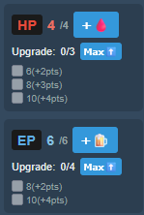

* **EXP:** Increase Attack or Defense.

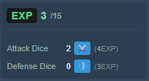

**4. Combat**

This phase is only executed if there are Hunters in the Forest. Players in the Forest choose the monster level they want to fight. Higher-level monsters are tougher to defeat but offer better rewards. After choosing a monster level, players must pay EP.

* **Level 1:** 2 EP
* **Level 2:** 3 EP
* **Level 3:** 4 EP

If the player has a pet, additional EP must be paid.

* **Pet Level 1:** 2 EP
* **Pet Level 2:** 3 EP
* **Pet Level 3:** 4 EP

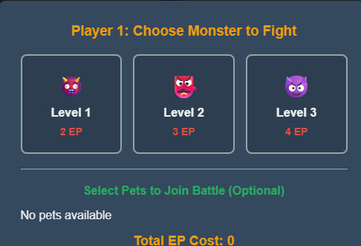

Next, the player decides which specific monster to fight. A pop-up window displays the monster's HP, attack power, rewards, and special effects. If the player is not satisfied, they can pay 1 EP to view the next monster.

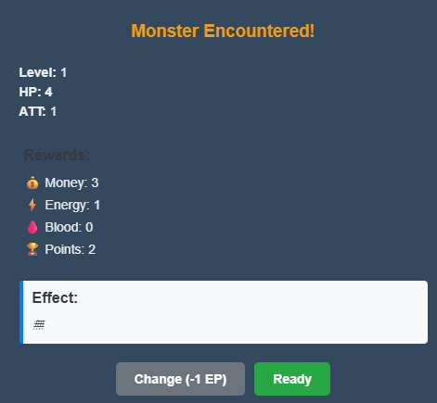

Once decided, the battle begins.

1. **Player Attacks:** The player rolls a number of dice equal to their attack power. Damage is calculated based on the weapon's accuracy.
2. **Monster Attacks:** The monster deals damage to the player equal to its attack power.
3. **Tame:** When the monster has only 1 HP remaining, the player can choose to spend 1 EP to capture it and make it their pet.

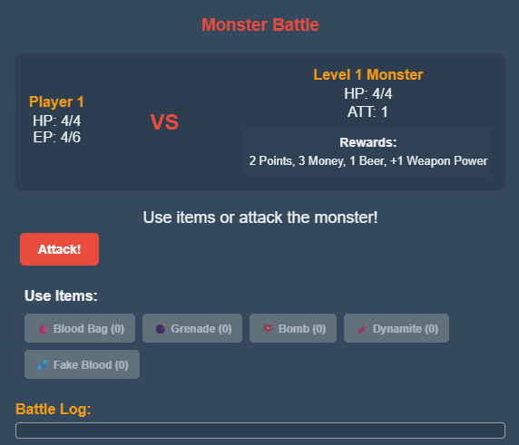

Each time a player defeats a monster, they gain points and resources and advance on the Weapon Power track. Advancing on the track unlocks new skills.

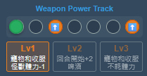

Gaining 2 weapon powers unlocks level 2 power; Gaining 6 weapon powers unlocks level 3 power.