**Anton Slizh’s**

**U1M4.LW. Access and Join Methods Part 1**

*GitHub: https://github.com/drapejny/DataCamp2022/tree/master/u1/lab_4*

**Task 1**

Step 1:

Creating table t2

CREATE TABLE t2 AS

SELECT TRUNC(rownum / 100) id, RPAD(rownum, 100) t_pad

FROM dual

CONNECT BY rownum < 100000;

Step 2:

Creating index on t2(id)

CREATE INDEX t2_idx1 ON t2 (id);

Step 3:

Selecting block count

SELECT blocks

FROM user_segments

WHERE segment_name = 'T2';

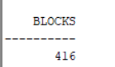

Selecting used blocks count

SELECT COUNT(DISTINCT (dbms_rowid.rowid_block_number(rowid))) block_ct

FROM t2;

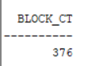

Enable autotrace

SET AUTOTRACE ON;

Selecting all rows count and show statistics

SELECT COUNT(*)

FROM t2;

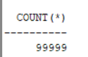

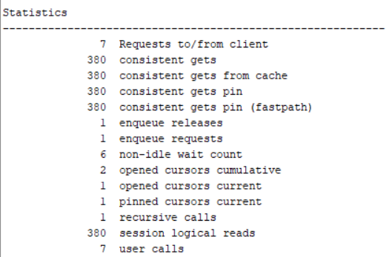

Step 4:

Deleting all rows from t2

DELETE FROM t2;

Step 5:

Repeating step 3

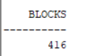

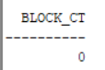

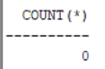

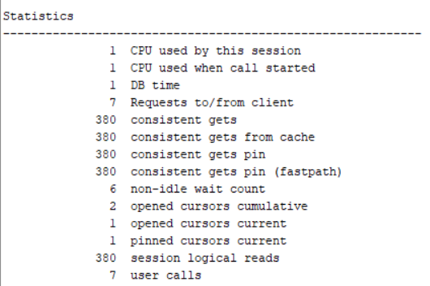

Step 6:

Inserting one row into t2 table

INSERT INTO t2 (ID, T_PAD)

VALUES (1, '1');

COMMIT;

Step 7:

Repeating step 3

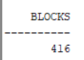

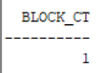

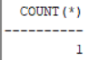

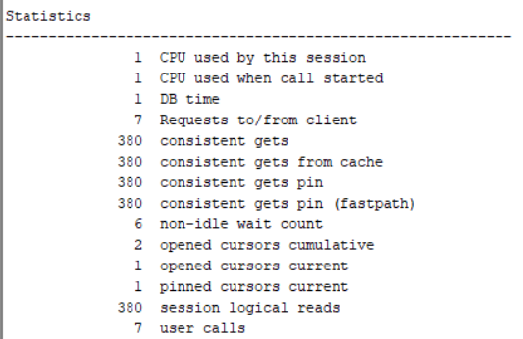

Step 8:

Truncating t2 table

TRUNCATE TABLE t2;

Step 9:

Repeating step 3

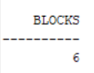

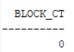

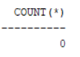

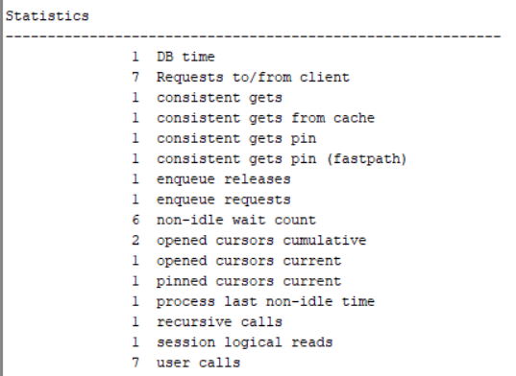

Result table

|  |  |  |  |  |  |
| --- | --- | --- | --- | --- | --- |
| № | Count of Blocks | Count of Used Blocks | Count of Rows | Consistent gets | Description |
| 1 | 416 | 376 | 99999 | 380 | Selecting on filled table |
| 2 | 416 | 0 | 0 | 380 | Selecting on empty table after delete operation |
| 3 | 416 | 1 | 1 | 380 | Selecting on table with 1 row |
| 4 | 6 | 0 | 0 | 1 | Selecting on empty table after truncate operation |