**Anton Slizh’s**

**U1M6.LW.Star Schema Basics**

*GitHub:* [*https://github.com/drapejny/DataCamp2022*](https://github.com/drapejny/DataCamp2022)

**Task 1**

Successfully executing all necessary scripts to create database objects.

Showing all created objects:

SELECT * FROM all_objects

WHERE owner IN ('U_DW_REFERENCES',

'U_DW_EXT_REFERENCES')

ORDER BY object_type, object_name;

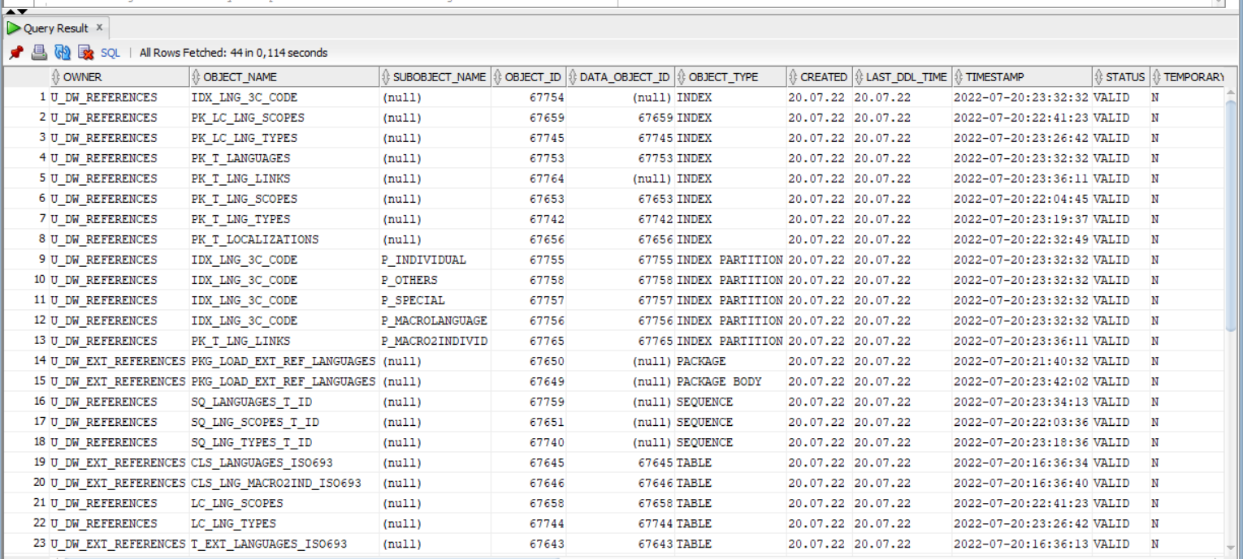

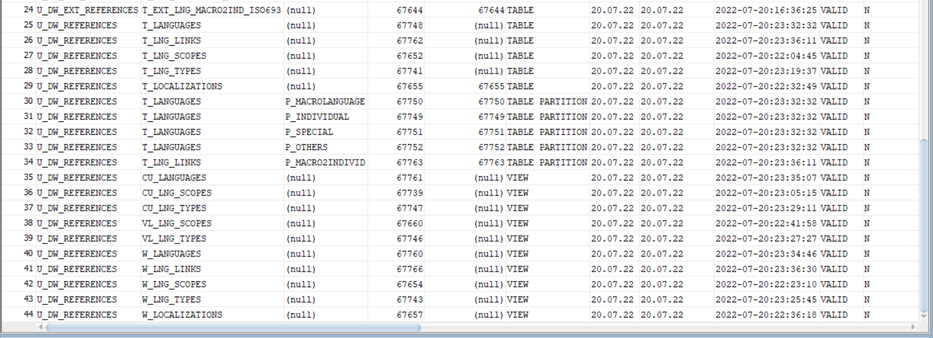

Selecting data from specified objects:

* *t_localizations*

SELECT * FROM u_dw_references.t_localizations;

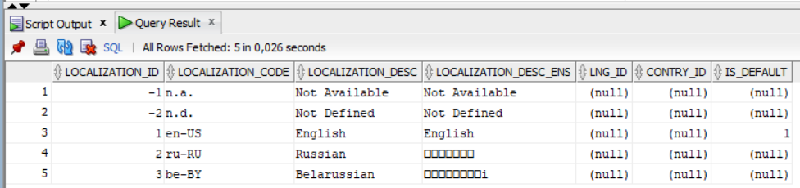

* *cu_languages*

SELECT * FROM u_dw_references.cu_languages;

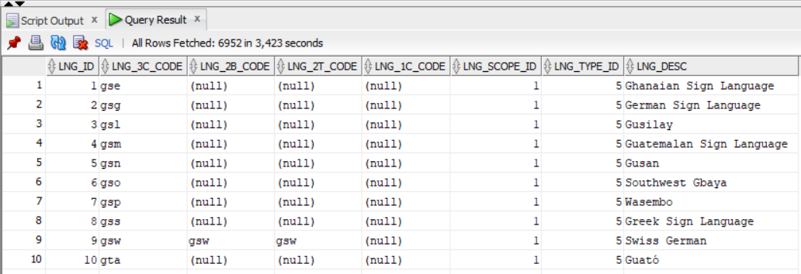

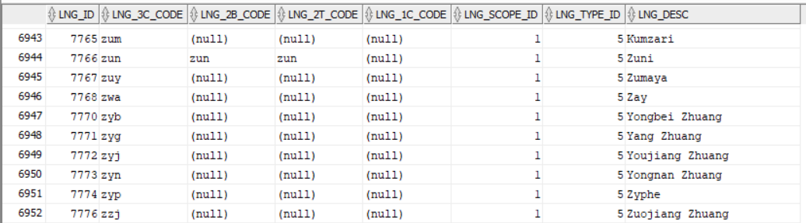

* *w_lng_links*

SELECT * FROM u_dw_references.w_lng_links;

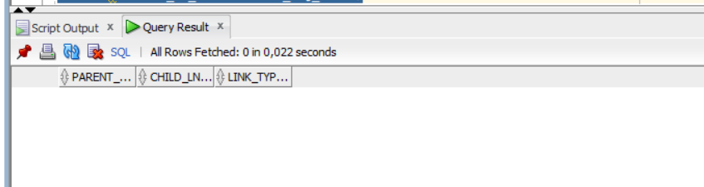

* *cu_lng_scopes*

SELECT * FROM u_dw_references.cu_lng_scopes;

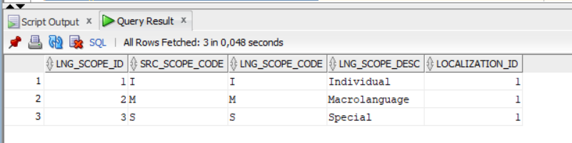

* *cu_lng_types*

SELECT * FROM u_dw_references.cu_lng_types;

