**Anton Slizh’s**

U1M7.LW.Dimension and Facts Basics

*GitHub:* [*https://github.com/drapejny/DataCamp2022*](https://github.com/drapejny/DataCamp2022)

**Task 0**

First of all, we need to create calendar table (*cls_calendar*) and generate calendar data using provided script.

Creating *cls_calendar* table:

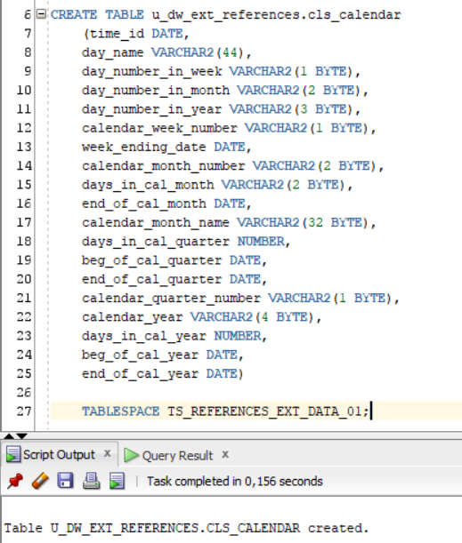

Next, compile procedure to generate calendar data. After compiling run this procedure.

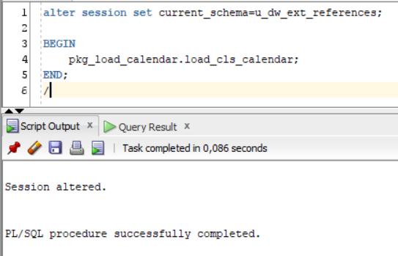

Checking inserted calendar data in *cls_calendar* table:

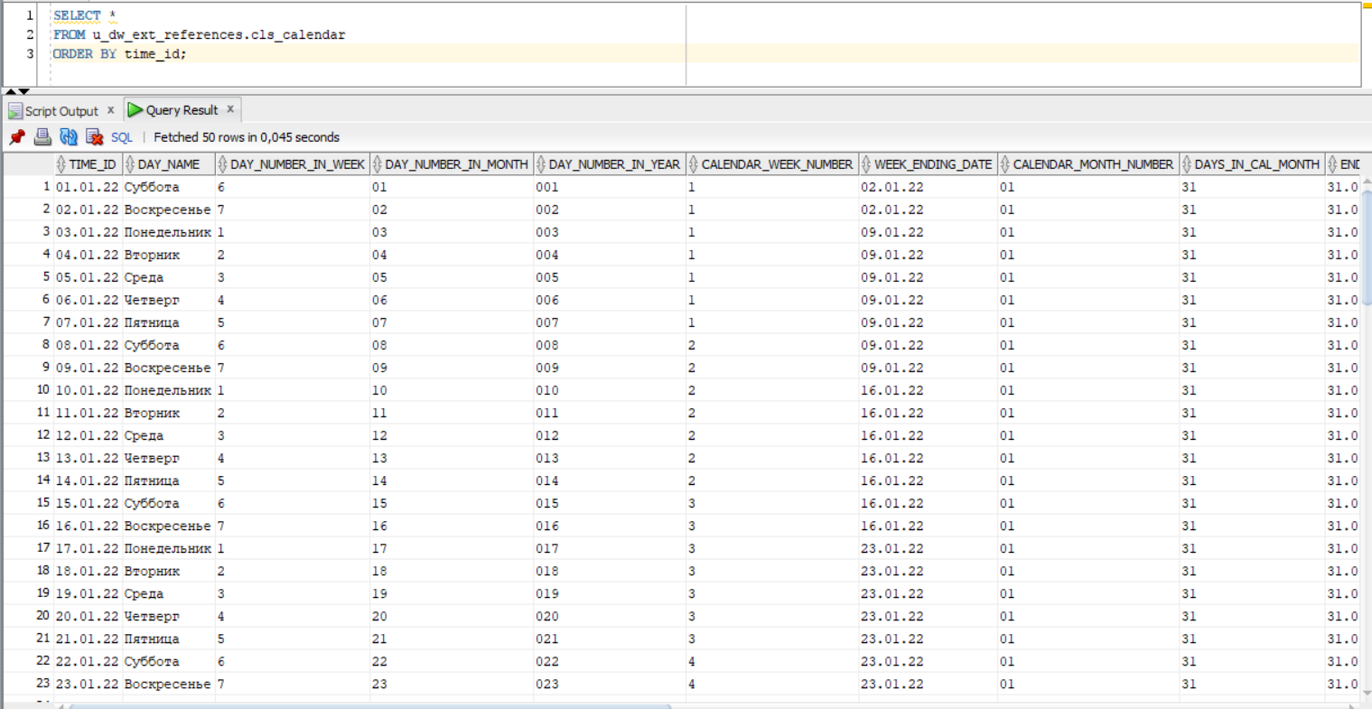

**Task 1 t_days**

CREATE TABLE u_dw_references.t_days(

    time_id DATE,

    day_name VARCHAR2(44),

    day_number_in_week VARCHAR2(1),

    day_number_in_month VARCHAR2(2),

    day_number_in_year VARCHAR2(3),

    CONSTRAINT pk_t_days PRIMARY KEY (time_id)

)

TABLESPACE TS_REFERENCES_DATA_01;

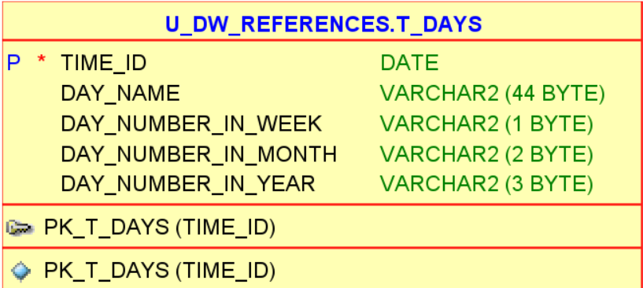

**Task 2 t_weeks**

CREATE TABLE u_dw_references.t_weeks(

    time_id DATE,

    calendar_week_number VARCHAR2(1),

    week_ending_date DATE,

    CONSTRAINT pk_t_weeks PRIMARY KEY (time_id)

)

TABLESPACE TS_REFERENCES_DATA_01;

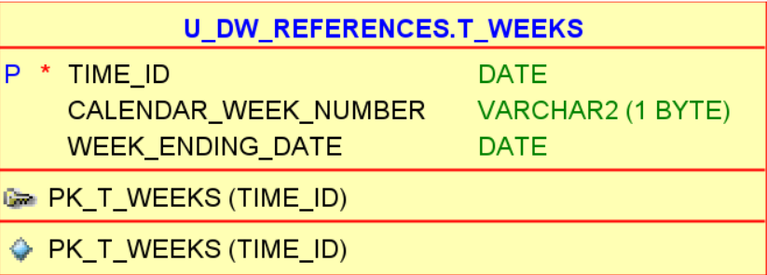

**Task 3 t_months**

CREATE TABLE u_dw_references.t_months(

    time_id DATE,

    calendar_month_number VARCHAR2(2),

    days_in_cal_month VARCHAR2(2),

    end_of_cal_month DATE,

    calendar_month_name VARCHAR2(32),

    CONSTRAINT pk_t_months PRIMARY KEY (time_id)

)

TABLESPACE TS_REFERENCES_DATA_01;

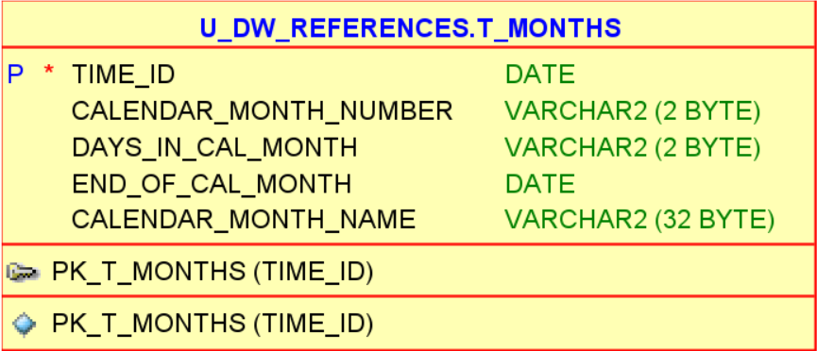

**Task 4 t_quarters**

CREATE TABLE u_dw_references.t_quarters(

    time_id DATE,

    days_in_cal_quarter NUMBER,

    beg_of_cal_quarter DATE,

    end_of_cal_quarter DATE,

    calendar_quarter_number VARCHAR2(1),

    CONSTRAINT pk_t_quarters PRIMARY KEY (time_id)

)

TABLESPACE TS_REFERENCES_DATA_01;

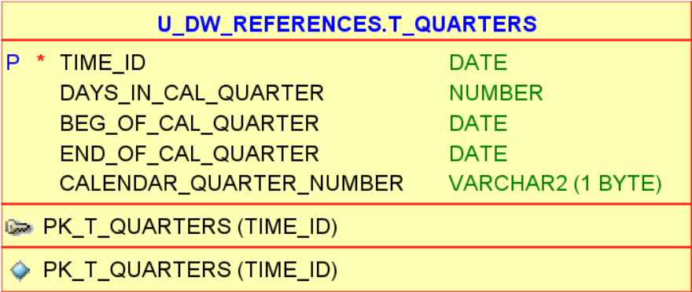

**Task 5 t_years**

CREATE TABLE u_dw_references.t_years(

    time_id DATE,

    calendar_year VARCHAR2(4),

    days_in_cal_year NUMBER,

    beg_of_cal_year DATE,

    end_of_cal_year DATE,

    CONSTRAINT pk_t_years PRIMARY KEY (time_id)

)

TABLESPACE TS_REFERENCES_DATA_01;

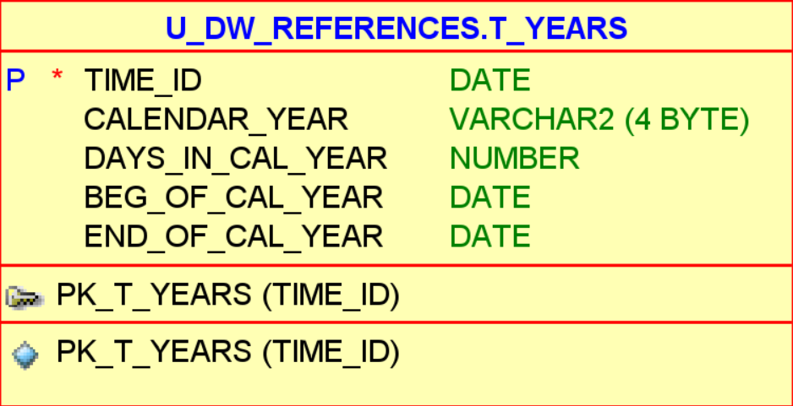

After executing all scripts, we can select data from tables:

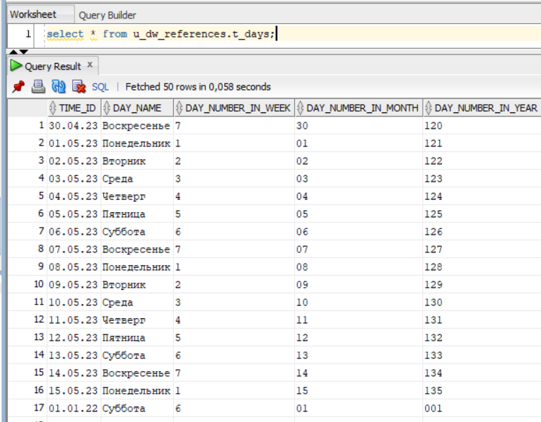

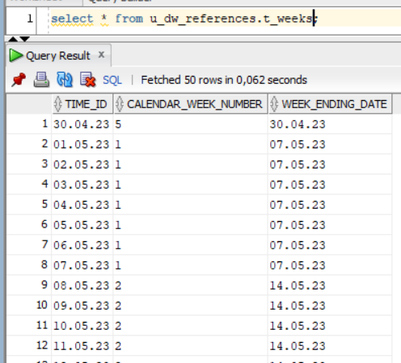

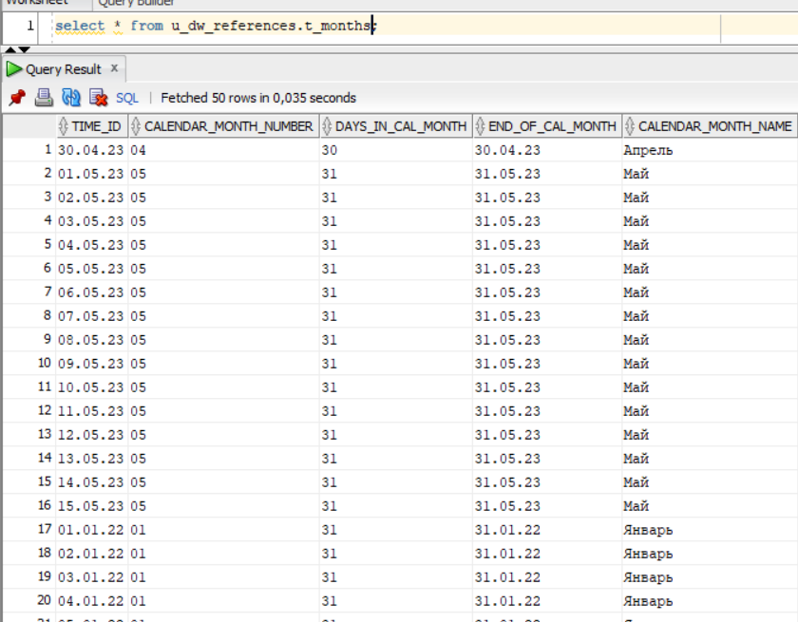

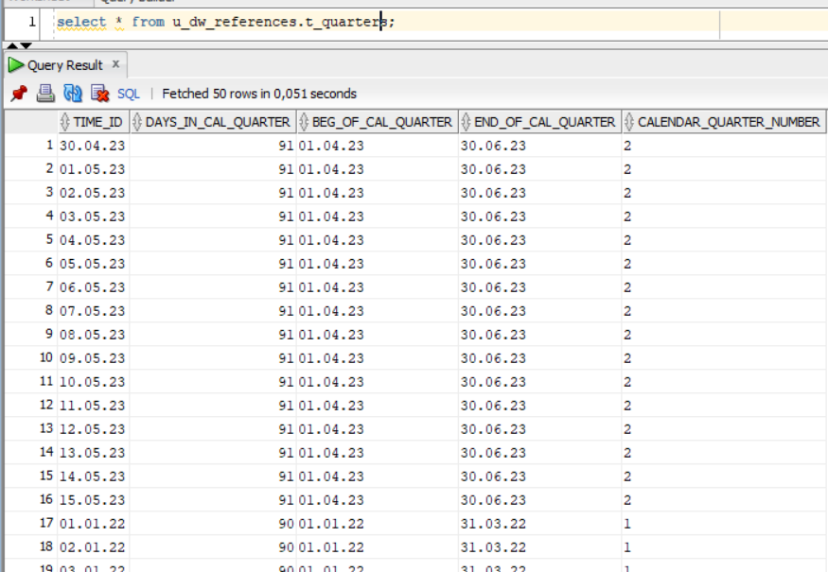

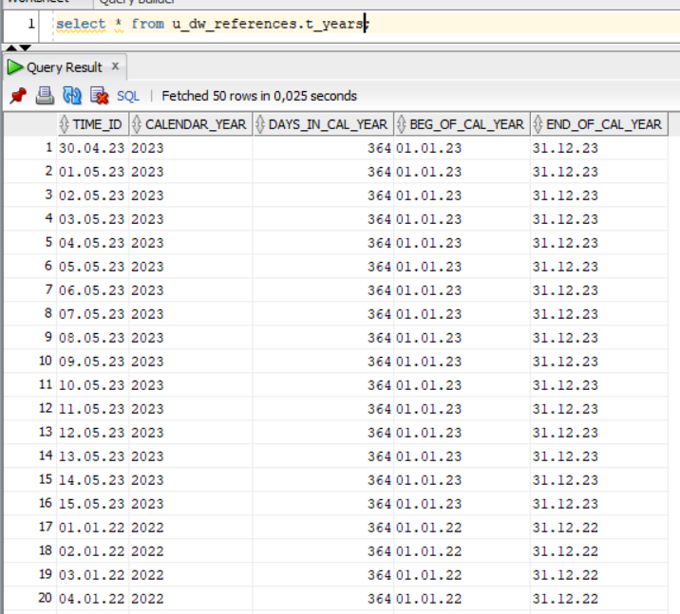

Second part of the lab is coming soon