**Anton Slizh’s**

**U1M7.LW.Dimension and Facts Basics**

**Part 2**

*GitHub:* [*https://github.com/drapejny/DataCamp2022*](https://github.com/drapejny/DataCamp2022)

## 3.1. Task 06 – Solution concept – Add: Chapter Dimensions Types

|  |  |  |  |  |
| --- | --- | --- | --- | --- |
| Name | Type | Size | DW – Merged Dimensions | Descriptions |
| DIM_GEN_DATE | SCD1 | BIG | DW.T_DAYS, DW.T_WEEKS, DW.T_MONTHS, DW.T_QUARTERS,  DW.T_YEARS | TBD – Example row |
| DIM_PRODUCT_SCD | SCD2 | SMALL | product_id  sku_num  eff_time  exp_time  price  description  type  brand  producer_country  volume  shelf_width  shelf_hight  shelf_depth  package  package_color  package_reusable  tase  alcohol | This dimension contains the information about kvas drinks products, which are presented in company stores. The dimension has SCD2 type, which allow us to keep history of product changes (for example producer changed the volume or color of package). The *eff_time* and *exp_time* attributes represent the time period when record was active. The *sku_num* attribute represented as natural key for dimension. |
| DIM_CUSTOMER | SCD1 | SMALL | customer_id  name  first_name  last_name  phone  country  email  birthday | This dimension contains information about ordinary customers. |
| DIM_STORE | SCD1 | SMALL | store_id  address  country  region  city  phone | This dimension contains information about company stores, which are located in different countries and cities. |
| DIM_GEO_LOCATION | SCD1 | SMALL | Geo_id  Geo_group_id  Geo_group_desc  Geo_sub_group_id  Geo_dub_group_desc  Geo_system_code  Geo_system_desc  Geo_region_id  Geo_region_desc  Geo_country_code_a2  Geo_country_code_a3  Geo_country_id  Geo_country_desc | This dimension contains information about countries, regions, groups. This information describes the location where company stores are located. |

## 3.2. Task 07 – Solution concept – Add: Chapter Dimensions Hierarchies

**DIM_GEN_DATE:**

**Hierarchy DAY-WEEK-MONTH-YEAR**

|  |  |  |  |
| --- | --- | --- | --- |
| Name | LEVEL_CODE | LEVEL_DESC | LEVEL_NATURAL_KEY |
| DAYs | DAY | Store all day at the calendar week | DAY_ID |
| WEEKs | WEEK | Store all weeks at the calendar month | WEEK_ID |
| MONTHs | MONTH | Store all months at the calendar year | MONTH_ID |
| YEARs | YEAR | Store all years | YEAR_ID |

**Hierarchy DAY-QUARTER-YEAR**

|  |  |  |  |
| --- | --- | --- | --- |
| Name | LEVEL_CODE | LEVEL_DESC | LEVEL_NATURAL_KEY |
| DAYs | DAY | Store all day at the calendar week | DAY_ID |
| QUARTERs | QUARTER | Store all quarters at the calendar year | QUARTER_ID |
| YEARs | YEAR | Store all years | YEAR_ID |

**DIM_GEO_LOCATION:**

**Hierarchy COUNTRY-REGION-PART-SYSTEM**

|  |  |  |  |
| --- | --- | --- | --- |
| Name | LEVEL_CODE | LEVEL_DESC | LEVEL_NATURAL_KEY |
| COUNTRIEs | COUNTRY | Store all counties in the geographic region | COUNTRY_ID |
| REGIONs | REGION | Store all regions in the part of the world | REGION_ID |
| PARTs | PART | Store all parts int the world | PART_ID |
| SYSTEMs | SYSTEM | Store system world | GEO_SYSTEM_ID |

**DIM_PRODUCT:**

**Hierarchy PRODUCT-BRAND-TYPE**

|  |  |  |  |
| --- | --- | --- | --- |
| Name | LEVEL_CODE | LEVEL_DESC | LEVEL_NATURAL_KEY |
| PRODUCTs | PRODUCT | Store all products of definite brand | PRODUCT_ID |
| BRANDs | BRAND | Store all brands of definite type | BRAND_ID |
| TYPEs | TYPE | Store all types | TYPE_ID |

**DIM_STORE:**

**Hierarchy STORE-CITY-REGION-COUNTRY**

|  |  |  |  |
| --- | --- | --- | --- |
| Name | LEVEL_CODE | LEVEL_DESC | LEVEL_NATURAL_KEY |
| STOREs | STORE | Store all stores of city | STORE_ID |
| CITIes | CITY | Store all cities of country region | CITY_ID |
| REGIONs | REGION | Store all regions of country | REGION_ID |
| COUNTRIes | COUNTRY | Store all countries where stores are located | COUNTRY_ID |

## 3.2. Task 08 – Solution concept – Add: Chapter Facts

FCT_SALES

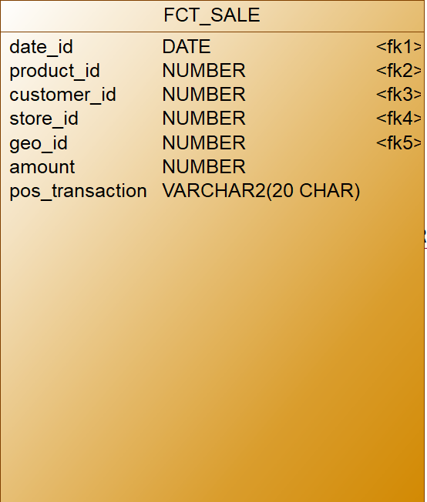

FCT_SALES represent individual sale transaction. Table contains 2 fact attributes. The *amount* attribute represents the number of individual product units. The *pos_transaction* represents the code of transaction that provide us to accumulate all products in definite basket.

Facts aggregations for the FCT_SALES table:

|  |  |  |  |  |
| --- | --- | --- | --- | --- |
| Name | Code | Table Name | Additive | Descriptions |
| Total number of products sold | amount | FCT_SALES | + | Calculates the number of sales according to range of time, product etc. |
| The code of transaction | pos_transaction | FCT_SALES | - | Accumulate all products from one basket (with same *pos_transaction)* |