**Anton Slizh’s**

**U1M8.LW.Data Warehouse Architecture Report**

*GitHub: https://github.com/drapejny/DataCamp2022*

## 2.1. Task 01: CREATE Schema of simple Data Warehouse Architecture

|  |  |  |  |
| --- | --- | --- | --- |
| Level Type | Object Name | Tablespace | Desctiption |
| Storage level  SA_* | SA_CUSTOMERS | ts_sa_customers_data_01 | Loading from Flat and Structured files. Contains customers, geo location information. |
| SA_PRODUCTS | ts_sa_products_data_01 | Loading from Flat and Structured files. Contains products, sales, stores, dates information |
| DW - Cleansing Level | DW_CL | ts_dw_cl_01 | Loading from stage level. Prepare data for cleansing. |
| DW – Level | DW_DATA | ts_dw_data_01 | Loading data after cleansing. |
| DW– Prepare Star Cleansing Level | SAL_DW_CL | ts_dw_cl_01 | Loading from DW level. |
| STAR - Cleansing | SAL_CL | ts_sal_cl_01 | Loading from DW level. Clean any redundancy. |
| STAR – Level | DM_SALES | ts_sa_fct_sales_01 | Store fact sales information. |
| DM_CUSTOMERS | ts_sa_dim_customers_01 | Stores dim customers information |
| DM_PRODUCTS | ts_sa_dim_products_01 | Store dim products information |
|  |  |  |

## 2.2. Task 02: CREATE Storage Level

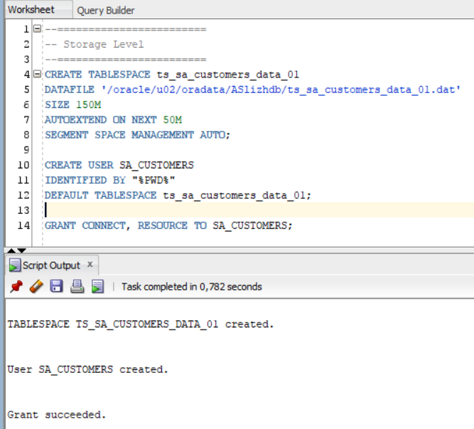

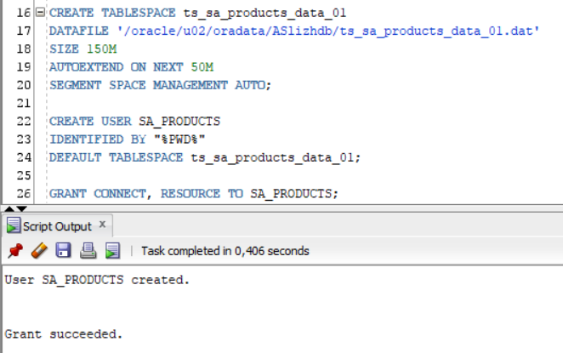

## 2.3. Task 03: CREATE Data warehouse Cleansing Level

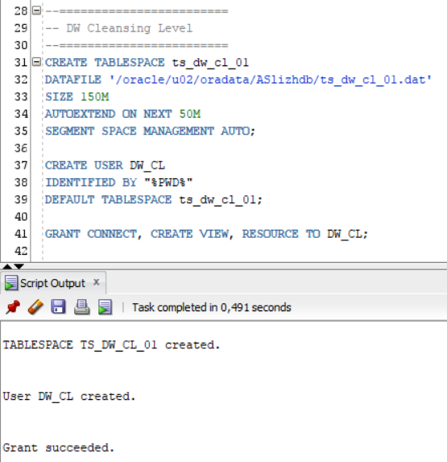

## 2.4. Task 04: CREATE Data warehouse Start Cleansing Level

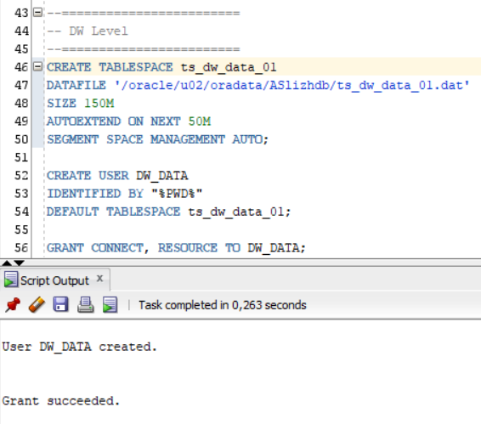

## 2.5. Task 05: CREATE Star Cleansing Level

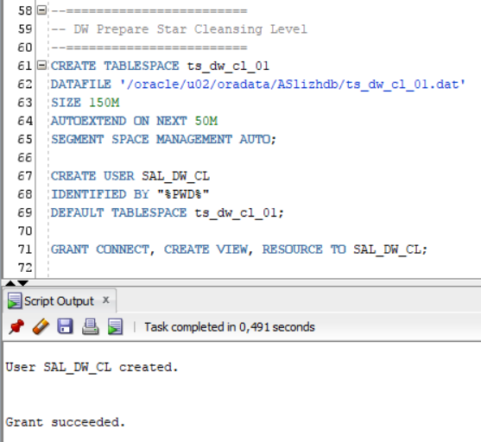

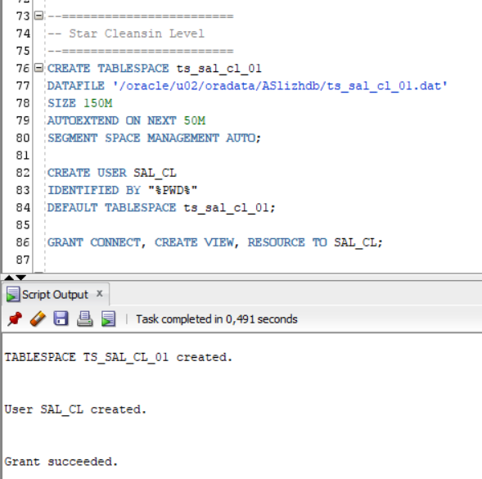

## 2.6. Task 06: CREATE Data warehouse Star Level and Data Marts

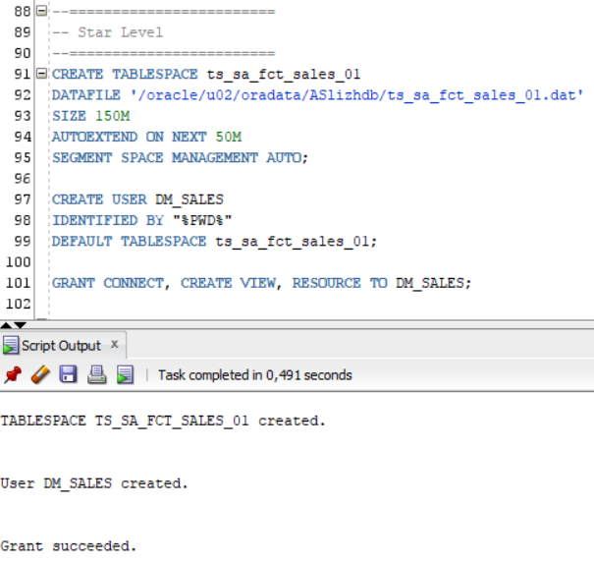

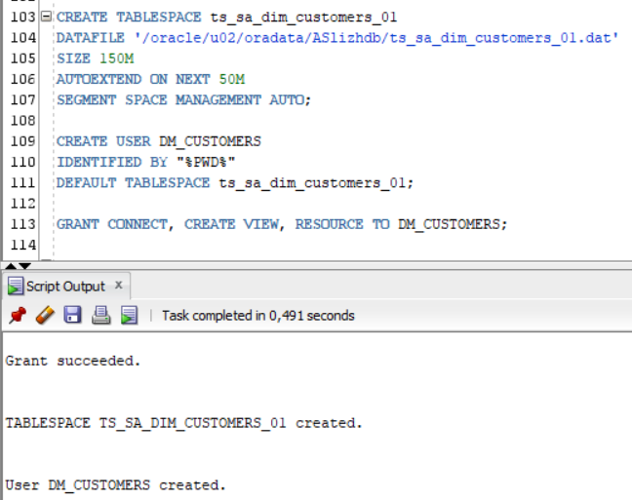

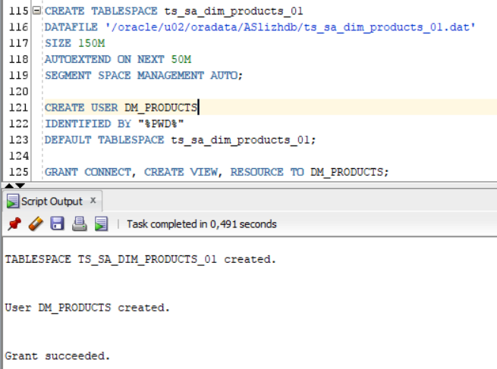

## 3.1. Task 07: CREATE Prepared Star Objects

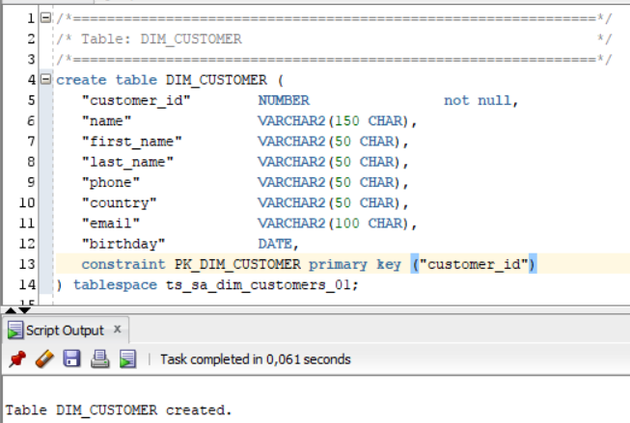

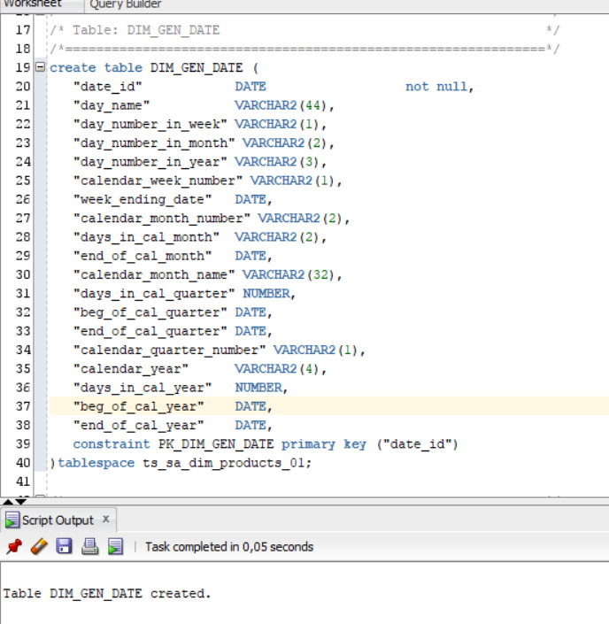

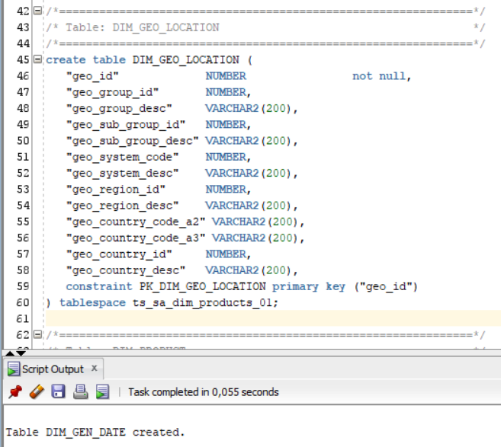

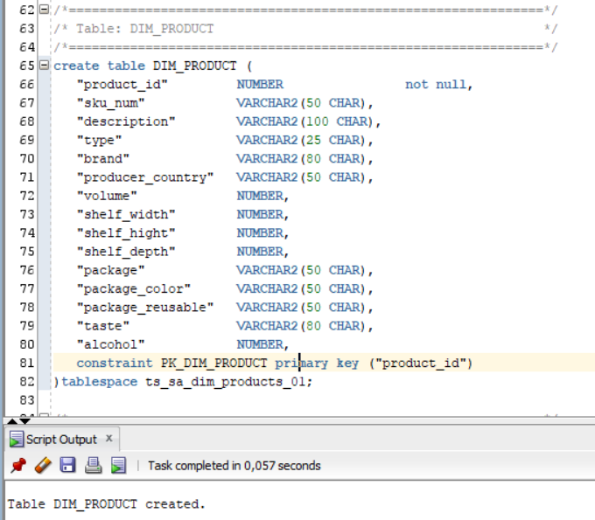

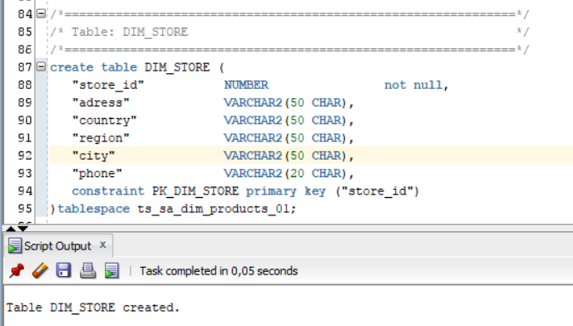

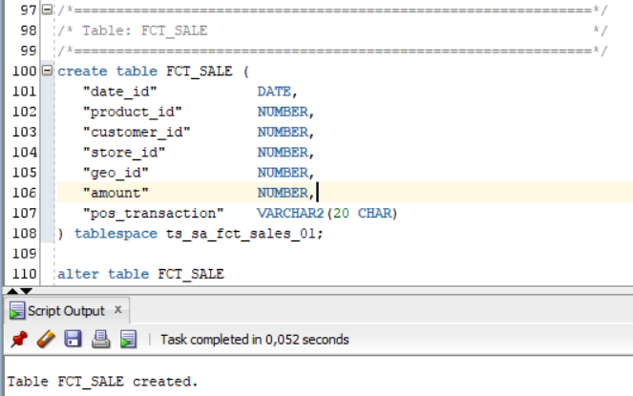

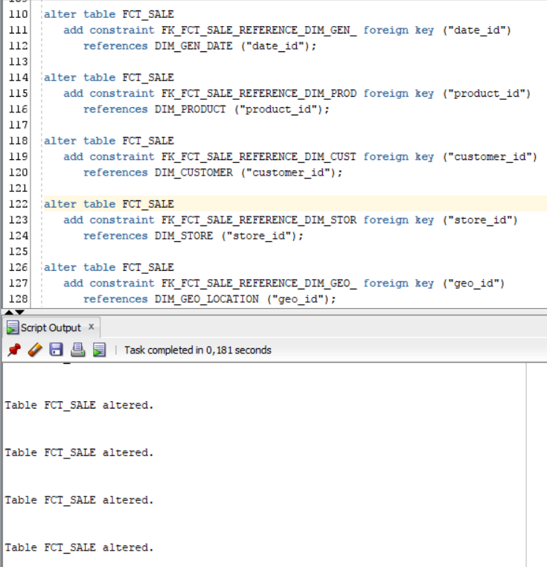

Creation script (*init_tables.sql*) is located on GitHub;

Result:

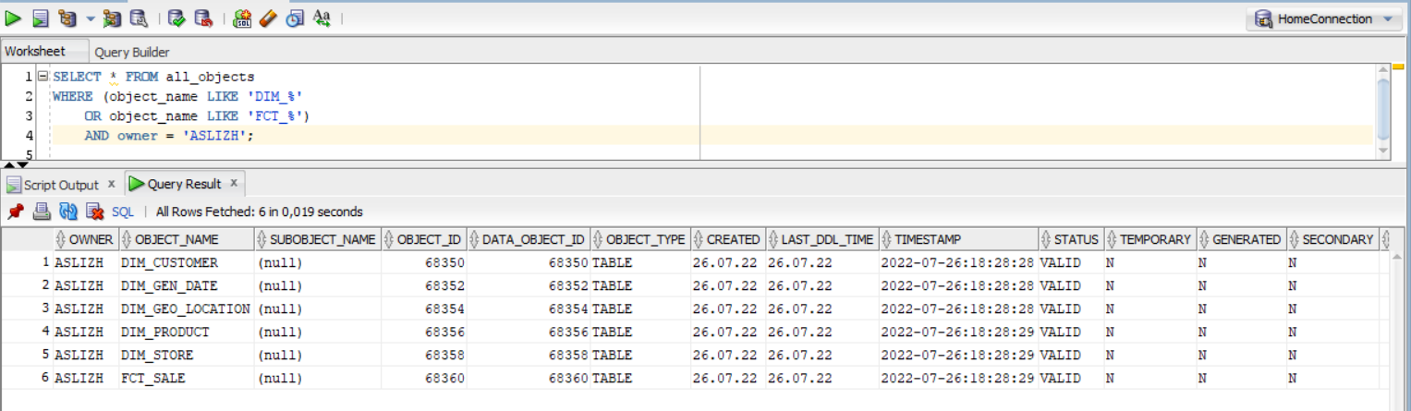

## 3.2. Task 08: DataFlow Diagram

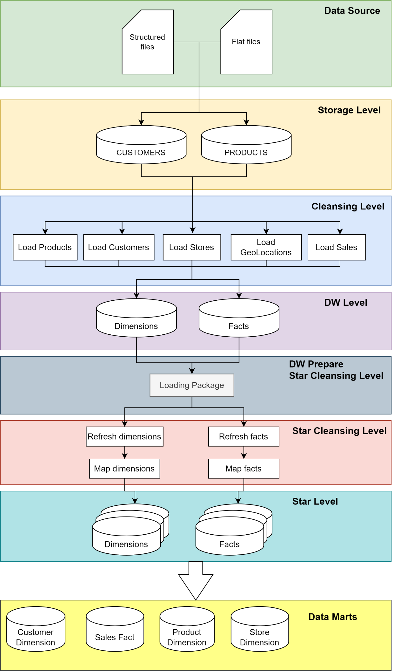

## 3.3. Task 09: Grants Object Privileges

|  |  |
| --- | --- |
| Users | Privileges |
| SA_CUSTOMERS | Connect, Resource |
| SA_PRODUCTS | Connect, Resource |
| DW_CL | Connect, Create View |
| DW_DATA | Connect, Resource |
| SAL_DW_CL | Connect, Create View |
| SAL_CL | Connect, Create View |
| DM_SALES | Connect, Create View |
| DM_CUSTOMERS | Connect, Create View |
| DM_PRODUCTS | Connect, Create View |

