**Anton Slizh’s**

**U1M9.LW.Partitioning**

**Task 1**

**Range partitioning**

Creating table and insert test data:

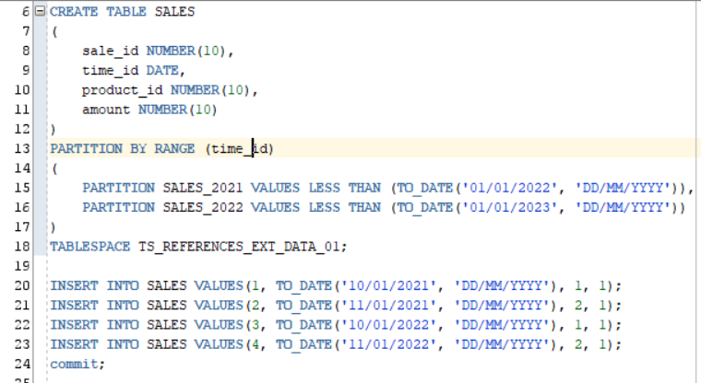

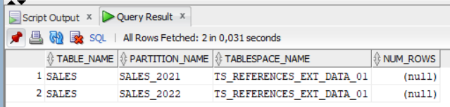

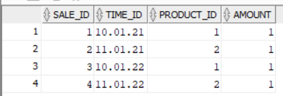

Merging partitions:

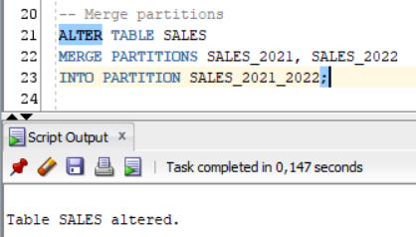

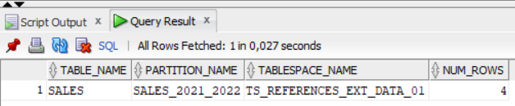

Moving partition to another tablespace:

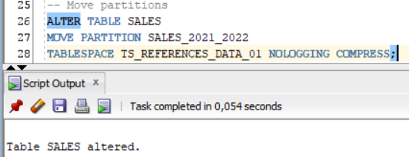

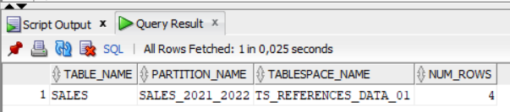

Splitting partition into 2 partitions:

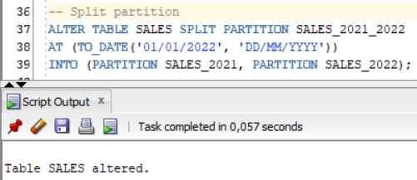

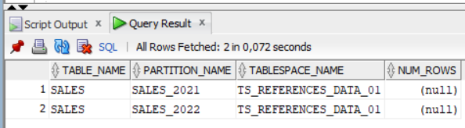

Truncating partition SALES_2021:

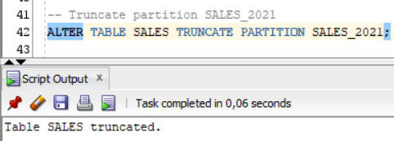

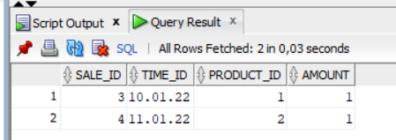

Dropping partition SALES_2021:

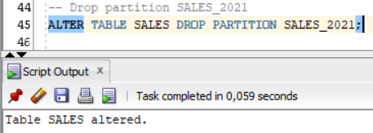

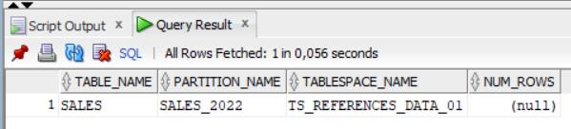

Adding partition SALES_2023

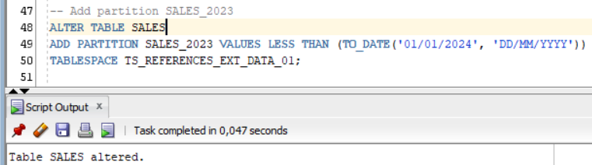

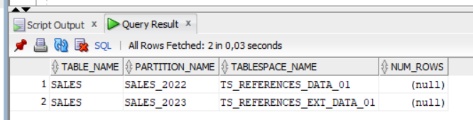

**Interval partitioning**

Creating table SALES:

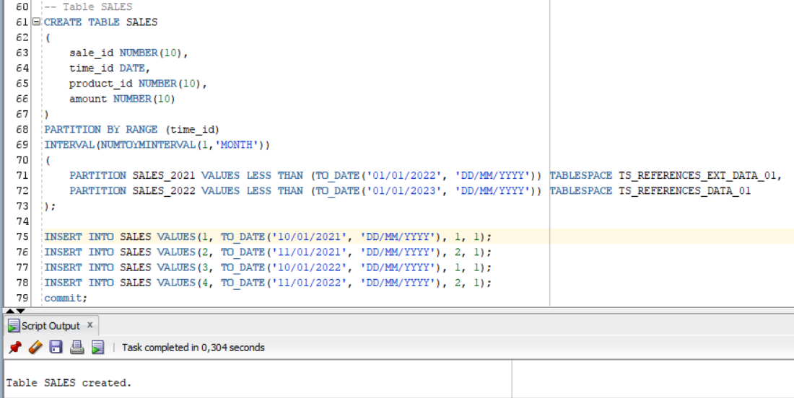

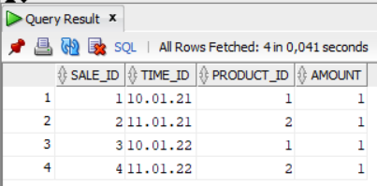

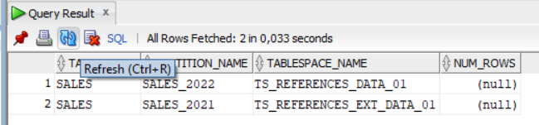

Merging partitions into SALES_2021_2022 partition:

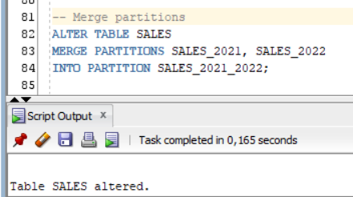

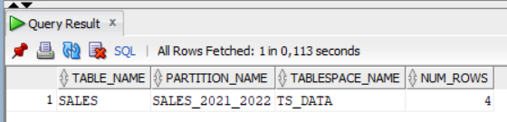

Moving partition to another tablespace:

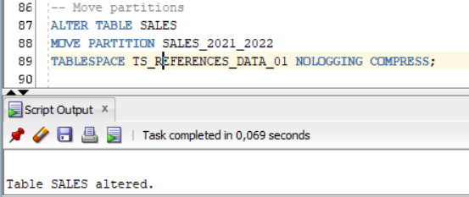

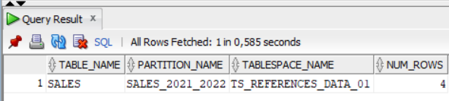

Splitting partition into SALES_2021 and SALES_2022 partitions:

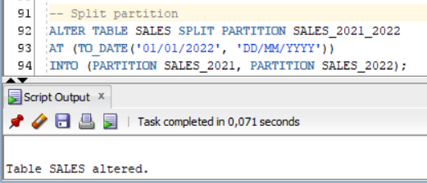

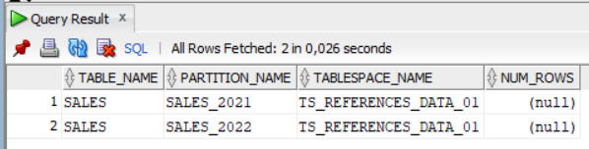

Truncating partition SALES_2021:

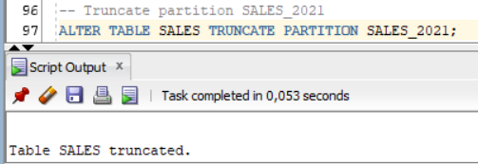

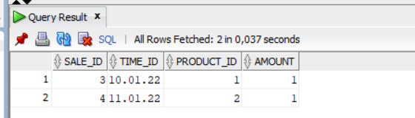

Dropping partition SALES_2021:

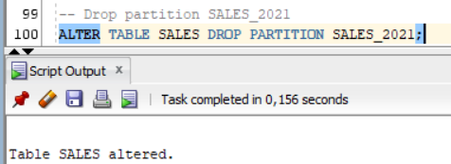

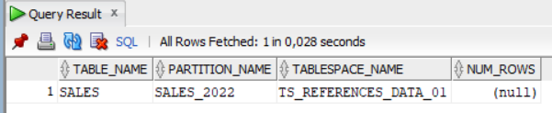

**List partitioning**

Creating table SALES and inserting test data:

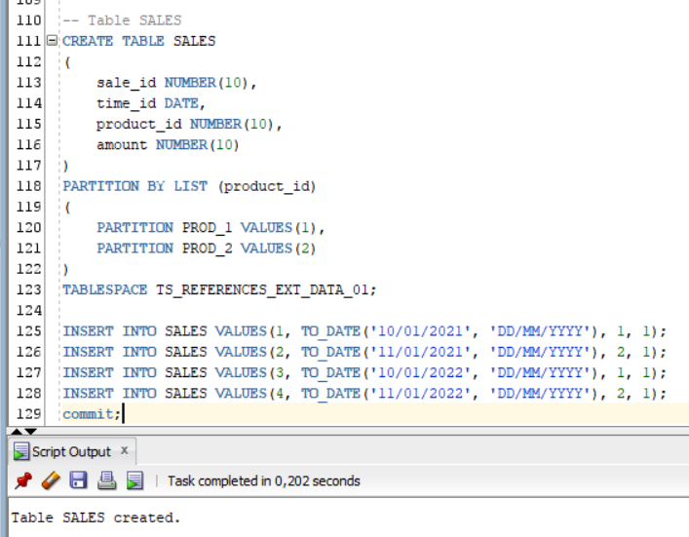

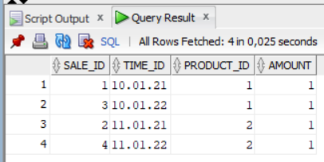

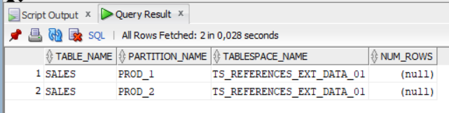

Merging partitions PROD_1 and PROD_2 into PROD_1_2:

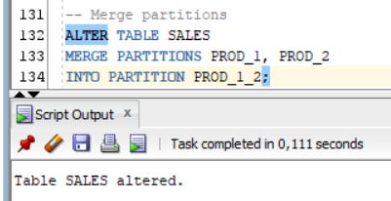

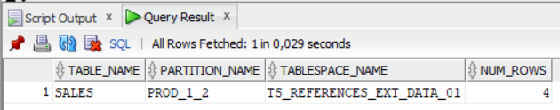

Moving partition to another tablespace:

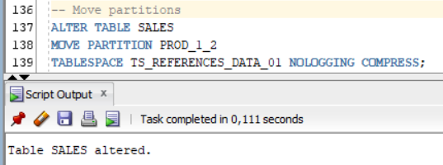

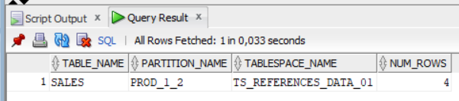

Splitting partition PROD_1_2 into PROD_1 and PROD_2:

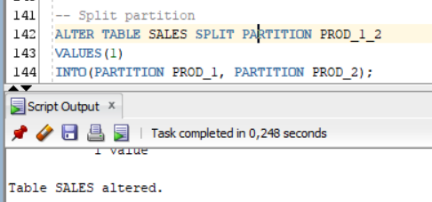

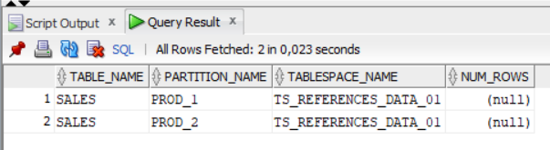

Truncating partition PROD_1:

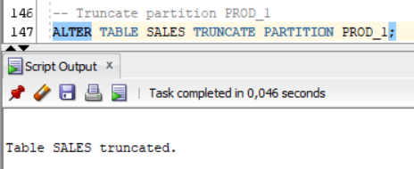

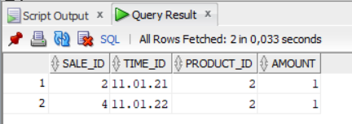

Dropping partition PROD_1:

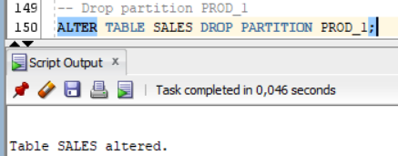

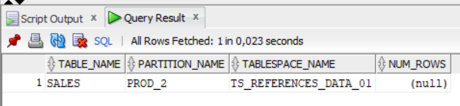

Adding new partition PROD_3:

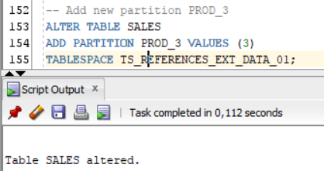

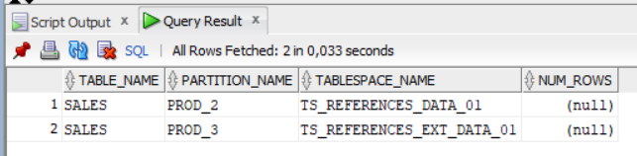

**Hash partitioning**

Creating table SALES and inserting test data

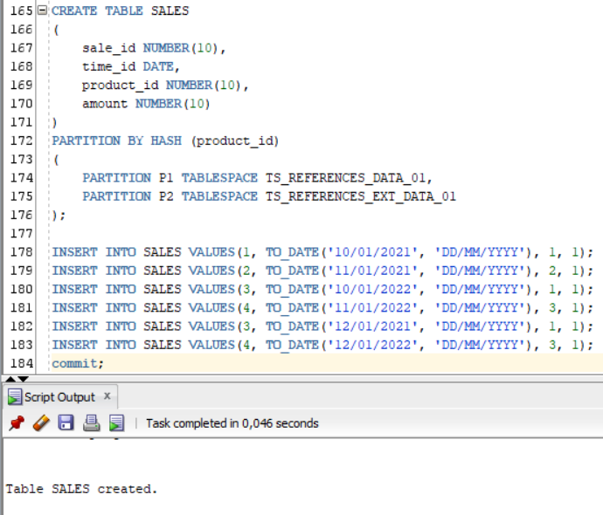

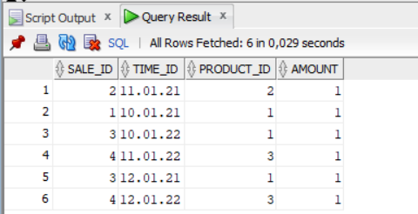

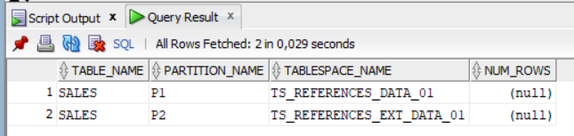

Adding new partition P3:

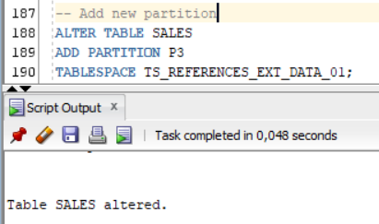

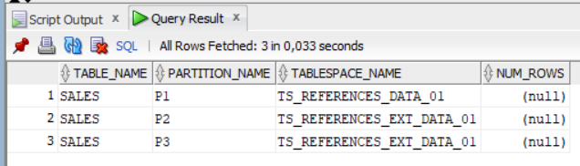

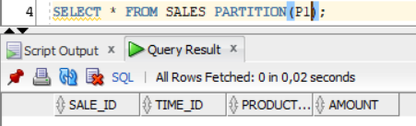

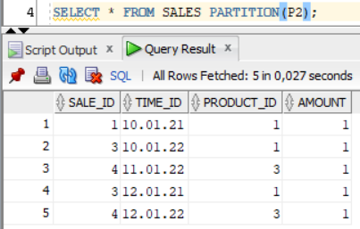

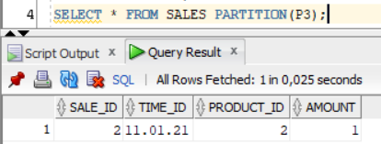

As we see, after we add new partition oracle relocated rows between all partitions.

Truncating partition P1 (it’s already empty, but I should to show this operation)

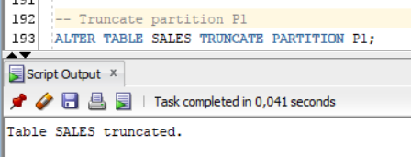

Coalescing partitions:

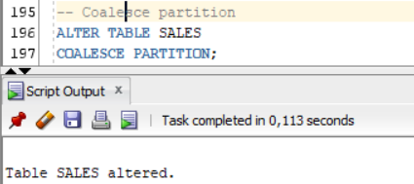

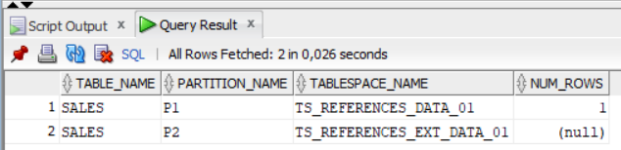

As we see, oracle reduced the number of partitions.

**Reference partitioning**

Creating tables

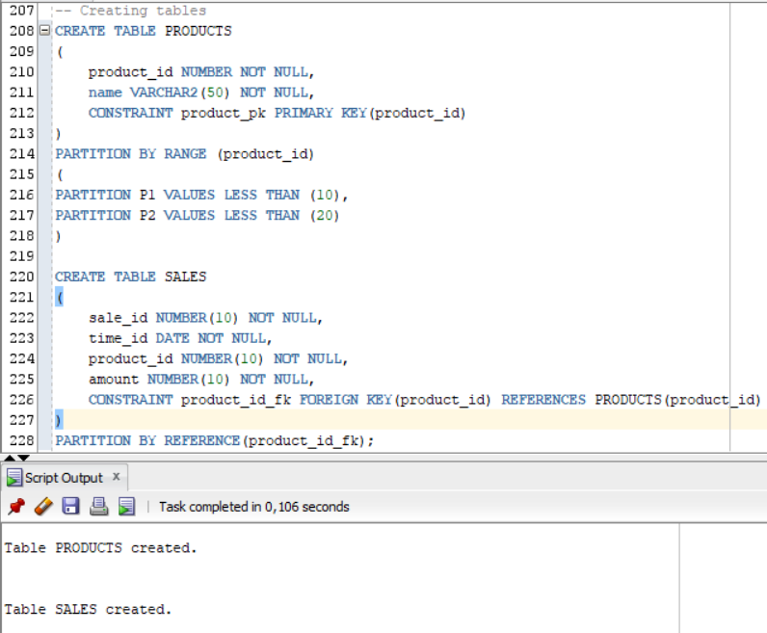

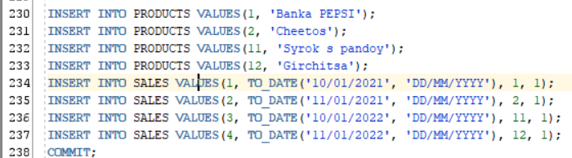

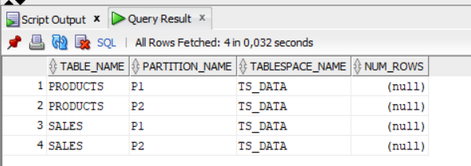

Moving partition P1 to another tablespace:

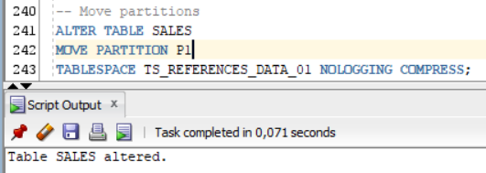

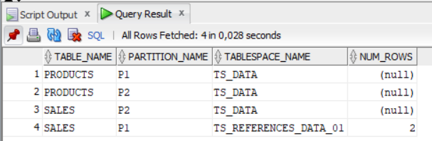

Truncating partition

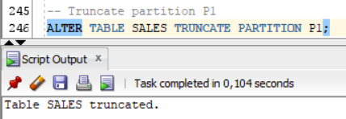

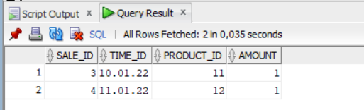

**Task 2**

**Fact Partitioning**

According to our single fact table FCT_SALES, we can create range partitioning by year. In my opinion, that’s action can optimize queries which include the year conditions.

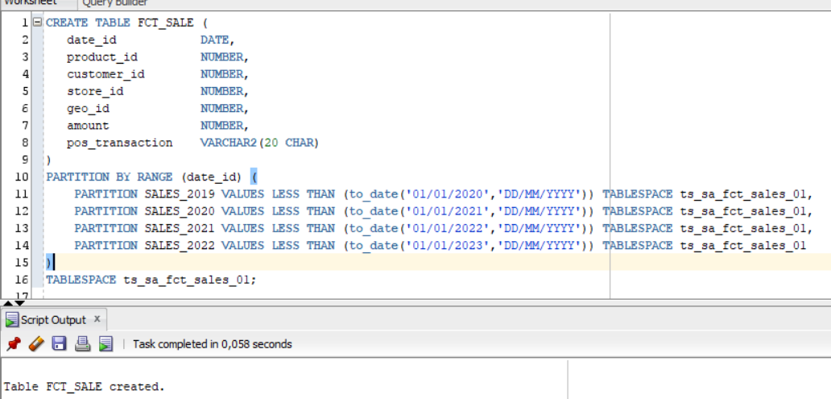

**Conclusion**

At this task I got basic knowledges about partitioning in Oracle. Partitioning allows database objects to be subdivided into smaller partitions.